Air Exchanger Control Narrative

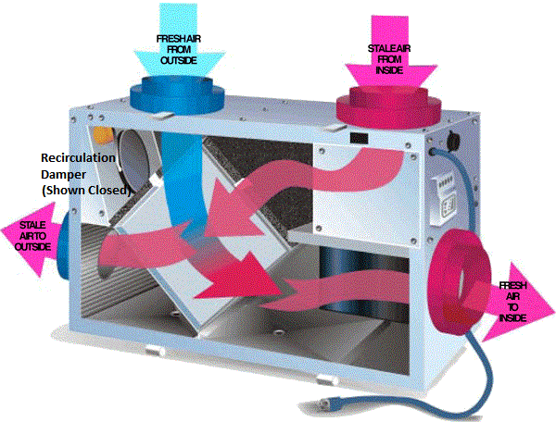

Common Terms
OSAT is Outside Air Temperature
OSAH is Outside Air Humidity
ISAT is Inside Air Temperature
ISAH is Inside Air Humidity

Button Operation
Double Click (Change Screen)
Press & Hold for 5 sec (Change Mode)
Single Click [Continuous] (Change Fan Speed)
Single Click [Air Economizer] (Change Fan Speed)
Single Click [High Occupancy] (Change Fan Speed

Recommended Setpoint Values | WINTER | SPRING | SUMMER | FALL
Mode | Continuous | Air Economizer - Heating | Air Economizer - Cooling | Continuous
Fan Speed (20 – 100%) | 20% | 60% | 60% | 60%
Ventilation Duration (10-60min) | 20min | --- | --- | 20min
High Occupancy Duration (0-12hrs) | --- | --- | --- | ---
Air Economizer Target ISAT (60 - 85 ºF)** | 85 ºF | 70 ºF | 70 ºF | 85 ºF
Inside Air Humidity High Limit [ISAH] (0 - 80% RH)* | 40% | 60% | 80% | 50%
Outside Air Humidity High Limit [OSAH] (25 - 80% RH) | 0% | 80% | 70% | 80%
Outside Air Temperature High Limit[OSAT](65 - 90 ºF)** | 90 ºF | 75 ºF | 75 ºF | 90 ºF
*Inhibits only in Continuous Mode
**Inhibits only in Air Economizer
Modes of Operation
- OFF
- Continuous– [SEASONS: Fall, Winter]
  - The HRV will run at the designated fan speed for the duration specified. It will be off for the remaining hour. i.e. duration is 25 minutes then the HRV will run for 25 minutes and off for 35 minutes. If duration is 60 minutes then it will constantly be on.
  - Frost Control will evaluate after the first minute sample period.
  - Dehumidify mode can interrupt this cycle at anytime. If the Outside Air Humidity (OSAH) is greater than the OSAH High Limit setpoint then this mode will be disabled for the duration, the step will move to IDLE and remain there until the next hour. Then the sample period will resume and re-evaluate the next hour.
  - SETPOINTS
    - Fan Speed (20%, 40%, 60%, 80%, 100%)
    - Ventilation Run Time Duration (10 – 50 min)
    - OSAH High Limit (25-80% RH)
- High Occupancy– [SEASONS: ALL]
  - On occasions where indoor air may become stale such as large gatherings or cooking odors this mode ventilates on maximum fan speed for specified time interval. After timer times out it will return to Continous mode.
  - Frost Control will evaluate after the first minute sample period.
  - OSAH High limit if reached will abort this mode and return to Continuous mode.
  - SETPOINTS
    - High Occupancy Duration (1-12HRS)
- Dehumidify (Automatic for Continuous Mode) – [SEASONS: Fall, Winter]
  - To control harmful, excess humidity during the heating season ONLY! The dehumidistat operates in % of RH (Relative Humidity) with 80 being high and 20 being low. The average person in comfortable in the range of 30-50%.
  - The dehumidistat will override the HRV in CONTINOUS mode to high speed when the ISAH > ISAH setpoint and the outside humidity is 1% less than inside humidity. Once the humidity is reduced, the HRV will revert back to the prior mode.
  - SETPOINTS
    - ISAH High Limit (25-80% RH)
- Frost Control (Automatic for Continuous and High Occupancy Modes) – [SEASONS: Fall, Winter]
Exhaust air recirculation is used for frost control to warm the heat exchanger core to prevent frost formation. This method of frost control routes exhaust air back through the supply side of the heat exchanger to warm the core. Since this method routes exhaust air back into the building (Recirculation Damper Open), the building is typically not depressurized when this frost control cycle is active.
This mode will be enabled during CONTINOUS or HIGH OCCUPANCY.
This is automatically done in a startup cycle based on outside air temperature. Outside air will be sampled for one minute to get an accurate temperature reading;. After the one minute has elapsed if one of the following conditions are met then this mode will run specified duration.
    - OSAT is less than -10 ºF then defrost time is 5 minutes
    - OSAT is less than 0 ºF then defrost time is 3 minutes
    - OSAT is less than 10 ºF then defrost time is 2 minutes
    - OSAT is less than 20 ºF then defrost time is 1 minutes
    - OSAT is greater or equal to 20 ºF then defrost time is 0 minutes
- Air Economizer (Cooling) – [SEASONS: Spring, Summer]
Save energy in buildings by using cool outside air as a means of cooling the indoor space. In this mode, the recirculation air damper closes and fan speed operates at fan speed setpoint to maintain the ISAT target set point. If any of the selected limits are exceeded, economizer is disabled for one hour until the next sample of outside air.
  - Free Cooling Mode. During mild weather (55°F to 70°F, for example), outdoor air can provide some cooling capacity. We refer to this mode as free cooling mode because it combines uses outdoor air to cool the indoor space. The system stays in free cooling mode while all of the following conditions are met.
    - OSAT < OSAT High Limit
    - OSAH < OSAH High Limit
    - ISAT > ISAT Target Temp
    - Fan Speed set setpoint value
  - AC Mode. During warmer weather (70°F to 95°F , for example), the economizer operation is disabled. The system stays in AC mode if one of the following conditions are met.
    - OSAT > OSAT High Limit
    - OSAH > OSAH High Limit
    - ISAT < ISAT Target Temp
    - Fan Speed set to 0%

