14”

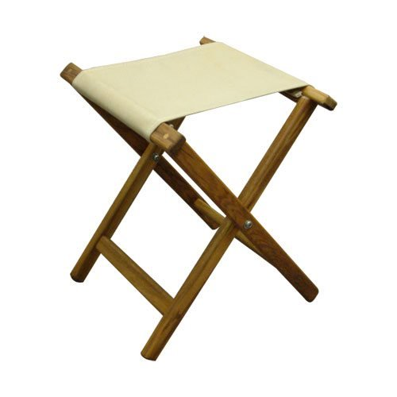

Fabric

Picture came from internet. The camp stool I want to make is these dimensions added. The tops of the legs , where the fabric is fastened will be a little different. I want the stool to be able to support a 300lb. person.

I am looking for a way to calculate the dimensions of the legs when made from Douglas Fir. The legs must be 22” long with the pivot point 13” above the bottom of the legs. Something like - ¾” x1-1/2” or 1” x 2” or ?

Trying to keep the weight to a minimum yet strong and safe. The fir (off-cuts from structurally laminated beams costs me 000$

13”

20”

16”

16”