Proteus Simulation
We run a proteus simulation for our project first because it can further take us to PCB layout
First of all, we are going to tell you how to make proteus project.
- Creating new project
Opened by clicking on New Project present on the tabs at the start up screen as shown in the following screen shot
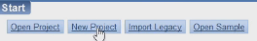
This opens a new project wizard on which the name of the project and location of the project has to be set up
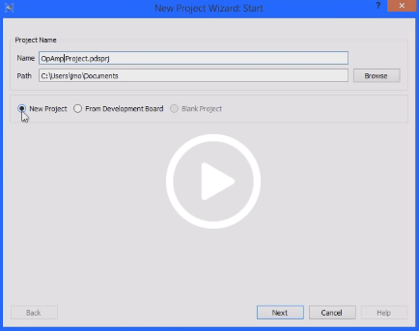

- Schematic design window
After clicking next on the new project wizard the next window of schematic design will appear for the selection of template. Select the default template as shown in the snapshot below
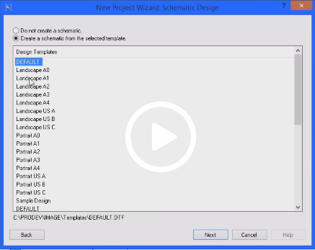

- PCB layout
By clicking next in the previous window we would have a PCB layout window. If we want to create the PCB layout for the schematic design, choose the required option in the list otherwise default layout shown in the snapshot below:
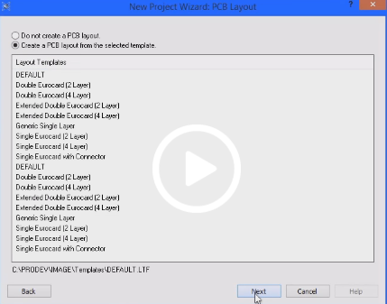

- PCB layer usage
By clicking next, we would have a window for setting up the board layers and names as shown below:
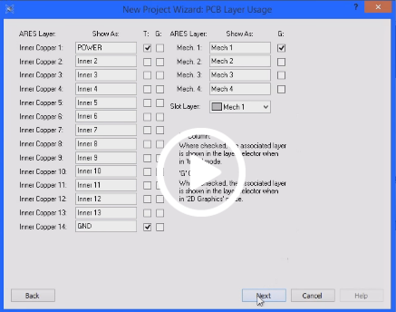

- Firmware
Next window appear will be used to set up firmware and no firmware project will be selected if we do not use proteus for assembling our design
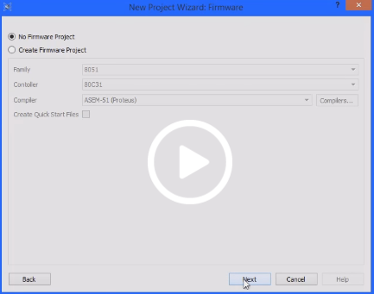

- Final configuration
This step is to verify our selected settings and continue if everything in the respective order otherwise you can move back
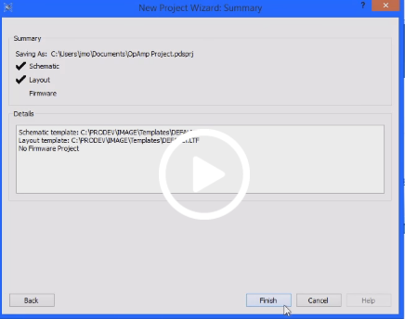
Click on finish button and view the schematic capture window by clicking on the tabs shown below:

- Schematic capture
Select a device by clicking P from the tab shown below
- Keyword
Keyword entry helps to find a specific requirement for which we are looking for
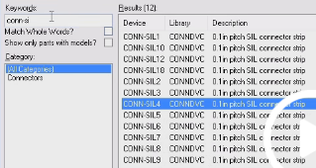

Select all of the components which you required for your design from the list of library one by one
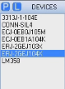

Simply select the component from the list you have made and start placing it on the template or drag and drop
All the components are placed in the same way and can be joined just by stretching the end of the component and through placing the wire as a joint.
Components:
- 74LS245 (Octal bus Transceiver)
- 7805 (5V fixed 1A Positive Power Supply Regulator)
- BUTTON (SPST Push Button)
- CAP (Generic non- electrolytic capacitor)
- COMPIM (COM Port Physical Interface Model)
- CONN-D9F (9 Pin female D-Type)
- CONN-D9M (9 Pin male D-Type)
- CONN-SIL2 (0.1 in pitch SIL connector strip)
- CONN-SIL3 (0.1 in pitch SIL connector strip)
- CONN-SIL8 (0.1 in pitch SIL connector strip)
- CRYSRTAL (Quartz Crystal)
- LED-BARGRAPH-RED (Red LED Bar Graph Display)
- LED-RED (Animated LED Model(red))
- MAX232 (Multichannel RS232 Driver/Receiver industry standard)
- PIC18F452
- RES (Generic resistor symbol)
- RESPACK-8 (8-way resistor pack with common)
- SWITCH
First select all the above mentioned devices
Then place them to develop a schematic capture
The wiring is shown in the figure where all the four ports of PIC18F452 are connected with 74LS245 which is an octal bus transceiver that are designed for asynchronous two-way communication between data buses. Then these 74LS245 transceivers are connected with LED Bars which is a 10 segment bar graph they are 10 individual red LEDs housed together, each with an individual anode and cathode connection and these LED Bars are further connected with RES-PACK-8(8-way resistor pack with common) while CONN-SIL8 is connected in between them.
CONN-D9M is connected with MAX232 which is used in Serial communication it basically provides communication through a serial port, this is a versatile IC which is one of those wonderful components that solve so many signal conversion problems. The T1IN pin max232(input of transmitter data) is connected with pin 5 PORT C of PIC18F452.
A Quartz Crystal along with two capacitors of 22pF is connected with pin 13 OSC1/CLK1 and pin 14 OSC2/CLK0 of PIC18F452.
A regulated power supply is very much essential for several electronic devices due to the semiconductor material employed in them have a fixed rate of current as well as voltage. So we use linear voltage regulator 7805 along with capacitors of 1nF. The input and output pins of the regulator are connected with CONN-SIL2
We have one port on PIC18F452 with three input/outpur registers for them we use separate LEDs and connect them with three respective resistors of 220 and in between them there is CONN-SIL3 and the LEDs are grounded from the other side.
After this run the proteus file in order to check wiring errors
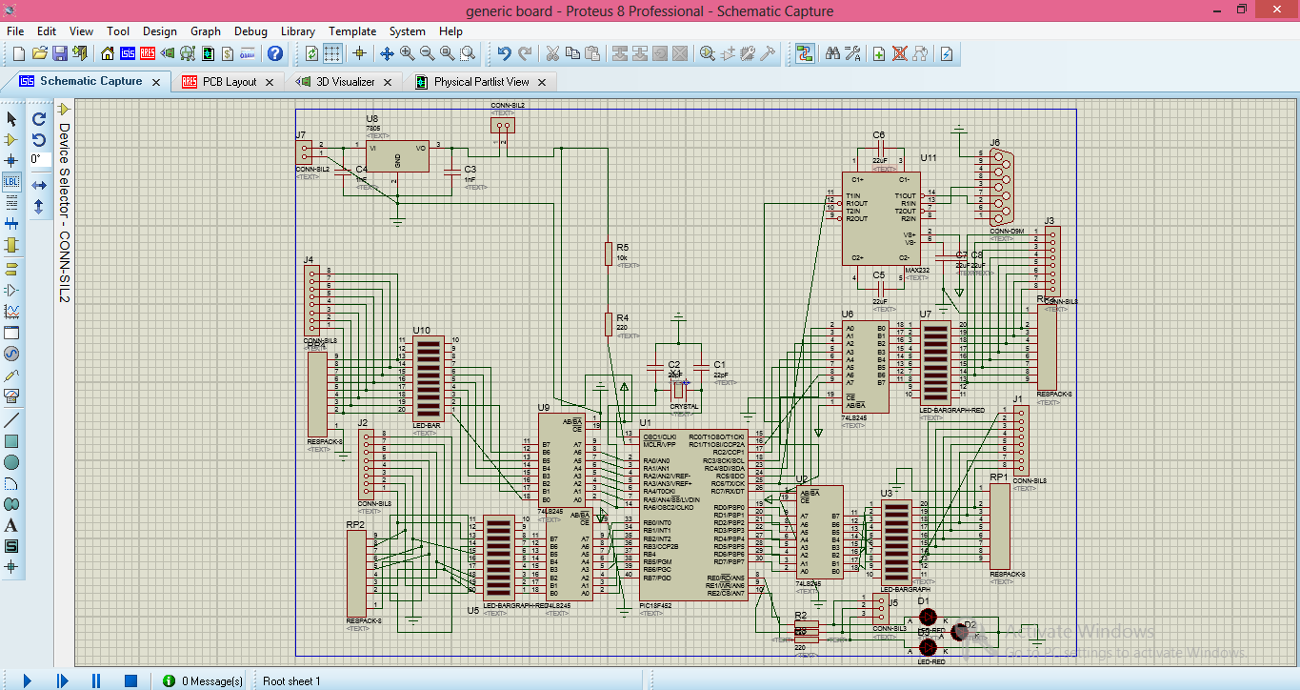
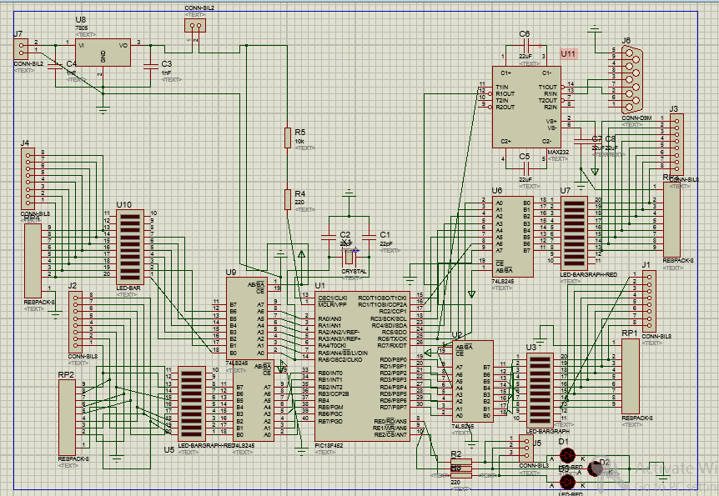

PCB LAYOUT:
- Now when the whole circuit is created switch to the PCB Layout tab. In this all the part that are placed in the circuit are visible(the names given by the user) along with their values.
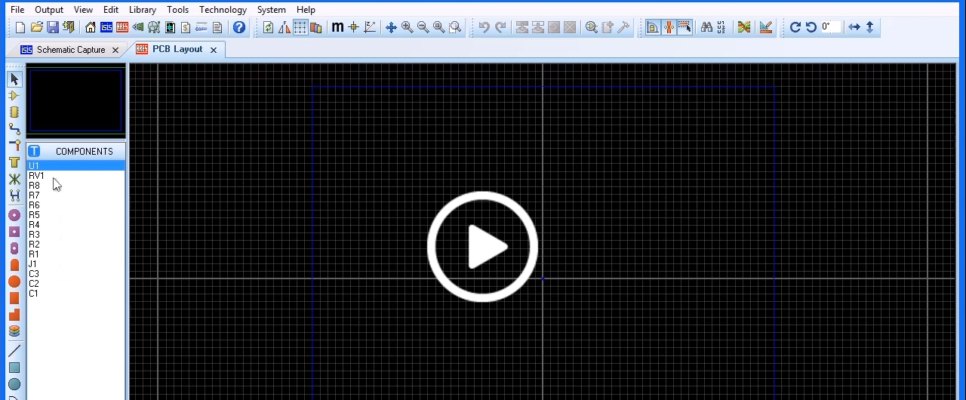
- Now before placing the components choose a design rule for this click on Technology menu and then click design rule manager a window will be appeared in which there is a design rule tab it provides layers and clearances which specifies subsets of sectary
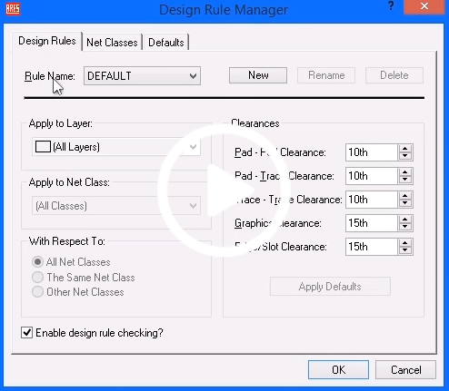
- and then there is a Net Classes tab it provides ability to specify the traces and wire settings and different routes of the connections it has two main options POWER and SIGNAL.
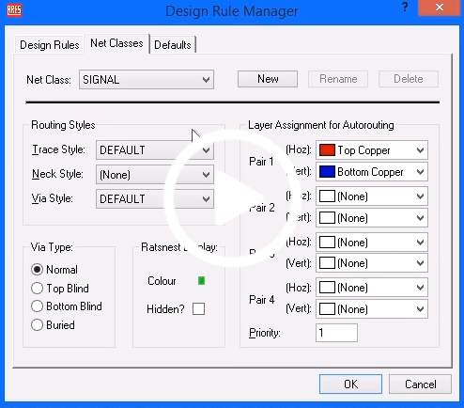
- Now by setting the design rules user again goes to PCB Layout and started placing the components on the black matrix screen. Now first the board is selected for the components by setting the 2d graphic tool and user have to make sure that the layer select at the bottom will be select to Board Edge it provides the user to have a accurate board size such that the measurements are accurate when the false origin is used the colour will be changed into magenta.
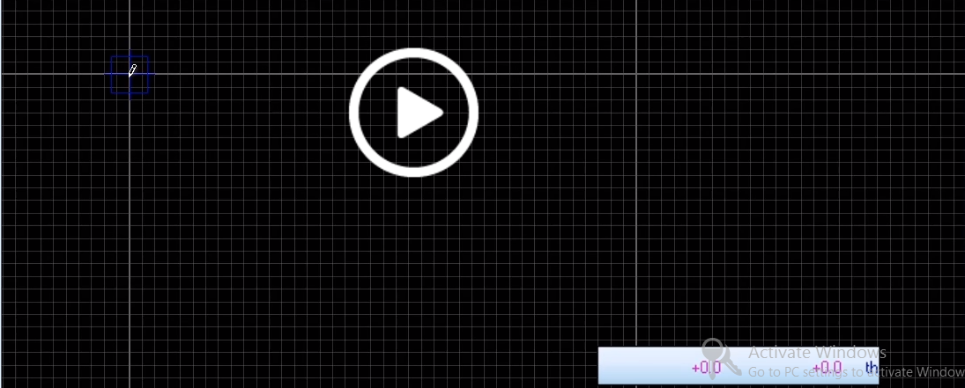
- By again left clicking it will complete placement of board and the boundary will be appeared in yellow colour.
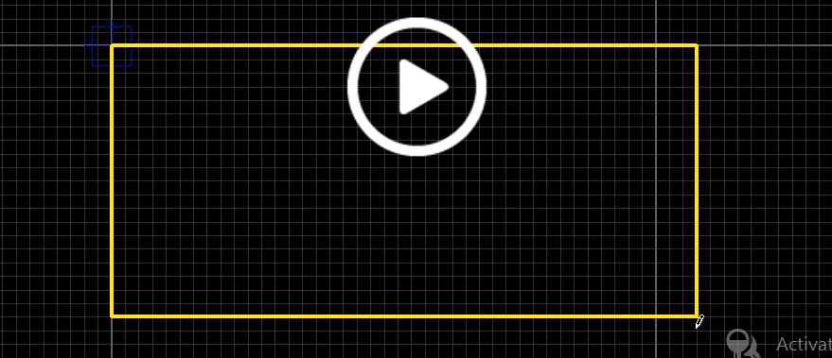
- Now the components and Ares are placed. Left click is use for placements and + and – are used for rotation
- Start placing the components OPAMP the connection wires with arrow heads are appeared and these connections are the same which we create in the Schematic Capture.
- In order to read the board manually user has to select Track Mode and select the layer selector to the desired starting layer of the route. Now start the routing by left clicking on the part the user want to route from.
- Proteus will recognise the connection and also change the connection now user has to follow the right path route the part in the right direction. By left clicking on the part that particular route is terminated and fixed space bar is used to change the route layer now route the whole circuit in the same way. Now place the power plane by clicking on Tools and then on Power Plane Generator a pop up will be appeared in which the user selects the net, layer, the edge and the boundary.
- Now by left clicking on the design the user is able to edit the properties and Route to this zone is checked so that routing will be completed manually.
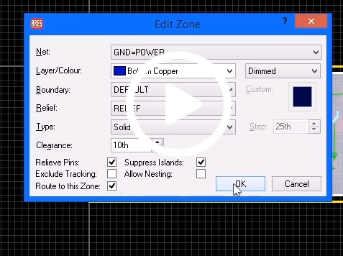
- Now from the tool menu select the Auto router a pop up will be appeared in which user have to select Begin routing and then routing will start automatically it tells whether the design or in the routing there are errors or not and tells the user about them which are displayed at the bottom of the screen.
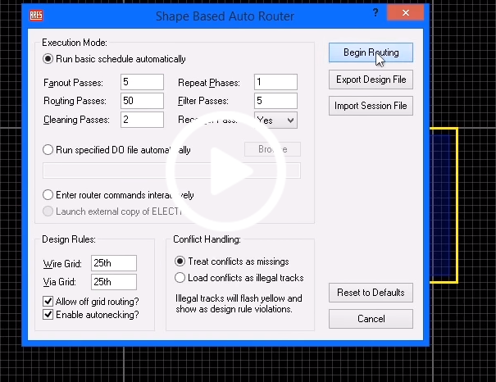

- Now after the completion of this step go to technology menu select Set Text Style from there the fonts and height of the design is selected as well as from their design graphics are also changed.
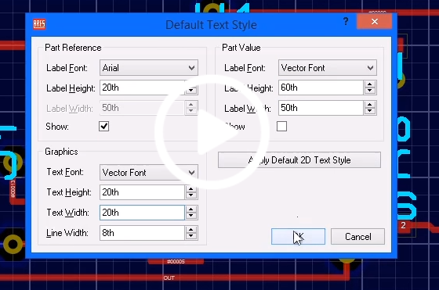
The final PCB Layout looks like
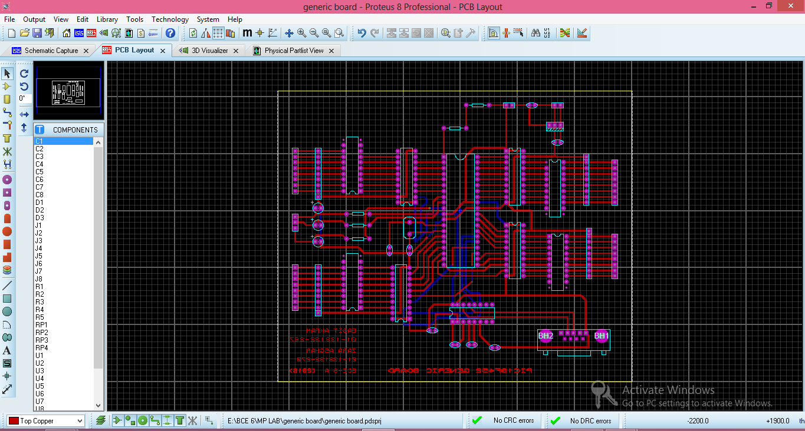
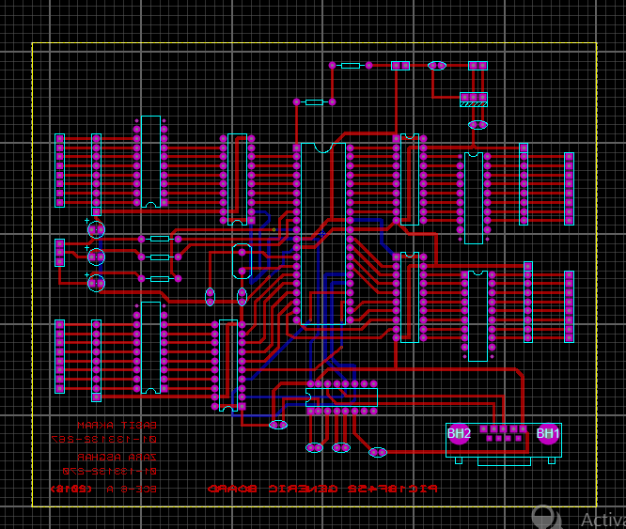
3D Visualizer:
After creating the PCB Layout create a 3D Visualizer as this Visualisation Tool (3D Viewer) in ARES provides a way to extrude a layout and view the board as it would appear in real life. This is extremely useful as a design aid during board layout.
