In this title will present the testing result of GSM based vehicle theft alert system result.
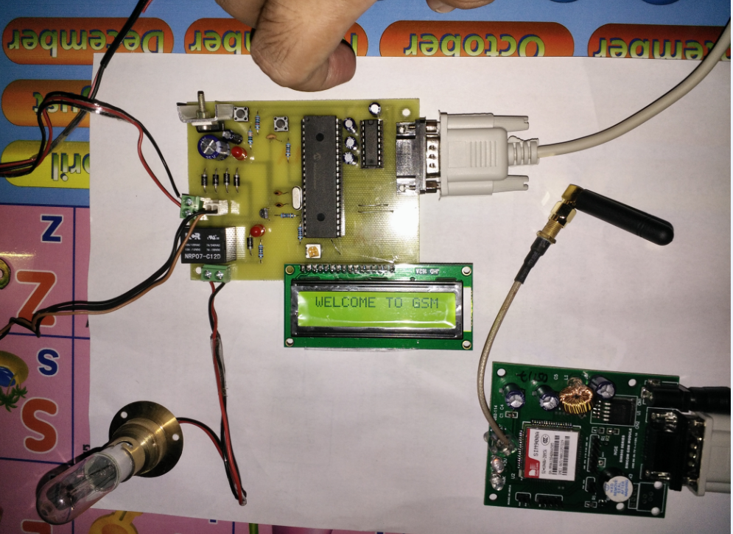
Fig15. Power Start On condition
This picture is the start condition of power on. When the power switch is on, the LCD display will show the system working state. This state is the 1st step of the power supply switch on.
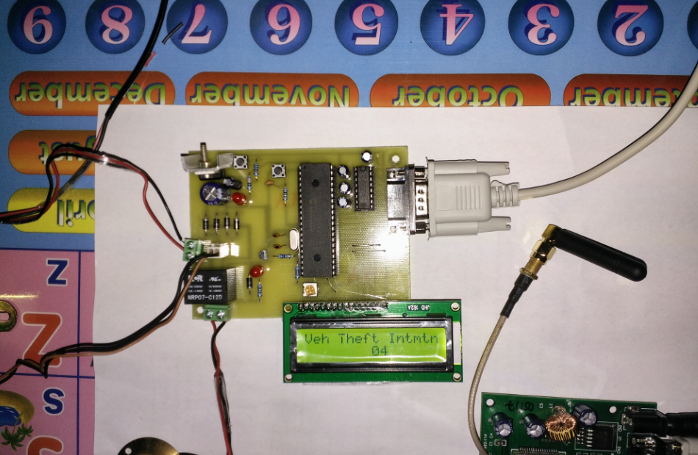
Fig16. System set timer count condition
After show the welcome condition of the GSM based theft alert system, the system will start to count to set. In here the counting second will show in LCD display. For the counting will long 20 second.
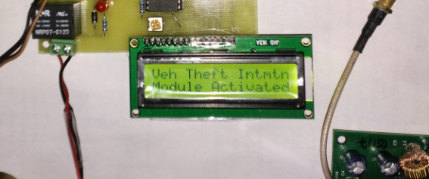
Fig17.System activate condition
This is the condition of system ready to prevent the theft. Therefore after counting the number of 20sec the LCD display will show that word on the display.
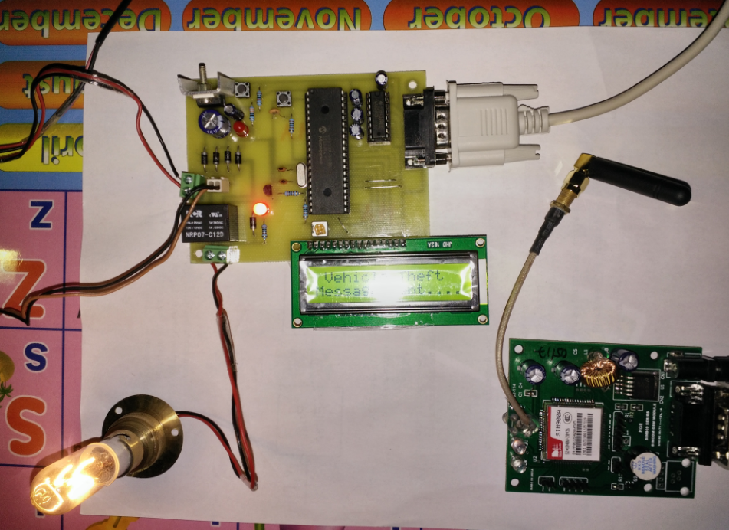
Fig18. Theft start attacking condition
The theft start to steal the car system will send the message to the owner or user of vehicle. In here the LCD display will show message sending word and the sing of the car engine working light will turn on.
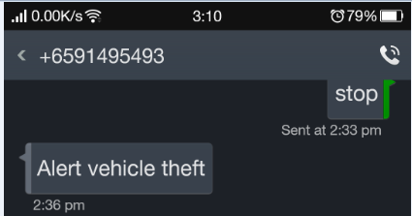
Fig19. Theft alert message from the circuit
This is the message from the GSM based vehicle theft alert system.
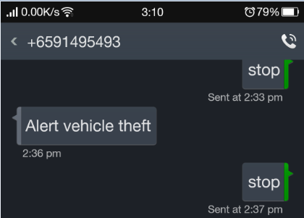
Fig20. Send back to the system to stop the condition
After seeing the theft alert message the owner will sent to stop message for the car. This stop message will cut the car ignition system so the car engine will stop and this car will not wake up again until the owner rest the system.
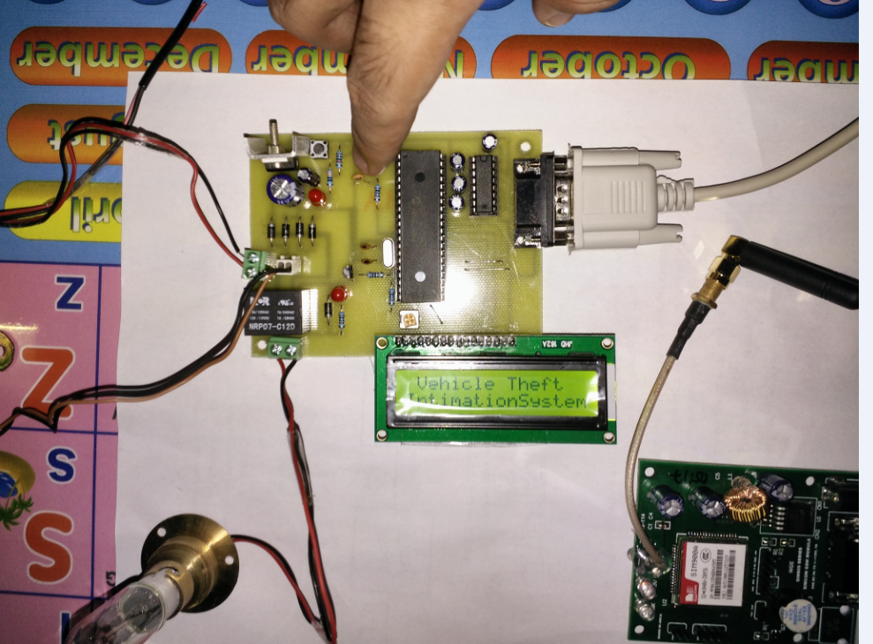
Fig21.After cutting the ignition system
In this condition the ignition system will stop. This system will be still remaining before the owner push the rest button of the system. So the car system will not work again after finishing this step. Therefore this system is very easy to used and very easy to know the condition of the vehicle or car.

