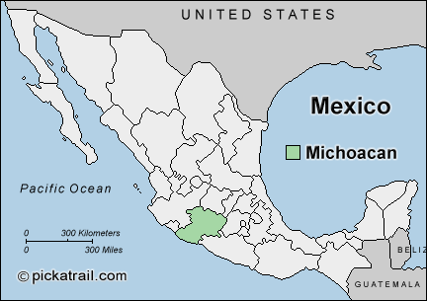

The monarch butterflies spend the winter in the forests near the town of Angangueo in the state of Michoacán, in Mexico, then fly thousands of miles north to the United States and Canada.

The monarch butterflies spend the winter in the forests near the town of Angangueo in the state of Michoacán, in Mexico, then fly thousands of miles north to the United States and Canada.

The monarch butterflies spend the winter in the forests near the town of Angangueo in the state of Michoacán, in Mexico, then fly thousands of miles north to the United States and Canada.

The monarch butterflies spend the winter in the forests near the town of Angangueo in the state of Michoacán, in Mexico, then fly thousands of miles north to the United States and Canada.

The monarch butterflies spend the winter in the forests near the town of Angangueo in the state of Michoacán, in Mexico, then fly thousands of miles north to the United States and Canada.

The monarch butterflies spend the winter in the forests near the town of Angangueo in the state of Michoacán, in Mexico, then fly thousands of miles north to the United States and Canada.

