It is recommended that you change your oil around every 3000 miles. These are the steps you should take in order to change the oil in a 1999 Dodge Ram 1500 to ensure a long life for your motor.
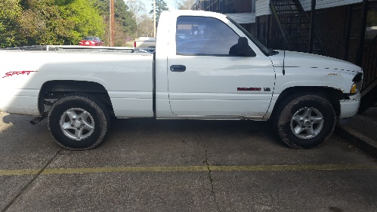
Tools and parts needed.
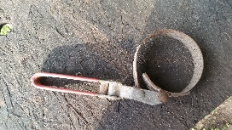
Figure 1.2

Figure 1.3
Figure 1.1
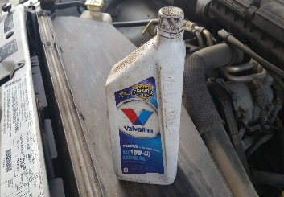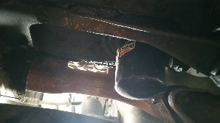
Five quarts of motor oil Oil filter Oil Filter Wrench

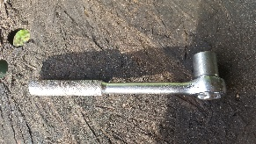 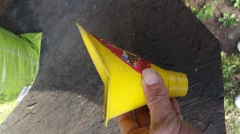 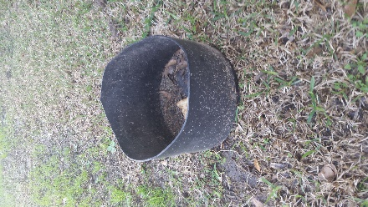
Ratchet (5/8 inch socket) Funnel Drain pan
Figure 1.6
Figure 1.5
Figure 1.4

STEP 1: Apply emergency Brake on the vehicle.

Step 2: Drain the old oil from the oil pan
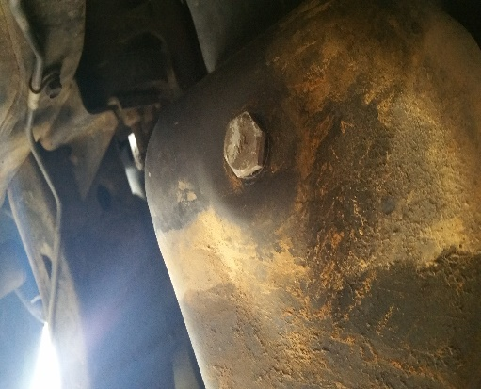
Figure2.1

STEP2.1: Locate the drain plug on the bottom of your oil pan. (Fig2.1)

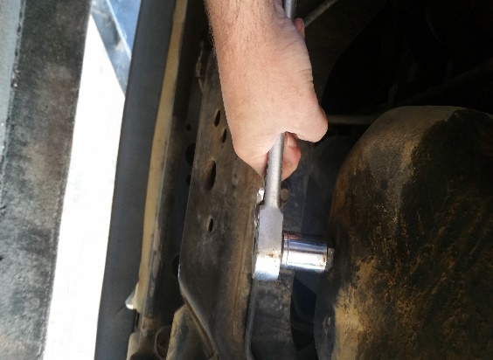
Figure 2.2

Step 2.2: Remove the drain plug using the ratchet and 5/8 inch socket (Fig.1.4)
Step 2.3: turn the ratchet counter clockwise. (Be sure to place you drain pan underneath the drain plug)

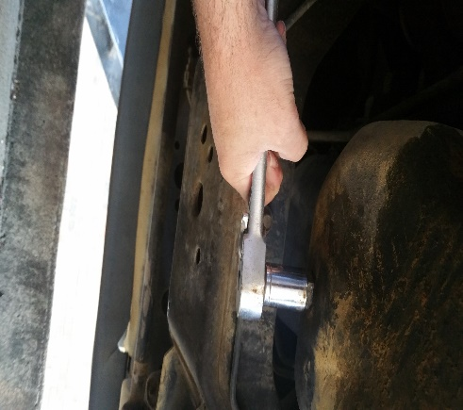
Figure2.3

Step 2.3: Replace drain plug back into the oil pan using the ratchet and 5/8 socket by turning clockwise (Fig 2.3)

Step 3: Remove old oil filter

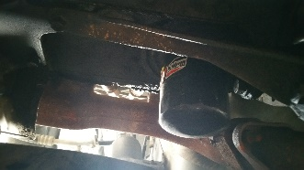
Figure 3.1

Step 3.1: Locate the old oil filter underneath your vehicle. (Fig1.2)

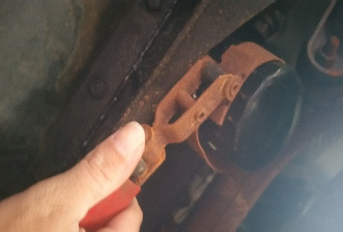
Figure3.2
Step 3.2: Remove the old oil filter by turning the filter wrench counter clockwise. (Fig3.2) (Make sure your drain pan is placed under the oil filter)

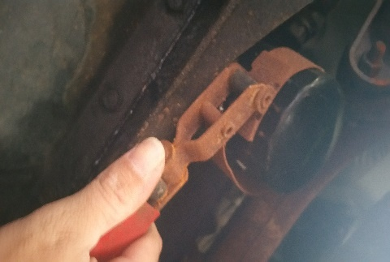
Figure3.3

Step 3.3: Place the new oil filter on by turning the filter wrench clockwise. (Fig3.3)

Step 4: Adding new oil

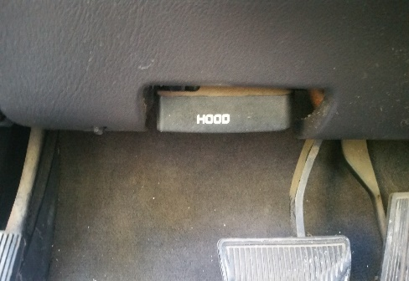
Figure4.1

Step 4.1: Open the hood of the truck by pulling the hood latch located in the cab of the truck
(fig 4.1)

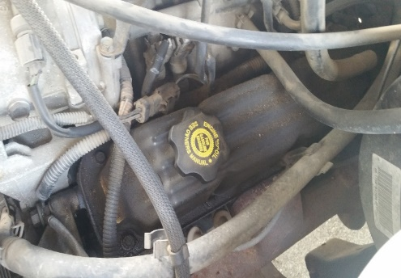
Figure4.3

Step 4.3: Locate the oil reservoir underneth the hood. (fig4.3)

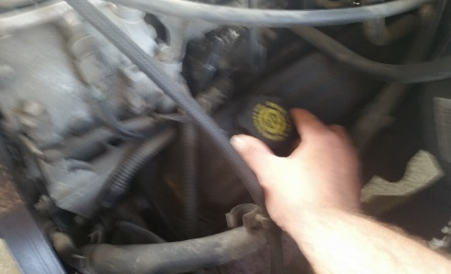
Figure4.4

Step 4.4: Remove the cap from the reservoir by turning counter clockwise. (fig4.4)

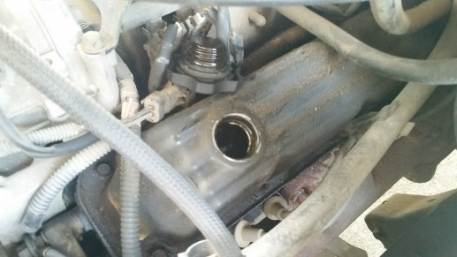
Figure4.5

Step 4.5: Place the reservoir cap to the side (fig4.5)

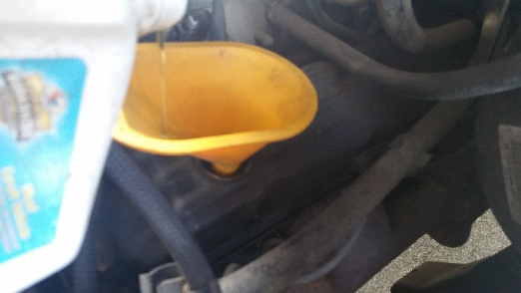
Figure4.6

Step 4.6: Place your funnel (Fig.1.5) inside the reservoir hole
Step 4.6.1: slowly pour your five quarts of motor oil (Fig. 1.1) into the funnel (Fig. 1.5).

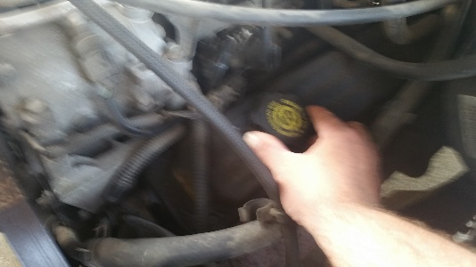
Figure 4.7

Step 4.7: Place the cap back on once you have added the new oil by turning clockwise (fig4.7)
and shut the hood.

Now you have successfully changed the oil in your 1999 Dodge Ram 1500 with these easy instructions. Remember to repeat this process every 3000 miles.

