Mousetrap Car |  | Advanced

Project Goal  Students are challenged to build a mousetrap car that can travel the farthest distance possible  Design Variables  Length string/arm/frame, weight of the frame  Key Concepts  Energy conversion is when one kind of energy is changed into another kind  Mechanical advantage is the ratio of the input force to the output force  Friction is a force that opposes the motion between two things that are in contact  Prep  - Build a basic example  - Cut craft sticks in half (4 ½-pieces per student)  Notes  Mousetraps are only unsafe when the metal spring-arm is pulled all the way back. It’s not especially dangerous to pull it back slightly while building the mousetrap arm. |  | Materials  Basic Example  - 20 craft sticks  - 4 cubes  - 1 straws  - 2 large wheels  - 1 1/4" dowel  - 2 small wheels  - 1 1/8" dowel  - 1 cable tie  - 1 mousetrap  - 30" string  - tape  - hot glue  - scissors  Advanced Idea  none
Troubleshooting
If the car is… | Then…
Not moving at all | - The wheels are pressed too tightly against the straw  - There’s excessive hot glue or something else interfering with the wheel rotation  - The mousetrap arm is too long
Not driving straight | - The wheel axles are not parallel to each other  - One of the small wheels is moving but the other isn’t
Not coasting very far | - There’s a source of excessive friction affecting the wheels  - The car is too heavy

Introduce the project demonstrate how it works (1 min)
Students are challenged to build a mousetrap car that can travel the farthest distance possible.

Explain how it works (1 min)
- The mousetrap stores potential energy when the spring-arm is pulled back.
- The string is wound around the drive wheel axle.
- When released, that potential energy is converted into kinetic (moving) energy in the form of the drive wheels turning.
- The distance the metal spring-arm travels is short, but the energy output is very strong. Through the extended arm and large wheels, that short burst of energy from the mousetrap is converted into a slow, longer-lasting output of energy because it has a very low mechanical advantage.

Show students how to build the basic example (10 min)
- Quickly show step-by-step how to build the basic example.
- Emphasize how to use a straw to correctly space the wooden cubes apart.
- Emphasize the sandwiching technique to create the extended mousetrap arm.

(Simple) Discuss how to optimize for distance (2 min)
- The car will be propelled forward as long as the mousetrap arm continues to pull on the string and turn the drive axle.
- After that, the car will continue to coast forward from momentum.
- Explain that the friction between the straws and the axles will slow down the car.
- Reducing friction by removing excessive hot glue, preventing the wheels from touching the straws, and minimizing the amount of contact between the dowels and the straws will increase the coasting distance.
- Friction can also be reduced by making the car lighter. Students may try to remove material from the car to make it as light as possible.

(Advanced) Discuss how to optimize for distance (20 min)
- See next page.

(Optional) Discuss how to calculate the mechanical advantage and minimum travel distance (15 min, in a separate demo)
- See next page for details.

Advanced Discussions

This section is designed for students in grades 8 and up.
There are a two suggested ways to use this information:
- Before building the car, explain these concepts to students through example equations and diagrams, then allow them to draw upon these concepts and formulas to design cars with customized dimensions.
- Have students build their basic example, then explain the concepts. Afterward, have them make measurements of their car and complete the calculations for mechanical advantage and predicted minimum distance travelled, then compare it to the actual distance travelled.

In-Depth Explanation of How the Mousetrap Car Works

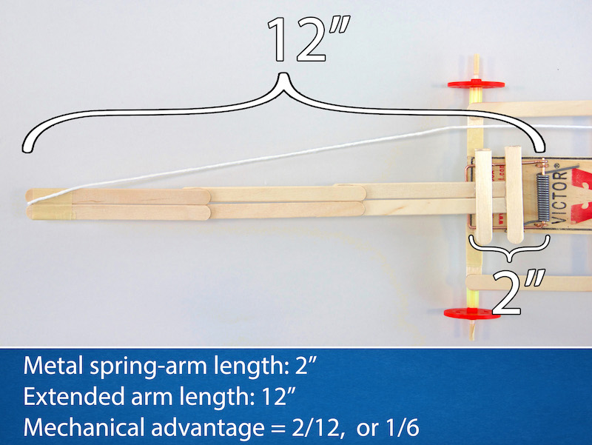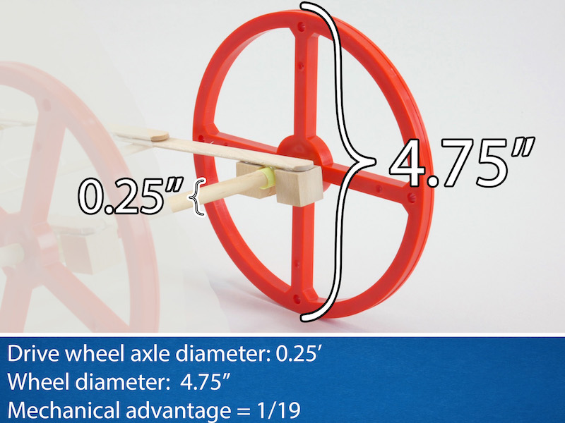

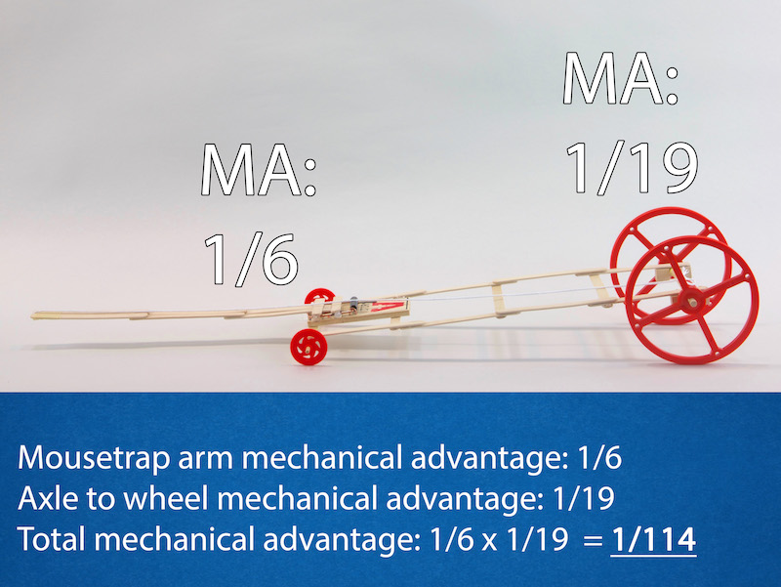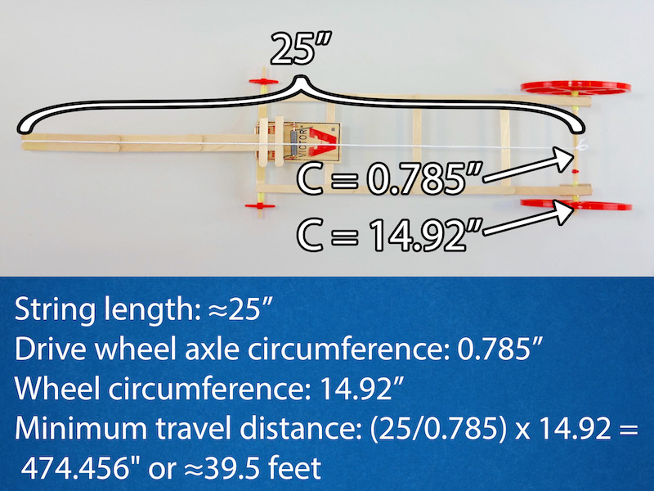

Mechanical Advantage
- The mousetrap car relies on a form of mechanical advantage to convert the fast burst of energy from the spring into a weaker but longer-lasting output of energy. The mechanical advantage can be calculated as follows:
- The metal spring-arm of the mousetrap is just 2" long and the craft stick mousetrap arm is 12" long, so the mechanical advantage of the extended arm is 2/12, or simplified as 1/6.
- This means that the force outputted at the end of the craft stick arm is 6 times weaker than the metal spring-arm, but it also travels 6 times farther.
- Additionally, the drive wheel dowel diameter is 0.25" and the wheel diameter is 4.75", so the mechanical advantage from the dowel to the wheel is 0.25/4.75 = 1/19.
- The total mechanical advantage can be calculated by multiplying the two: 1/6 x 1/19 = 1/114.
- This means that the force output at the outside of the drive wheels is 114 times weaker than the force at the end of the metal spring-arm, but it will also travel 114 times farther!
- 1/114 is a low mechanical advantage, meaning the output force is less than the input force. This is useful for mousetrap cars: a lower mechanical advantage means the energy from the mousetrap is used over a longer period of time so the car can be powered over a longer distance.
- By contrast, a high mechanical advantage would be useful if you wanted to move something heavy, but apply the force over a longer distance.

Calculating minimum distance
- The minimum distance can be calculated as follows:
- The circumference of the dowel axle is π (pi) x 0.25 = 0.785".
- The length of the string is about 25".
- Therefore the string can be wrapped around the dowel 25/0.785 = About 31.8 times.
- The circumference of the wheels is π x 4.75 = 14.92"
- So the minimum distance travelled will be the number of times the string can wrap around the dowel multiplied by the circumference of the wheels, which is 31.8 x 14.92 = 474.456", or about 39.5ft!
- In addition to the minimum distance, the car will continue to travel due to momentum. This extra distance depends on several factors such as the car weight, the surface it's driving on, and the amount of friction at the axles, which are too varied to reliably calculate here.

The arm length
- A longer string will result in a lower mechanical advantage. In theory, this would make the drive wheels will turn more times, and the car will drive farther.
- However, longer string also necessitates a longer arm and frame, which adds further weight.
- If the frame is shorter than the string, then part of the string won't be able to wrap around the drive wheels. This defeats the purpose of elongating the string: the total usable length of the string is equal to the diameter of the arm arc, so any string that's not wound around the drive wheels is essentially wasted.
- The added weight generates more friction, which mostly occurs at the point of contact between the straws and the dowels.
- This means that making the string longer is only helpful to a certain point! It's possible to create a car that's too long and heavy.
- Therefore, the string needs to be long enough to create very low mechanical advantage, but if it gets too long then it'll necessitate a car that's too heavy and slow.

Wheel size
- Large wheels will also theoretically result in greater distance since the a larger circumference will increase the minimum distance travelled
- Remember the formula is (drive wheel circumference) x (number of times the string is wrapped around the dowel).
- However, just like adding a longer arm, larger wheels can be heavier, but this is problematic for a different reason. Larger wheels don't generate friction in the same way as a larger arm; the wheels do not weigh further on the axle.
- Larger wheels still create more friction between the edge of the wheel and the surface it's rolling on. Heavier wheels press into the ground with more force, which increases friction.
- Additionally, large wheels have more inertia, which is the tendency for objects to remain at rest.
- This means it requires more energy to move larger wheels.
- Furthermore, whenever energy is transferred from one source to another, some of it is lost. This means that the larger wheels cannot store that extra energy very efficiently in the form of momentum.
- The summary, the science and math concepts behind the mousetrap car manifest as a balance between these principles: lower friction and inertia as much as possible and decrease mechanical advantage as much as possible.

Summary of Formulas:
- Mechanical advantage = ([length of metal spring-arm] / [length of extended mousetrap arm]) x ([circumference of axle dowel] / [circumference of drive wheel])
- Minimum travel distance = (String length / circumference of axle dowel) x Circumference of drive wheel

In-Depth Discussion for Maximizing Distance

The basic example mousetrap car built in this is a good place to start, but it's not the absolute best design. We can use our understanding of the math and science behind the car to test some ways to optimize its performance.
The best mousetrap car is one that starts by slowly crawling forward, using the smallest amount of energy possible to get moving. This indicates that it has the lowest possible mechanical advantage. As the car moves forward, it begins to build momentum. When the arm reaches the end of its arc, the car has generated enough momentum to continue coasting for some distance. The less friction the car generates, the greater the coasting distance will be.
With that in mind, challenge your students to think about the following categories of improvement:

Weight
- The first and most straightforward optimization is to make the car lighter. A lighter car will generate less friction, which means the car will coast farther using its momentum.
- What materials can be removed and the car will still work?
- Are there lighter materials that could be substituted for the heavier ones?

Friction
- The biggest enemy of a high performing mousetrap car is friction. There are ways to reduce friction without removing weight.
- First, look for any imperfections that might create excessive friction, such as bits of hot glue inside the straws, or the wheels pressed too tightly against the ends of the straws. Cleaning up small things can have a big impact on performance.
- From there, what else could you do to reduce friction?
- How could you modify the design so the side of the wheels doesn't rub against the ends of the straws?
- How can you reduce the amount of contact between the front wheel dowel and the straw?

String Length
- The length of the string (and consequently, the length of the extended arm and frame) plays an important role in determining how many times the drive wheels will rotate under the power of the mousetrap, but making it too long will increase the weight and consequent friction.
- Making the string too long may also create an extremely low mechanical advantage. If the mechanical advantage is too low, then the output force will be too weak to overcome the car's inertia.
- How long can the arm be before it becomes too long?

Drive Wheel Dowel
- Another way of lowering the mechanical advantage is to change the drive wheel dowel thickness. You can experiment with thinner dowels, and still fit them into the wheels by wrapping tape around the ends until it's thick enough to fit inside the 1/4" hole.
- So for example, in theory, replacing the 0.25" (1/4") dowel with one that's just 0.125" (1/8") thick will increase the ratio to 25/(π x 0.125) x (π x 4.75) = about 950", or 80ft.
- However in practice this won't work so well. The thin dowel may bend under the strain of the force of the mousetrap, causing excessive friction or even preventing the car from moving at all. Additionally, this equation assumes that the string will be wrapped in a single even layer over the dowel, but there isn't enough space for that; the string will start to wrap around itself, which increases the diameter of the dowel, and therefore results in a fewer number of wraps.
- What's the ideal dowel thickness?
- What other string-like materials can be used that can be wrapped around the dowel more efficiently?

