E-Funnel

Tarab Rizvi
Department of Electrical Engineering,
Jamia Millia Islamia
New Delhi, India
tarabzairarizvi@gmail.com
Kamini Kumari
Department of Electronics Engineering,
Jamia Millia Islamia
New Delhi, India
sikhapathak786@gmail.com
Ishan Hussain
Department of Electronics Engineering,
Jamia Millia Islamia
New Delhi, India
ishanhussain05@gmail.com
Raghav Goel
Department of Electronics Engineering,
Jamia Millia Islamia
New Delhi, India
raghavgoel1024@gmail.com
Sarthak Tanwani
Department of Electronics Engineering,
Jamia Millia Islamia
New Delhi, India
stanwani7@gmail.com
Ayush Aggarwal
Department of Electronics Engineering,
Jamia Millia Islamia
New Delhi, India
ayush98shanu@gmail.com

Abstract— A comprehensive Vehicle Monitoring System with GPS based vehicle tracking and accurate fuel measurement. This is realized using cloud based Web application, automotive grade GPS vehicle tracker and Digital Fuel Level Transmitter.The system compares the readings instantaneously and provides the consumer with data. The whole process is made user-friendly by the application of IOT in our project. We intend to keep an account of this data in form of digital files.

Introduction
In today’s world, the cost of fuel is always a concern, and fuel savings continue to be fundamentally important in running a successful fleet operation.
In most vehicle operations fuel expenses account for at least 32% of operating costs. Downstream players (e.g., petroleum products refiners and retailers) should see the most promising opportunities in terms of revenue generation by expanding their visibility into the hydrocarbon supply chain and targeting digital consumers through new forms of connected marketing. So fuel monitoring & management is the logical place to start in order to reach fuel efficiency. The increasing price of petrol and diesel consequently encourage fuel theft. Hence, to achieve high efficiency and simultaneously reduce fuel theft we have implemented a vehicle monitoring system.
This system aims at providing the customer with accurate data of the fuel amount that is filled in the tank. The fuel gauge fitted in automobiles is used to indicate just the level of fuel in the tank but the amount of fuel filled during the time of visit to a fuel station remains undetermined leading to biasing.
A Special Task Force Raid took place in Lucknow, the capital of Uttar-Pradesh, in March 2018 with an aim to check fuel theft. The reports quoted that the police found a minimum of 7 petrol stations where rampant stealing of fuel was taking place. Reports said that the petrol stations were stealing 50 ml of petrol every litre. This essentially means that every time a customer pays for 1 litre of petrol he/she would get only 950ml.
In order to curb this issue, we have used an open source IoT platform, to notify the owner about the syphoning taking place. This enables the consumer to get exact fuel amount data.

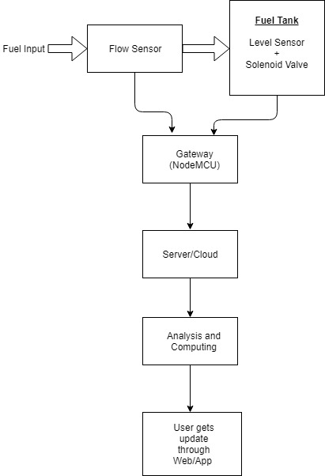

Current fuel theft solutions
- Fuel Storage Tanks - Armoured fuel storage tanks can be bought and replaced in your machine.
Con: Expensive, External and Heavy

- Security Lights & CCTV - Cameras can be fitted to the vehicle/ machine and can be surveilled by a person.
Con: All time surveillance required

- Tank locks and Alarm Padlocks - Traditional mechanical locks or digital padlocks can be used.
Con: Sometimes Expensive, Ineffective

- Anti Siphon device - The anti-siphon is suitable for owner drivers and small fleets that are at risk of third party fuel theft. Flow apertures with Teeth prevent siphoning tubes from bypassing the device.
Con: High cost and expensive installation

The following concepts are used in our project :

- Flow Sensor (To measure the amount of fuel entering in the machine’s tank)

An ultrasonic flow meter is a type of flow meter that measures the velocity of a fluid with ultrasound to calculate volume flow. Using ultrasonic transducers, the flow meter can measure the average velocity along the path of an emitted beam of ultrasound, by averaging the difference in measured transit time between the pulses of ultrasound propagating into and against the direction of the flow or by measuring the frequency shift from the Doppler Effect. Ultrasonic flow meters are affected by the acoustic properties of the fluid and can be impacted by temperature, density, viscosity and suspended particulates depending on the exact flow meter.

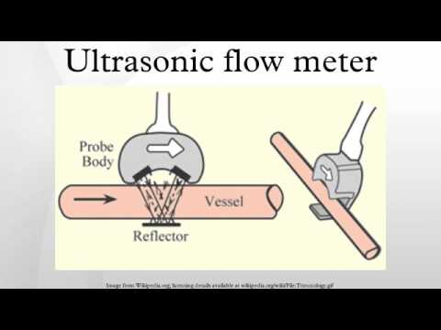

- Communication System (IOT, Full Duplex system)
NodeMCU is an open source IOT platform which allows the flow of information using WiFi.
Full Duplex system
- Solenoid Valve (To detect theft while the machine is OFF)
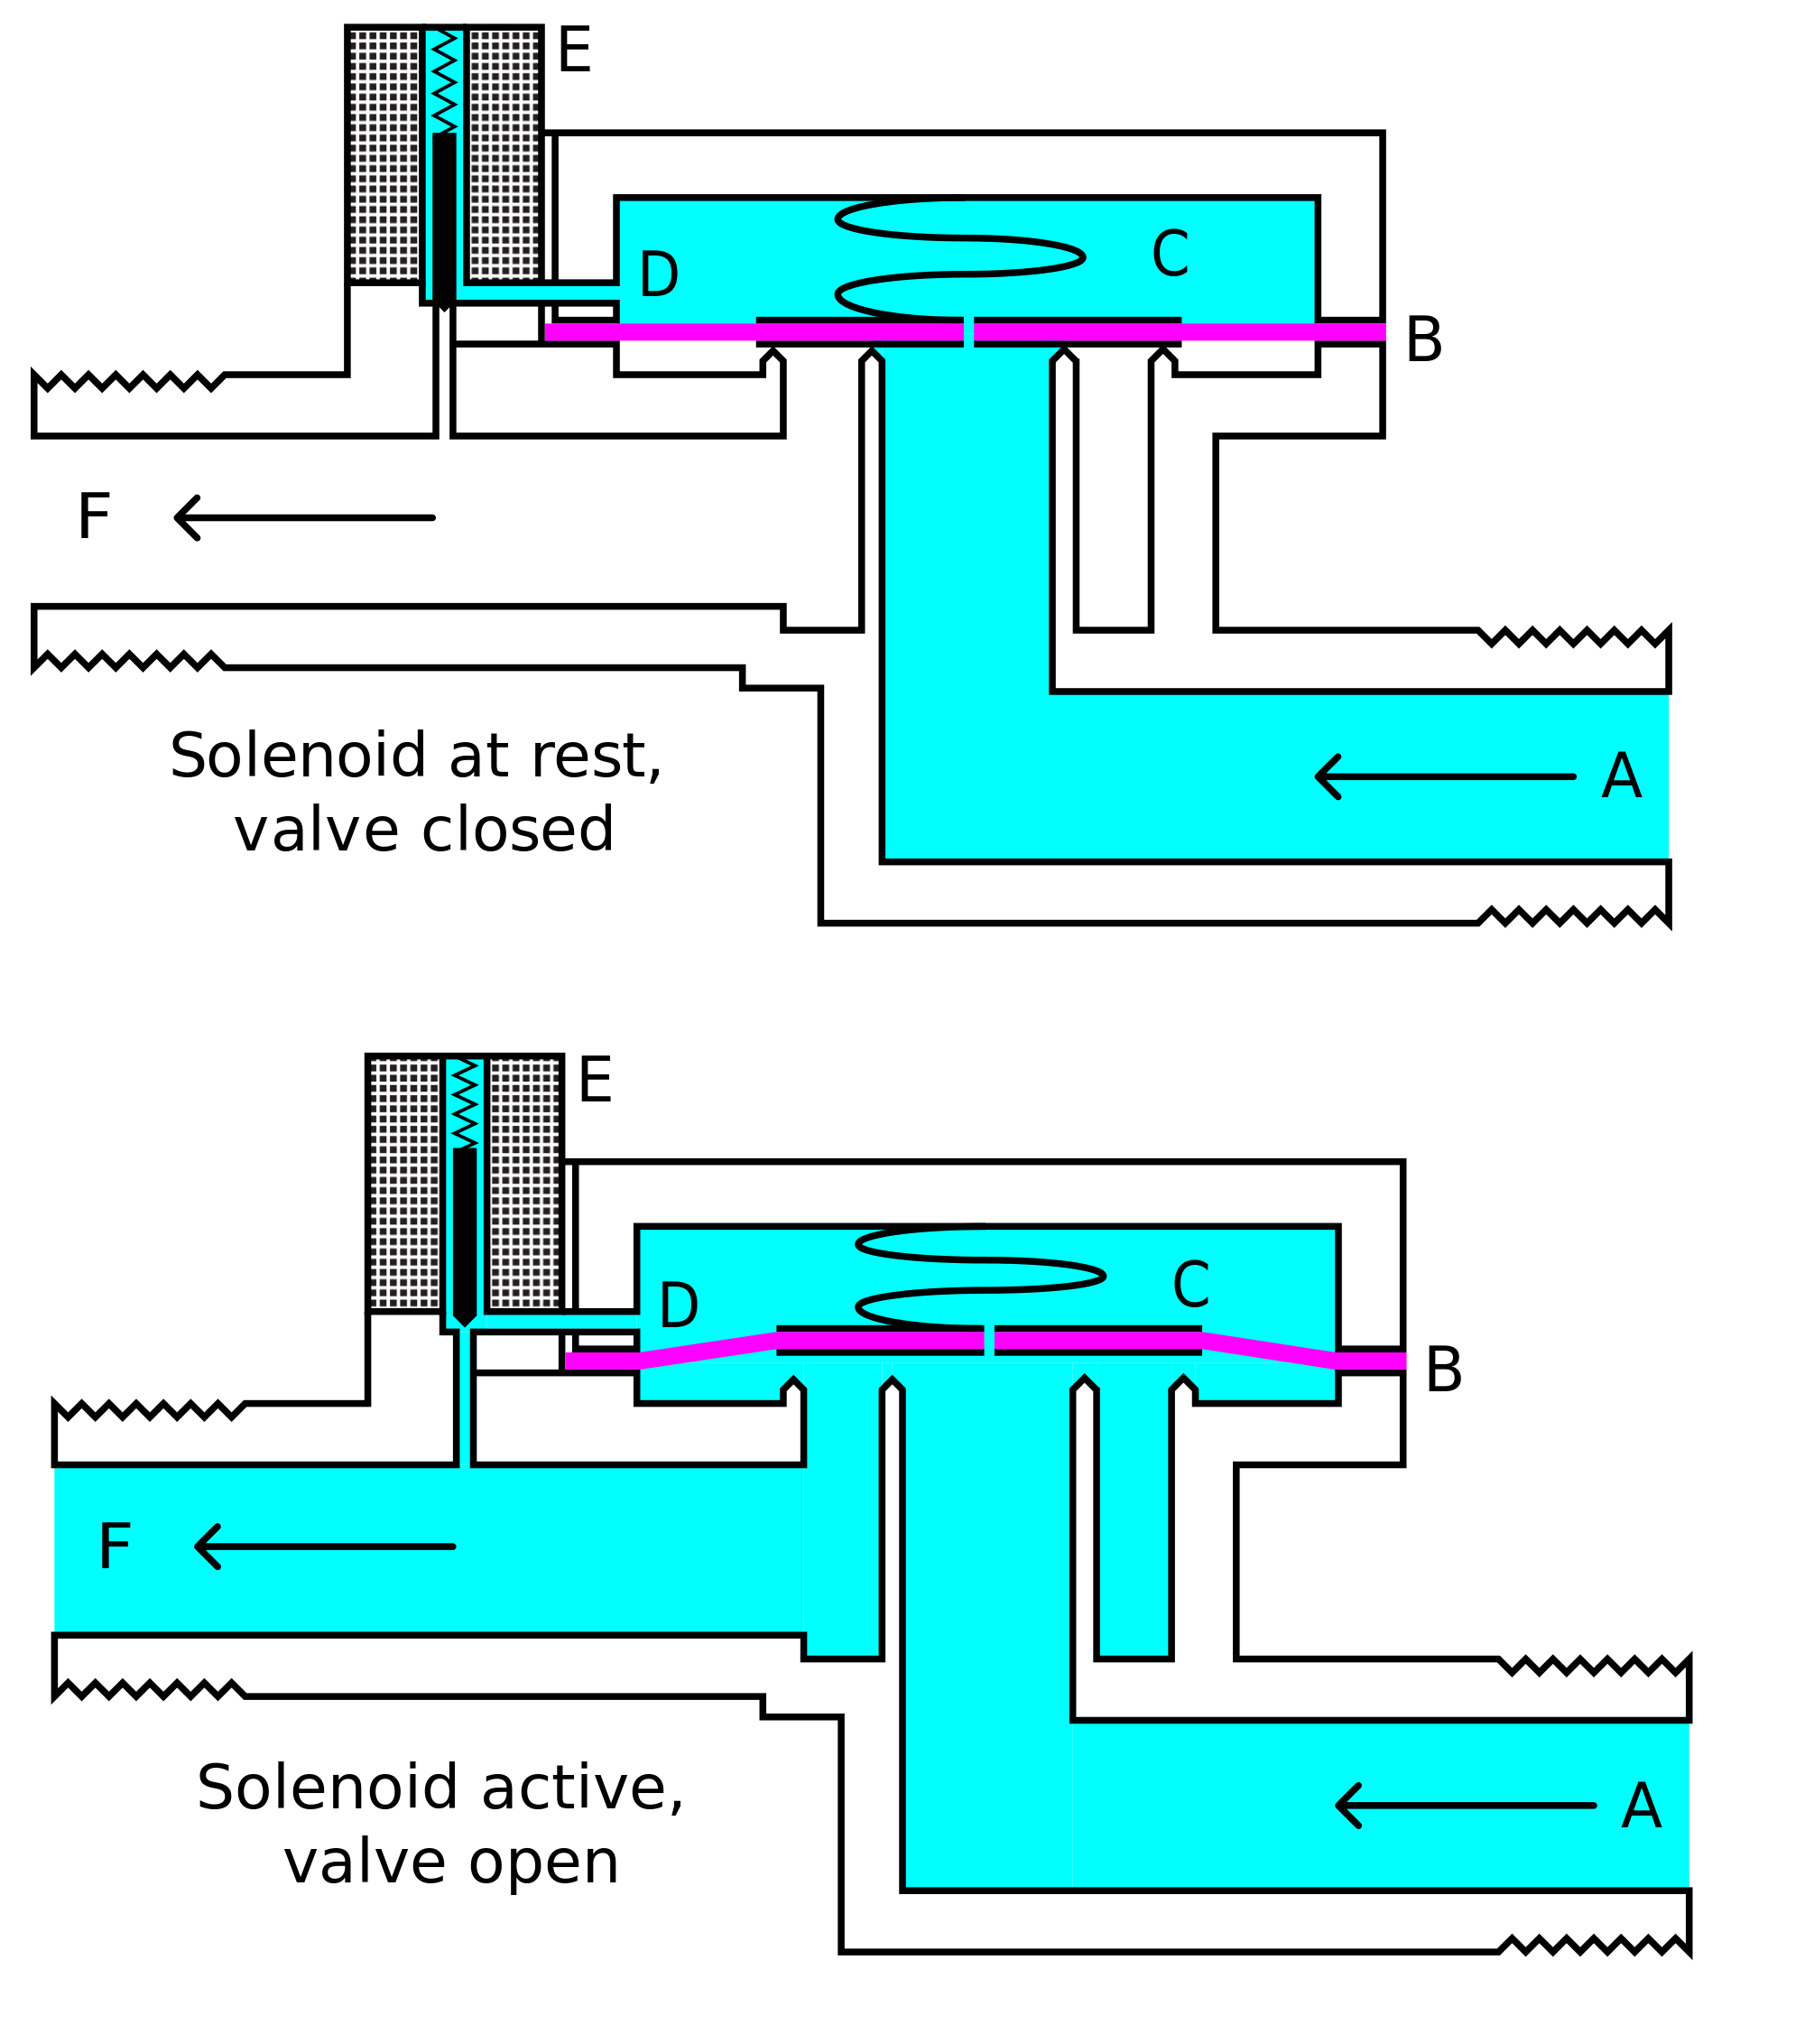
The solenoid valve controls the flow of petrol when the vehicle is switched off. It will also detect any tampering in the fuel line/hose.

Features offered by our device:
- GPS: Track your vehicle; Track the routes, nearest fuel stations and timelines of your Vehicle schedule.
- GPRS/Mobile Internet: Access the Vehicle status 24×7, from anywhere, anytime.
- Digital Fuel Sensors: High accuracy diesel sensors will keep you informed about Refill quantity, Consumption, and immediate alerts on theft cases.
- Service scheduling: Plan your schedules and track the servicing
- Parts accounting: Maintain consumption and expense records

Future Aspects for our device

- Vehicle Tracking - This feature will allow the user to track his vehicle’s whereabouts. To make it more interactive, the information will be displayed with timelines. It will also display additional information such as nearest fuel stations, etc.

- Vehicle’s fuel status - The owner will be able to view the status of the fuel tank, i.e. amount of fuel left in the tank, capacity, etc. The present fuel gauge in automobiles only notifies the user when the tank is empty. It doesn’t show the amount of fuel left in the vehicle’s tank.

- Schedule planning - According to the status of the fuel tank, the owner will be able to plan his visit to the fuel station.

- Parts Accounting - The app will provide the user with the fuel consumption which will help the owner in streamlining his/her expenses.

Conclusion
The E-funnel is a versatile device which circumvents all the aforementioned issues. The current solutions to tackle fuel theft individually suffer through various shortcomings. E-funnel along with its unique approach for fuel theft prevention also offers other features such as Vehicle tracking, Parts accounting, etc. It has a long range of applications, starting from automobiles to generators and DG sets.
Acknowledgment
We thank Dr. Ahteshamul Haque (Assistant Professor, Jamia Millia Islamia), and Dr. M. Nizamuddin (Associate Professor, Jamia Millia Islamia)for their continuous support and assistance throughout the course of this project, although any errors are our own and should not tarnish the reputations of these esteemed persons.

