Hall magnetic sensor
By Zihao Miao
Components:
The hall magnetic sensor consist of a Hall Effect sensor (44E 402), a led and a resister.

The Hall Effect Sensor:
The Hall Effect sensor can detect changes in the magnetic fields:
For example, say that you present a magnet nearby the sensor; it would be able to sense it and put a low current on its pin to notify a micro-controller.
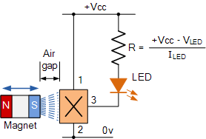
Structure:
The Hall Effect sensor has a structure on the left. It is important to know that the south pole of magnet should be facing the sensor.

Pins
Signal
+5V
Ground
There are three pins on the hall magnetic sensor. On the picture, the two pins on the side are labeled – and S, thus I am referring them as the – pin, the middle pin and the S pin. The – pin is ground, thus should be connected to the ground pin on the Arduino or Raspberry Pi. The middle pin is the +5V input, which should be connected to the +5V pin on the Arduino or Raspberry Pi. Notice that the sensor needs +4V to work. The S pin is the signal pin. When a magnet is not present, the hall magnetic sensor would output a high signal (+3.3), when the sensor detects a magnetic field, it would output a low signal.

Interaction
Thus, to interact with this sensor, we have to first wire this sensor up with the description in the pins section. As described in the components section, we should not need to wire an extra LED or resister, as the sensor is 3 in 1. Afterwards, the sensor is ready for magnetic field detection.

