Filtration Investigation
Provided by TryEngineering - www.tryengineering.org
Lesson Focus
Lesson focuses on how filtration systems solve many problems throughout the world such as improving drinking water. Through this lesson, students work in teams to design and build a filtration system to remove dirt from water. Students select from everyday items to build their filter, test the resulting system evaluate the effectiveness of their filters and those of other teams, and present their findings to the class.

Lesson Synopsis
The "Filtration Investigation" lesson explores how engineering has developed various means to remove impurities from water. Students work in teams of "engineers" to design and build their own "filtration system" out of everyday items. Working with "muddy" water, students develop a design, and then build and test a system to remove as much impurities from the water as possible. Students view their own tests and those of other student team, evaluate their results, and present findings to the class. The group with the clearest "filtered" water is considered to have developed the best filter system.

Age Levels
8-18.

Objectives
- Learn about engineering design.
- Learn about planning and construction.
- Learn about teamwork and working in groups.

Anticipated Learner Outcomes
As a result of this activity, students should develop an understanding of:
- engineering design
- problem solving
- teamwork

Lesson Activities
Students learn how filtrations systems are of many sorts for many purposes. Students work in teams to design and build a filtration system out of everyday items that can remove the most "dirt" or sediment from water. They then test their filters and those of other student teams, determine the filter design that was the most effective in the class, evaluate their own results and those of other students, and present their findings to the class.

Filtration Investigation

Teacher Resource
◆ Lesson Goal
Lesson focuses on how engineered filtration systems have impacted the availability of drinking water. Through this lesson, student "engineering" teams are challenged to remove as much sediment or "dirt" as possible from a muddy water source. The students work in teams to determine which everyday items they will use, then design and build their filtration system. Student teams test their own filters and compare their results with those of other student "engineering" teams. The team with best plan will be the test with the clearest "filtered" water. Students evaluate the effectiveness of their own filter systems and those of other teams, and present their findings to the class.
Lesson Objectives
- Learn about engineering design.
- Learn about planning and construction.
- Learn about teamwork and working in groups.
Materials

- Student Resource Sheet
- Student Worksheets
- Classroom materials:
  - Water basin for testing student filter systems
  - Supply of "muddied water" which can be made by taking a quart of drinking water and adding two tablespoons of dirt.

- One set of materials for each group
  - Two cups of "muddied water"
  - Plastic or paper cups, straws, cardboard, cotton balls, sand, aluminum foil, rubber bands, tape,
  - toothpicks, paper towels, plastic wrap, aquarium or other small rocks, cornmeal, flour, tape, and/or other materials (such as grass or charcoal if available)
- Procedure
  - Show student "engineering" teams their various Student Reference Sheets. These may be read in class, or provided as reading material for the prior night's homework.
  - Divide students into groups of 2-3 students, providing a set of materials per group.
  - Explain that students must work as a team to design a filtration system to remove as much dirt or sediment from a provided water supply. The team with the clearest resulting water (based on a visual inspection) will have developed the best filter in the class.
  - Students meet and develop a plan for their filtration system, including a list of all materials they require for construction.
  - Student teams draw their plan and present their plan to the class. Students may adjust their plan based on feedback received at this stage.
6. | Student teams build their filtration system. They may determine that additional
 | materials are needed to complete this step. If so, they need to indicate the new
7. | materials or quantity of materials on their design worksheet.  Next students will try their filtration system with the muddy water.

◆ Time Needed: Two to three 45 minute sessions
- Tips
  - Be sure to stress that the "filtered" water, no matter how clear, is not suitable for drinking.
  - For younger students, do not provide charcoal as a filtration option.
  - Suggest to student teams that layers of filters -- or perhaps many filtration stages - - may result in the most effective filtration system.
  - Teams may require additional materials which they will request of the teacher, or they may be encouraged to exchange building materials with other teams

Filtration Investigation

Student Resource

What is Filtration ?
There are many different methods of filtration, each has a goal of separating substances. Filtration systems are important to providing safe drinking water, to separating materials for many purposes such as research or gathering pure samples
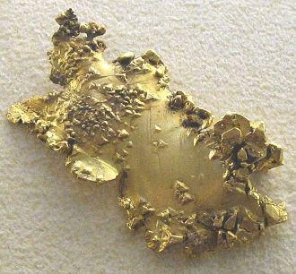
of an element. The simplest way to "filter" is to pass a mixture, or solution, of a solid and a fluid (such as water and dirt or mud) through a porous material or system so that the solids are trapped as the fluid passes through. Panning for gold is an example of a filter, where prospectors hold pans with holes punched in the bottom, or fitted with a screen through riverbeds thought to contain gold nuggets. The materials too big to fit through the screen are then explored to see if gold has been gathered.

Filtration is used in waste treatment facilities where settling tanks allow for separation. The concept of filtration is found all around us, in community services and everyday items at home. An example is a coffee filter used in a coffee maker. The filter prevents the coffee grounds from reaching a coffee cup, but allows for smaller materials or particles of the coffee to pass through, resulting in a cup of coffee without coffee grounds. There are many different types of filters used in making coffee, some made out of paper, some out of recycled paper, and some using metals coated in gold. In each case, the size of the openings -- even microscopic -- will determine how much of the particles will make it through.
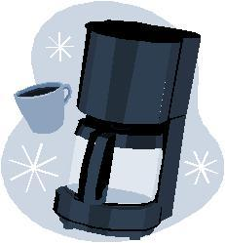

◆ How Gravity Can Help
Liquids usually flow through the filter by gravity. This is the simplest method, and can be seen by revising the coffeemaker example. The water usually sits in the filter, and then drips down to a receptacle (cup or coffee pot) as a result of gravity. In chemical plants, gravity is also used to separate -- and is an economical method as it requires no additional energy. Sometimes pressure is added to speed up the filtration process…but if too much pressure is added to the system, the filter may clog or even tear or break.

◆ Filtration Materials and Stages
Many materials can be used for making a filter…all depending upon the types of liquids, solids, or gases that need to be separated. Some filtration materials include paper, sand, cloth, charcoal, and rocks. Often staged filters are employed…where a liquid, for example, might pass through a series of different filters. In this case, sometimes the first filter will eliminate larger particles, while the second, third, or fourth filter will eliminate smaller and smaller particles or sediment. The image to the right shows a rough filtration system that might be made from sticks using three different stages of filtration…but there are many ideas for systems and engineers must develop new systems based on the challenges they face!

The provision of a safe, sustainable supply of water has been a challenge for millennia. It remains the most pressing environmental problem in much of the developing world, and is increasingly difficult even in the developed world. Emerging pathogens and new chemical contaminants, changing climates, population growth, and watershed encroachment all lead to pressures that will require innovative scientific and policy responses. Engineers all around the world are working on this issue. It is said that providing safe drinking water is one of the greatest engineering feats of all time. To solve many of the world's problems, engineers and other individuals work in teams, bringing their individual expertise to work on issues as a group.

"Engineers Without Borders" is an international non-profit humanitarian organization established to partner with developing communities worldwide in order to improve their quality of life. This partnership involves the implementation of sustainable engineering projects, while involving and training internationally responsible engineers and engineering students. The quest for potable water is one of the group's current focus areas.
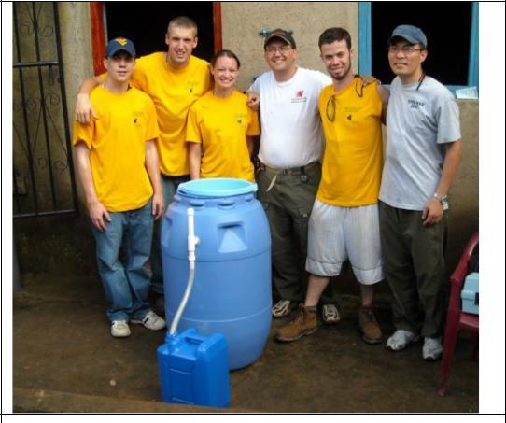
In addition, many universities are focused on supporting the quest for potable water globally. For example, recently a group of students from West Virginia University’s College of Engineering and Mineral Resources had the opportunity to do something a little outside the norm and, in the process, made a difference in the lives of people in two small communities in Nicaragua. The students are members of Engineers Without Borders, and spent some time in Nicaragua where they assessed the water supplies of the two small towns of Rancho Grande and Cerro Verde and helped build and install water filtration systems for the town's’ children’s feeding centers.

Because of a lack of regulation and poor infrastructure, the inhabitants of the towns are continually exposed to pathogens in their water supply. By measuring turbidity, pH, temperature, nitrate, chlorine and fecal coliforms in the water supply, as well as installing the water filters, the project aimed to improve overall health conditions for the town’s children

Filtration Investigation

Student Worksheet

Design Your Own Filtration System
You are part of a team of engineers who have been given the challenge of developing an filtration system to eliminate as much dirt or mud as possible from a water sample you have been provided. If your system works, you'll end up with water that looks completely clear. How you accomplish the task is up to your team! The team with the clearest resulting water (based on a visual inspection) will have developed the best filter in the class.

◆Planning Stage
Meet as a team and discuss the problem you need to solve. You'll need to determine which materials you'll request from the many everyday items your teacher has available. As a team, come up with your best design and draw it in the box below. Be sure to indicate the materials you anticipate using, including the quantity you'll request from your teacher. Present your design to the class. You may choose to revise your team's' plan after you receive feedback from class.

Design:

Materials Required (list each items and the quantity you expect to use):

◆ Construction Phase
Build your filter system. During construction you may decide you need additional items or that your design needs to change. This is ok -- just make a new sketch and revise your materials list. You may want to trade items with other teams, or request additional materials from your teacher.

◆ Testing Phase
You will be provided with two cups of "muddy" water by your teacher. You'll test your filter in a classroom basin and gather the "filtered" water for later evaluation. Be sure to watch the tests of the other teams and observe how they designed their filters, including what materials they selected.

Filtration Investigation

S t u d e n t E v a l u a t i o n F o r m

- Did you succeed in creating a filtration system that passed the source water? What "grade of clarity" did you achieve?

- What aspect of your design do you think worked best? Why?

- What aspect of your design would you have revised if given more time? Why?

- What was unique about the design of the filtration system in your class that had the best results on this challenge? How did it work better than yours, if it did, and what would you have done differently if you had seen this design prior to developing your own?

- Did you decide to revise your original design while in the construction phase? Why? How?

- Do you think that engineers have to adapt their original plans during the construction of systems or products? Why might they?

- Do you think your filter would have been able to withstand water running through it for an hour? Why?

- Do you think you would have been able to complete this project easier if you were working alone? Explain.

- If you could have used a material or materials that were not provided to you, what would you have requested? Why do you think this material might have helped with the challenge?

- What was your favorite part of the challenge? Design Phase? Building Phase? Testing Phase? Why?

