Reverted Gear Train
Lesson Plan

Goals/Objectives

- Understand the principles of gear and shaft speed ratios
- Understand the principle of Torque
- Understand mechanical shaft features such as keys, spurs

Background

A Geneva Mechanism, also known as a Geneva Wheel, is a mechanism that converts constant rotational motion into intermittent rotational motion.

Geneva Mechanisms can come in a variety of forms and sizes. Increasing the number of slots in the mechanism’s driven wheel decreases the angular displacement by each rotation of the driving wheel.

The other characteristic of Geneva mechanisms is the “locking” feature. That is, when the driven wheel is not being turned by the driving wheel, it is locked in place and is unable to rotate.

Instructor Prep

Follow the Instructables instructions to print and assemble the device.

Familiarize yourself with the concepts demonstrated by the device.

Class Activities

Show the videos from the Instructables site to show the intermittent motion of the mechanism.

Discuss how the number of slots in the mechanism affects the motion of the device. Discuss the advantages of having the mechanism “locked” when the driven wheel is not in motion.

Pass around the 3D printed mechanism to allow students to experience the mechanism and observe how the wheels interact with each other.

After Class Activities

Have students research common uses for Geneva Mechanisms.

Have students come up with their own use for a Geneva Mechanism. How could a Geneva Mechanism be used in day-to-day life to make something easier?

Additional Materials:

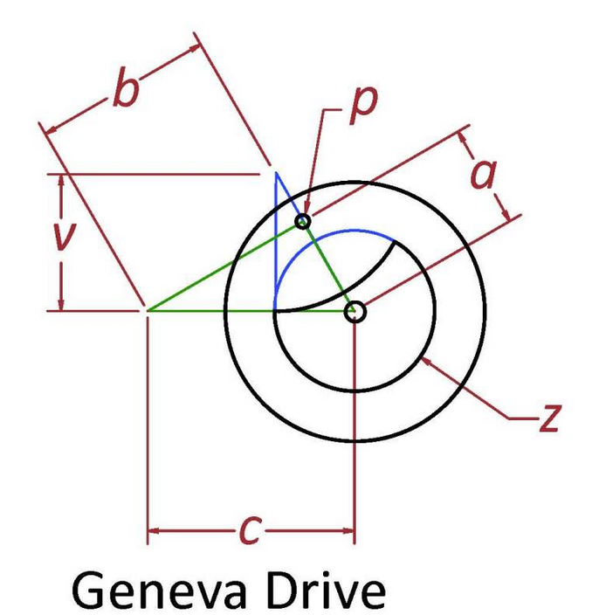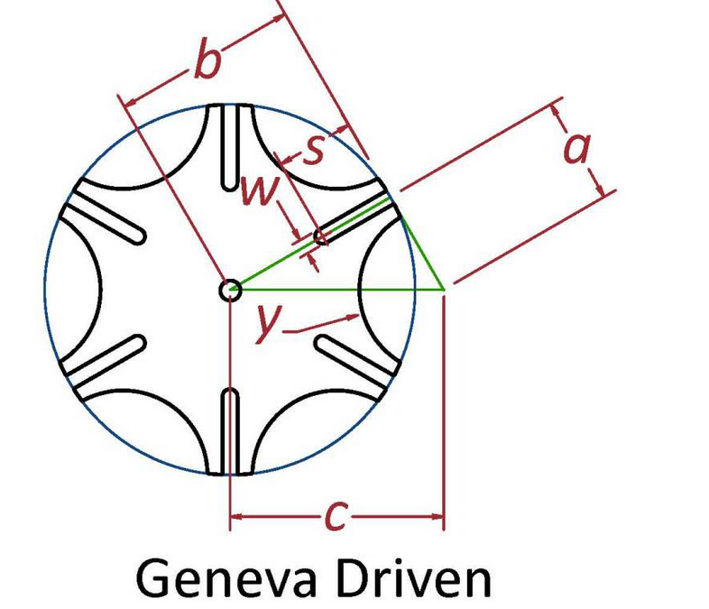

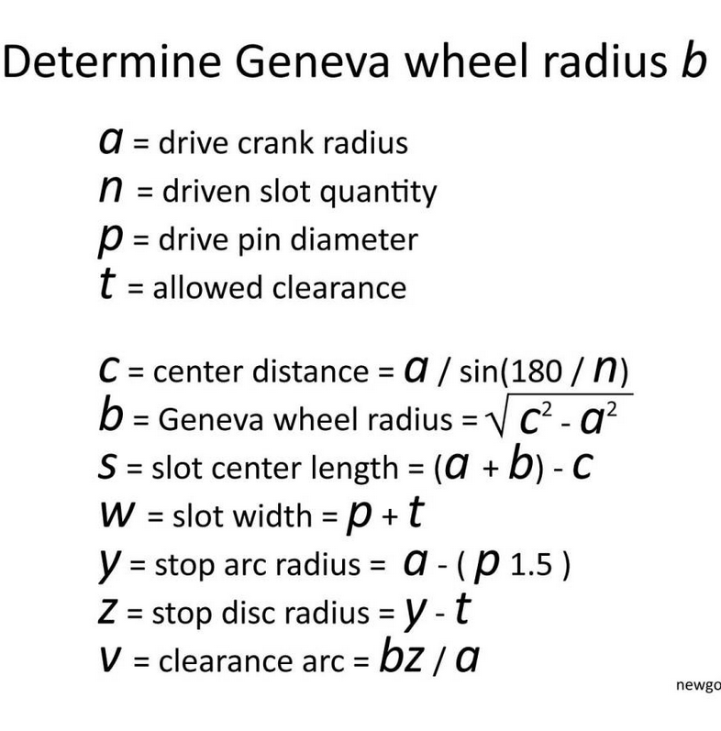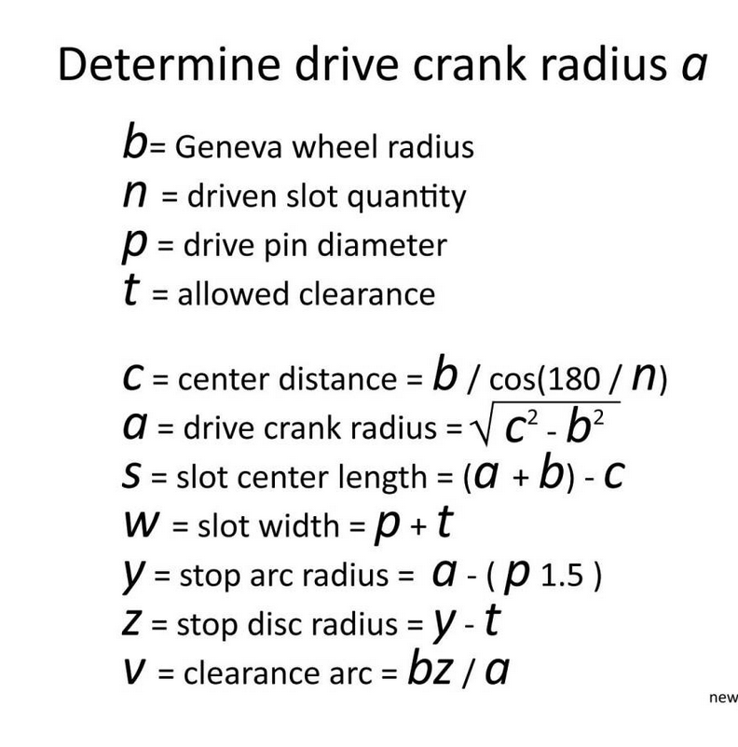
http://newgottland.com/2012/01/08/make-geneva-wheels-of-any-size/

