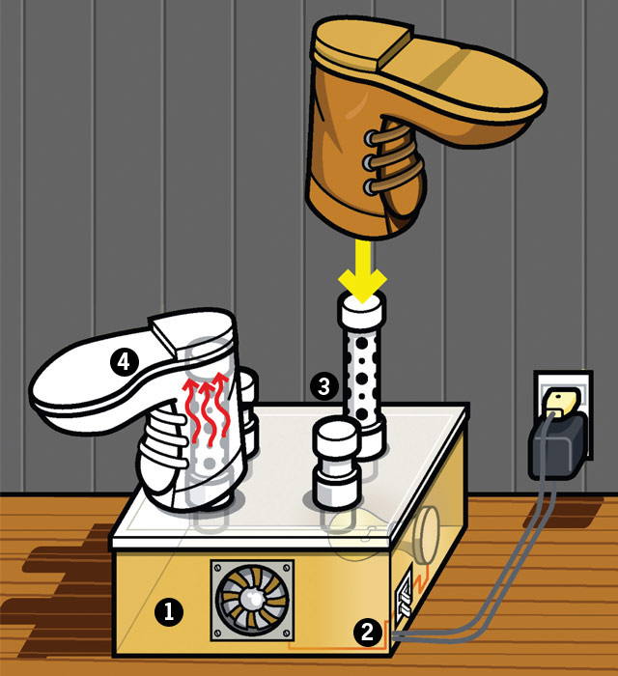
1.) Build the Box
The boots dry on perforated PVC pipes that waft warm, gentle air supplied by a light bulb and a computer fan. Build the box out of ½-inch-thick plywood, 1-inch deck screws, two light switches, a lamp holder, a lamp cord, a "rough service" 40-watt bulb (for safety, don’t use a higher wattage), a 12-volt DC 80-mm computer fan, a few feet of 1½-inch-diameter PVC pipe and smooth PVC couplings and pipe end caps.
Start by boring paths for the pipes to run through the box top. Drill four 115⁄16 holes in a 15 x 15–inch sheet of plywood. Paint it. Cut four 15 x 6–inch side walls, leaving two edges short to account for the plywood thickness. Measure the fan; saw a square hole in one side to fit it. Cut a hole in a different side for the light-switch box. Attach the lamp holder in the middle of the action. Use the 1-inch screws to fasten the plywood sides into a square, but leave the top open. Seal the inner side joints with caulk.
2.) Wire it Up
Mount the fan, light switches and lamp holder to the box sides. Wire the fan and 12-volt transformer to one light switch. Wire the lamp holder and AC power cord to the other. Add a bulb. Test the connections. Fasten the box top. Tilt the box if serious slush requires drainage into a pan.
3.) Mount PVC
Cut a 6-inch length of PVC for every boot you plan to dry. Drill several ¾- and ½-inch airflow penetrations in each 6-inch pipe. Slip a smooth coupling over the pipe, leaving 1 inch exposed. Cap the opposite end and slide the open ends into holes in the box top. For drying a single pair (as shown above), cut a pair of small, non-perforated PVC pieces that can be capped when not in use.
4.) Dry Boots
Wet boots on the pipes dry adequately in hours. An overnight stay yields blissful, total desiccation.

