Project: Battery Charger
Requirements:
- Be Small
- Indicate when charging
- Indicate when Charge is complete
- Selectable charge rate for USB Hub and normal USB Port/ power adapter 100 / 500 mAh
- Be economical
- Be able to construct myself – 1st time!

So, after a lot of research, and wanting to MAKE MY OWN CHARGER, I settled on the following items – All available from RS components of where you can also find the datasheets too:

Amount: | Name: | Description: | RS Number | Unit Price as of 15/01/2018 AUD
1 | MCP73831T-2ACI/OT | Charging IC | 738-6360 | $0.794
1 | SN74LVC1G04DBVT | Single Inverter | 662-8685 | $1.012
1 | Osram Opto CHIPLED 0603 530 nm Green LED | Green LED - LT Q39G-Q1S2-25-1 | 697-3715 | $0.365
1 | Osram Opto CHIPLED 0603 633 nm Red LED | Red LED - LS Q976 | 654-5420 | $0.089
2 | 4.7µF MLCC 10V dc ±10% | AVX 0805 (2012) Capacitor | 698-3579 | $0.037
1 | 100nF MLCC 16V dc ±10% | AVX 0603 (1608M) | 698-3320 | $0.012
1 | Alps - SSSS810701 | Slide Switch 1-pole 2-positions | 123-8937 | $1.03
1 | Resistor 0.125W,1%,12K4 | Resistor 0805 | 679-0863 | $0.009
1 | Resistor 0.125W,1%,120K | Resistor 0805 | 679-0841 | $0.028
1 | Resistor 0.125W,1%,2K15 | Resistor 0805 | 679-1197 | $0.007
1 | Micro USB Connector - Reverse | Micro - USB connector | 136-2263 | $1.26
1 | Charger with inverter-v2 | PCB |  | $4.30US /3 boards

I have added a 2 position switch, for either HUB power( 77 mA) or Port Power (454 mA). The reason that they are not totally up to the limit is simple, you have to include the power draw from the LED and the devices themselves, ok, mostly the LED that will be on, of which would consume close to 20 mA plus waste from the resistor, and you reach basically 100 mA for the hub power draw.

The other reason I chose this option is quiet simple, if you want to charge a small capacity battery, i.e. 100 mA – 400 mA,

Designed as per datasheet and “design ideas – Oct. 13, 2005”, using the logic inverter mentioned in the article on p100 for using dual LED for visual.
EDN article – please view the PDF as the images do not show on the on-line version.

Getting started:

- Put the large components 1st
- Now put all the other components, while being careful not to flood the place with solder paste!
- Put through-hole last!
- Check and confirm that all power is correct!
- Confirm again!
- Test GND with C1, C2, IC1, IC2 and GND output.
- Test V_{CC} with C1, IC1 & IC2
- Pay attention to the LED polarity!

SMD Version: V2
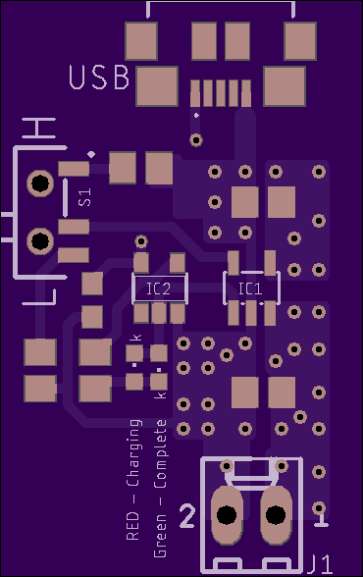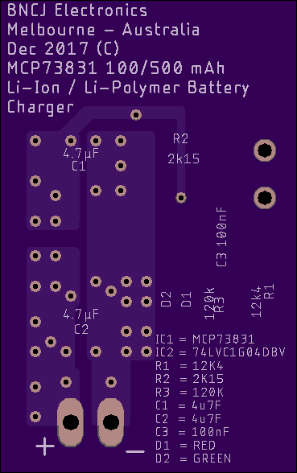
This was done on a 2oz copper board, and followed most of the suggestions for the copper pour for thermal plus plenty of extra vias for the heat transfer to both layers. The silkscreen denotes the values and location of the various components.

PCB:
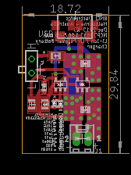

Schematic:
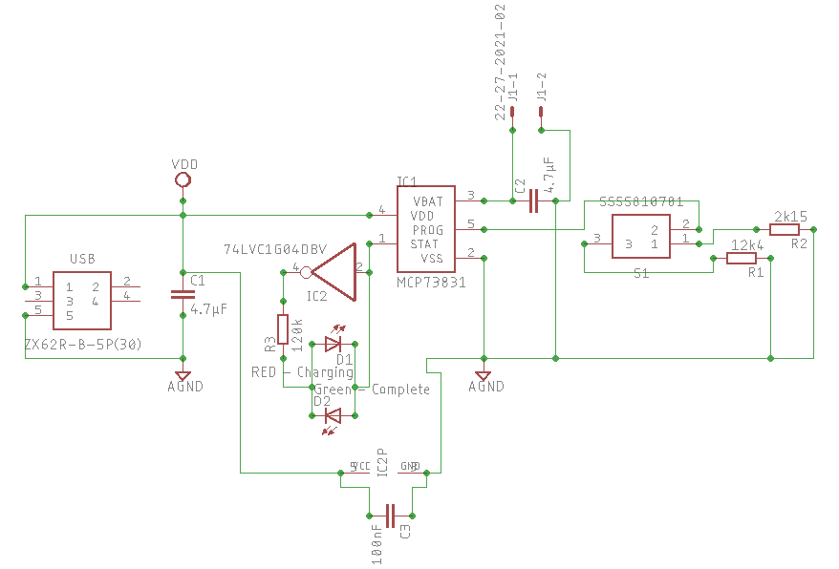

Now, as you can see in the schematic, the status output is connected to the LED’s and the inverter.
Below is an explanation of how this will work.

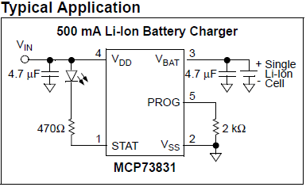
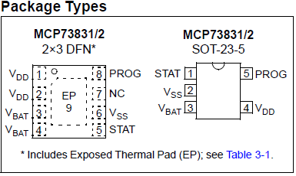
So, what is happening here, is that when the battery is charging, the status output pin will go Low – “L”, in other words, will have “GND” as its output, that is why with a single LED, it is connected to V_{DD}, and since the inverter “inverters”, the inverters output will be “Positive” or V_{DD}, so in this case, D1, that is the Red LED, will be showing that it is charging, and then, once the charging is complete, the STAT pin will go High – “H”, aka V_{DD}, or Positive Voltage, so the inverter will go low and the Green LED will light up to advise that the charge is complete.

Below is the truth table:
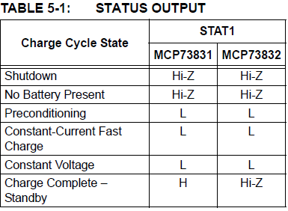

Here is the completed project:
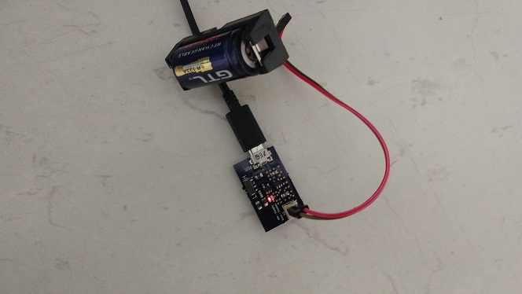
Charging – Red Light
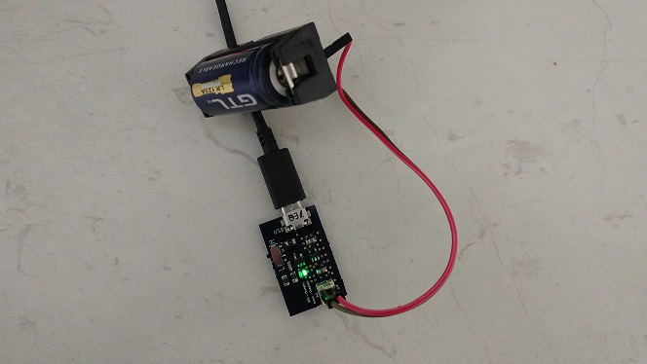
Charge Complete – Green Light
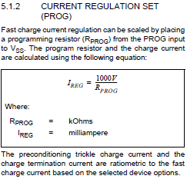 Over here, we see the formula needed to program the MCP73831. So, put the value in K Ohms, and you get your regulation. For example, for 500 mA, 1000/2K Ohm = 500 mA. 1000/10Kohm = 100 mA. The charger is rated from 15 mA up to 500 mA.
So, if you are in a hurry, and have a huge battery, this is NOT for you.

