 | Mouser #: 863-2N4401G  Mfr. #: 2N4401G  Manufacturer: ON Semiconductor  Desc.: Transistors Bipolar (BJT) 600mA 60V NPN  RoHS: RoHS Compliant |  | Availability  5 Ships Now | $0.25  (each)
 | Mouser #: 291-150-RC  Mfr. #: 291-150-RC  Manufacturer: Xicon  Desc.: Carbon Film Resistors - Through Hole 150ohms 0.05  RoHS: RoHS Compliant |  | Availability  30 Ships Now | $0.054  (each)
 | Mouser #: 595-CD74HC238MT  Mfr. #: CD74HC238MT  Manufacturer: Texas Instruments  Desc.: Encoders, Decoders, Multiplexers & Demultiplexers Hi-Spd CMOS 3-8 Line Decoder/Demltplxr  RoHS: RoHS Compliant |  | Packaging Choice:  Cut Tape  Availability  5 Ships Now | $1.01  (each)
www.mouser.com

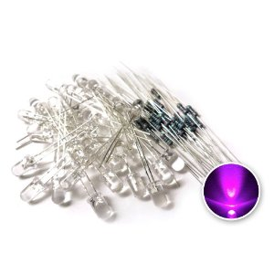
Click for larger image and other views

www.amazon.com

microtivity 5mm Clear Pink LED w/ Resistors (Pack of 30)
by microtivity
5.0 out of 5 stars See all reviews (1 customer review) | Like(0)

Price: | $10.50
Sale: | $6.69
You Save: | $3.81 (36%)

In Stock.
Sold by microtivity and Fulfilled by Amazon. Gift-wrap available.
Want it delivered Thursday, May 3? Order it in the next 15 hours and 59 minutes, and choose One-Day Shipping at checkout.Details

