Step 1: Preheat Griddle
- You will want to preheat the griddle to 350 degrees, by turning the knob attached to the griddle.
Step 2: Heat Seeds
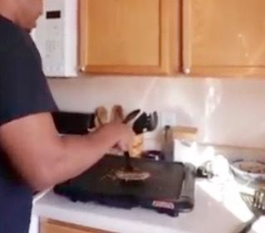
Heat:
- 1 tablespoon caraway seeds
- 1 tablespoon coriander seeds
- Spray the griddle with cooking spray.
- You will heat these seeds on griddle for about 5 minutes or until they have browned. Stir seeds occasionally.
- Be sure to let the seeds cool for about 2 mins.
- Use 2 spatulas to scoop up seeds, then place into mortar.
Tip: It is easier to measure seeds when taking off the caps.
Video: 0:01-0:45
Step 3: Grind Seeds and Crushed Red Pepper
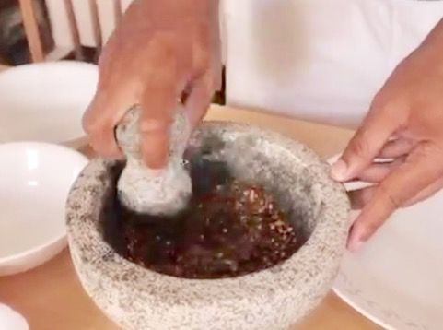
Place in mortar:
- seeds
- 1 tablespoon crushed red pepper
- 1/2 tablespoon cumin
- Hold pestle with firm grip, and roll the rounded end against the mortar, until you have your preferred consistency (recommend fine powder).
Video: 0:46-1:17
Step 4: Add Oil and Garlic
Add:
- 2 tablespoons olive oil
- 1 tablespoon garlic powder
- Add these ingredients to mortar with spice mixture.
Tip: May need to use napkin to wipe utensils after using oil.
Video: 1:18-1:41
Step 5: Grind Ingredients
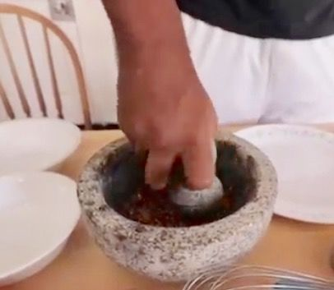
- Grind the ingredients in the mortar to a smooth paste.
- Hold pestle with firm grip, and roll the rounded end against the mortar.
Video: 1:42-2:00
Step 6: Add Paprika and Salt
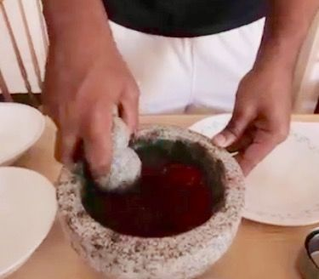
Add:
- 2 tablespoons paprika
- 1 1/2 teaspoons salt
- Add these ingredients to your mixture in the mortar.
- Mix paste mixture.
- Use a spoon to scrape off ingredients to bring down from the sides.
Video: 2:01-2:38
Step 7: Whisk
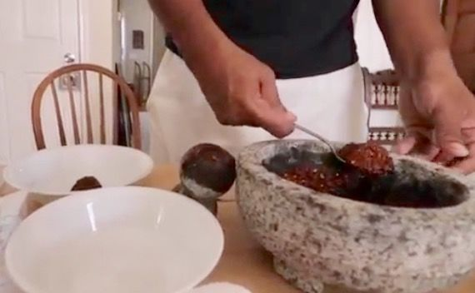
Whisk:
- Use all harissa mixture
- 2 tablespoons olive oil
- 2 tablespoons lime juice
- Whisk the given amounts of these ingredients in a small bowl.
Video: 2:39-3:34
Step 8: Marinate Chicken
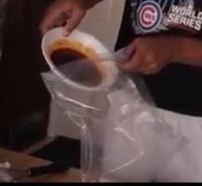
There is information out there, warning against washing raw chicken before cooking it. We have provided two sources that explain why you should not wash your chicken before you cook it. Please understand, you are cooking this chicken at your own risk.
http://www.npr.org/sections/thesalt/2013/08/31/216...
https://www.livescience.com/50919-why-washing-chic...
- Pour the mixture created in step 6 into the gallon Ziploc bag.
- Add chicken to bag, close bag, then shake until the chicken is completely covered in mixture.
- Let chicken sit in bag for approximately 2 minutes.
Video: 3:35-4:04
Step 9: Cut Chicken
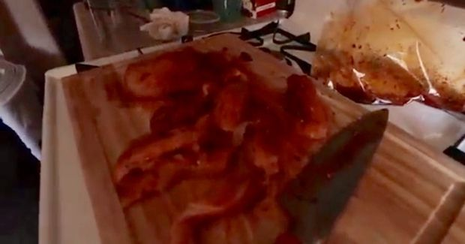
- Place the chicken onto the cutting board.
- Cut up chicken into small byte size pieces.
- Place chicken onto griddle.
Video: 4:05-4:16
Step 10: Grill Chicken
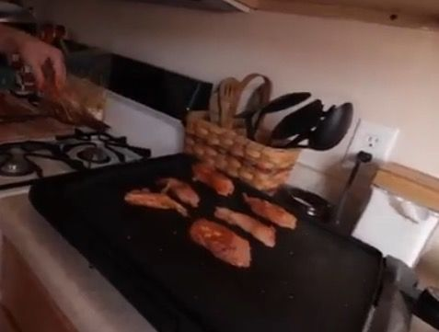
- Turn the heat on the griddle to 400 degrees.
- Grill chicken on griddle, until chicken is completely cooked.
- Use meat thermometer to verify that internal temperature of the meatiest part of the chicken is 165 F.
- Once your chicken is cooked through, it is ready to eat!
Add On: The chicken is delightful by itself, but you can also pair it with other items to enhance flavor. We recommend pairing it with couscous and a nice vegetable. You could also pair it with a nice bed of rice. The choices are endless.
Video: 4:16-4:43
Step 11: Clean Up
- To disinfect your countertops you can use a Bleach/Water Solution:
Ratio:
- 1/4 (minimum) to 3/4(maximum) cup of bleach
- 1 table- spoon (minimum) to 3 table- spoons (maximum) of bleach to 1 quart of cool water.
Contact Time:
- Let stand for 2 minutes, then wipe or air dry.
If you would like more information on sanitizing and disinfecting, please see the attached link below.
https://www.cscinc.org/wp-content/resource_pdfs/Sa...
- To clean your utensils, you can use:
hot water and soap

