**[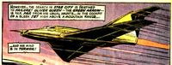](http://vignette3.wikia.nocookie.net/marvel_dc/images/0/06/Arrowplane_001.jpg/revision/latest?cb=20110607035242)**