Railroad switch
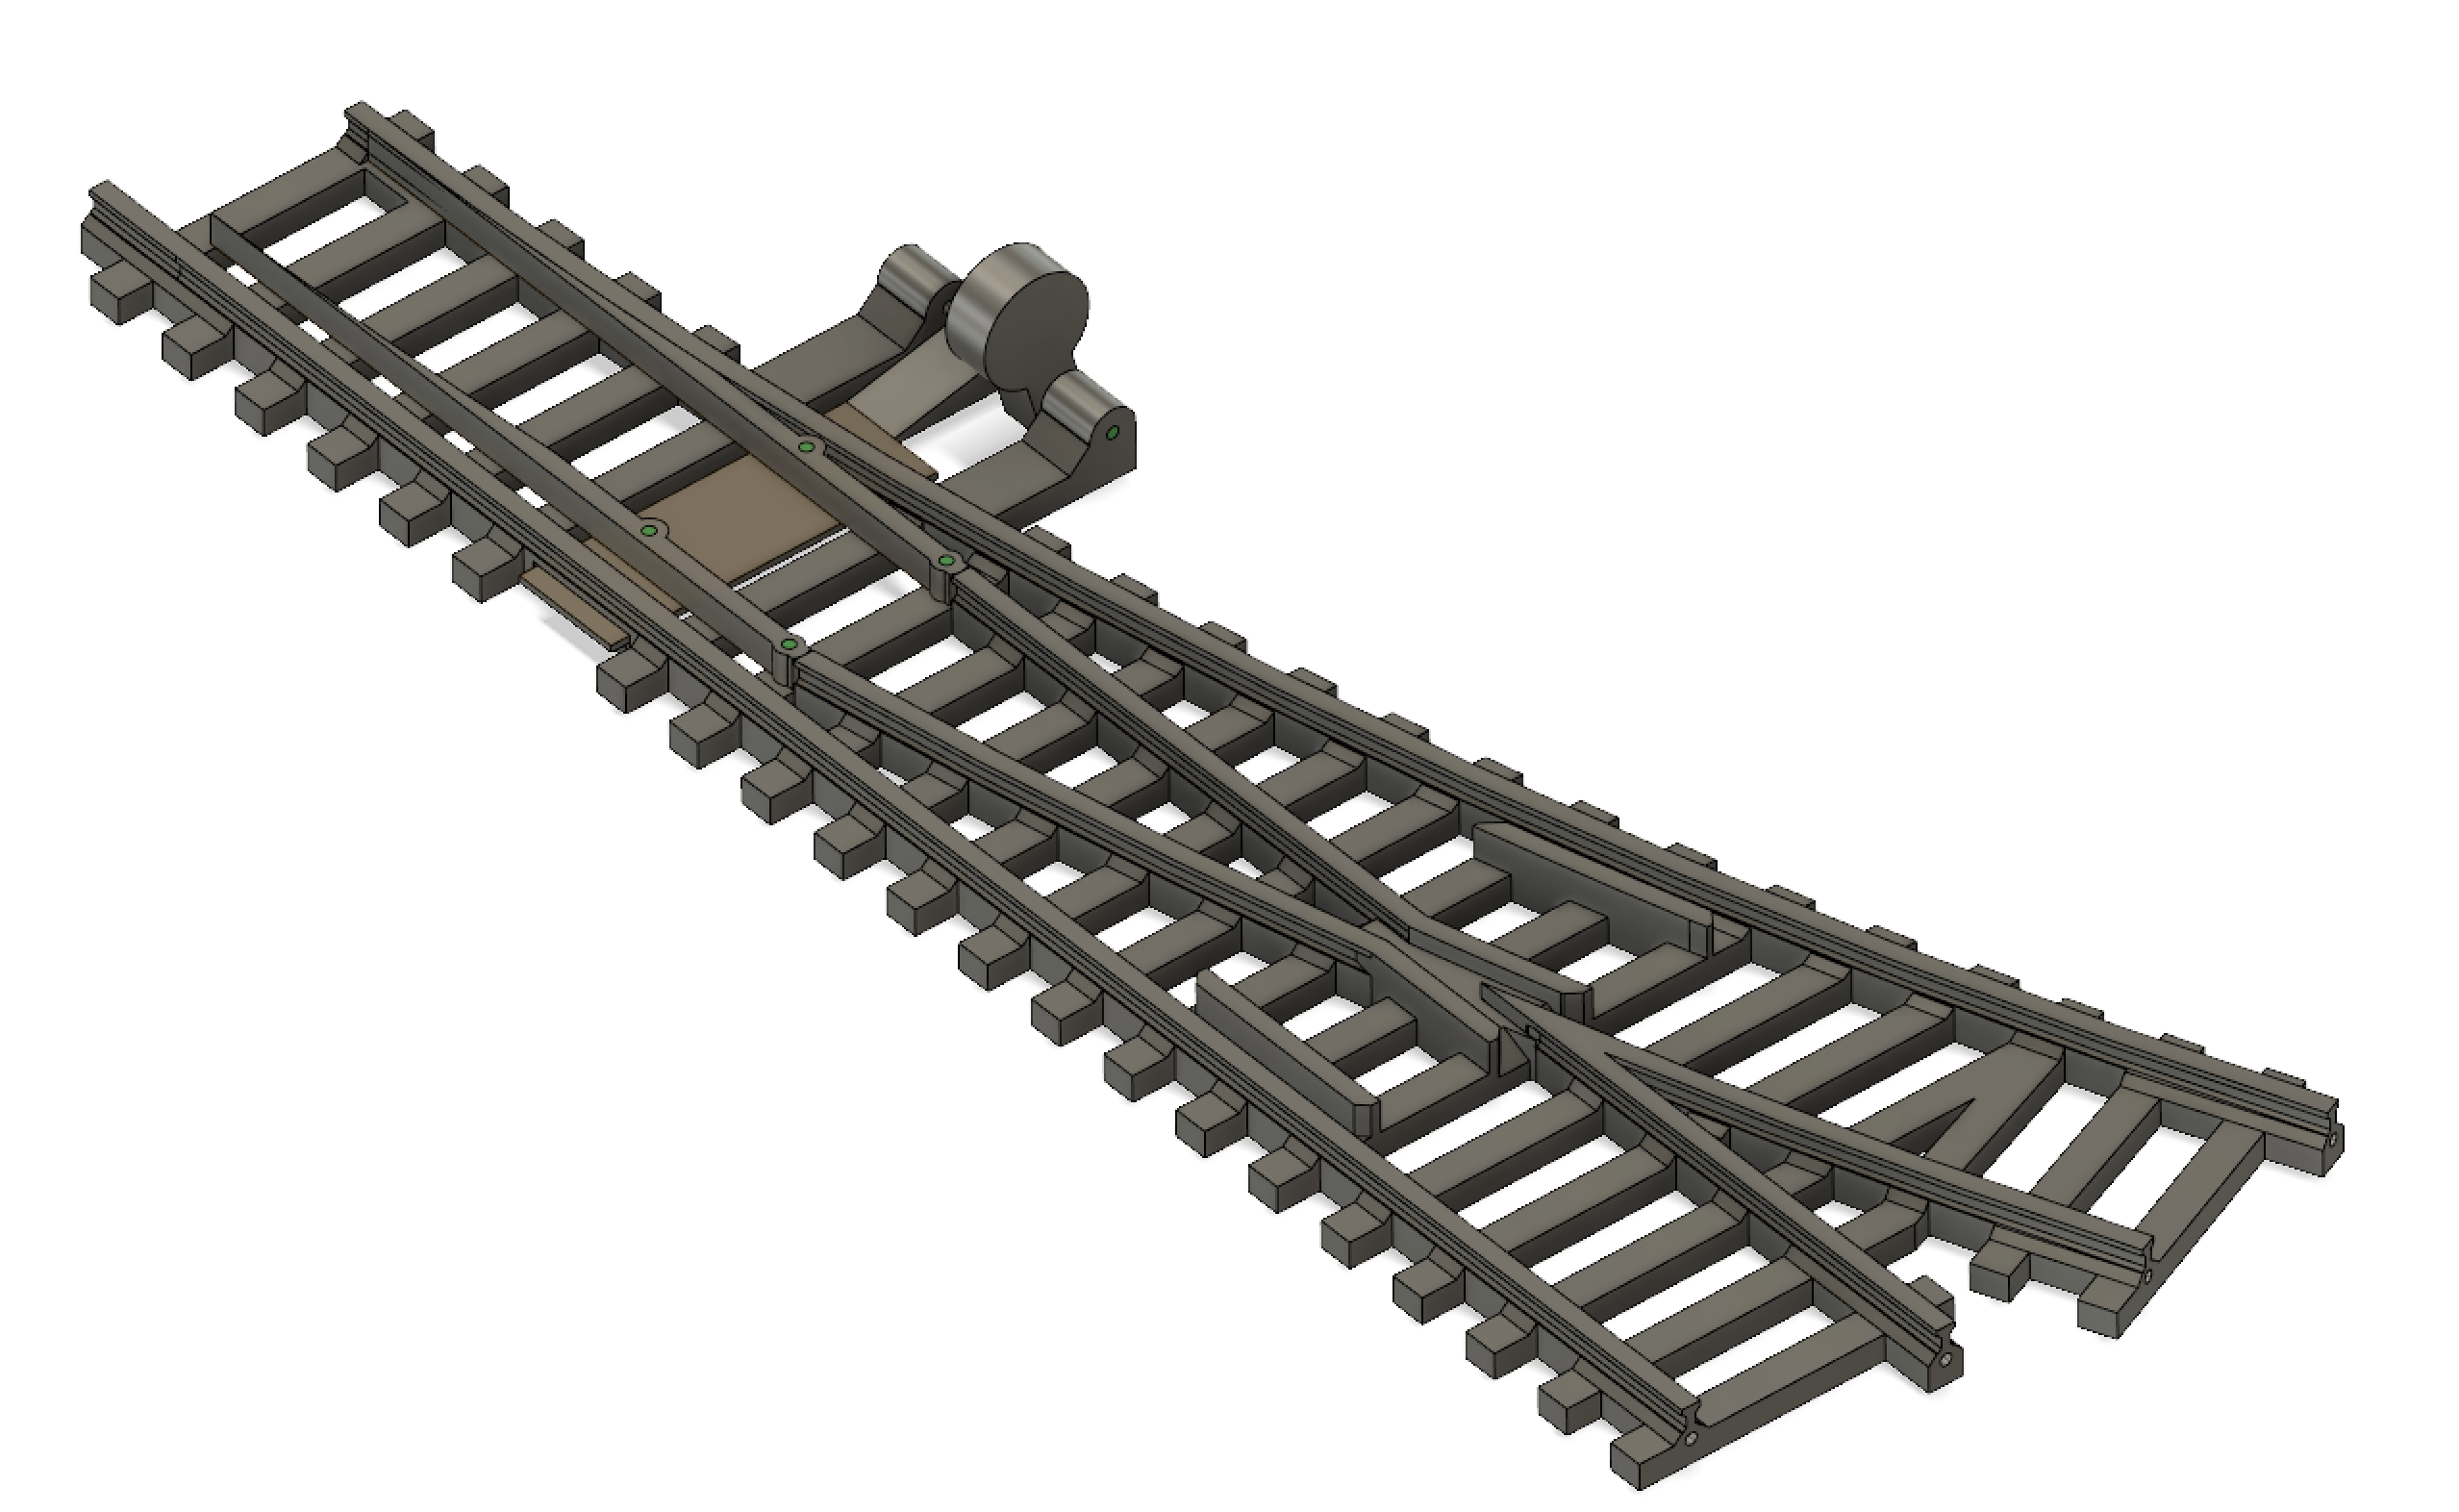

- Print “RailroadSwitch1” with 3d printer.
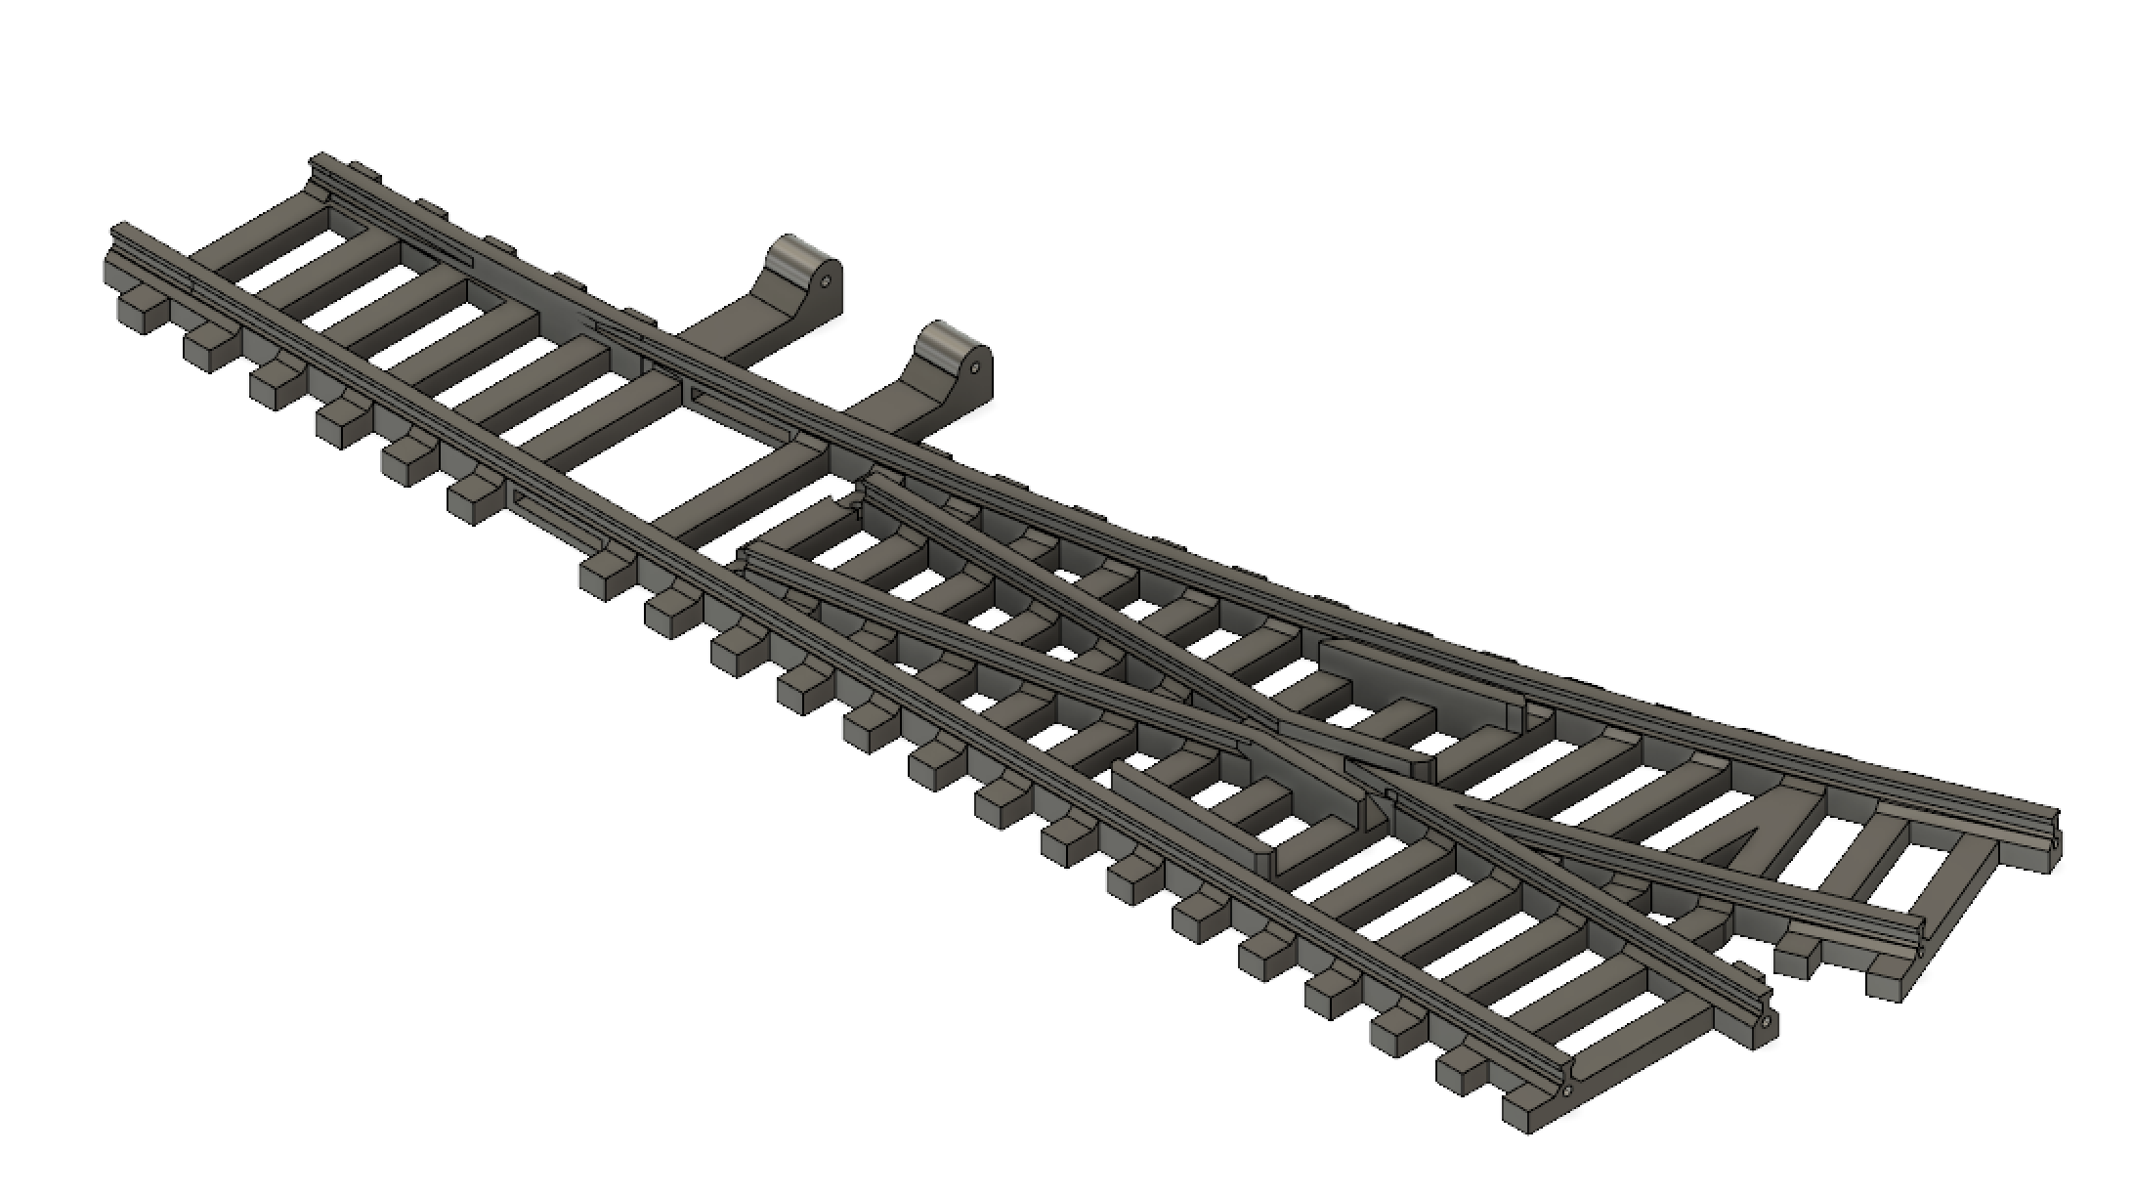
- Cut the 1mm diameter nail at 14 mm length and glue it inside left holes (as you did at rails). You can drill right hole with 1,1mm drill bit.
- Print “RailroadSwitch3” with 3d printer.
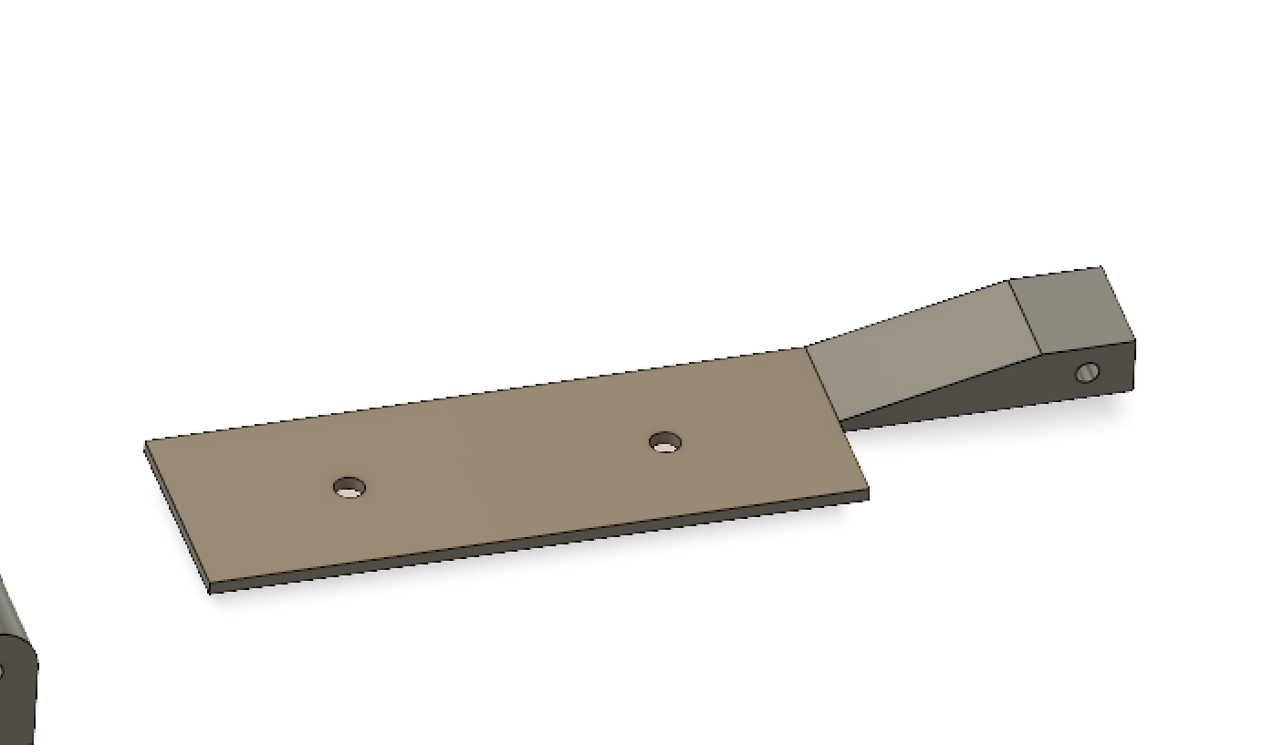
- Cut nail (1mm diameter, 9mm length) and put it in hole as you see on picture.
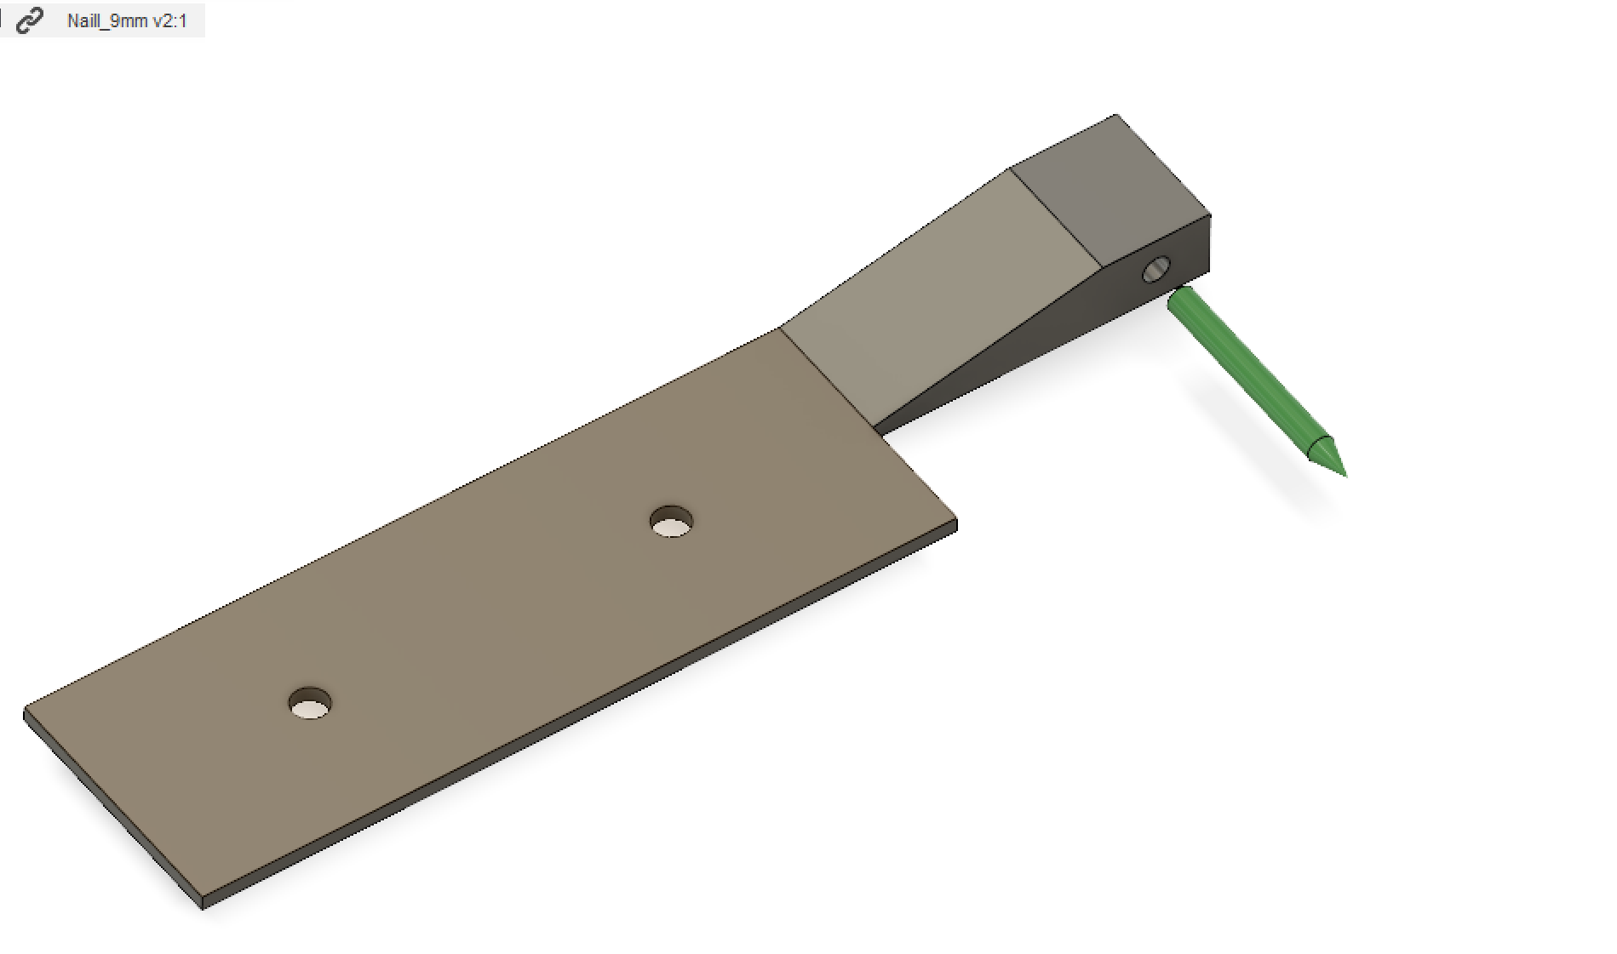
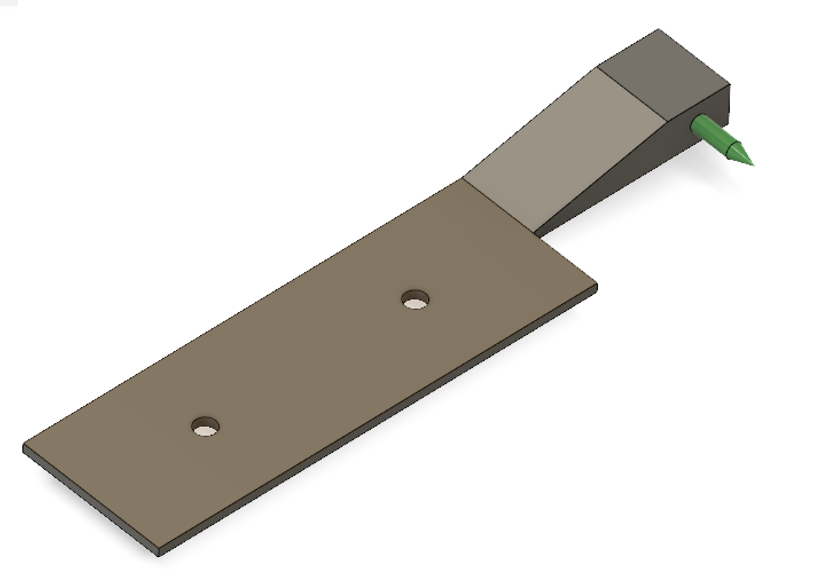

- Put “RailroadSwitch3” in hole of part “RailroadSwitch1”, as you see on picture.
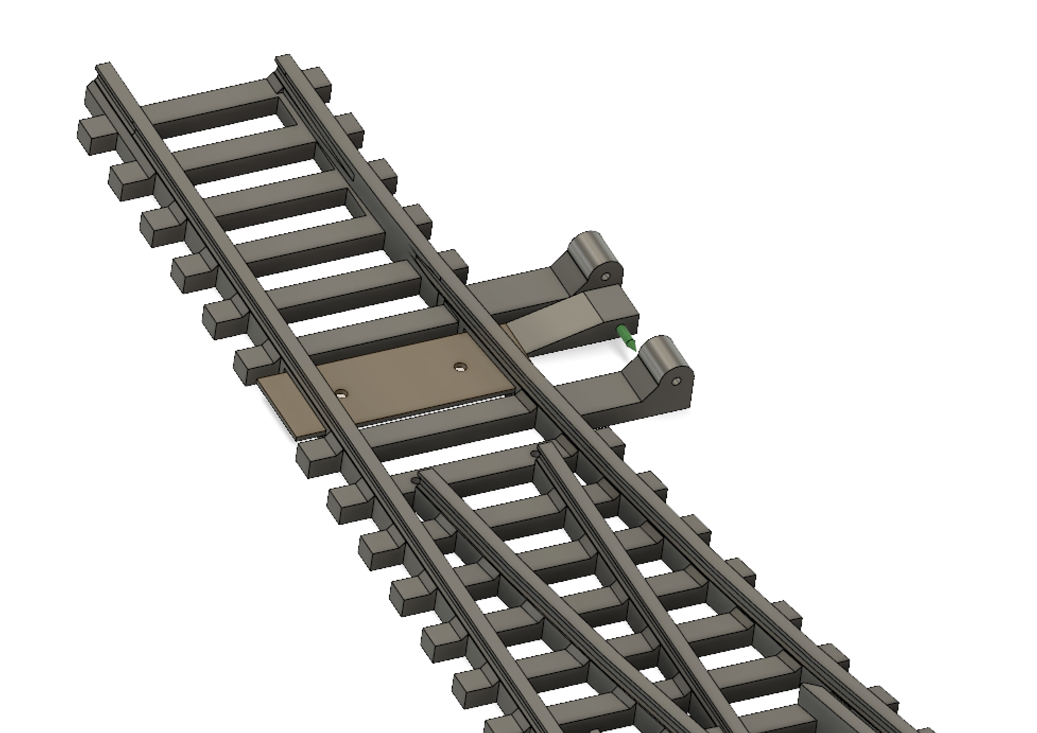

- Print two “RailroadSwitch2” pieces with 3d printer.
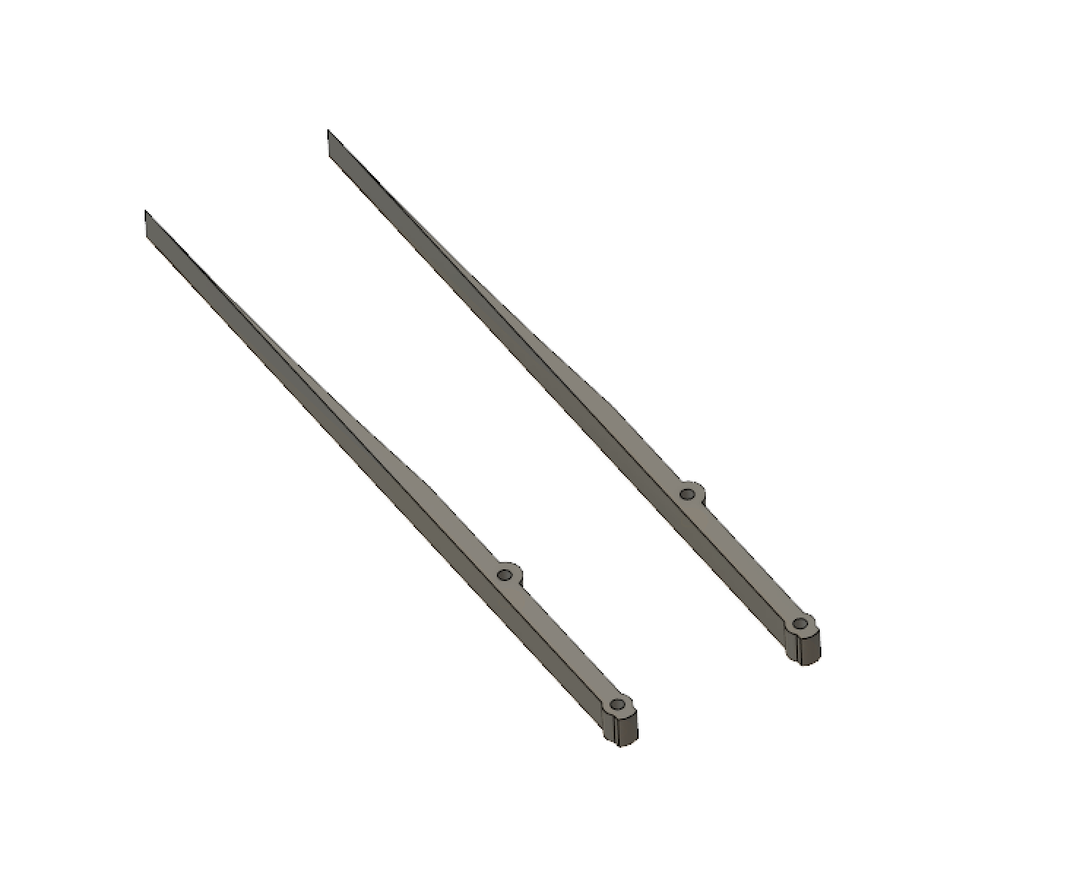
- Cut 4 nails (diameter: 1mm, length: 5mm), and put them in holes as you see on picture.
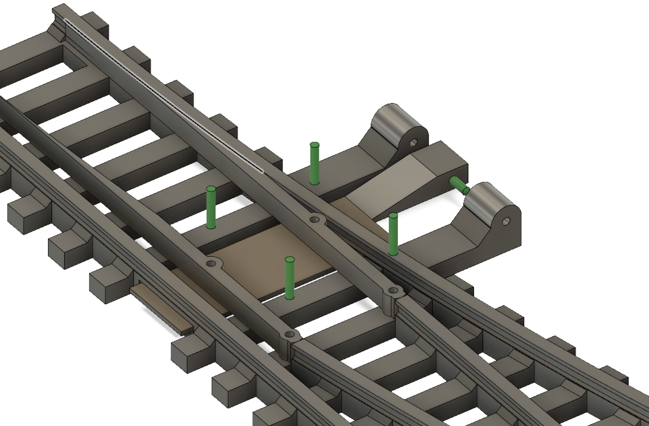
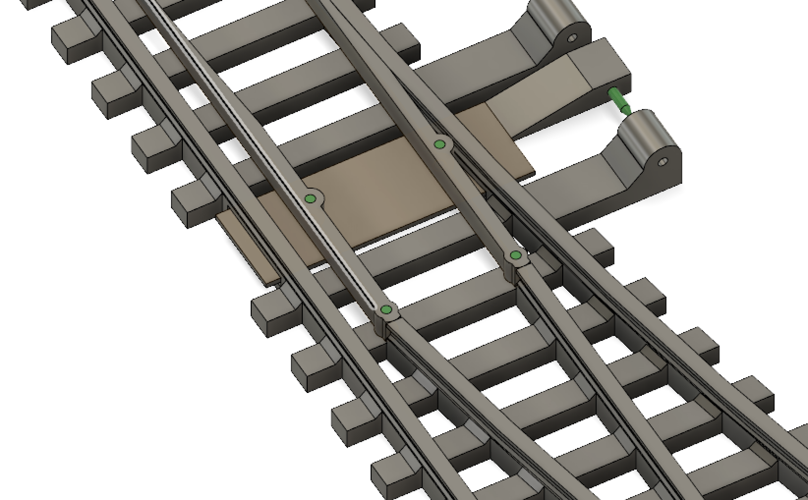
- Print “RailroadSwitch4” with 3d printer.
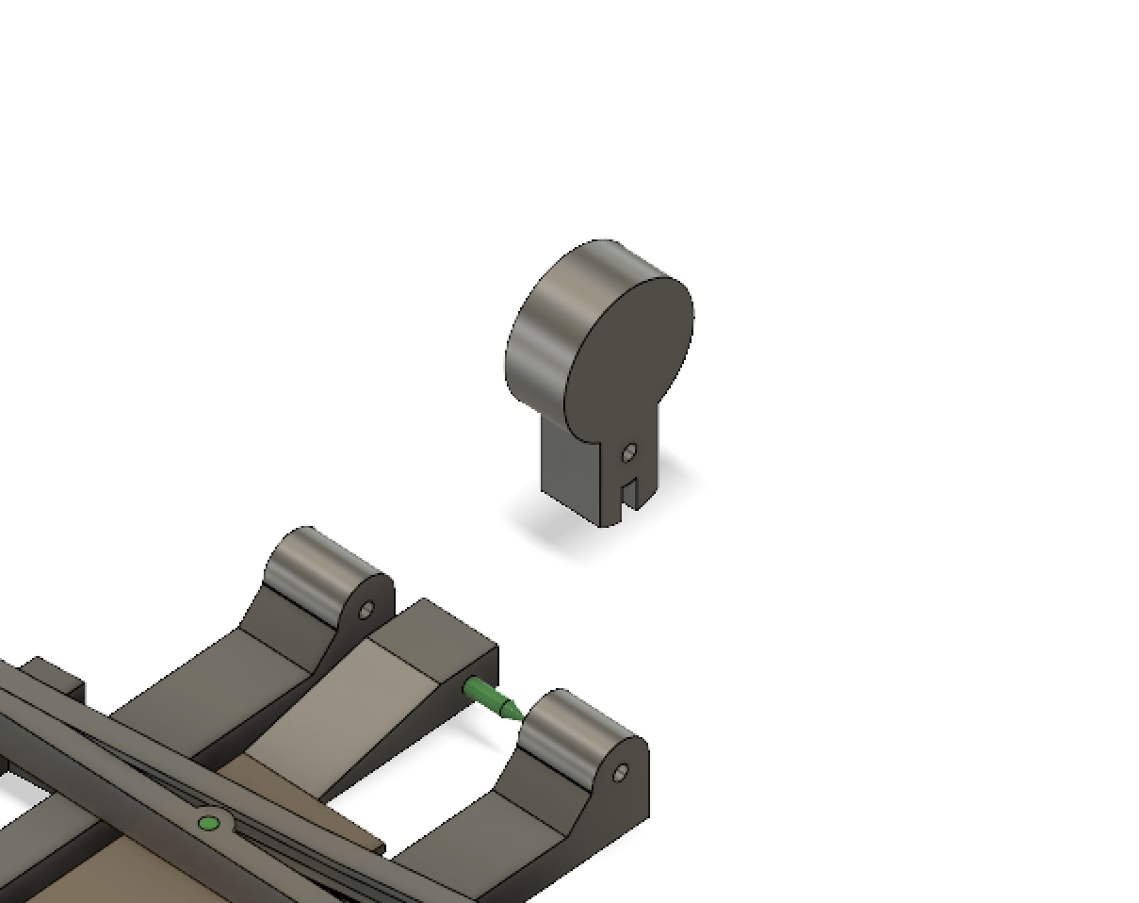

- Cut nail (diameter: 1mm, length: 9mm), and put it in hole as you see on picture.
