Locomotive
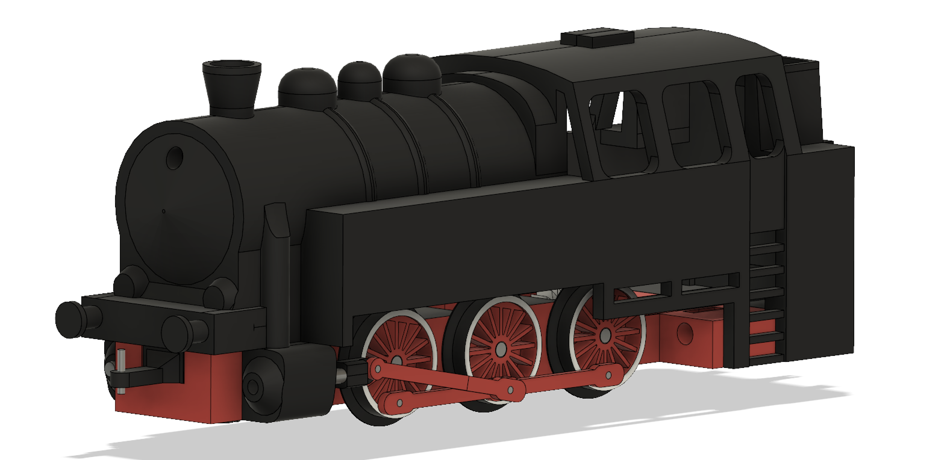

- Print “Locomotive1” with 3d printer.
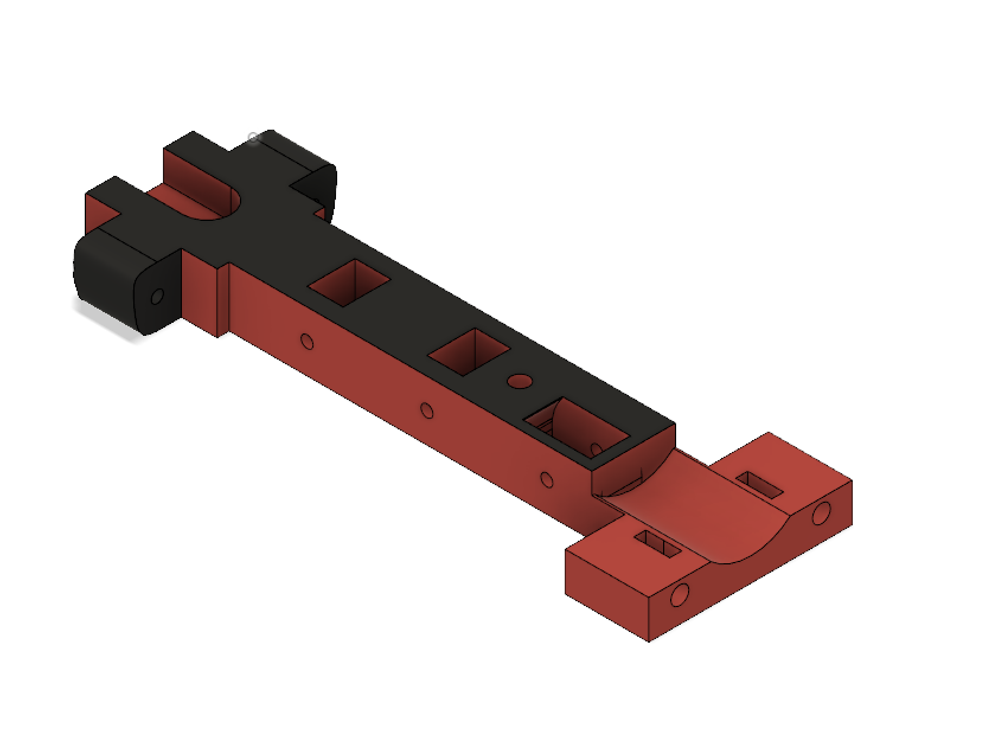
- Print “Locomotive3” with 3d printer, and screw it together with “Locomotive1” with m3 screws.
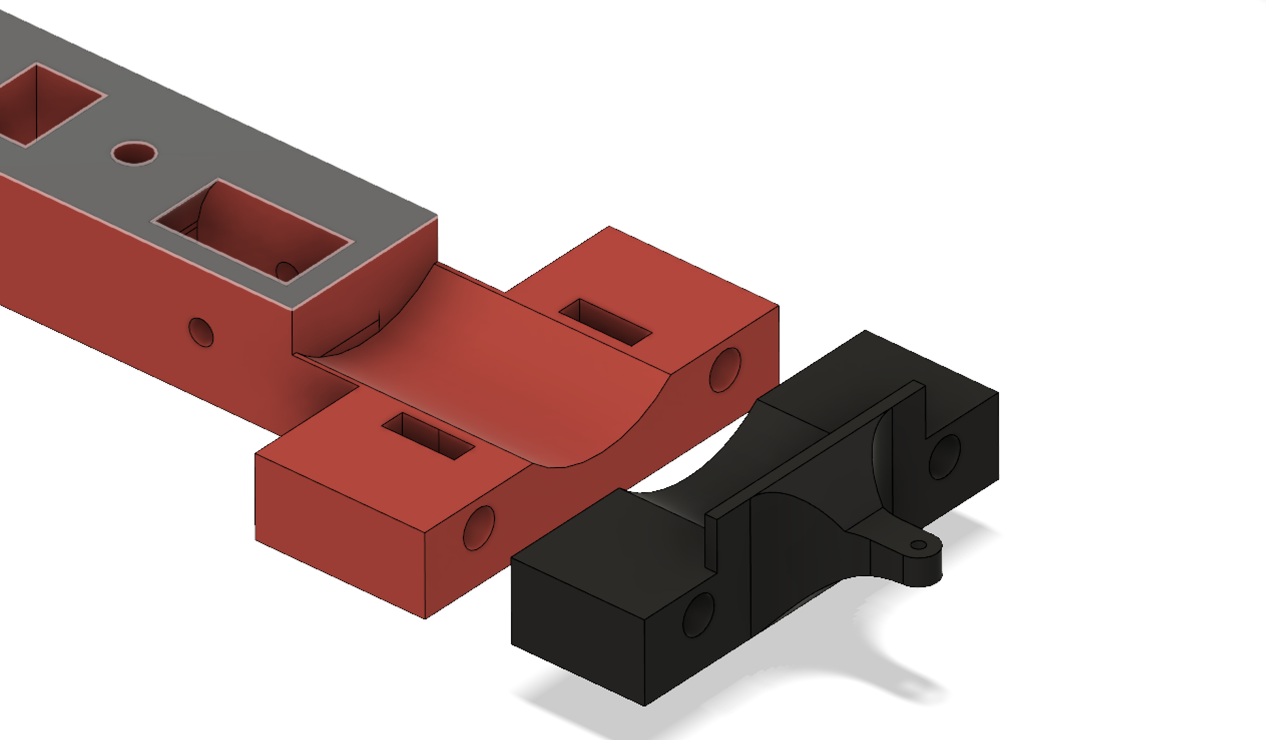
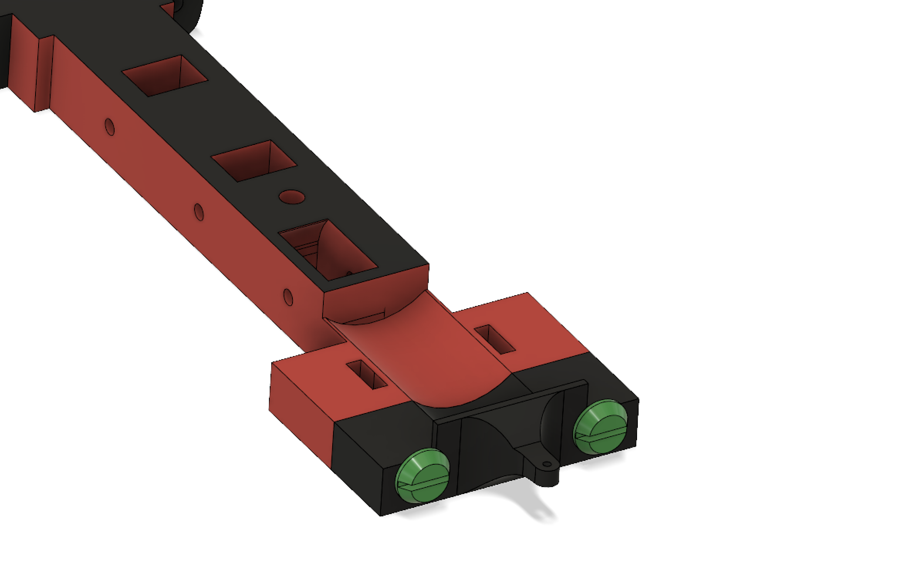

- Print six pieces “Locomotive2” with 3d printer. Cut three nails (2,2mm diameter, 19,2mm length). Put gear (13,8mm diameter) in hole as you see on picture.
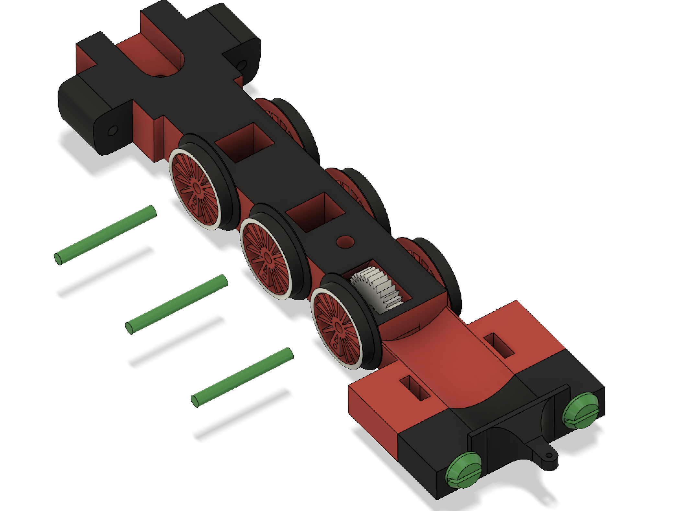
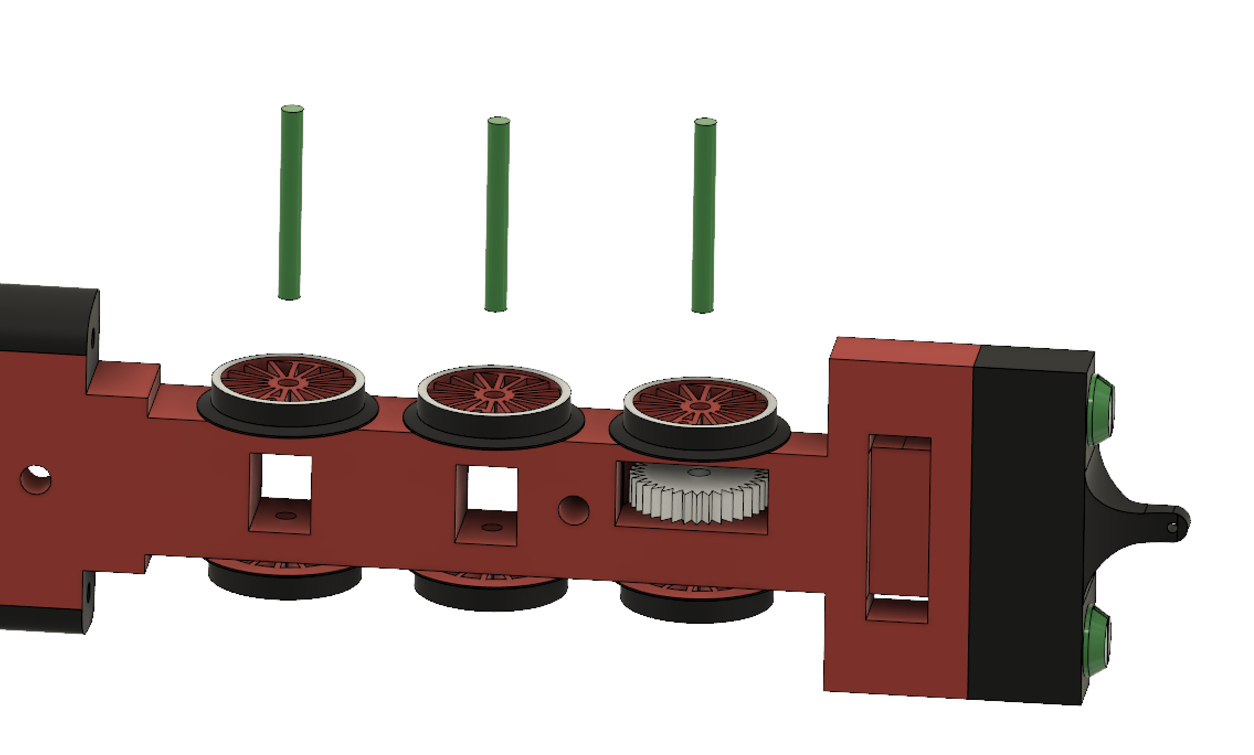
- Put nail in holes. Rotate wheels so hole on left side will be “delayed” for 90°, at hole on the right side. Don’t delay holes for 180°!
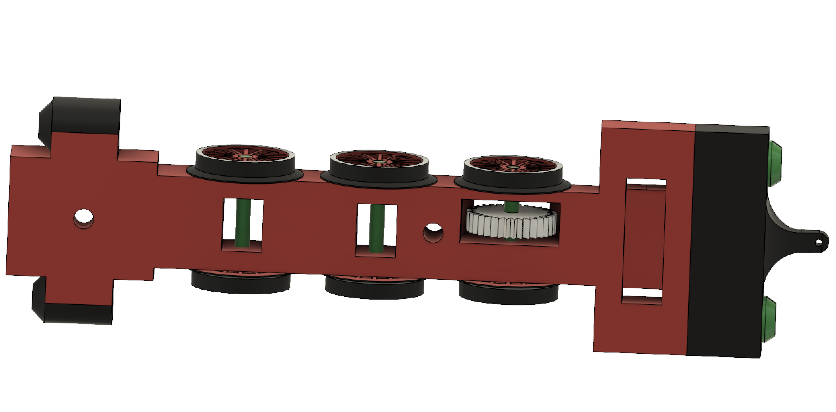
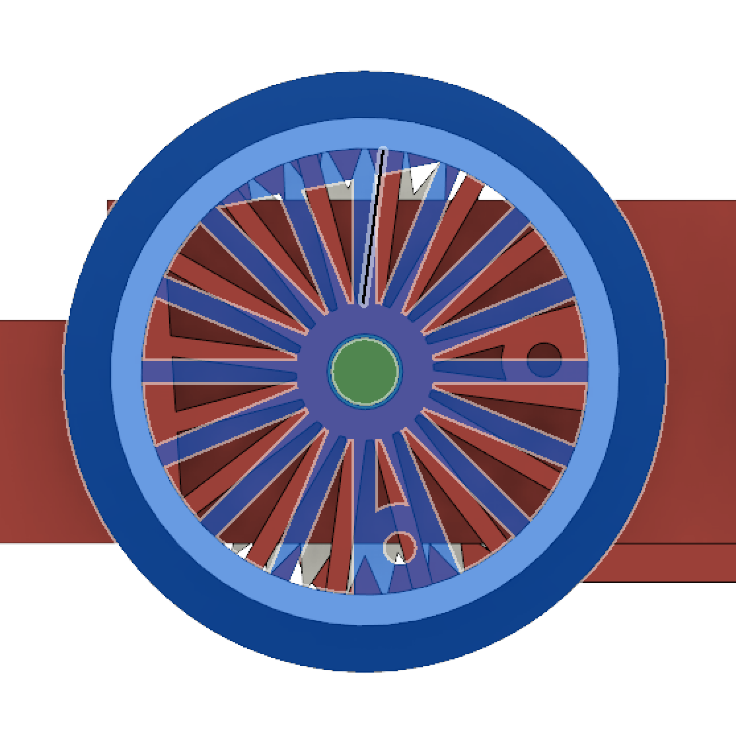

- Print two pieces “Locomotive5”. Cut 4 nails (diameter: 1mm, length: 4mm). Attach two parts on wheels using nails, as you see on picture.
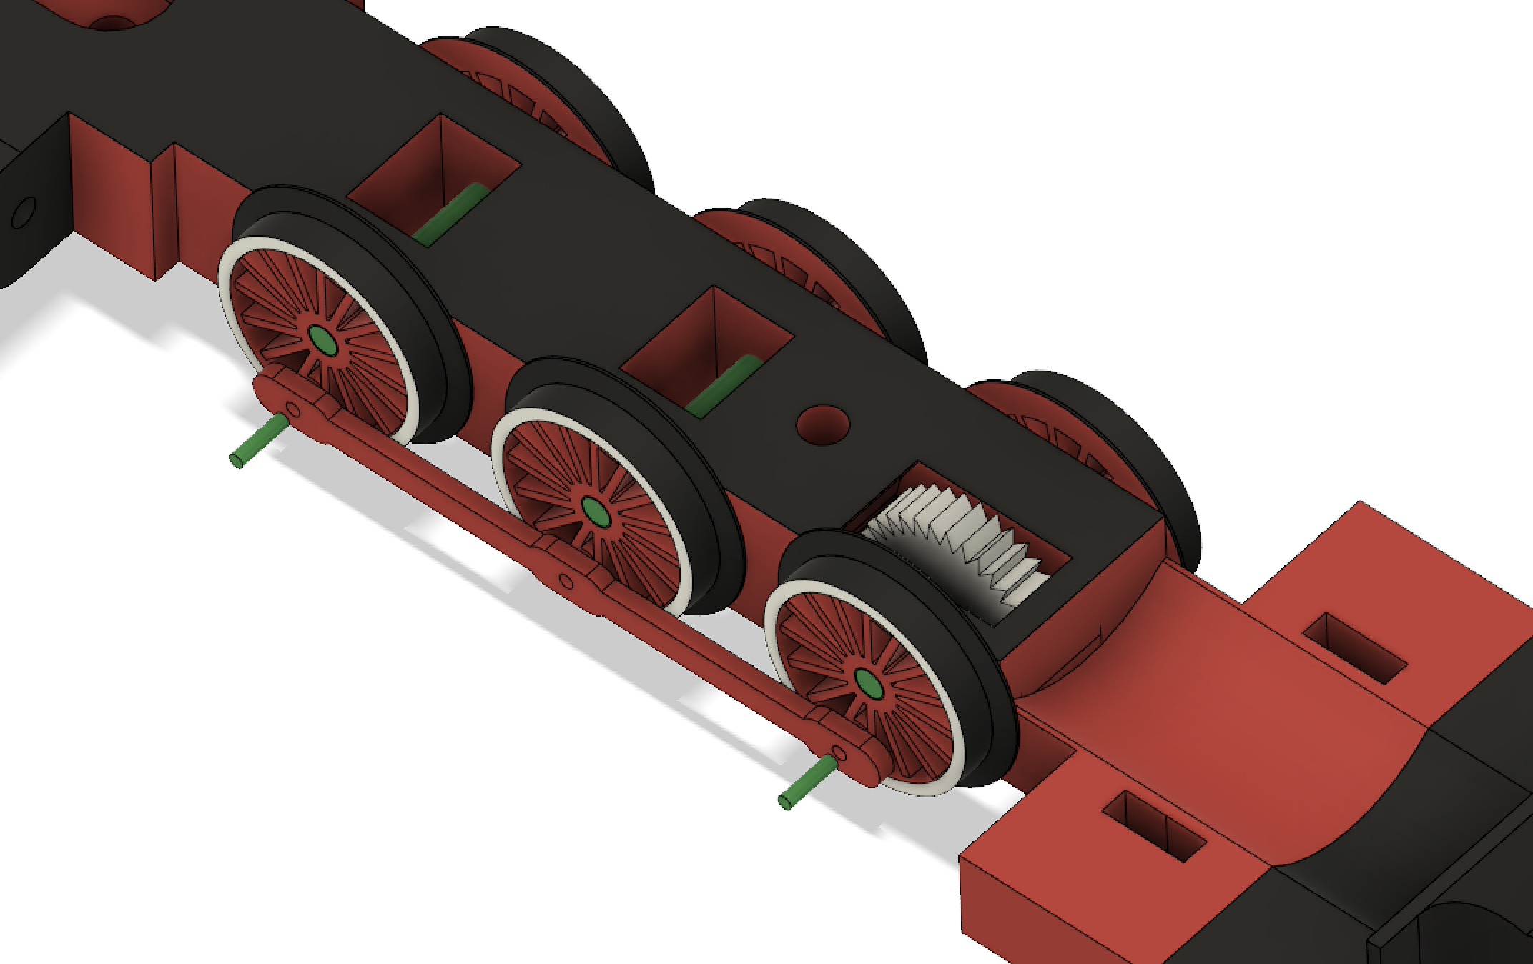
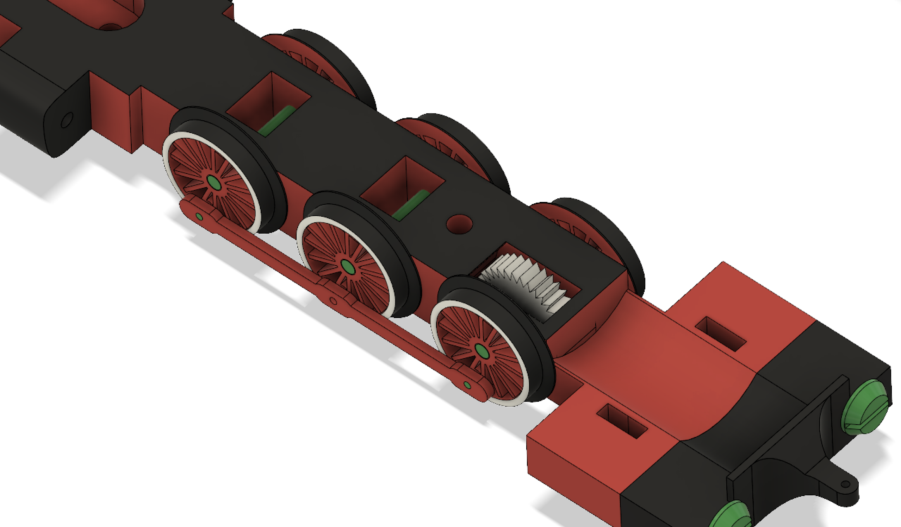
Do same on other side.

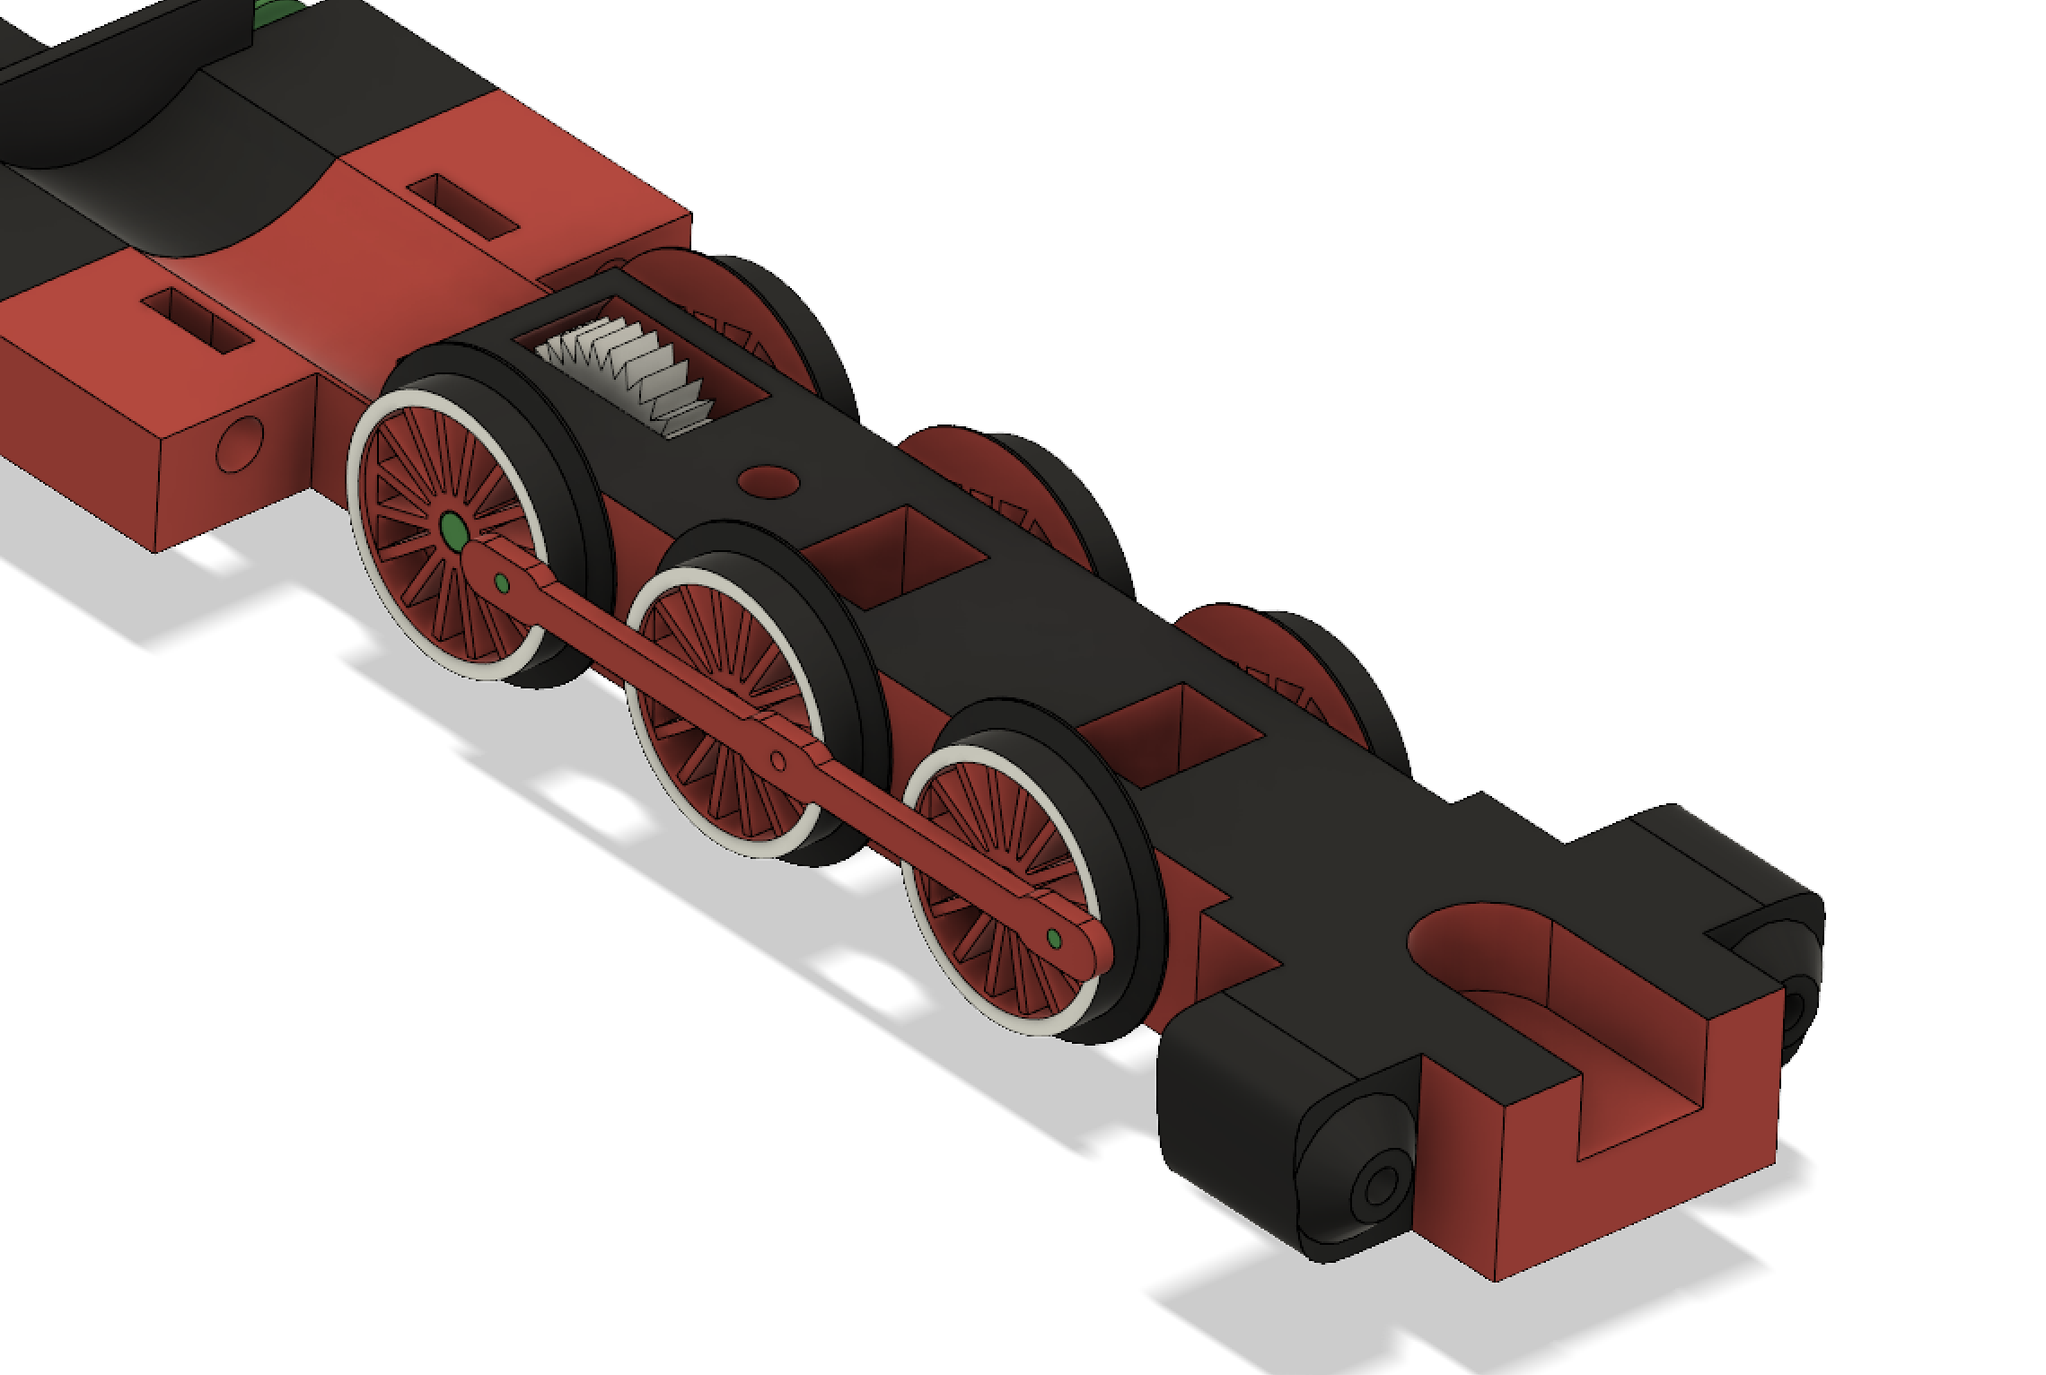
- Print two pieces “Locomotive6”, and attach them on wheels by two nails (diameter: 1mm, length: 2,4mm).
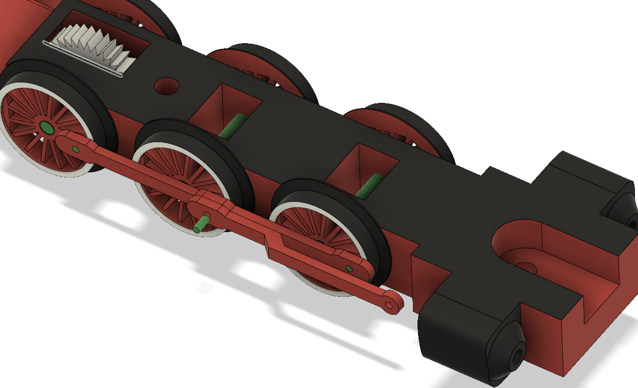
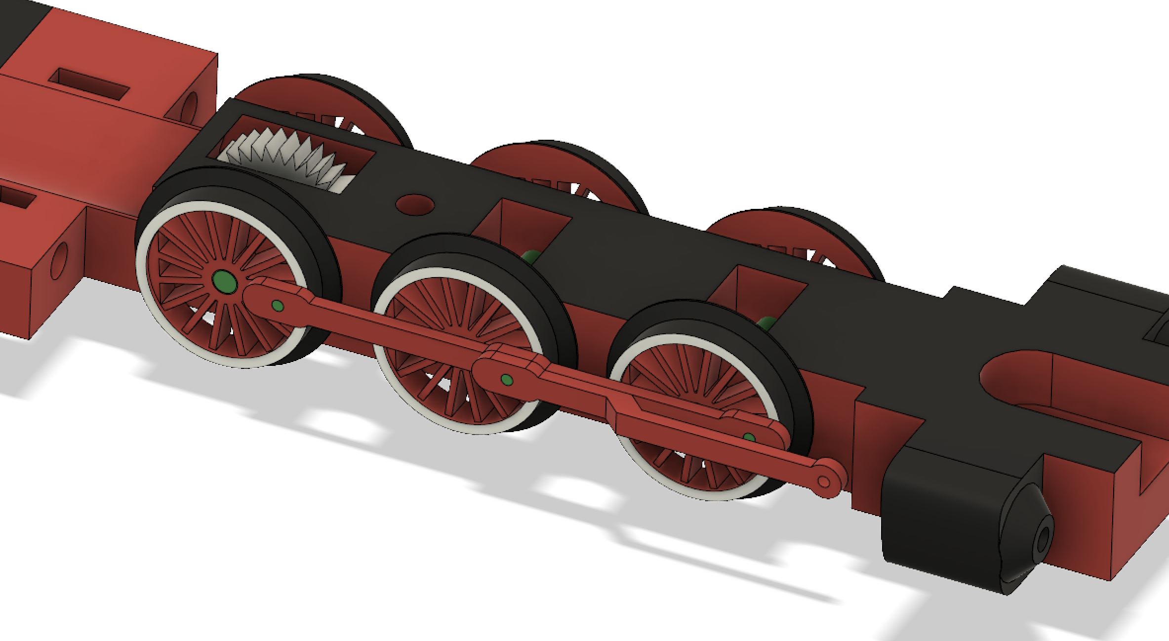
Do same on other side.
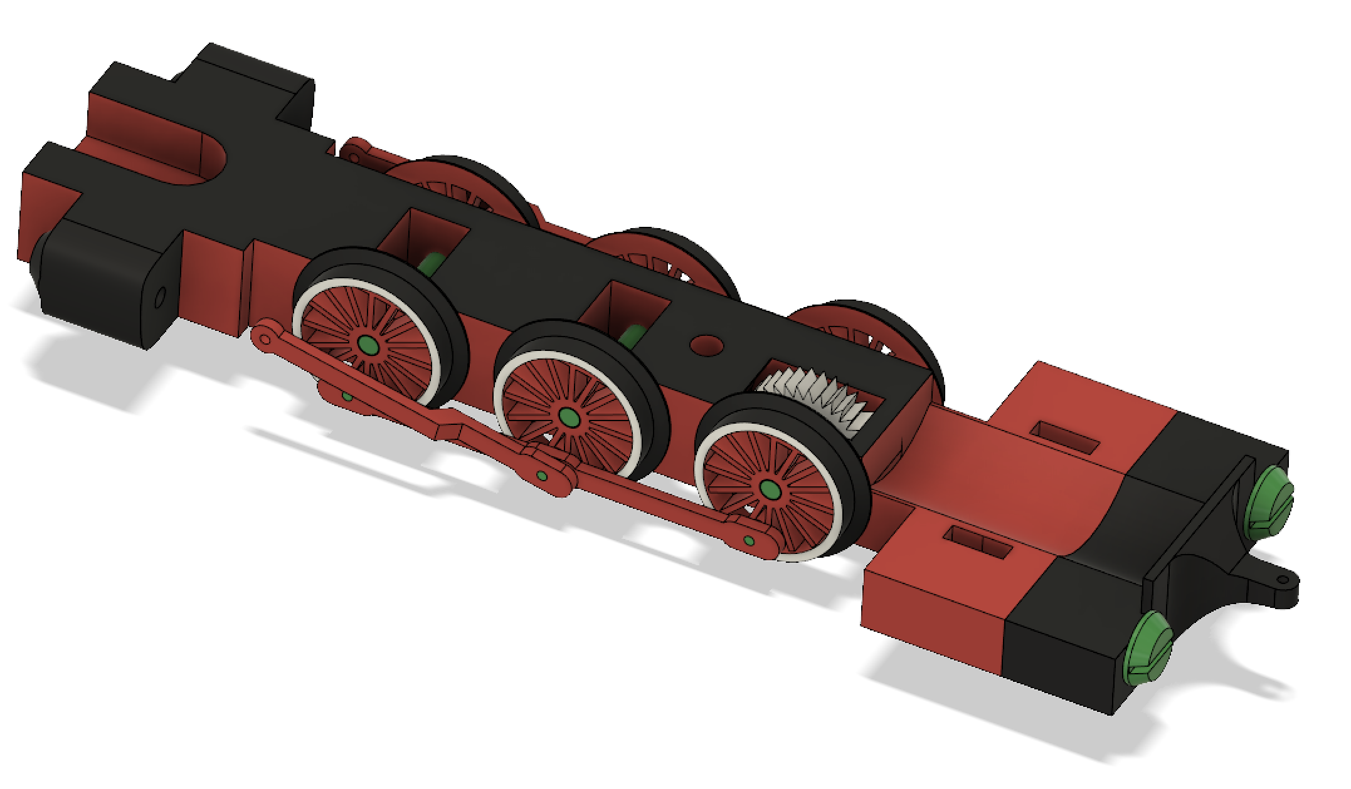
- Cut to nails (diameter: 2mm, length: 17mm) and print two “Locomotive7” parts.

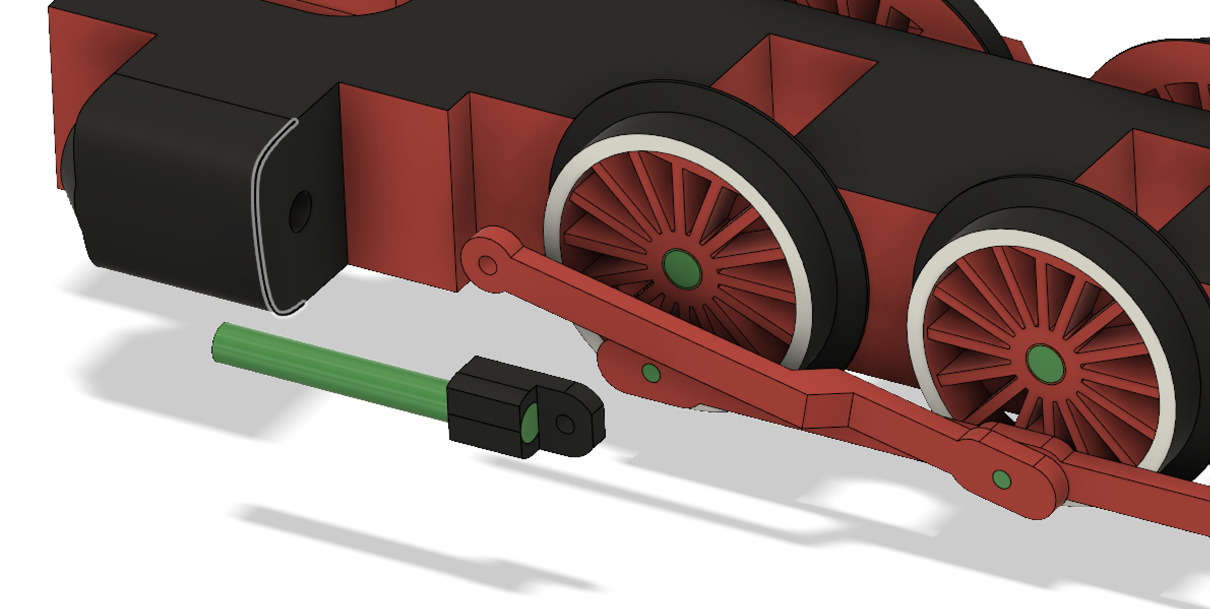
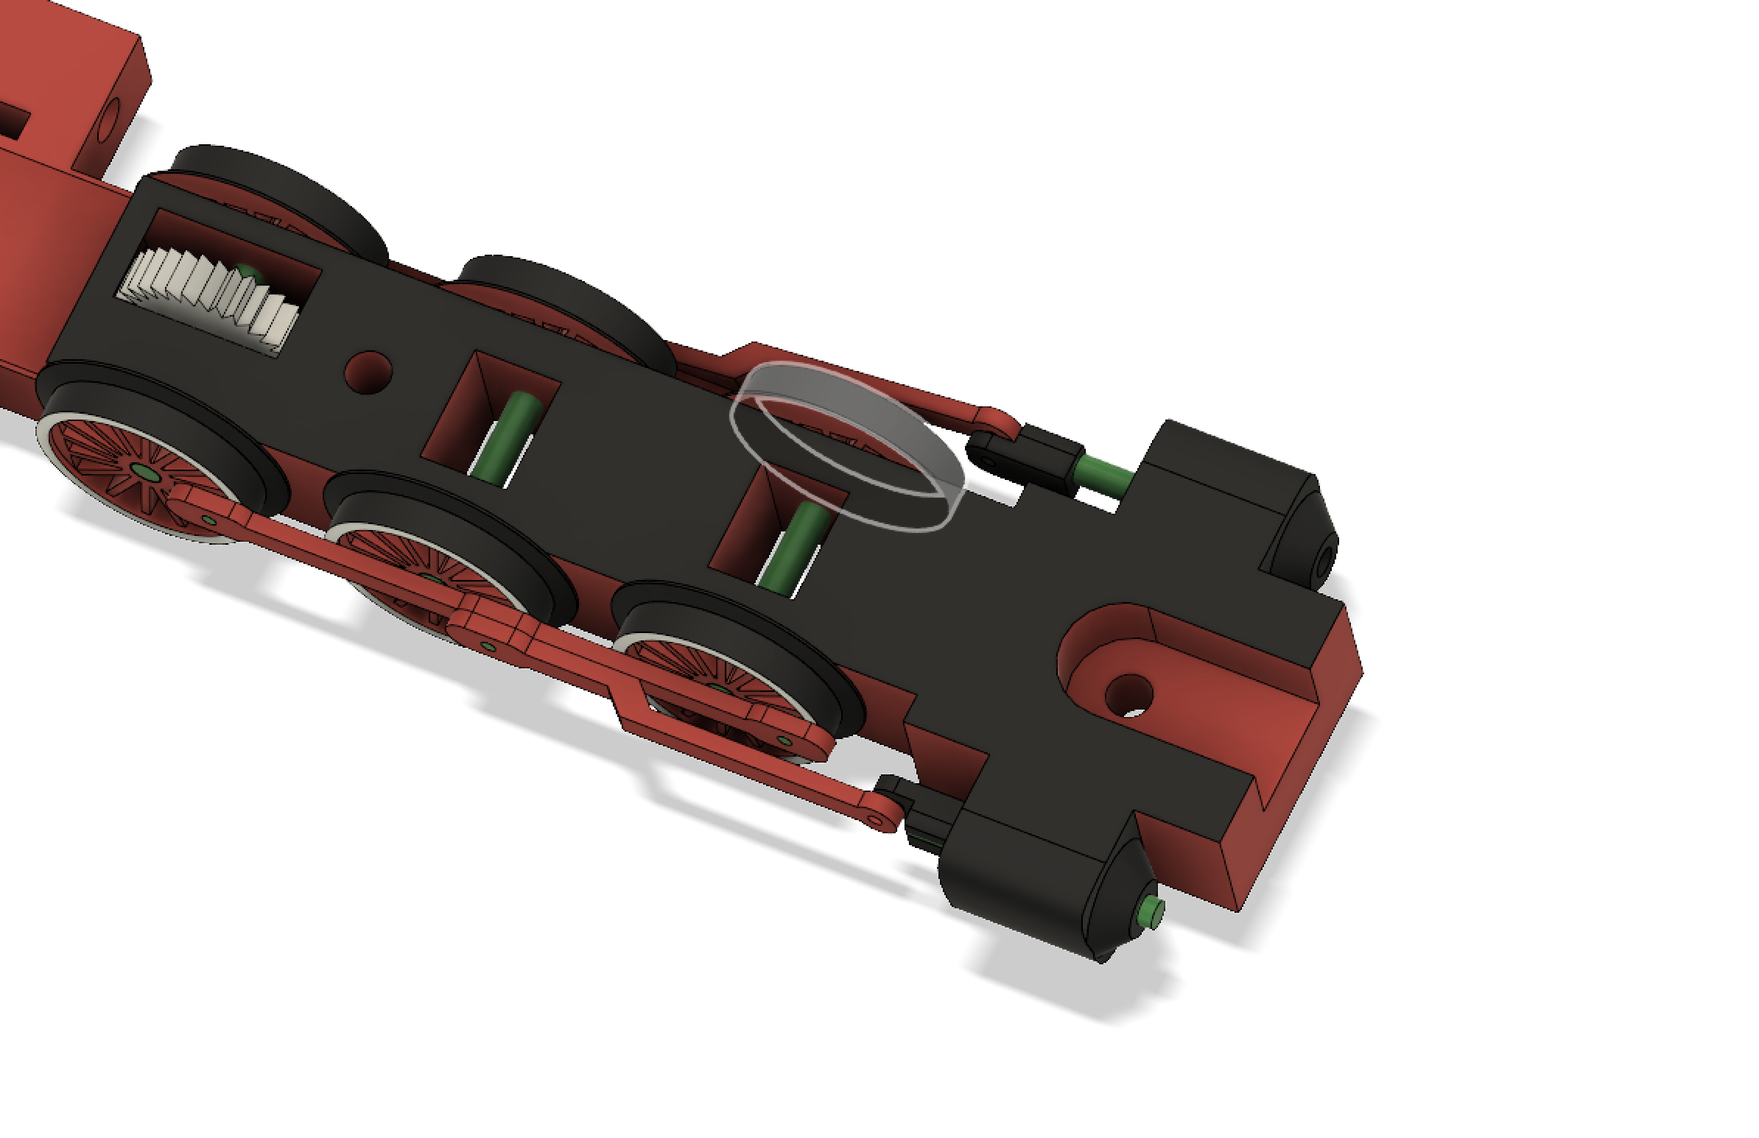

Cut two nails (diameter 1mm, length 2,8mm), and put them in holes as you see on picture.
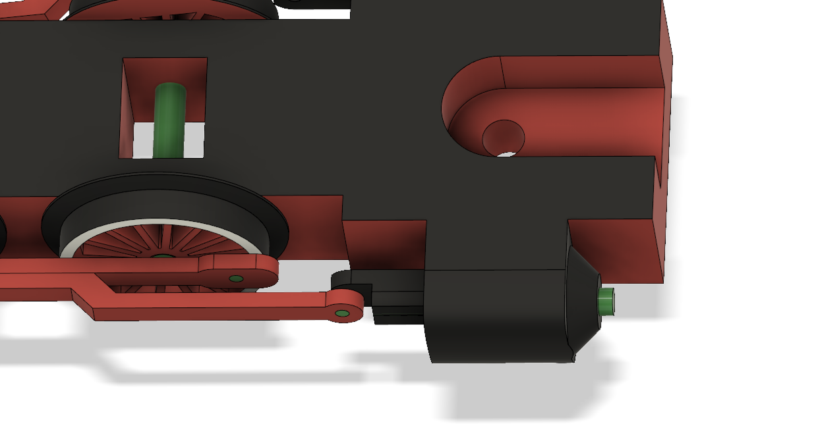
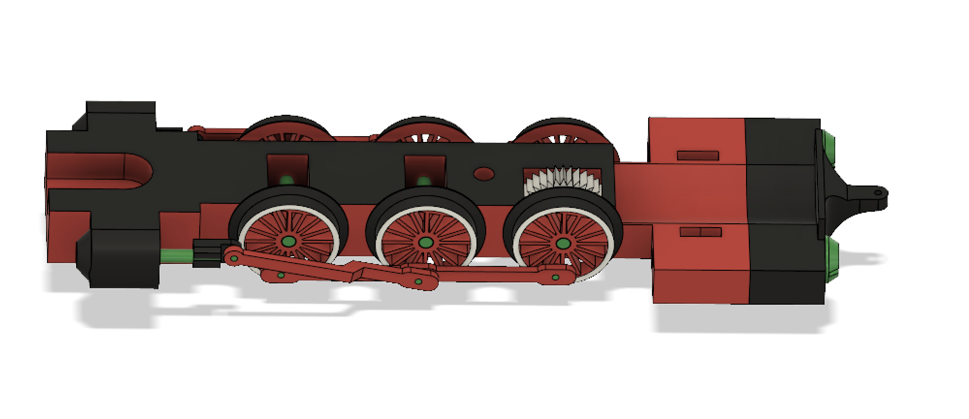

- Print “Locomotive4”, and attach it on chassis.
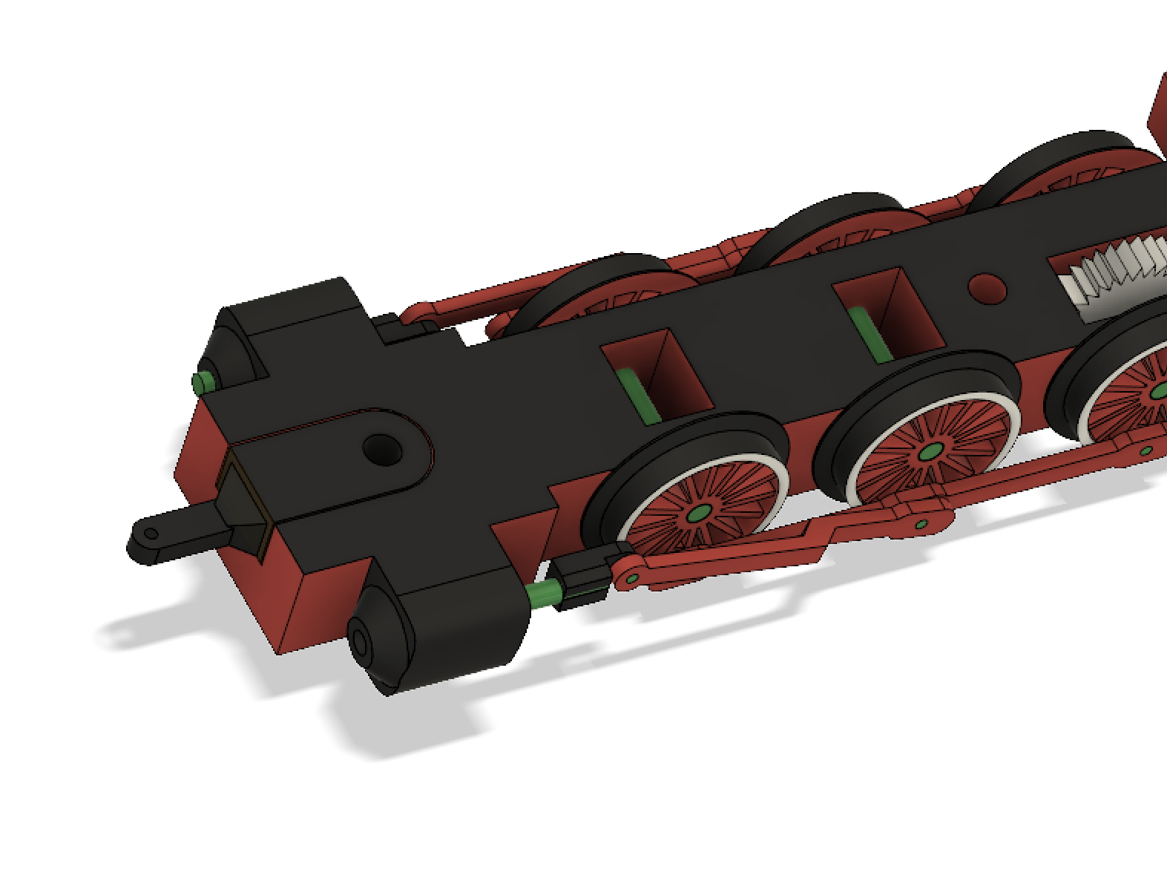
- Print “Locomotive8” and add it to chassis.
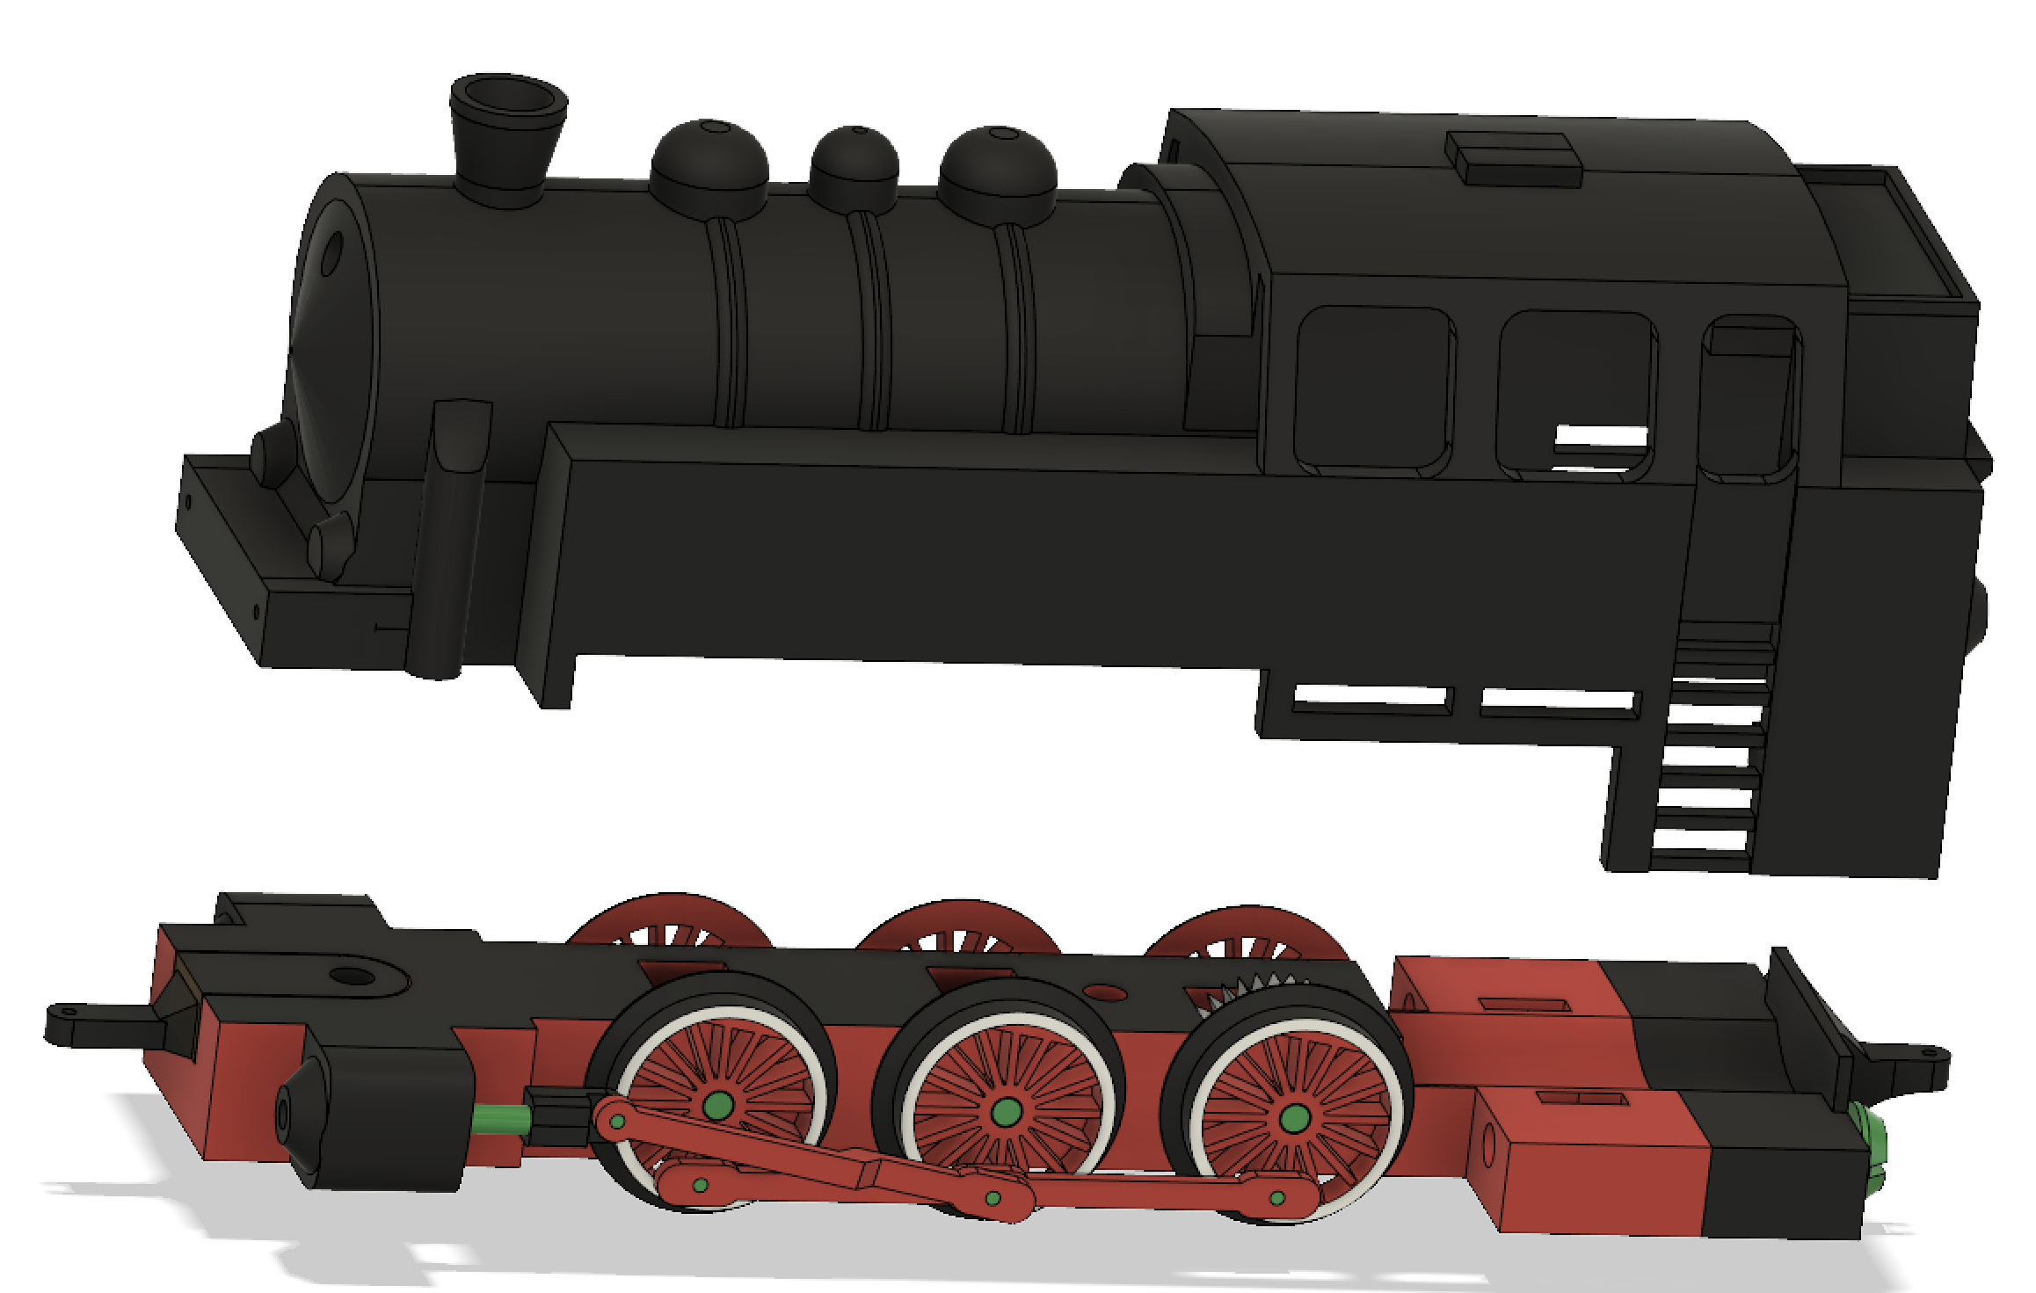
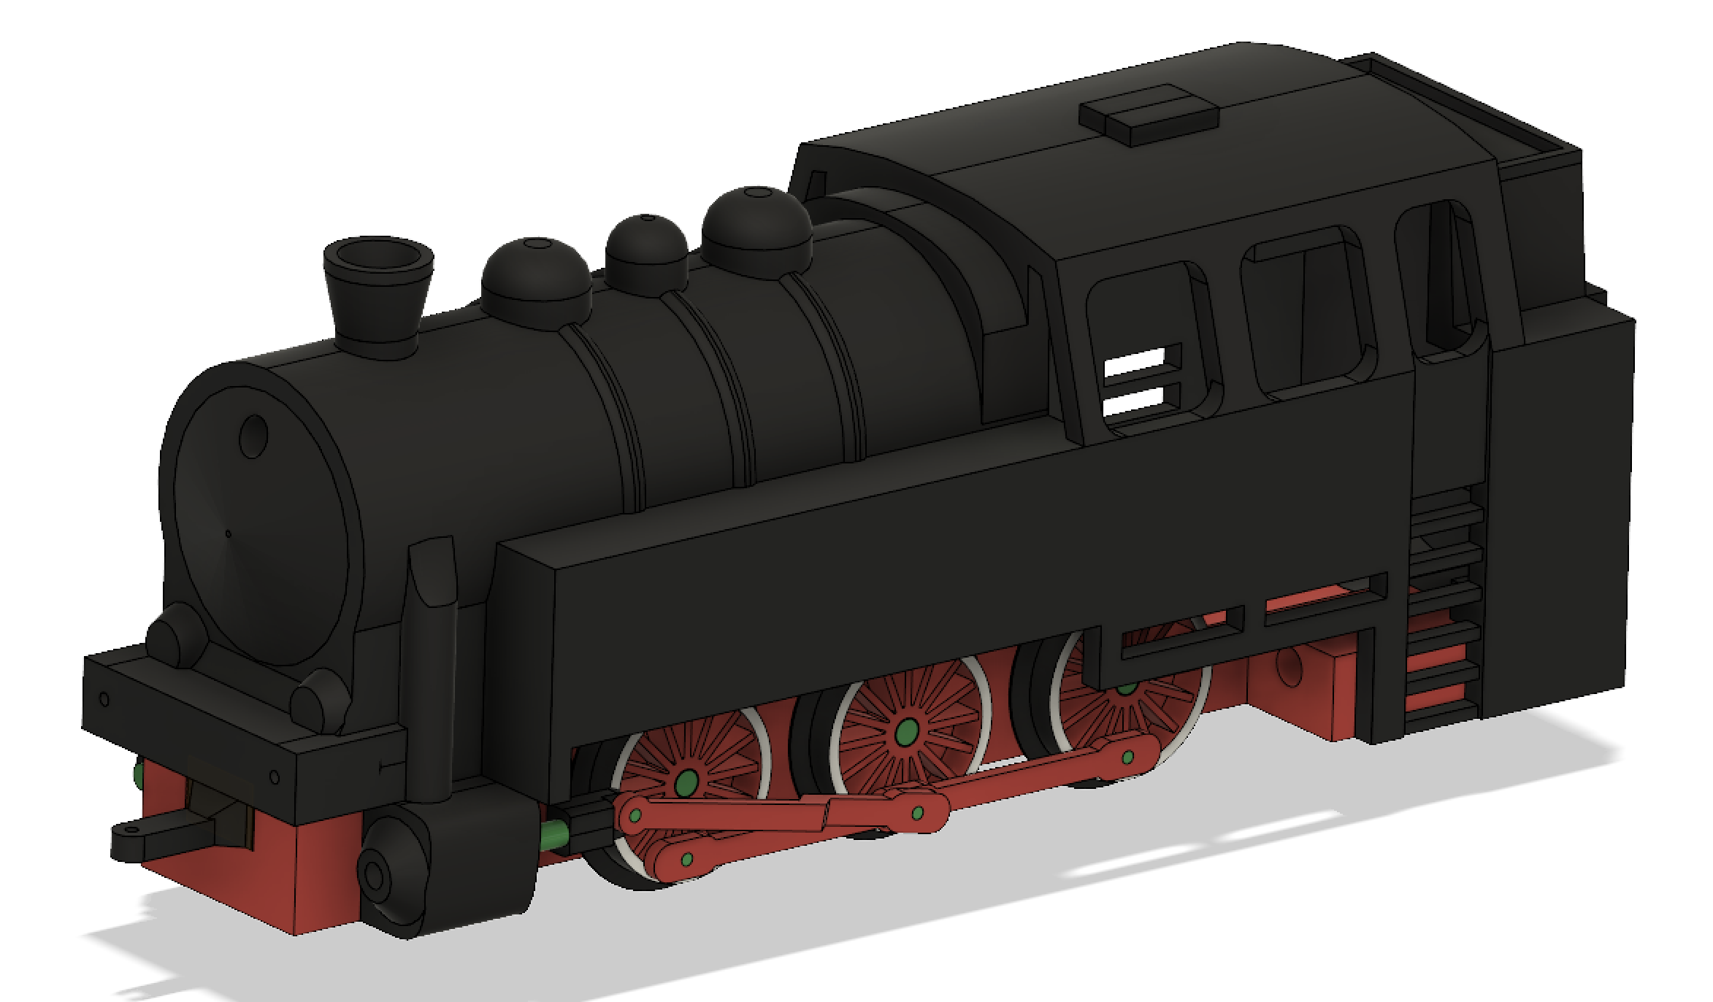
Screw part on chassis:
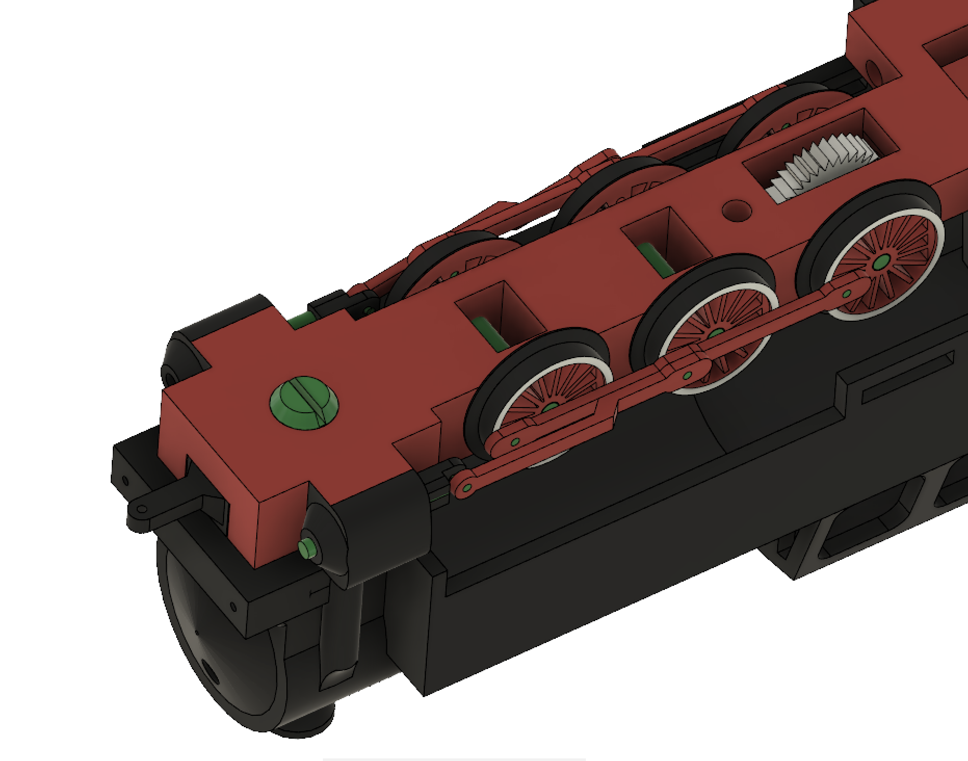

- Print four “Locomotive9” and cut four nails (diameter 1mm, length 8mm). Follow pictures.

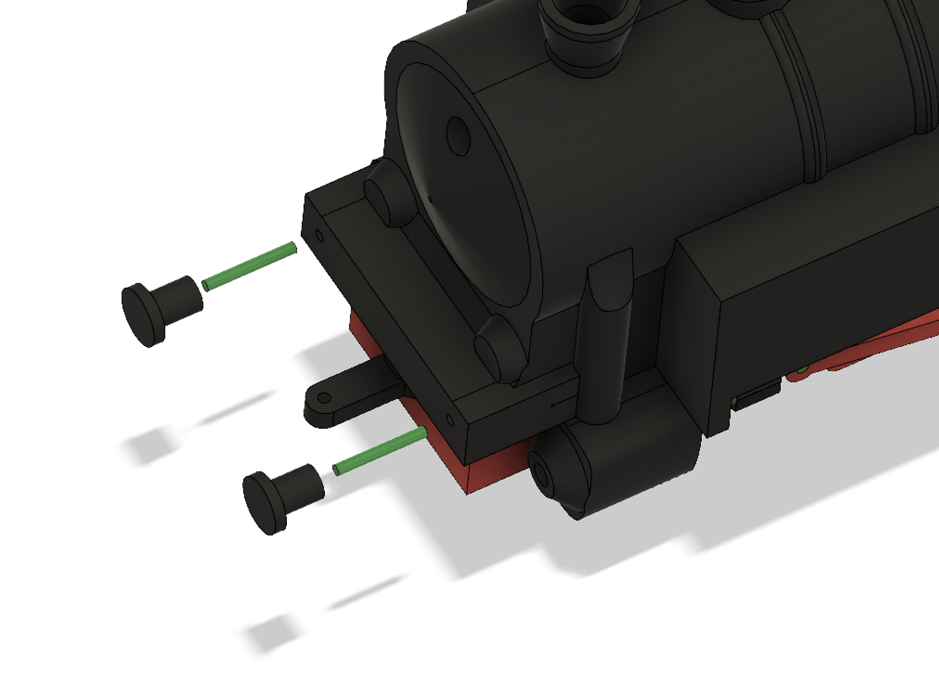
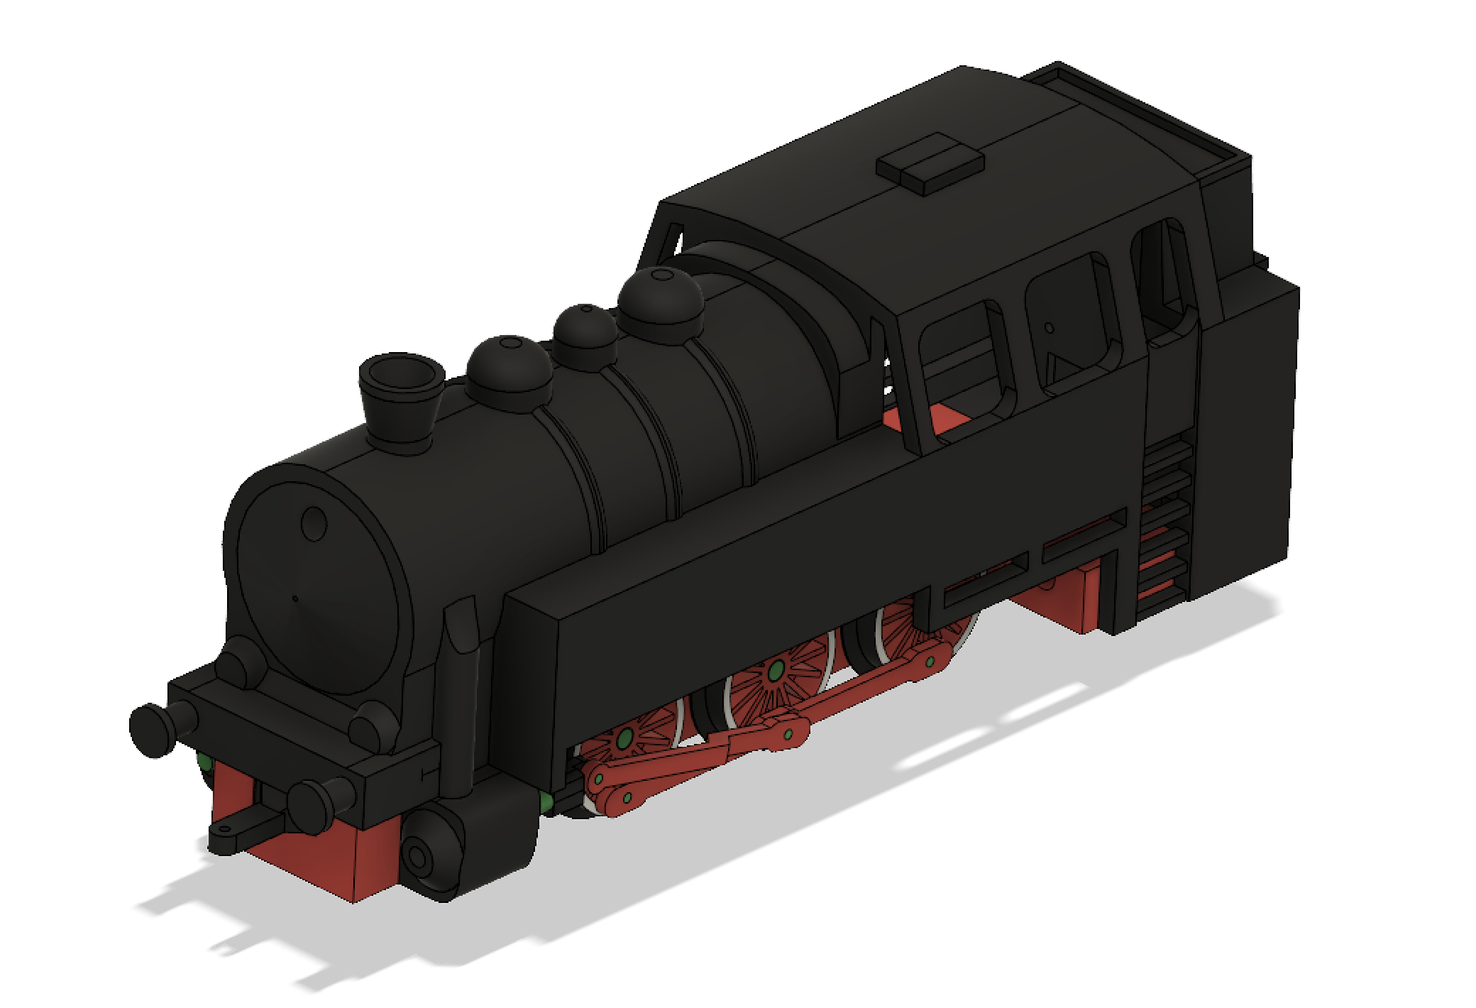
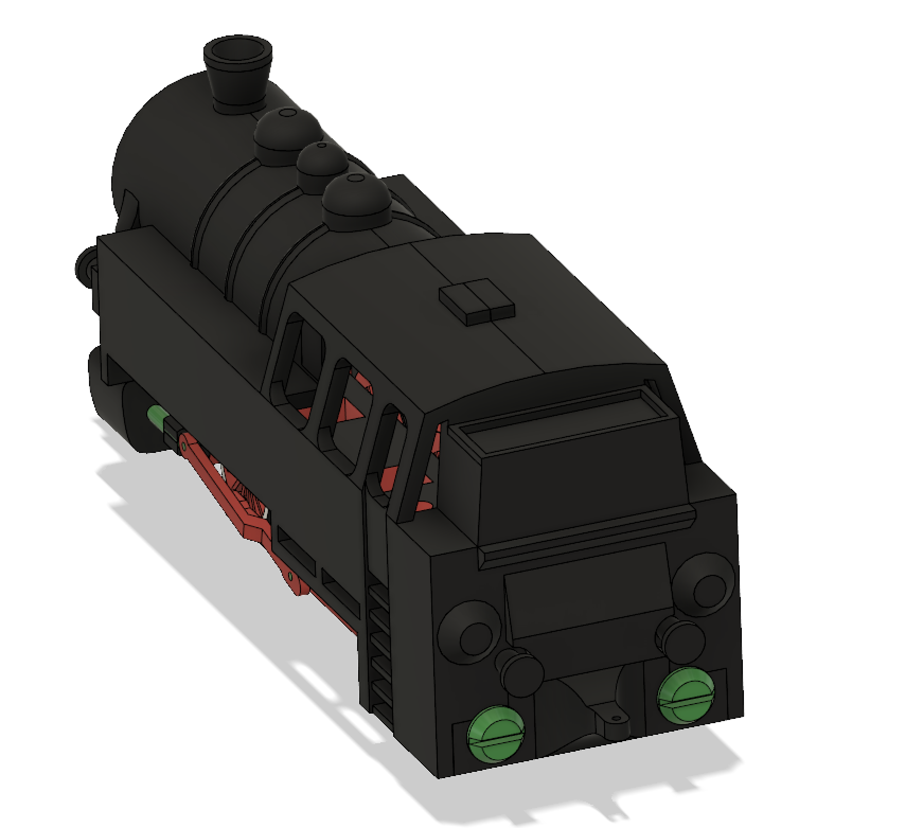
- Cut two nails (diameter 1mm, length: 6mm) and follow pictures.
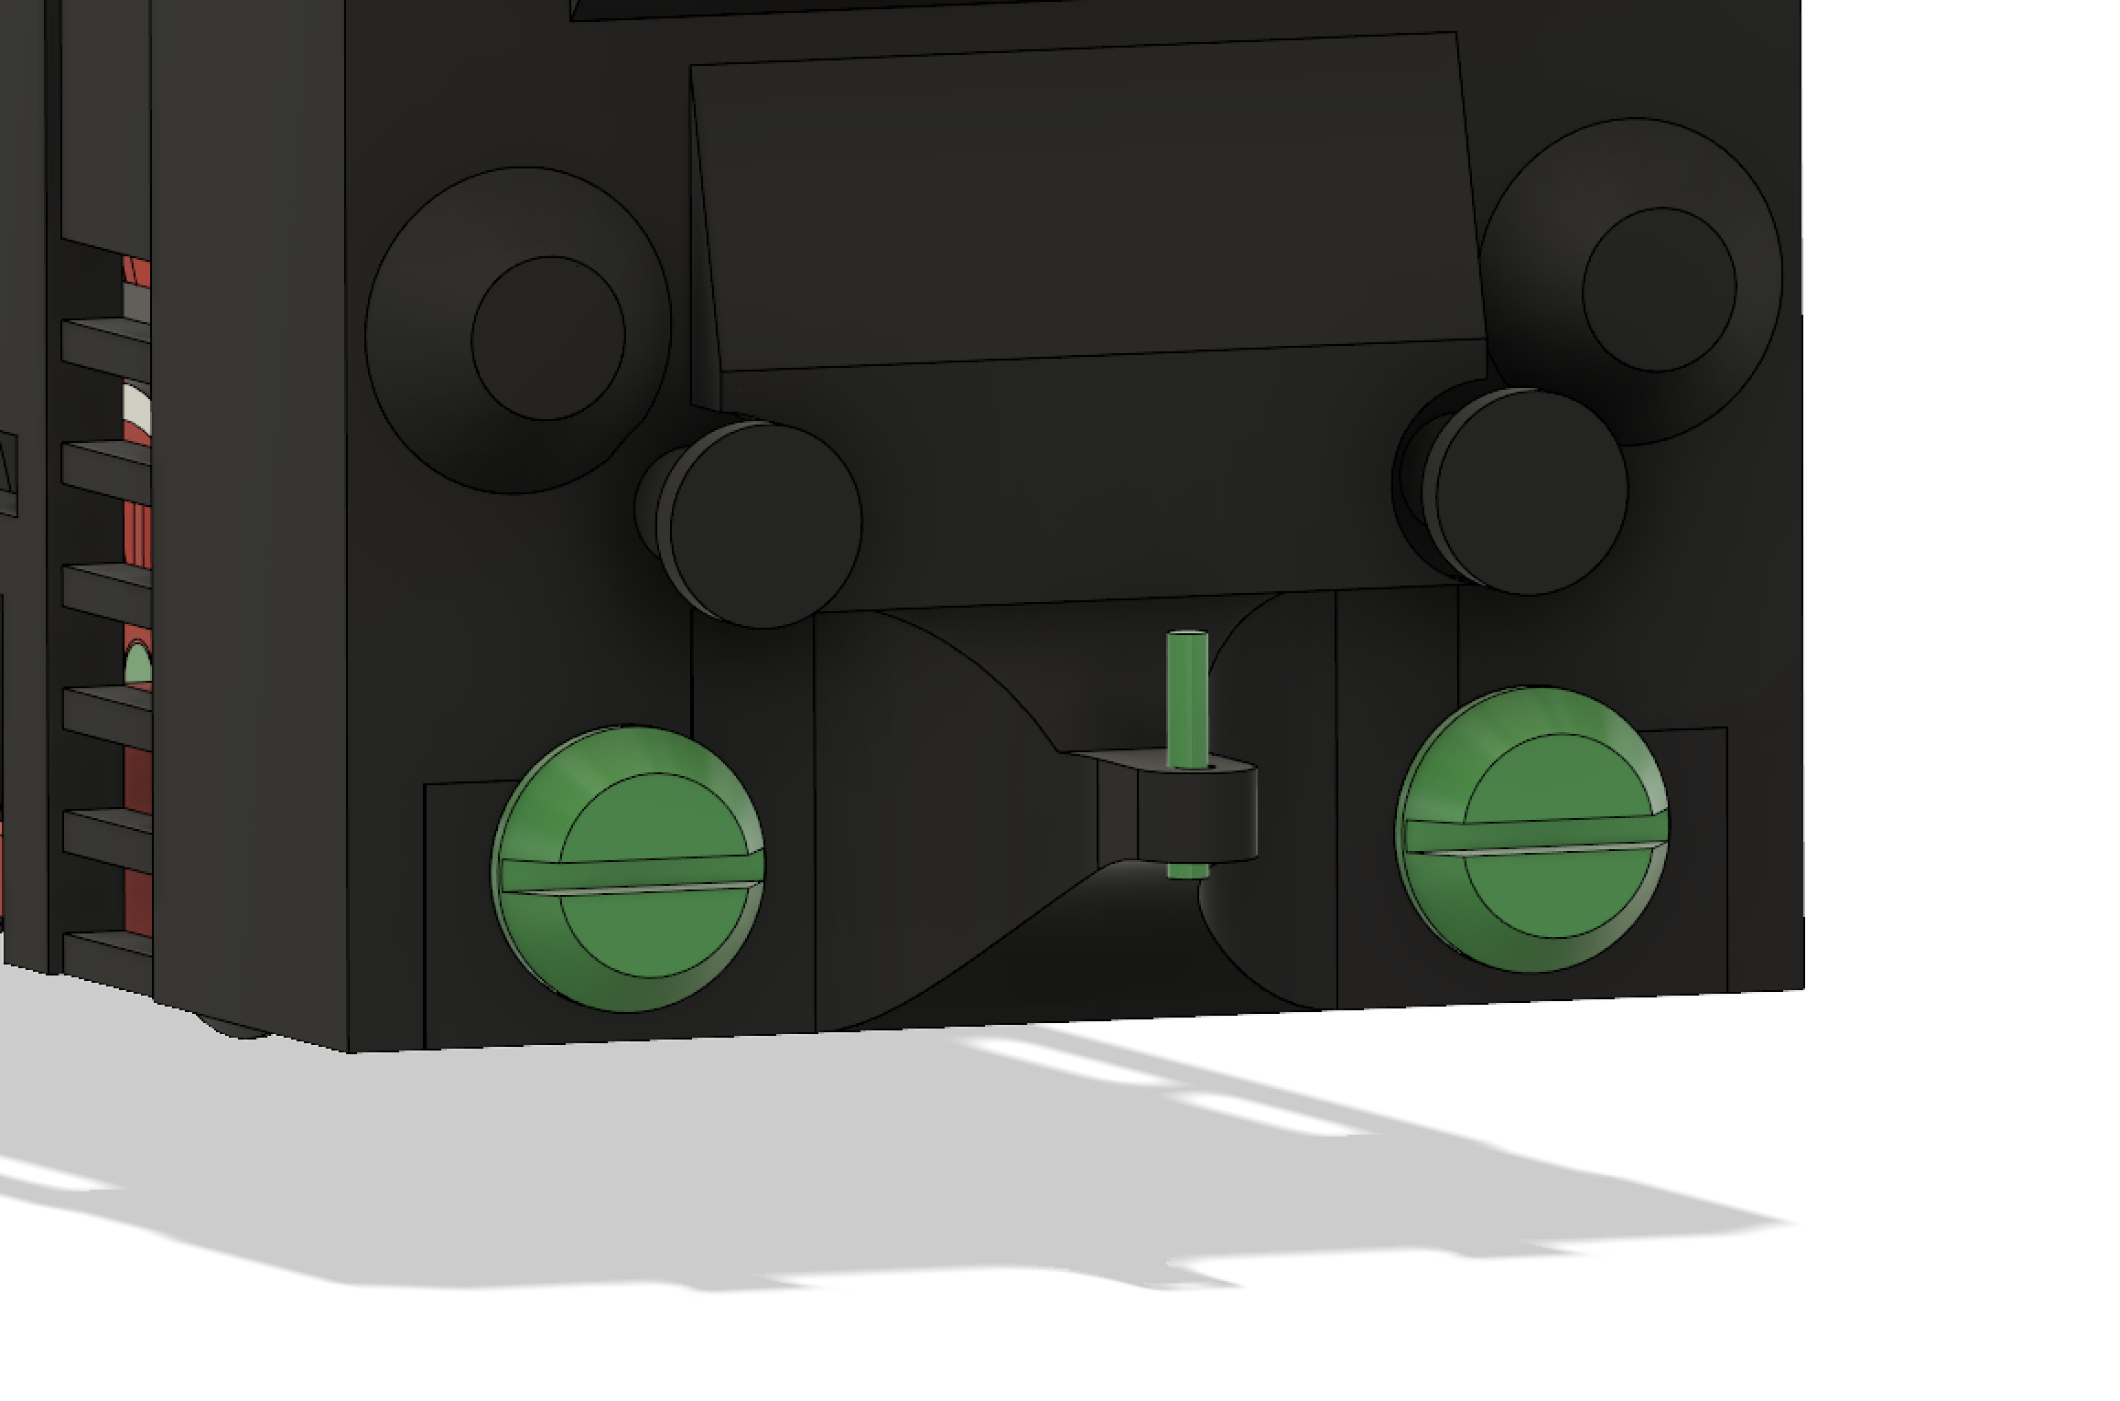
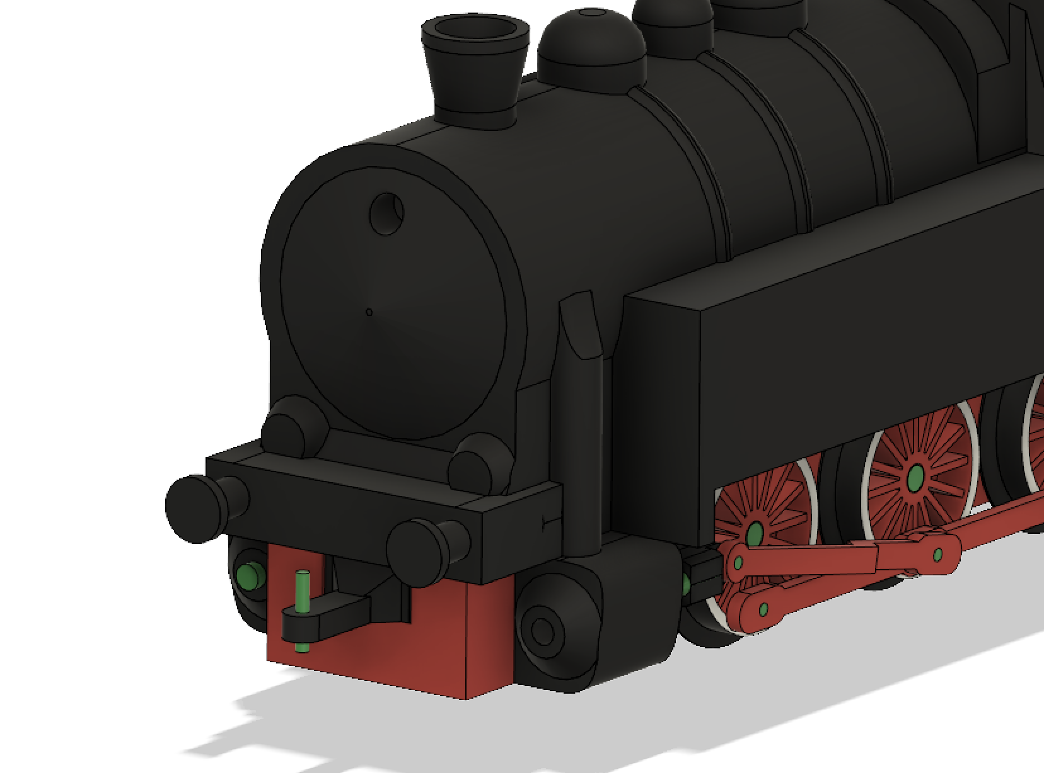

- Electronics:

I will add this step in next few days.

