How To Rig The Hobie 16
By: Josh Nale
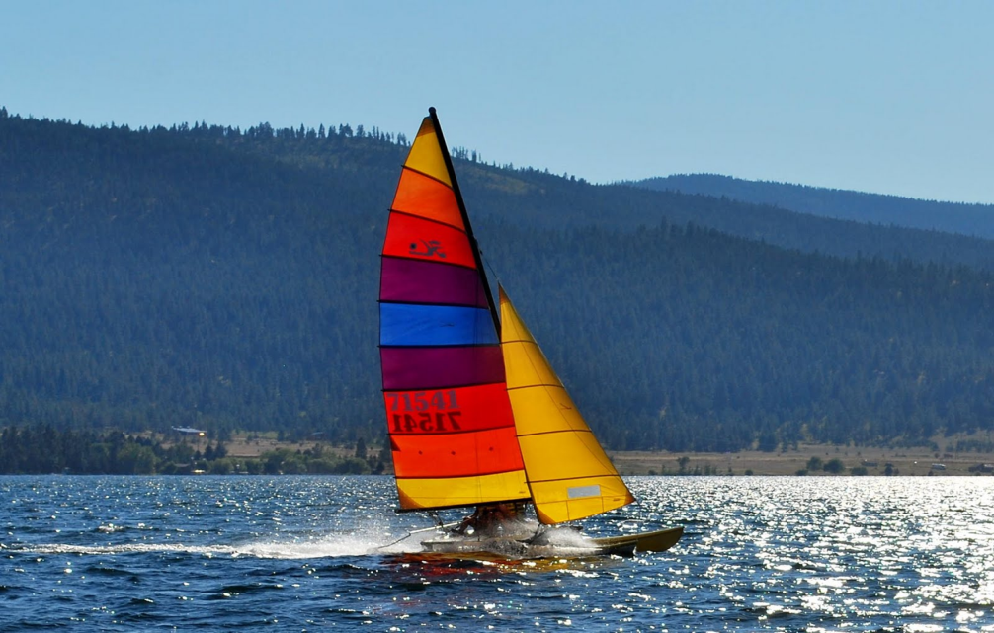
The Hobie 16
- The Hobie 16 is a catamaran sailboat created by the Hobie Cat company. It is one of the most successful sailing catamarans even sailboats ever created, there are 108,000 in existence, partly because they are so forgiving on the water and can adapt to any skill level but is big enough for 3 people to sail on
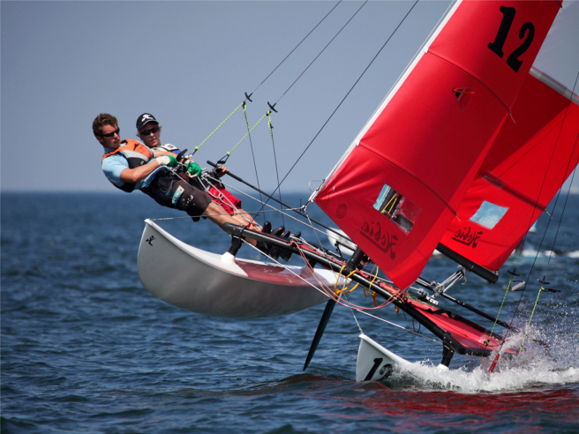

Attaching The Halyards
- The halyards are what raise and lower the sails so they need to be run through the block and tackle at the top and ¾ of the way down the mast.
- To run these lines you first need to the appropriate Block and Tackle and line(Blue for main sail and Red for the Jib sail)
- Once you have run the line through the block and tackle you need to cleat it off at the bottom of the mast(both ends of the line)
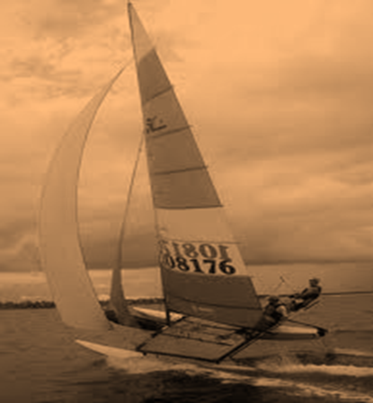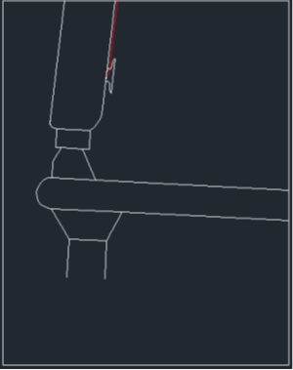
Putting Up The Mast
- First you have to attach the base of the mast to the mast step and make sure all of the stays are attached to the mast
- After you make sure all stays are attached to the mast you have to attach the two shrouds to the hulls
- Once you have connected the shrouds you can begin to raise the mast (this takes at least 2 people) when the mast is up as far as the shrouds will allow it, the person(s) holding the mast will apply pressure toward the forward of the boat until another person attaches the forestay to the bridle which is attached to the hulls.
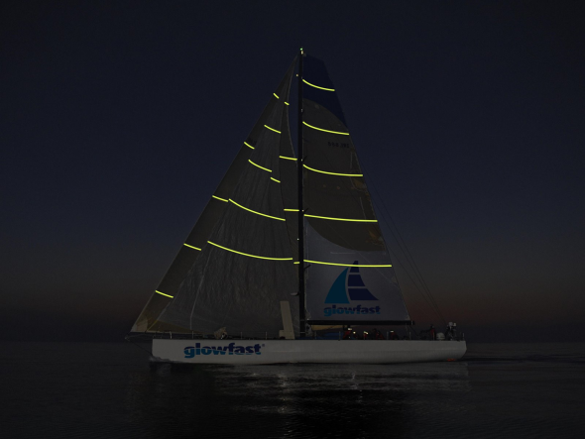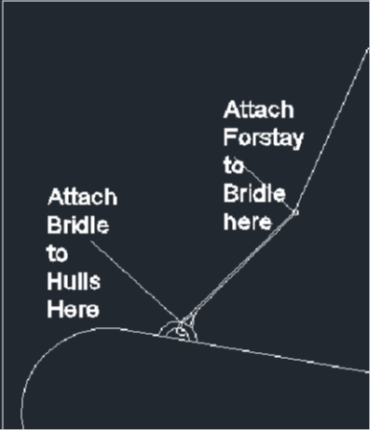
Attaching The Rudder/Tiller Assembly
- The rudder and tiller assembly is one of the most important pieces of equipment on the boat, it allows you to turn.
- Start by attaching the rudder/tiller assembly to the mounts on the back of each hull with the included bolts. After this is done the tiller should move the rudders from side to side effortlessly.
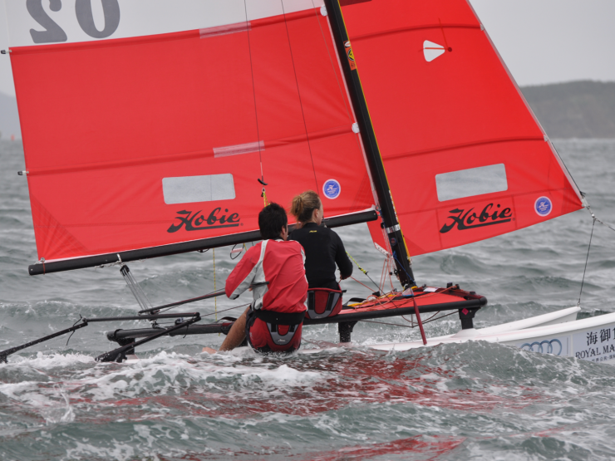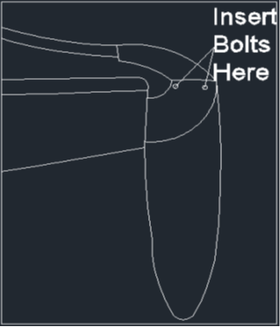
Attaching The Boom To The Mast
- The boom attaches into a groove that holds the sail to the mast. The groove widens about 2-3 ft from the mast step just enough to slip the boom slider into and down the groove.
- After the boom has been attached the downhaul needs to be attached by looping it through the boom slider and cleating it off lower on the mast.
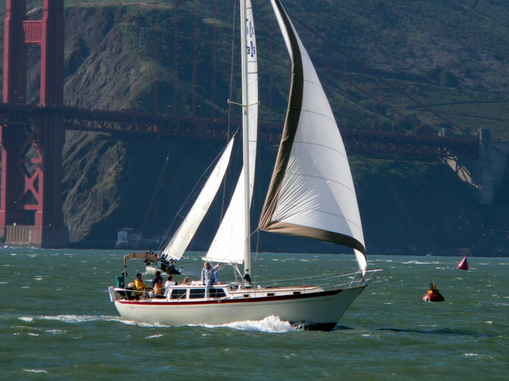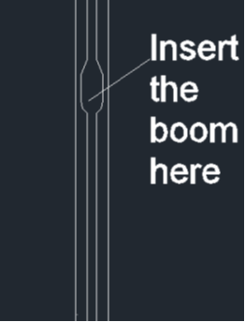
Hobie 16
- The Hobie 16 has been around since 1979 and sailing it is still one of the most adrenaline filled experiences you can find. WARNING: It is exciting yet can be dangerous so sail at your own risk and do not go out in heavy wind or bad weather unless you are an experienced and weathered sailor and know the limits of the boat.
