Why led driver why not just normal dc power supply !!!!

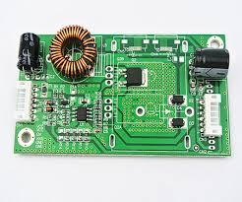

Led tv is the same as lcd tv the only difference is that lcd tv uses ccfl as backlight and inverter as driver board but led tv uses leds as backlight and boost driver board as driver

Leds use dc voltage to work , unlike normal leds the high power leds that used in tv works at 3vdc per led

The purpose of led driver board is to keep current constant in the led

If current increase in a led beyond predetremind level as recommended by the manufacture the led will just fail

Current can increase in a led if we operate the leds by forcing voltage higher than the needed forward voltage or by other factors

Many people will ask why a led wont work on just normal dc power supply

For example if one led needs 3vdc why it wont work on 3vdc power supply
why the leds in tv are driven by sophisticated driver board

lets exam this 3 circuits and see why only the last one will work and why the first two circuits wont work very well in driving leds

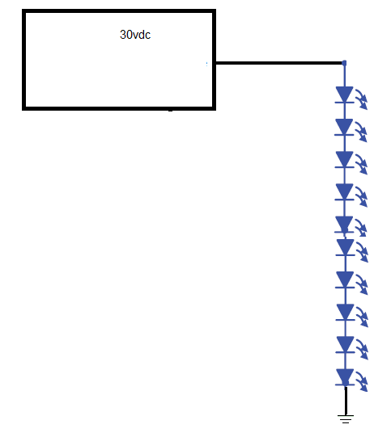

In this circuit 10 series leds are drivin by 30vdc power source so that each diode have 3vdc across it

It seems that every thing in order right!! However driving led is not that simple

The problem is that leds are tempreture sensitive if tempreture increase

Each led will now ask lower forward voltage and 3vdc now is just too high ..and remember as I mentioned before forcing higher forward voltage across a led and very high current will pass in it and it will eventually fail

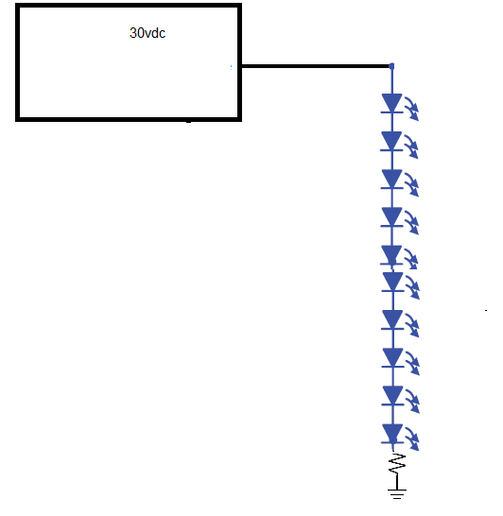

In this circuit a resistor was put in the serious diode string

A resistor will ensure that no manner how the voltage is high across the diode string each diode will only work at its desired forward voltage because the excess voltage will fall across the resistor

Still current cant stay constant with this method
When tempreture raise each diode will drop much much lower forward drop voltage and there will be high excess voltage across the resistor
Now the current in the string is clearly the same as the cureent in the resistor which now will be high due to fact that the voltage across it is high

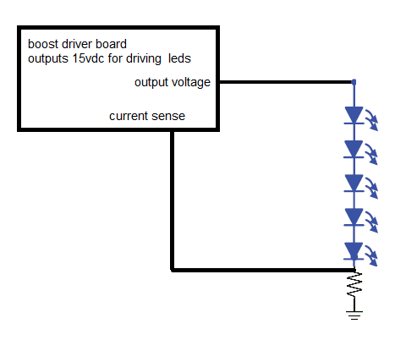
Now in this circuit each led consumes 3 volts if temperature increase each led will consume say 2.8 vdc 2.8*5=14vdc the entire string
Will consume 14vdc and one volt will drop over the resistor, the controller sense this one voltage drop ,and readjust its output voltage so that the current passing in this resistor and all diode string remains fixed as set by the designer..in the first circuit
Voltage regulation across the diode was not ok and thus current regulation is also not ok in the second circuit voltage regulation across the diode was good but current regulation was not good only in the third circuit where voltage and current across the diode were very good ..and remember that the ultimate goal of led driver board is to keep current constant in the led..
One more thing I forget to mention is why this board called a boost!!
It is called so because it output voltage much much higher than its input voltage and can easily take in 30 to 50vdc and put out some thing in the range of 100 to 170vdc to drive a very large string of leds

This report is part of electronics repair course contact me if you want to buy the ebook kingwaeel@yahoo.com the price of the ebook is just 15usd !! it is very good bargain when can see that the ebook
Contains smps information lcd led tv inverters power factor correction and many more other topics!

