BINARY TO 9’s COMPLEMENT

Aim: -
To design and verify four bits binary to 9’s complement converter circuit.
Hardware Requirement: -
- Equipment – Digital IC Trainer Kit
- Discrete Components – 74LS86 EX-OR gate
74LS04 NOT gate
74LS08 AND gate
Theory: -
The conversion from one code to another is common in digital systems. Sometimes the output of a system is used as the input to the other systems.
The availability of large variety of codes for the same discrete elements of information results in the use of different codes by different systems. A conversion circuit must be inserted between the two systems if each uses different codes for same information. Thus, code converter is a circuit that makes the two systems compatible even though each uses different binary codes. The bit combination assigned to binary code to 9’s complement. Since each code uses four bits to represent a decimal digit. There are four inputs and outputs. The inputs variable is designated as A, B, C, D and the output variables are W, X, Y, Z from the truth table, combinational circuit is designed. The Boolean functions are obtained from K-Map for each output variable.

Binary to 9’s Complement conversion: -
To obtain the 9’s complement of any number we have to subtract the number with (${10}^{n}$-1) where n=number of digits in a number.
Examples: - Consider the decimal number 8.
$(8_{10}$)=(${1000}_{2})$
Binary code: - 1000
9’s complement: - 0001

Truth Table: -
INPUT |  |  |  | OUTPUT
A | B | C | D | W | X | Y | Z
0 | 0 | 0 | 0 | 1 | 0 | 0 | 1
0 | 0 | 0 | 1 | 1 | 0 | 0 | 0
0 | 0 | 1 | 0 | 0 | 1 | 1 | 1
0 | 0 | 1 | 1 | 0 | 1 | 1 | 0
0 | 1 | 0 | 0 | 0 | 1 | 0 | 1
0 | 1 | 0 | 1 | 0 | 1 | 0 | 0
0 | 1 | 1 | 0 | 0 | 0 | 1 | 1
0 | 1 | 1 | 1 | 0 | 0 | 1 | 0
1 | 0 | 0 | 0 | 0 | 0 | 0 | 1
1 | 0 | 0 | 1 | 0 | 0 | 0 | 0

Boolean equation from truth table: -
W=A’B’C’D’+A’B’C’D=A’B’C’(D’+D) = A’B’C’
X=BC’+B’C
Y=C
Z=D’
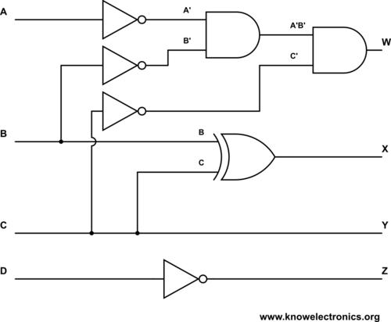

Procedure: -
- Using the derived expressions, implement binary to 9’s complement convertor using logic gates and verify its functional table.
- The inputs A, B, C, D are given at respective pins and outputs W, X, Y, Z are taken for all the 10 combinations of inputs.
Result: - Four bit binary to 9’s complement converter circuit has been designed and verified.

