Tool list

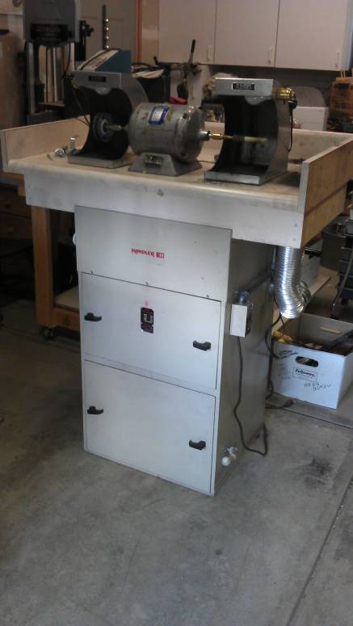

Handler dust collecting system, model 77 with Baldor 2 speed polisher model 353T and 2 lit hoods, with new filter bag. $1600.00 http://www.ottofrei.com/store/product.php?productid=5800&cat=0&page=1 http://www.ottofrei.com/store/product.php?productid=5822&cat=0&page=1

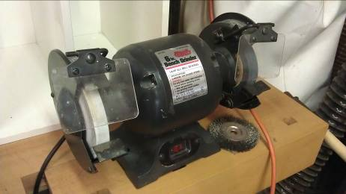
Collins 6” bench grinder LF137 $40.00

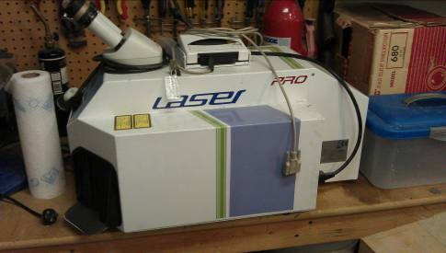
Laser Pro laser welder $9600.00 http://www.jewellerytool.com/DesktopLaserSpotWelding-xxs30j.html http://www.jewelerstoystore.com/Bench_Top_Pro_Laser_BD_60_p/l104.htm

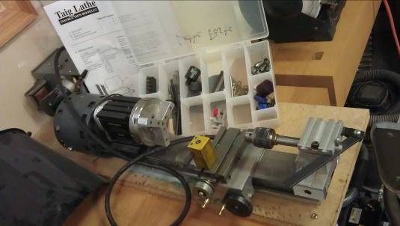
Taig Micro lathe 2 (model 4500) with accessories $350.00

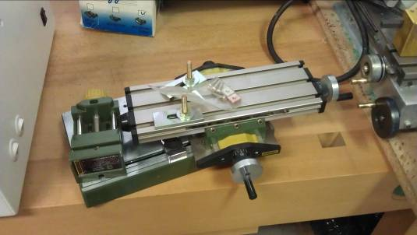
Proxxon benchtop clamps PX-219014 $45.00

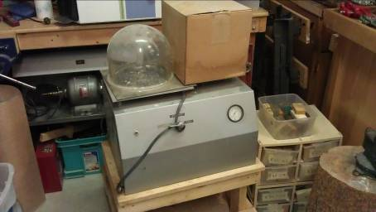
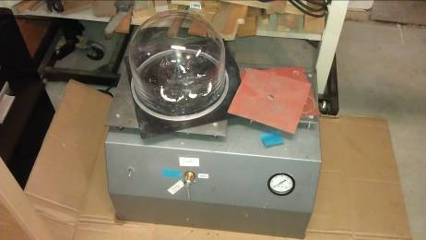
2 - Vacuum casters with pads and one with extra dome. $150.00 each

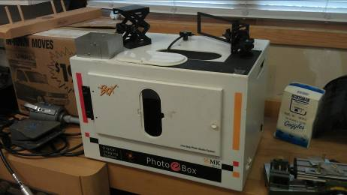
MK Photo Box – Digital Imaging System (no camera). $250.00
http://www.mkdigitaldirect.com/products/lighting-systems/mk-photo-ebox-plus.html

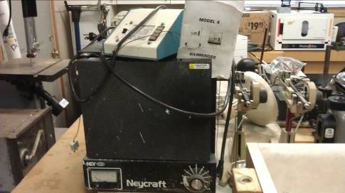
Neycraft Kiln JFF2000 and model 4 kilnminder $600.00 http://www.ottofrei.com/store/product.php?productid=9162&cat=1921&page=1

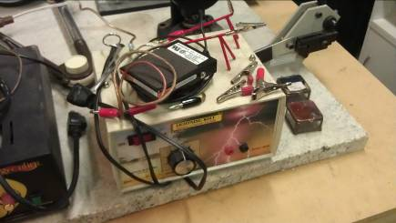
Gesswein Lightning bolt tack welder. $150.00 http://www.ottofrei.com/store/product.php?productid=20362&cat=1940&page=1

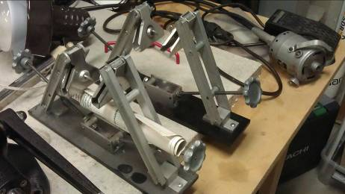
AC Mold Cutter x 2 $20.00 each
Kagan Ring Stretcher S-92 $230.00 http://www.ottofrei.com/store/product.php?productid=3087&cat=681&page=1

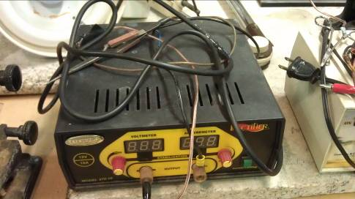
Rectifier – Model 270-10 $130.00 http://www.jemcousa.com/eshop/10Expand.asp?ProductCode=270-10

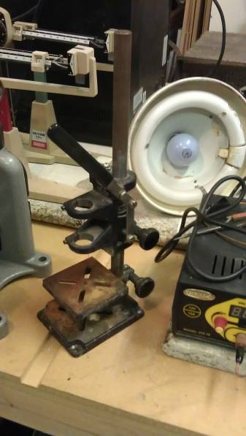
Foredom DP30 Drill press $45.00 http://www.mhcrafters.com/servlet/the-1686/Foredom-Drill-Press,-DP30/Detail

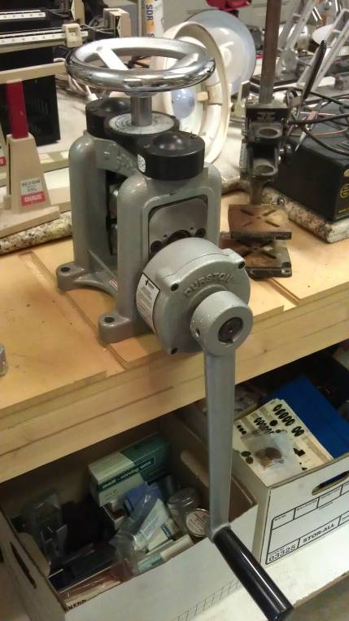
Durston Rolling Mill C-100 $600.00 http://www.ottofrei.com/store/product.php?productid=3319&cat=713&page=1

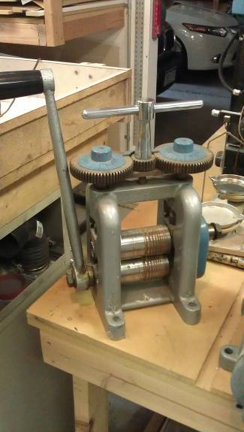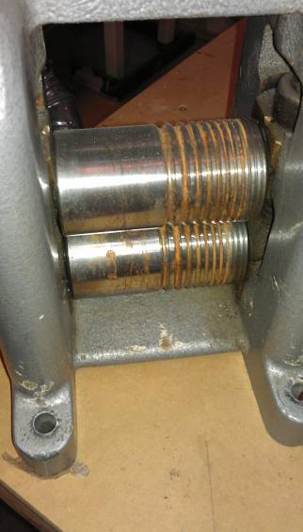
FC-1-10 rolling mill, rusty $150.00

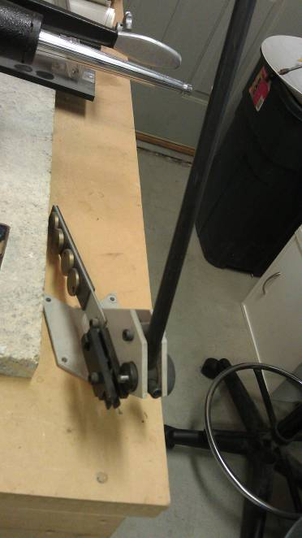
GRS Ring cutter $100.00 http://www.riogrande.com/MemberArea/ProductPage.aspx?assetname=118667&category|cat_120|332=Pliers+and+Cutters&category|cat_332|1318=Cutters+and+Shears&category|cat_1318|3038=Specialty+Cutters

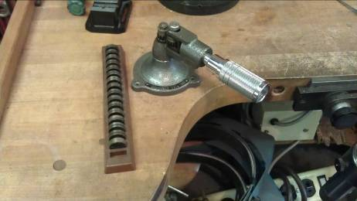
GFC Ring Stretcher with all blanks model 618. $35.00 http://www.jewelrysupply.com/jewelry_making_supply_tools/ring_stretcher_and_rolling_mills.html

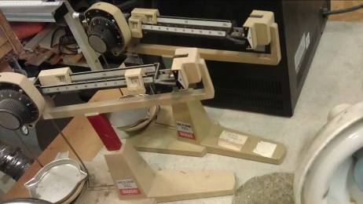
OHaus Dial-O-Gram 310g (2) $45.00 each http://www.scalesgalore.com/product/?product_id=4411

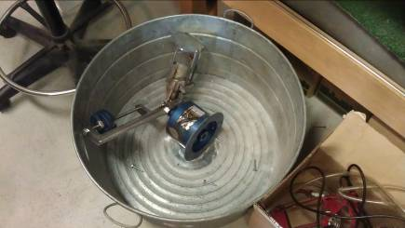
Vigor Centrifugal casting machine in tub. $50.00

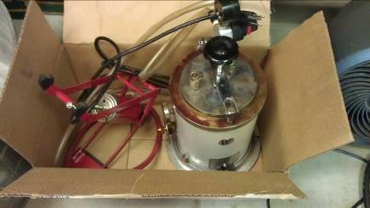
Wax injector model 0596, model A with foot pump, (tubing needs to be replaced) $225.00 http://cgi.ebay.ph/ws/eBayISAPI.dll?ViewItem&item=180685635655

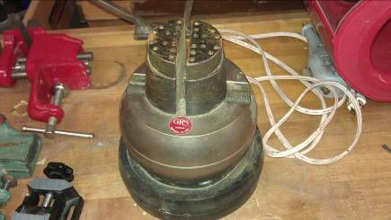
GRS engraving block, shows some rust but still operates. $225.00 http://www.grstools.com/workholding/vises-and-blocks/standard-block.html

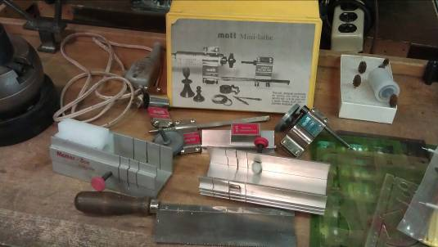
Matt mini lathe and cutting block with saw $75.00 http://www.amazon.com/MATT-MINI-LATHE-WITH-GAUGE/dp/B000HWHZR2

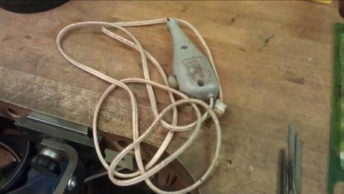
electric engraver $5.00

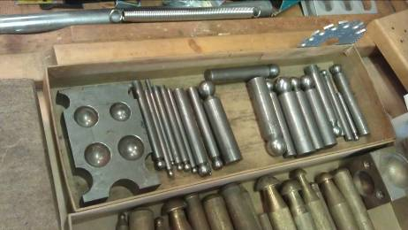
Steel dapping block $20.00

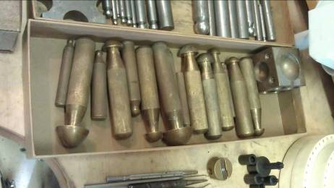
Brass dapping block $15.00

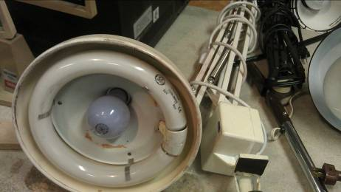
1 dual light bench lamp $25.00

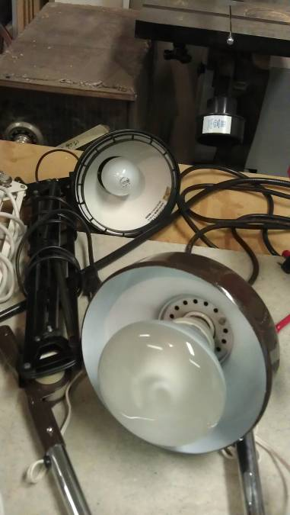
2 misc bench lamps $5.00 each

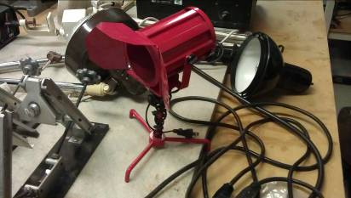
spot light $3.00

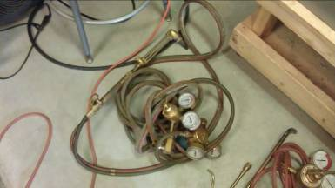
Oxy/Acetylene melting torch with gauges $50.00

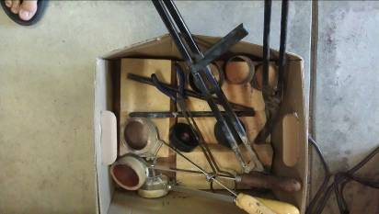
Box of misc casting tongs, crucibles and bricks $30.00

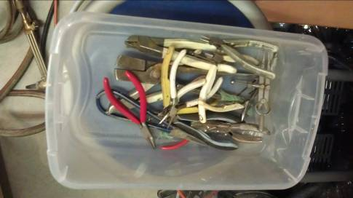
box of misc rusty pliers. $20.00

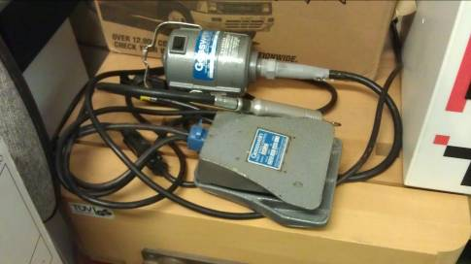
Gesswein model S flex shaft with #30 handpiece $75.00

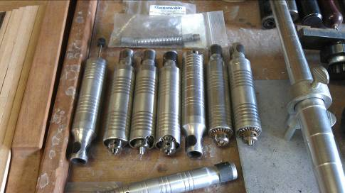
7 – number 30 hand pieces $20 each

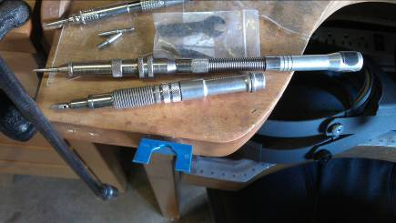
2 hammer hand pieces $100.00 each

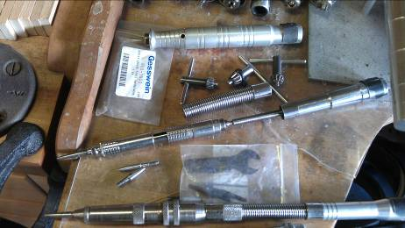
1 hammer hand piece in pieces and parts, $50.00

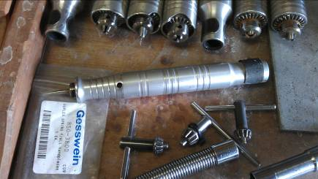
foredoom handpiece (no key) some rust $15.00

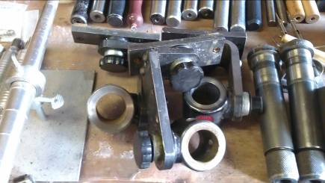
3 GRS benchmate ring clamp $25.00 each

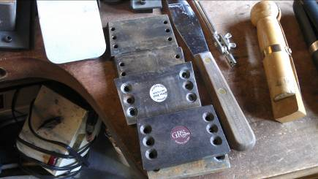
5 GRS mounting blocks $4.00 each

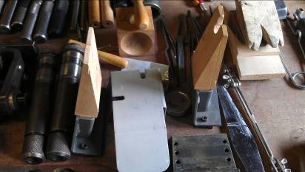
2 – GRS bench pins $8.00 each

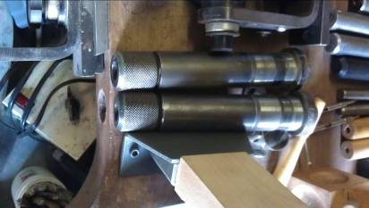
2 – bench mate ring clamps.

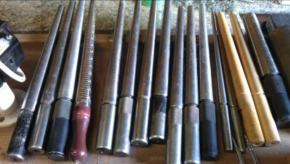
11 – ring mandrels $2.00 each

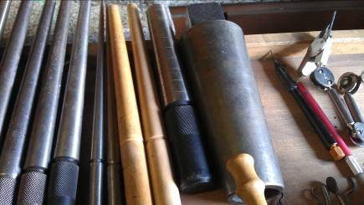
large finger mandrels $10.00
bracelet mandrel $15.00

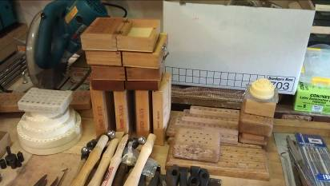
misc burr holders $2.00 each

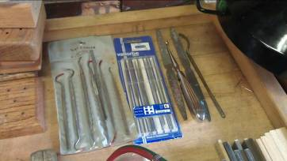
misc wax files $15.00 set

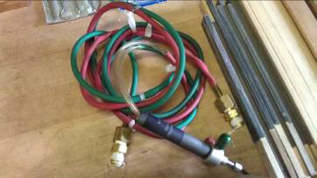
Mini Torch with home made fix it job. $15.00

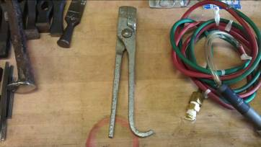
Draw Tongs $8.00

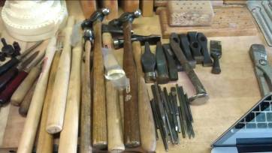
5+ chasing hammers, 7 chasing hammer heads, 4 hammer handles, 20+ chasing tools $50.00

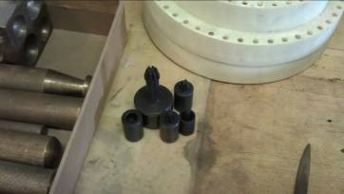
head building set $15.00

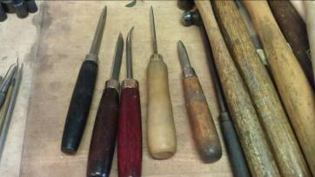
5 misc. burnishers

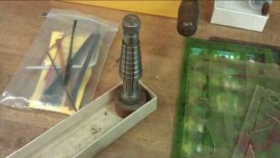
Old model ring stretcher $10.00

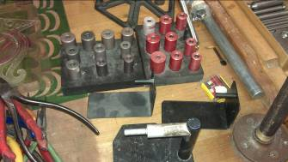
2 wax building sets $8.00 each

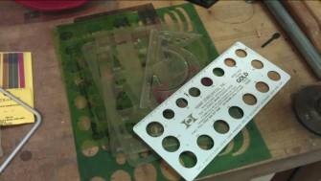
11 templates $5.00

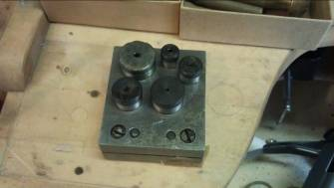
pepetools disc cutter set

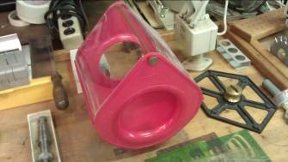
Matt gold collector $5.00

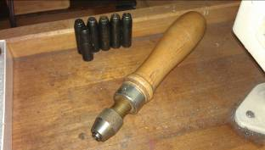
Handheld multiple collett set.

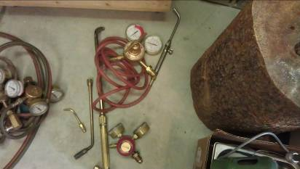
Misc torch and tips and gauges $25.00

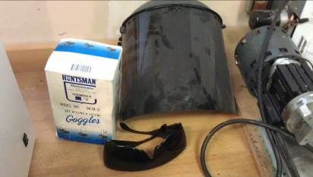
2 welding goggles and one hood $15.00

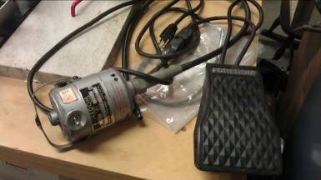

Foredom flex shaft, missing connector for hand piece. $20.00

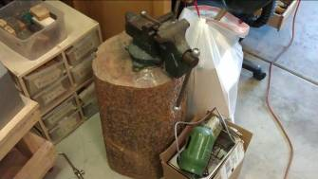
Stump and Vice $15.00

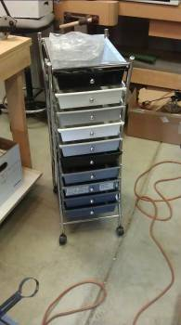
Storage drawer rack $15.00

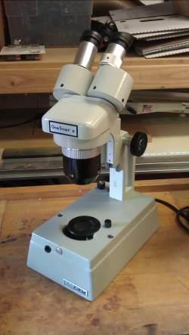
GIA Gemscope II - $350.00

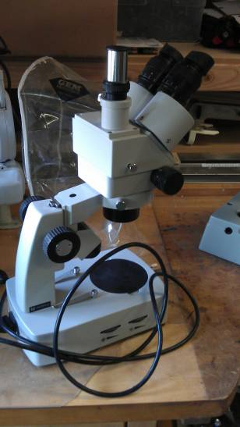
Chinese Gem scope. Top light works but back light does not $150.00

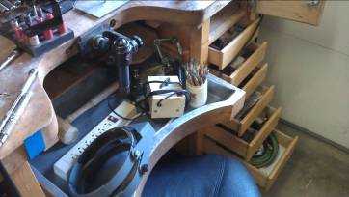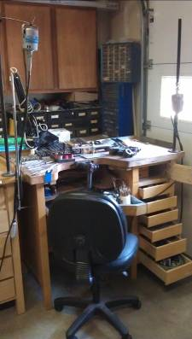

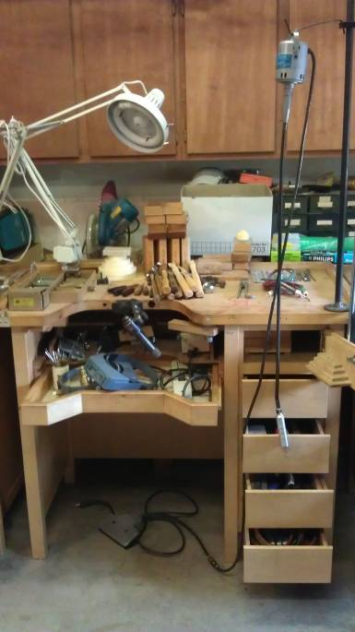

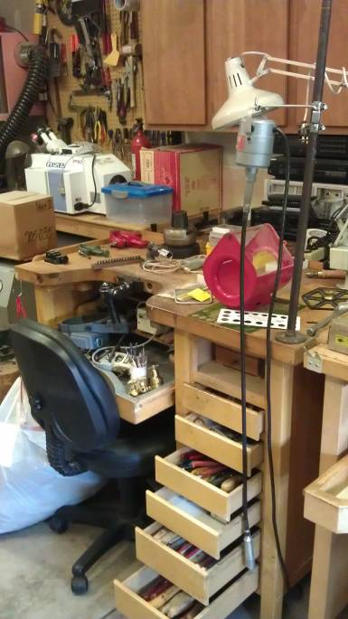

All items in drawers and bench pans are included. Only the light and Flexshafts are included on the tops of the benches!!!

3 otto frei benches http://www.ottofrei.com/store/home.php?cat=357 including everything listed below. $950.00 per bench.
- GRS hand piece
- Soldering block with tweezers
- GRS bench pin
- GRS soldering tweezers
- Power strip
- bench lamp
- office chair (only two available First come-first served)
- 2 magnifiers
- Wax pen with 4 tips
- burnisher
- knife
- one or two sharpening stones
- 2 mandrels
- copper tweezers
- bench brush
- leather mallet, rubber or wooden mallet
- saw frame
- 2 -flint lighters
- Ring clamp
- dividers
- exacto knife or two
- 3 large files
- 2 soldering picks
- 8 misc tweezers
- 15+ needle files
- file brush
- aluminum shellac pad
- 8+ pliers
- soldering mandrel
- steel block
- 10+ sanding sticks
- bur block
- hammer
- shears
- mini torch with extra tips and hoses (2 benches with oxy/acetylene gauges
- wolf wax carving set and extra carving tools
- extra bench pin and holder
- foredoom or Rio Grand motor with #30 hand piece and pedals

All benches are equally balanced for the most part and contain a minimum of the items listed above. There may be some variation on the exact number and type of tools. All benches are on a first come, first served basis.

