Plan of Procedures for a starfish
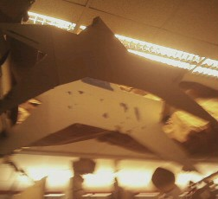

Supply list
ITEM | MATERIAL DESCRIPTION | QTY | SIZE | REMARKS - PART
S1 Cardboard | Durable | 2, 3 | 3 feet by 4 feet, 6in. by 4 in.
S2
S3
S4
S5
S6
S7
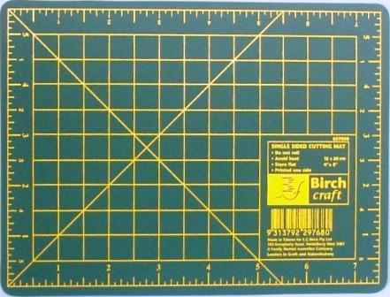
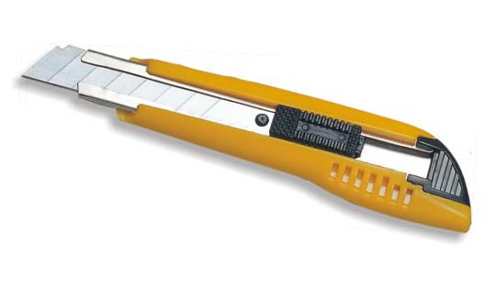
Tools and Equipment list
ITEM | TOOL | USE
TI | CUTTING MAT | Under cardboard to protect table
T2 | UTILITY KNIFE | Cutting the card board
T3 | RULER | Measuring sizes of pieces
T4 | PENCIIL | Sketching the costume pieces
T5
Steps for producing parts: (State tool with (T#) to use, include action, supply with (S#). Use words like measure, draw, scribe, cut, score, fold. – Delete this text.

Part P1:Steps for producing Front of Starfish
1. Put cutting mat (T1) down under the cardboard piece.
2. Draw, using a pencil (T4), a 3' by 4' starfish.
3.Cut ,using utility knife (T2), the first cardboard piece (S1) into a 3' by 4' starfish.
4. Cut , using utility knife (T2), three 6'' slots along the top left of the star fish and the upper parts of the left and right arm, see along picture.

Part P2:Steps for producing Front of Starfish
1. Put cutting mat (T1) down under the cardboard piece.
2. Draw, using a pencil (T4), a 3' by 4' starfish.
3.Cut ,using utility knife (T2), the first cardboard piece (S1) into a 3' by 4' starfish.
4. Cut , using utility knife (T2), three 6'' slots along the top left of the star fish and the upper parts of the left and right arm, see along picture.

Part P3: Steps for Producing Connectors
1. Draw, with a pencil (T4), a 6'' by 4'' rectangle.
1. Cut, with utility knife (T2), cardboard (S2) into a 6'' by 4'' rectangle
2. Do step two more times

PART LIST
ITEM | QTY | PART NAME
P1 Front | 1 | Front of Starfish
P2 Back | 1 | Back of Starfish
P3 Connector | 10 | Connectors

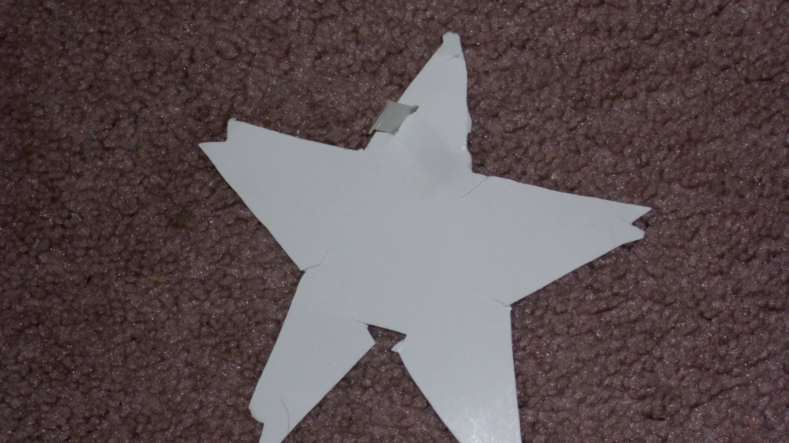
Steps to Assemble
1. Take front piece of starfish (P1) and the three connectors (P3).
2. Slot the three connectors (P3) into the 6'' marks on the front of the starfish (P1) piece.
3. Take the back of the starfish (P2) and slot the ends of the connectors (P3) ,that are already connected to the front of the starfish, into the 6'' slots on the back of the starfish piece.
You now have your starfish costume!

