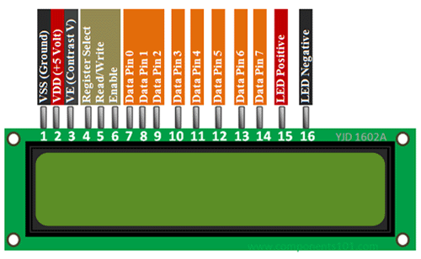

LCD | Arduino
Pin 1 VSS | Ground on breadboard
Pin 2 VDD | applied to positive breadboard rail
Pin 3 | Lead from potentiometer (variable);see circuit
Pin 4 | Connect to Arduino digital 12
Pin 5 | Connect to ground
Pin 6 (enable) | Connect to Arduino digital 11
Pin 7-10 | nothing
Pin 11 | Connect to Arduino digital pin 5
Pin 12 | Connect to Arduino digital pin 4
Pin 13 | Connect to Arduino digital pin 3
Pin 14 | Connect to Arduino digital pin 2
Pin 15 | Connect to a 220 ohm resistor and then to positive rail (5 volts)
Pin16 | Connect to ground

Piezo speaker connect positive lead to Arduino digital pin9
Piezo speaker connect negative lead to ground on digital side .
Connect Arduino 5 volts to positive breadboard and ground to negative breadboard

