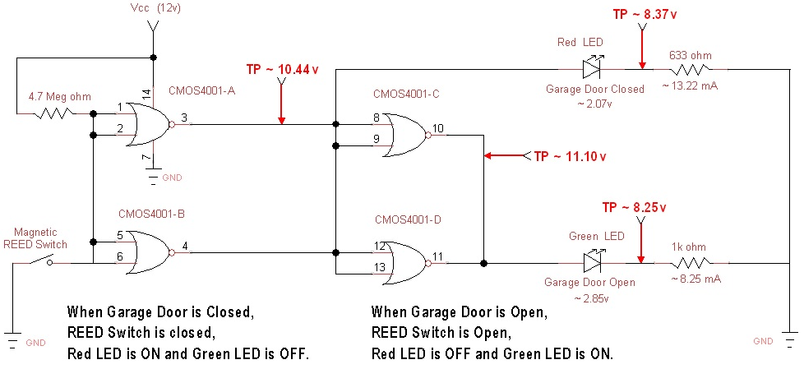

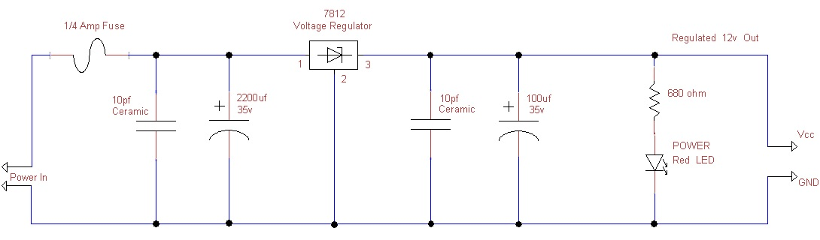

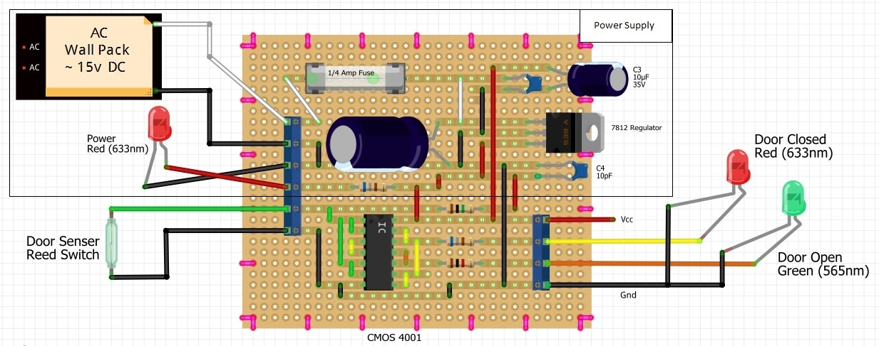
120v AC input
Wall Pack
~ 15v AC output

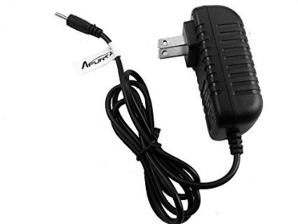
Re-purpose an old “Wall Power-Pack” to feed the Power Regulator CKT above. Make sure it has at least a 200 mA output rating. CKT above is designed for a 14v to 18v “AC output Wall Power-Pack”, to get the well regulated 12v DC power (heatsink not required), however the circuit above can be re-designed for a lower voltage rating like 5v (7805 Regulator) or 9v (7809 Regulator). Caution: a heatsink for the 78xx may be required depending on how much the 78xx Regulator needs to dissipate to get to the desired DC output voltage. You could also eliminate the Power Supply Ckt and switch to a Wall Pack that would supply 12 DC (or 5v or 9v).

NOTE: This CMOS Ckt may not be reliable with a 5v operating voltage?? The “Wall Power Pack” I used is labeled as a 12v AC output but measures closer to 15v AC, even under load.

NOTE: Some “Wall Packs” produce a DC output, others output an AC voltage!!!

NOTE: CMOS 4001 NOR Gates can typically Source or Sink about 10 to 15mA, thus the circuit above has the NOR Gates in parallel to make sure they can properly Source the currents required for LEDs. There are some LEDs that will light with much smaller currents, thus you may need to size your LED current limiting Resistors for your particular LEDs.

Simple design. The Magnet is mounted on the Garage Door in such a way that the Reed Switch (mounted on the Garage Door Frame) will only close (Red LED on) when the door is completely closed, else the Green LED is illuminated (indicating door is ajar or open). The Ckt board is mounted inside a two-gang Blue Plastic electrical box with a Blank two-gang cover plate. One hole is drilled in this cover plate to mount the Red “Power On” indicator LED (has two short wires that go back to the Ckt Board).

This two-gang Blue Plastic electrical box (with its Blank two-gang cover plate) is mounted, out of the way, on the wall above the Garbage Door. Three cables run to this two-gang Blue Plastic electrical box;
- The Power Cable from the “Wall Power-Pack” that is plugged into a 120v AC Wall Receptacle.
- A four wire 20 AWG cable (only used 3 wires) that runs (about 100’ in my case) to the Master Bedroom, where a one-gang Blue Plastic Electrical box (with a Blank one gang cover plate) is flush mounted in the Ceiling, where the LEDs can be easily viewed. Two holes are drilled in this one-gang cover plate to mount the Red LED and Green LED.
- A four wire 20 AWG cable (only used 2 wires) that runs (about 2’) to the Reed Switch mounted on the Garage Door frame, such that the magnet (mounted on the top edge of the Garage Door) will only engage… when the door is completely closed. Had to fashion a small 4”x3” piece of Laminated MDF to mount the magnet on the door, to get this process to work properly.

NOTE: I found that the Red LED (indicating the Garage Door is closed) was much more astatically pleasing when I was trying to sleep at night, whereas the Green LED just seemed to be more obtrusive. You may want to use a different color schema… each too their own!!!

