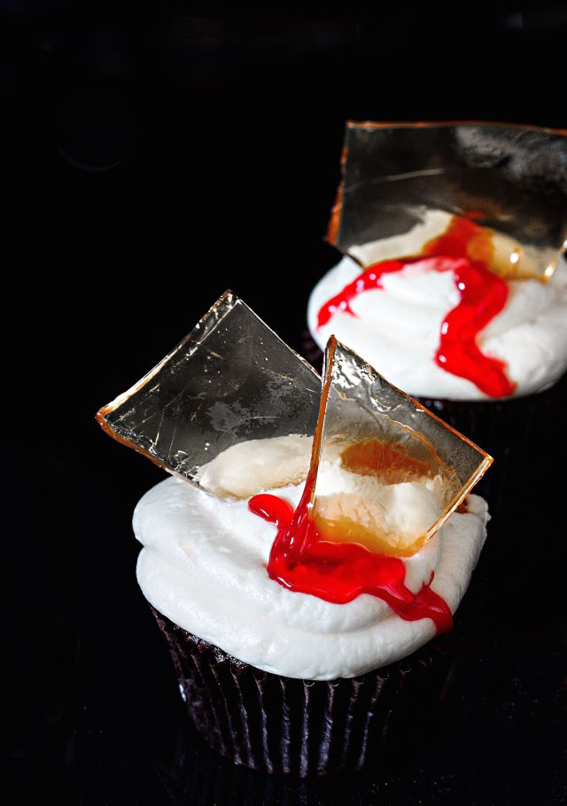

ngredients
For the Cupcakes

1 1/4 c. all-purpose flour
1/2 c. Unsweetened cocoa powder
1/4 c. malt powder
1 3/4 c. sugar
1 tsp. instant coffee
1 tsp. baking soda
1 tsp. baking powder
1 tsp. salt
2 large eggs
1 c. buttermilk
2/3 c. unsalted butter, melted
2 tsp. vanilla extract
2 c. Buttercream Frosting

For the Glass Candy

1/2 c. light corn syrup
3 c. sugar
1/4 tsp. cream of tartar
1 1/2 c. water
Red food coloring gel, for garnish

Directions

Preheat oven to 350 degrees F. Fill cupcake pan with liners; set aside.
Make cupcakes: In the bowl of a stand mixer fitted with a whisk attachment, mix together first eight ingredients. Add in next four ingredients and beat on medium until well combined, about 2 minutes. Pour in 3/4 cup boiling water and beat until well combined. Fill liners 2/3 of the way. Bake until toothpick inserted in the center comes out clean, 18 to 22 minutes. Remove from oven and transfer to a wire rack to cool completely before frosting.
Make glass candy: Line a baking sheet with foil. Place all ingredients in a small saucepan over medium-high heat and stir until mixture begins to boil. Stop boiling and clip candy thermometer to side of pan. Use a brush and water to wash down any crystals. Bring mixture to 300 degrees F, then pour hot candy mixture onto prepared pan. Set aside at least 1 hour, then break apart candy into shards.
Assemble: Pipe frosting onto cupcakes. Insert candy glass into center. Pipe red gel onto cupcakes for a blood drip finish.

