Neck tracker or neck mate

One motion band to connect with an application that reads your neck movements, checks your left and right movements, forward and backward, and tilting left and right. Will also include a pressure sensor to detect how much force you are using on strength workouts.

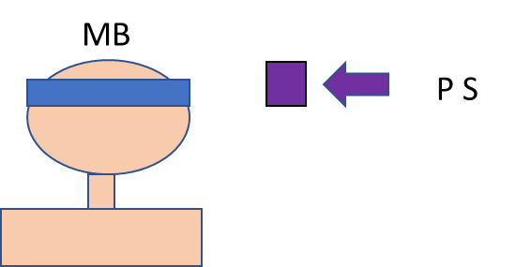
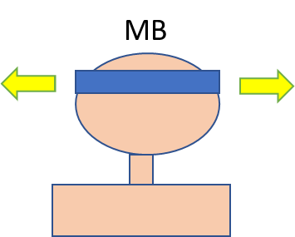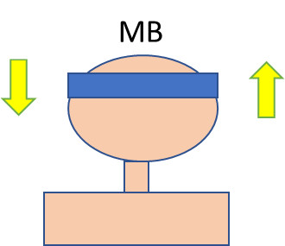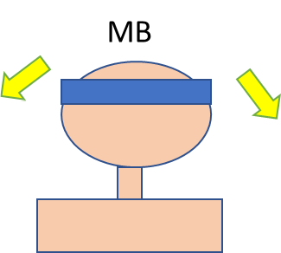

Moving your head left and right, forward and backwards, and tilting your head left to right will register on the application that will have a wireless connection with a tablet to show you how you did on each particular movement. It will log your movements and will track how you have improved, if there is no change or, the lack of improvement. There will also be a pressure sensor for strength workouts that will show the application how much force is being applied on the sensor if you have applied more force, has stayed the same, or are losing force applied to the sensor.

