LILI the sugar DISPENSER machine
ABSTRACT: Generally we are using sugar packets, so that sugar wastage and no of sugar packet waste will occur. we use two hands to tear the packets this is quite difficult for very busy person to do, to reduce this problem we are introducing “LILI” the Sugar Dispenser machine it will give more accurate sugar quantity and easy to use.

AIM: It can pour accurate sugar quantity so that it can minimize wastage of sugar. It is a Robust Design for the sugar dispenser machine.

EXPLANATION: LILI machine has made of fully wooden blocks, in this machine we are using screw conveyor to feed the sugar, this screw conveyor we done in the 3d printing. This machine is very easy to handle, we installed ultrasonic sensor. By showing your hand signal to nearby sensor (with in a 20 cm). By talking this signal, it will send to the Arduino then the Arduino will give the permission to the servomotor (continuous servomotor) to run.
STEP 1:
MATERIALS REQUIRED :
1. Arduino Uno
2. 360-degree servo motor
3. HC-SRO4 Ultrasonic Sensor
4. Wooden Blocks
5. Jumper wires
6.Bread board
7.Sugar Box
8.3D print screw conveyor
9.PVC pipe and T shape PVC
10.Drilling machine
11.Screws
12.Funnel
13.Powder adaptor charger

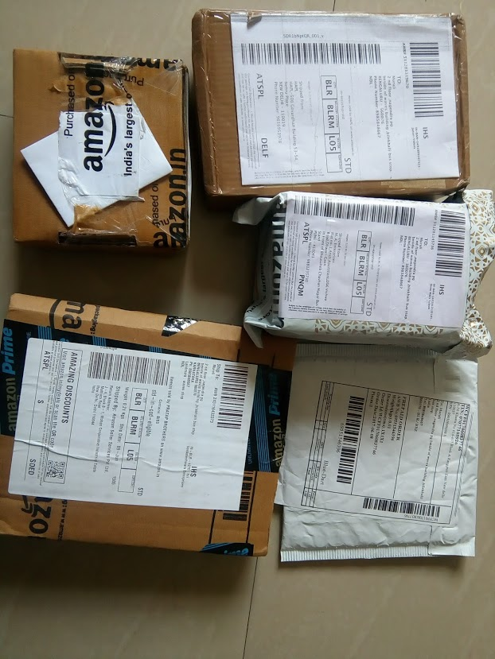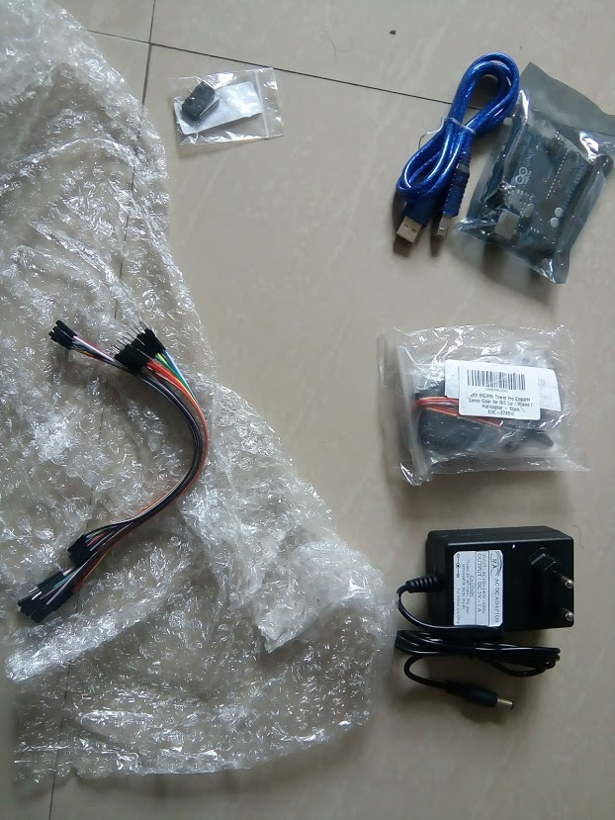STEP 2:
How It Works – Ultrasonic Sensor

It emits an ultrasound at 40 000 Hz which travels through the air and if there is an object or obstacle on its path It will bounce back to the module. Considering the travel time and the speed of the sound you can calculate the distance.
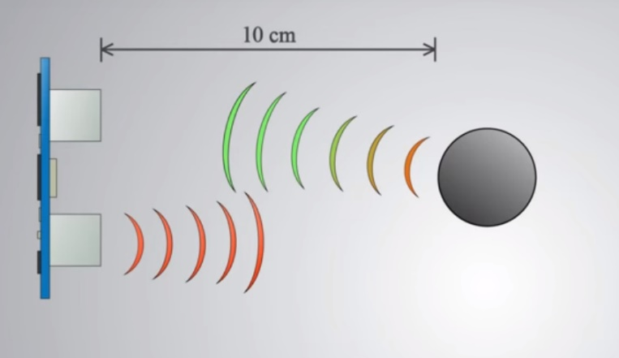
The HC-SR04 Ultrasonic Module has 4 pins, Ground, VCC, Trig and Echo. The Ground and the VCC pins of the module needs to be connected to the Ground and the 5 volts pins on the Arduino Board respectively and the trig and echo pins to any Digital I/O pin on the Arduino Board.In order to generate the ultrasound you need to set the Trig on a High State for 10 µs. That will send out an 8 cycle sonic burst which will travel at the speed sound and it will be received in the Echo pin. The Echo pin will output the time in microseconds the sound wave travelled.
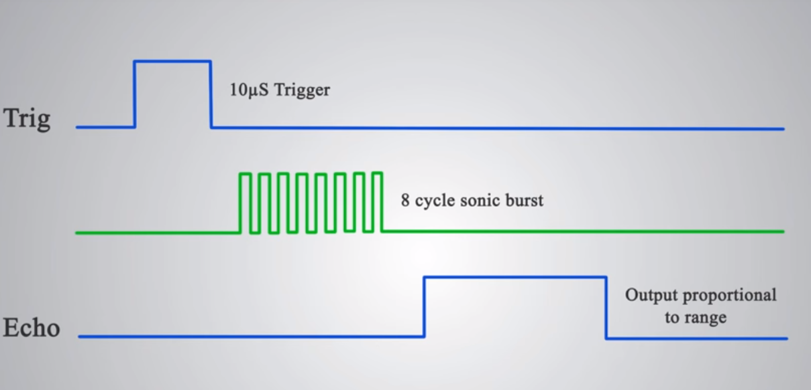
For example, if the object is 10 cm away from the sensor, and the speed of the sound is 340 m/s or 0.034 cm/µs the sound wave will need to travel about 294 u seconds. But what you will get from the Echo pin will be double that number because the sound wave needs to travel forward and bounce backward. So, in order to get the distance in cm we need to multiply the received travel time value from the echo pin by 0.034 and divide it by 2.
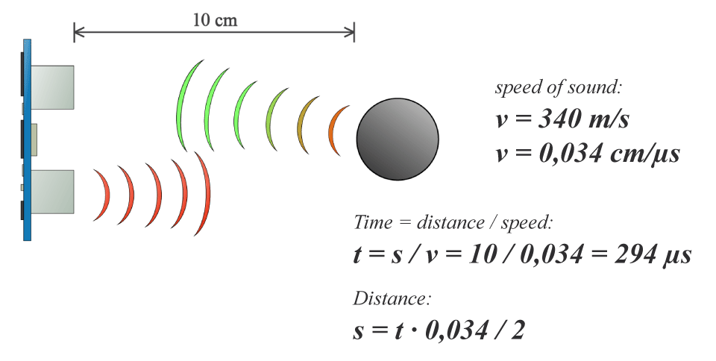
STEP 3:
As per the Above principle we should know how much distance you are giving the signal. According the signal you will develop the prototype model. In my case I will give the signal with in the 20-cm distance, now built the prototype model using wooden blocks.
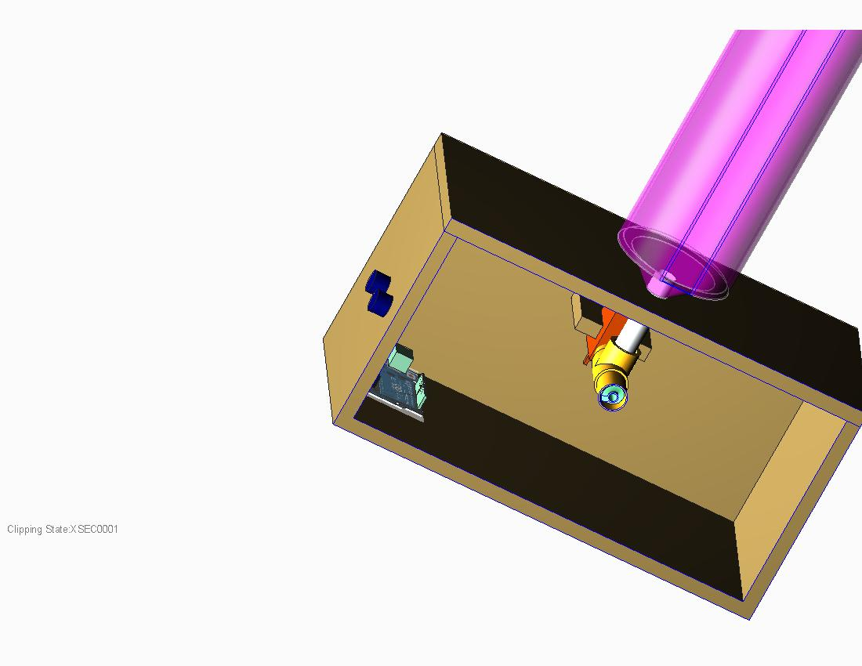
CAD MODEL as per this I developed model.
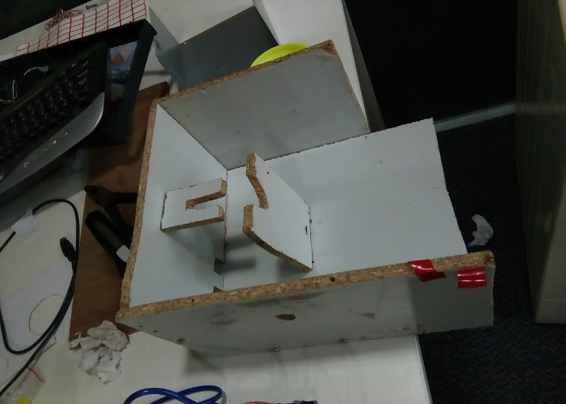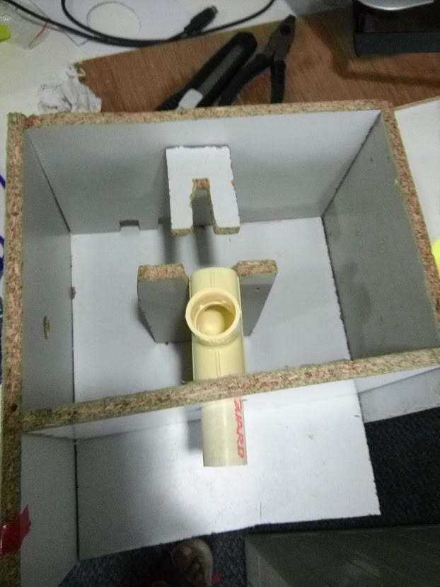

STEP 4:
Built screw conveyor 3D print part

1.Flow direction of screw conveyor is Right hand
2.anticlockwise (motor) direction
The above 2 conditions very imported for the sugar feeding or flow
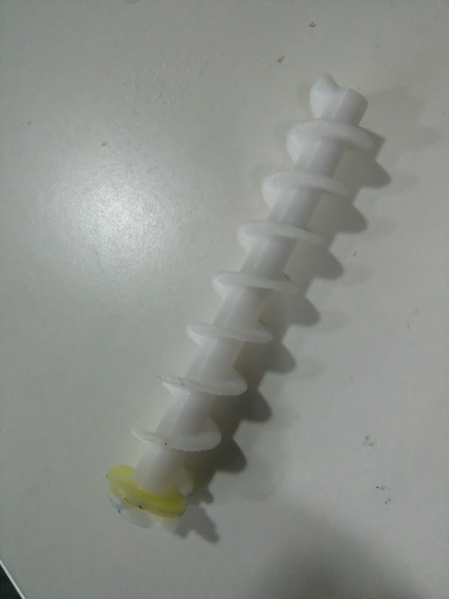
3d PRINT PART
STEP 5: Installation
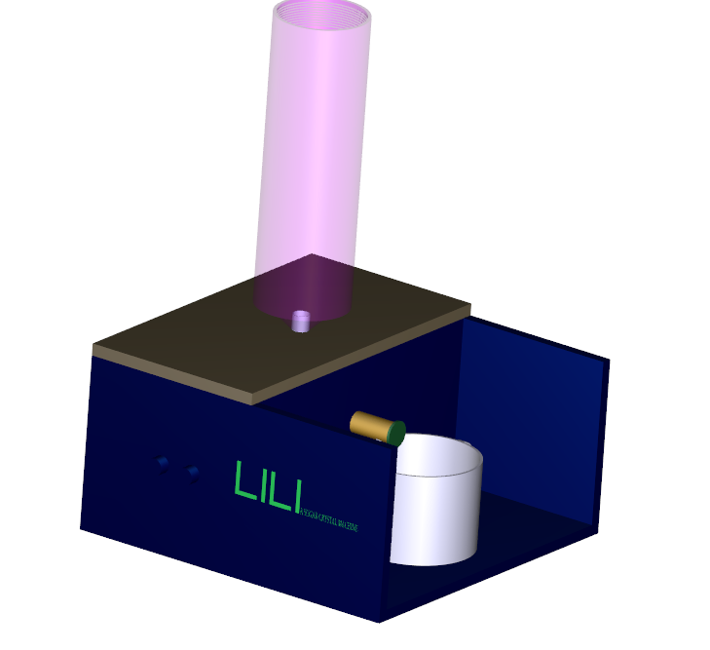
Fig: Wireframe of LILI machine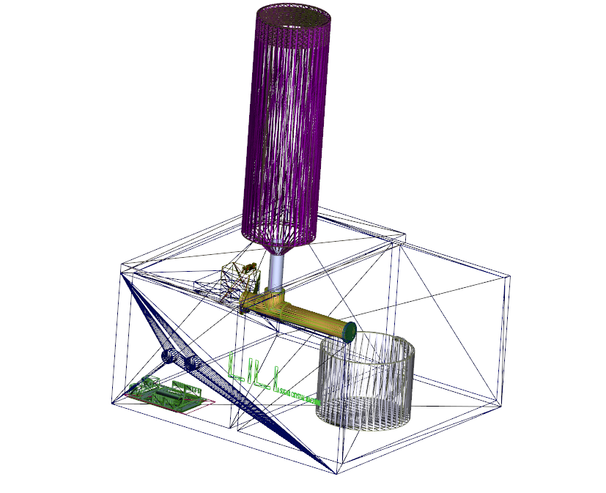
STEP 6: CONNECTIONS
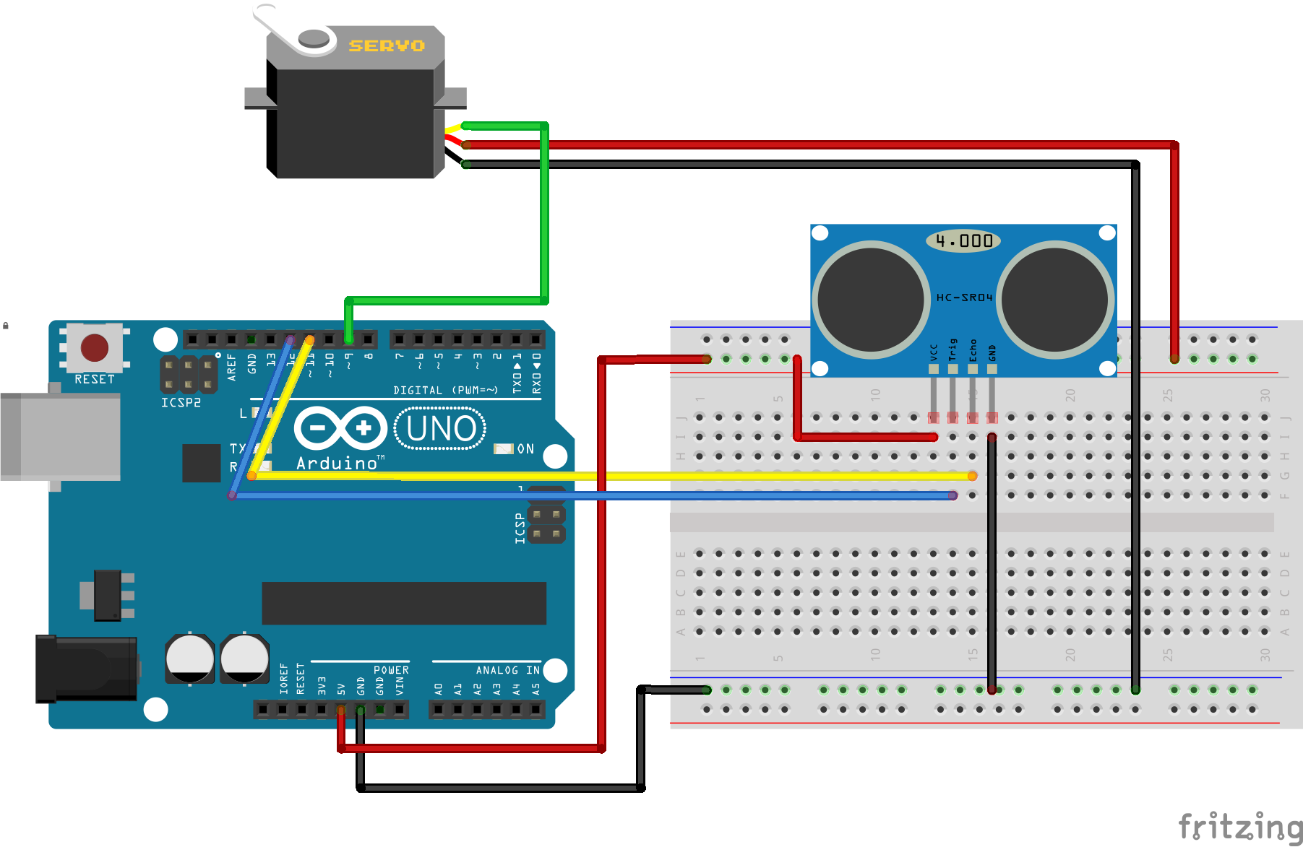
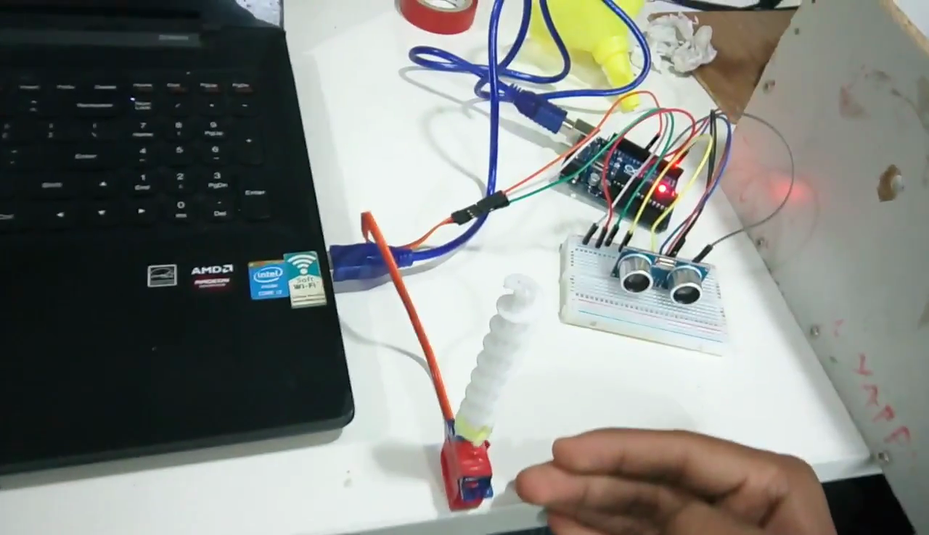

STEP 7: code
#include <Servo.h>
Servo myservo;// declare servo name type servo
const int trigpin = 12, echopin = 13 ;
int duration, distance;//declare variable for unltrasonic sensor

void setup() {
Serial.begin(9600);
pinMode(trigpin, OUTPUT);

pinMode(echopin, INPUT);
myservo.attach(9);// attach your servo
myservo.writeMicroseconds(1500);
// put your setup code here, to run once:

}

void loop() {

myservo.write(1500);// always set servo to 1500 to position stop position
//ultrasonic code
digitalWrite(trigpin,HIGH);
_delay_ms(3000);
digitalWrite(trigpin, LOW);

duration=pulseIn(echopin,HIGH);
distance=(duration/2)/29.1;

if(distance <=20)// if ultrasonic sensor detects an obstacle less than 20cm in 90 degree angle.
{
myservo.write(3500); //servo rotates at full speed to the right
delay(2500);

}
else
{
myservo.write(90);// else servo stays at 90 degree angle.
delay(10);

}
Serial.print("cm"); //print distance unit cm
Serial.println(distance);//distance

// put your main code here, to run repeatedly:
}

STEP 8: Final Output
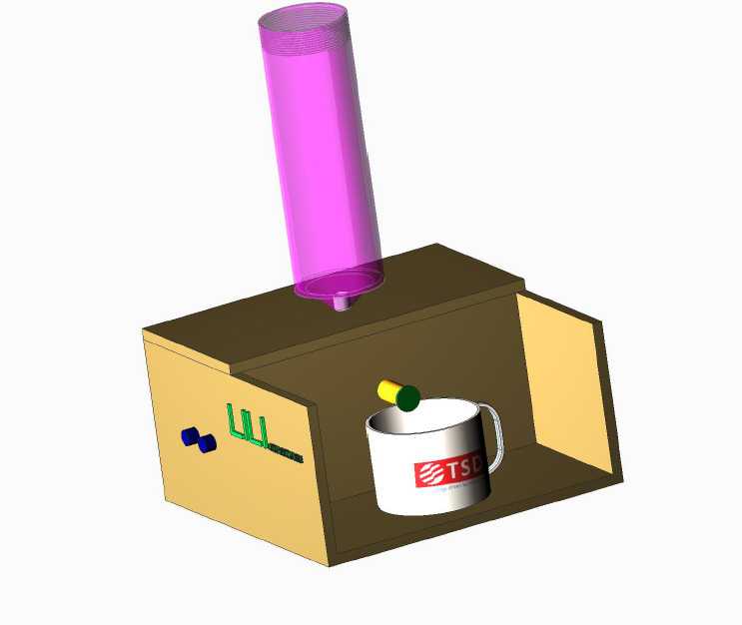

Output:
one time giving the signal you will get 8 grams of sugar
References:
1.www.instructables.com
2.ww.youtube.com
3.www.google.com

