User manual SafetyLock

Step1: go to the website
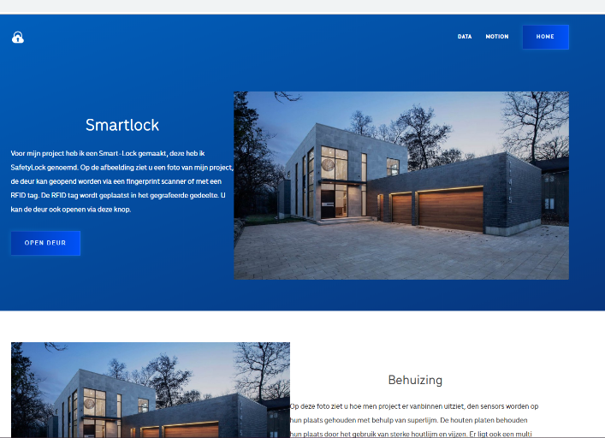
This is the page you will see when you enter the IP of your Raspberry Pi in a browser. On this page you can open the door with a button or go to the other pages to see the data out of the database

Step2: Opening the door
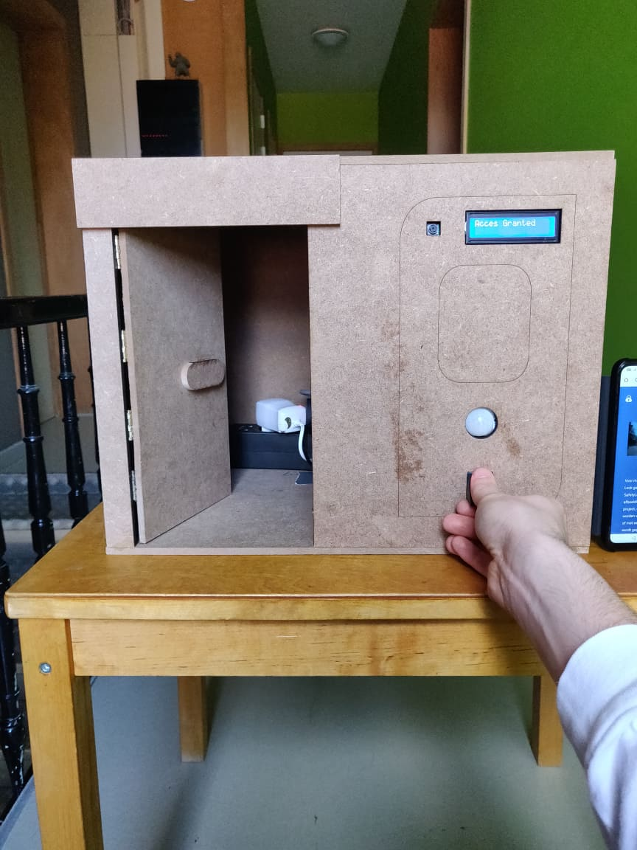
You can also open the door by using a registered RFID tag.

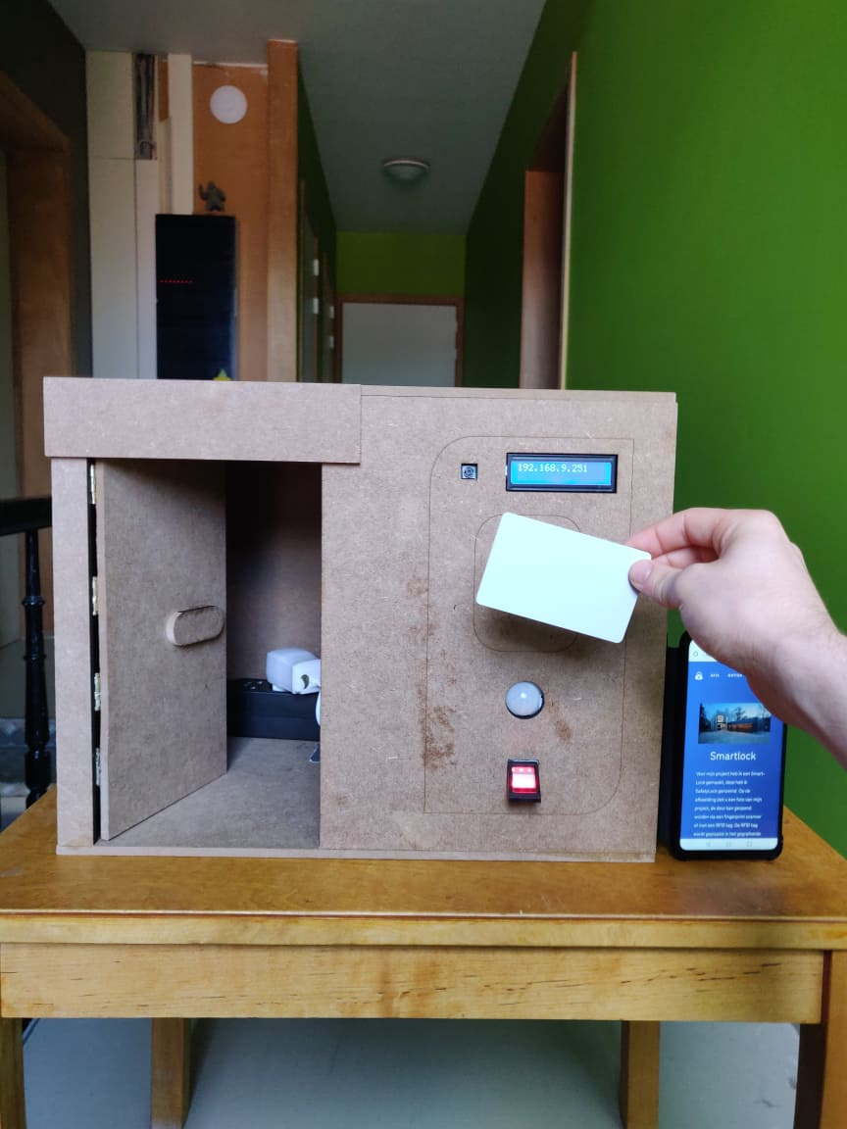
Or by using a finger that is registerd into the database.

