**Photopolymerization kinetics for 3D Printing**

Brian Adzima, 2016

This document outlines a mathematical model for photopolymerization in a DLP based printing process. The end model is pretty similar to [Dendekuri et al. (2008)](http://pubs.acs.org/doi/abs/10.1021/ma801219w), but accounts for the minimal bleaching of the UV absorber in most 3D printing resins. If one really wants to understand methods herein, the best approach would be to work thru the series of papers on polymerization process modeling published by Christopher Bowman at the University of Colorado in the 1990’s.

*Introduction: A basic mathematical model of a photopolymerization*

$PI →{2P}^{*}$ (1)

$P_{n}^{*}+M→P_{n+1}^{*}$ (2)

${2P}_{n}^{*}→P_{2n}$ (3)

A photopolymerization can be described in three steps. First in the *initiation* step a photoinitiator molecule, *PI*, absorbs a photon and forms two radicals, *P\**. Next, during the *propagation* step the radical undergoes a chain reaction where it repeatedly (tens to thousands of times) reacts with a monomer to form a radical that is one monomer unit bigger. Finally, in the *termination* stage the radical reacts with another radical, to form a non-reactive polymer.

Thermoplastics like ABS and PLA are very long linear molecules that are solids are room temperature, but can be heated and behave as liquids at higher temperatures. These polymers are prepared by the polymerization of monomers with only one reactive group. However, most materials used for SLA and DLP printing the monomers have more than one reactive site, so instead of forming long chains of molecules, in *thermoset*s the long chains formed are also connected thru the multiple reactive sites in the monomers. A consequence the whole 3D print is one very large single molecule that cannot melt. In most cases the transition between solid and liquid occurs when only 2 to 10% of the bonds are reacted, but the polymerization continues on until about 50-70% of the bonds are reacted. Consequently, throughout the process large changes in the material are occurring, which necessitates the complicated mathematical model described later on. Further complicating the situation, the polymerization process releases a lot of heat, which in a purely adiabatic situation can lead to temperatures rises of hundreds of degrees.

Mathematically, these three steps can be described by equations 4-6. The rate of initiation,

$\frac{ d\left[PI\right]}{dt}=-ϕI_{a}\left[PI\right]$ (4)

(or conversely the rate at which the photoinitiator is consumed) is proportional to the rate of photon absorption, *I­a* and the quantum yield, *φ*, (number of radicals generated per absorption event). The propagation rate,

$\frac{ d\left[M\right]}{dt}=-k_{p}\left[M\right][P^{*}]$ (5)

(or the rate at which the monomer is consumed) is proportional to the monomer concentration and the radical concentration. Finally, the termination rate is proportional to the

$\frac{ d\left[P^{*}\right]}{dt}=-k_{t}{[P^{*}]}^{2}$ (6)

the square of the radical concentration. The propagation and termination rate constants,1 *kp*, and *kt*, are dependent on the monomer, viscosity, temperature, radical size, pressure, and among other factors; however, for some purposes they can be treated as constant value.

By assuming that the rate of change in the radical concentration is small relative to the change in concentration of monomer, one can solve for the polymerization rate as,

$\frac{ d\left[M\right]}{dt}=-k_{p}\left[M\right]\sqrt{\frac{ϕI_{a}\left[PI\right]}{k_{t}}}$ (7)

*The temperature dependence of the polymerization rate*

The temperature dependence of most chemical reactions can be described by an Arrhenius relationship, where the rate constant, *k*

$k=ae^{\left(\frac{-E}{RT}\right)}$ (8)

has an exponential dependence on the temperature, *T.* The activation energy, *E*, and the pre-exponential factor, *a*, are well known for some monomers, allowing the dependence of a photopolym`erization to be estimated as,

$\frac{d\left[M\right]}{dt}\sim \frac{k_{p}}{k_{t}^{1/2}}\sim \frac{a_{p}}{\sqrt{a_{t}}}e^{\left(\frac{-E_{p}+1/2E_{t}}{RT}\right)}$ (9)

For the simplest of (meth)acrylates, methyl acrylate and methyl methacrylate, an approximately 30 °C temperature is required for the polymerization rate to double. Both models of the local the temperature during polymerization and the bulk rise in printing show a rise of less than 10 °C, corresponding to 30% increase in the polymerization rate.

**Table 1. Pre-exponential factors, activation energies, and ratio of rate constants at 35 °C and 25 °C for methyl acrylate and methyl methacrylate.**

|  |  |  |  |  |  |  |
| --- | --- | --- | --- | --- | --- | --- |
|  | **kp** | | **kt** | | **kp/kt0.5** | |
|  | MA | MMA | MA | MMA | MA | MMA |
| a(1/M/s) | 1.00E+08 | 8.70E+05 | 1.50E+00 | 1.10E-02 | 8.16E+07 | 8.30E+06 |
| E (kJ/mol) | 29.7 | 26.4 | 22.2 | 11.9 | 18.6 | 20.45 |
| k(35 °C) / k(25 °C) | 1.5 | 1.4 | 1.3 | 1.2 | 1.28 | 1.31 |

*Diffusion controlled rate constants*

Both the propagation and termination rate constants are strongly dependent on the viscosity of the media, which in turns depends significantly on the resin properties and extent of reaction. During the course of the polymerization the viscosity of the reaction mixture becomes infinitesimally large, as the entire sample becomes one large crosslinked molecule. As the viscosity increases and diverges, the mobility of the propagating polymer chains is greatly restricted, and the polymerization rate rapidly increases. This phenomenon, known as the Tromsdoff effect, occurs because the polymer radicals only slowly diffuse towards and terminate with another radical, while the small monomers can more easily diffuse towards the radical and react. Eventually, the diffusion of the monomers is also reduced, and the polymerization begins to slow. At this point the reaction continues through a *reaction-diffusion* mechanism where the radical diffuses only by reacting with an adjacent monomer.

One phenomenological approach to modeling this situation is the Doolittle model, which is based on the concept of *free volume* (*f*)*.* As the polymerization progresses the large amount of free volume between the relatively mobile species in in the liquid is reduced as the molecules polymerize and move closer together. The free volume has a linear dependence on the conversion (thru the volume fraction (φ)) and can be calculated from the coefficients of linear expansion, α, and the glass transition temperature, *Tg,.*

(10)

In this approach, the initial prorogation rate constant, *ki,0,* (which incorporates the above temperature dependence) is reduced by a second rate constant, *kr* , that is dependent on the free volume*,*

$k_{i}=\frac{k_{i,0}\left(T\right)}{1+k_{r,t}\left( f\right)}$ (11)

For the propagation rate constant,

$k_{r,p}=e^{β_{p}\left[\frac{1}{f}-\frac{1}{f_{c,p}}\right]}$ (12)

the constant, β, relates how, *kr*, increases near the critical free volume fraction for propagation, *fc,p*. The termination rate constant is similar, but also includes a term for reaction-diffusion with the parameter, R.

$k_{r,t}=\frac{1}{R\frac{k_{p}\left[M\right]}{k_{t,0}}+e^{-β_{t}\left[\frac{1}{f}-\frac{1}{f_{c,t}}\right]}}$ (13)

The downside of this approach is that the critical volume fractions and constants (β) must be fit from data. Figure 1 shows the value of *kp/kt0.5,* (which is proportional to the reaction rate) during the course of a polymerization. Additionally, the current model uses this same approach to account for the reduction in the diffusivity of oxygen as the polymerization progresses.



**Figure 1. Dependence of the rate constants on conversion.**

*Oxygen*

Radicals react with oxygen 105-6 times faster than with monomer. The resulting peroxy radicals, *POO*,* react with 103 times slower with monomer, and once formed effectively no longer participate in the polymerization.

$P^{*}+O_{2}→{POO}^{*}$ (14)

*Chain length dependence*

The propagation and termination rate constants also depend on the length of the polymer chain. This is due both to diffusion of the individual chains themselves (in addition to the macroscopic behavior described by equations 10-13), and the chemical properties of the radical depending on its distance from the initiator fragment. The former results in a decrease of approximately *0.5k*, and is typically ignored for all but the most rigorous mathematical treatments. In the latter effect, once the radical is separated from the initiator fragment by two or more monomers, any differences in chemical reactivity vanish. Most photopolymerization models only differentiate between the initiator fragment, and the polymer radical, as shown below in equations 15-21:

$PI →R^{*}$ (15)

$R^{*}+M→P^{*}$ (16)

$P_{n}^{*}+M→P_{n+1}^{*}$ (17)

${2P}_{n}^{*}→P_{2n}$ (18)

$P_{n}^{*}+R^{*}→P_{n}$ (19)

$R^{*}+O_{2}→{ROO}^{*}$ (20)

$P_{n}^{*}+O_{2}→{P_{n}OO}^{*}$ (21)

*Diffusion*

In the current model only the diffusivity of oxygen and heat is accounted for. Thus the light, mass, and thermal balances are five ODEs (22-26) are coupled with two PDEs (27 and 28):

0 $=-\frac{ d\left[I\right]}{dx}-Σ\left(εc\right)ln(10)\left[I\right]$ (22)

$\frac{ d\left[PI\right]}{dt}=-ϕ\frac{ε_{PI}}{Σ\left(εc\right)}\frac{dI}{dt}\left[PI\right]$ (23)

$\frac{ d\left[R*\right]}{dt}=+2ϕψ\frac{dI}{dt}\left[PI\right]-k_{i}\left[M\right]\left[R*\right]-k_{O_{2},1}\left[O_{2}\right]\left[R*\right]-k_{t,2}\left[P*\right]\left[R*\right]$ (24)

$\frac{ d\left[P*\right]}{dt}=+k_{i}\left[M\right]\left[R*\right]-k_{O_{2},2}\left[O_{2}\right]\left[P*\right]-{k_{t,1}{\left[P*\right]}^{2}-k}_{t,2}\left[P*\right]\left[R*\right]$ (25)

$\frac{ d\left[M\right]}{dt}=-k_{i}\left[M\right]\left[R*\right]-k_{p}\left[M\right]\left[P*\right]$ (26)

$\frac{ d\left[O_{2}\right]}{dt}=D_{O_{2}}\frac{ d^{2}\left[O_{2}\right]}{dt^{2}}-k_{O_{2},1}\left[O_{2}\right]\left[R*\right]-k_{O_{2},2}\left[O_{2}\right]\left[P*\right]$ (27)

$\frac{ d\left[T\right]}{dt}=\frac{k}{ρc_{p}}\frac{ d^{2}\left[T\right]}{dt^{2}}-\frac{ΔH}{ρc_{p}}\left(\frac{ d\left[M\right]}{dt}\right)$ (28)

Equation 22 is a restated version of the Beer-Lambert-Bouger law used for the derivation of (4); however it is formulated in a manner that allows more facile accounting of the light absorbed by the photoinitiator, and that absorbed by a non-reactive UV blocking dye.

*Solutions with MATLAB pdepe.m*

The Matlab function pdepe.m provides numerical solutions to systems of coupled parabolic PDEs in in up two dimensions. The limitation to one spatial dimension confines the solution to only areas far removed from the edges in the other two dimensions. The solution is represented by the z-vector in Figure 2.

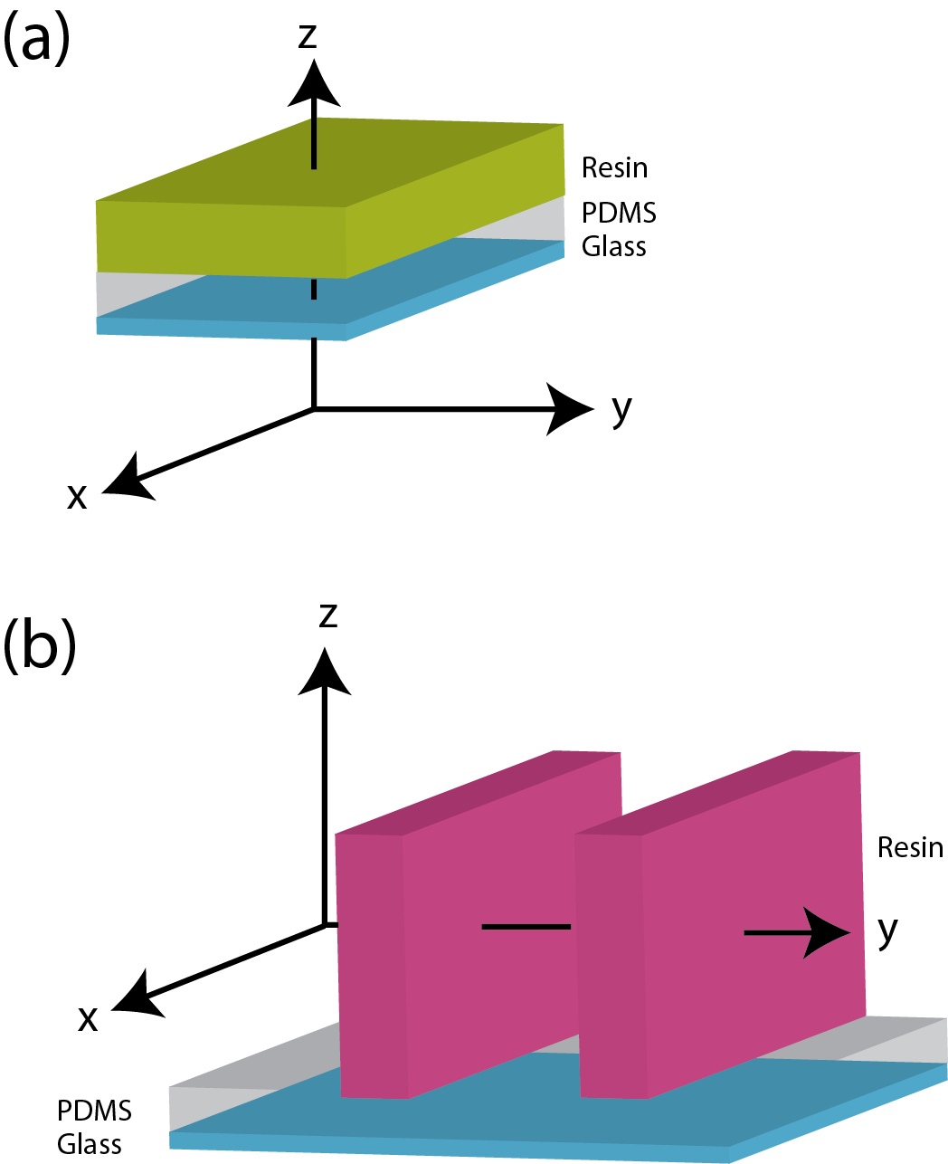

**Figure 2. The solutions given by pdepe.m apply only in a vector z (a) or y (b) thru blocks that are infinitely large in the orthogonal directions.**

*Z-axis model: layout and boundary conditions*

The current model consists of a 1mm layer of glass, a 3 mm layer of PDMS, and 2.5 mm layer of resin. No flux boundary conditions are used for the photoinitiator, monomer, and radical species. A no-flux boundary condition is used at the glass boundary for oxygen, and a constant concentration condition at the resin-air interface. A lumped heat transfer coefficient (Newtonian cooling) based on experimental results is applied at both the resin and glass boundaries.

*Model Results*

The models show the follow three results which really are not too surprising:

1. An inhibited layer, on the order of 10 microns thick exists between the forming layer and the PDMS window.
2. That layer slowly decreases in thickness over time as oxygen is depleted from the PDMS window which acts as a source.
3. The layer grows in thickness in a log linear fashion consistent with the working curve model.

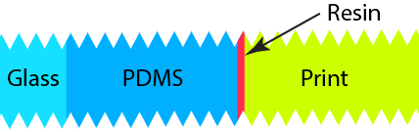

**PDMS**

**Resin**

**[Acrylate]**

Figure 3. Acrylate concentration as a function of time and distance for PR48 resins and 20 mW/cm2 illumination at 405 nm.



**PDMS**

**Resin**

**[O2]**

Figure 4. Oxygen concentration as a function of time and distance for PR48 resins and 20 mW/cm2 illumination at 405 nm.