My original sketch for my module looked like this. (right side)
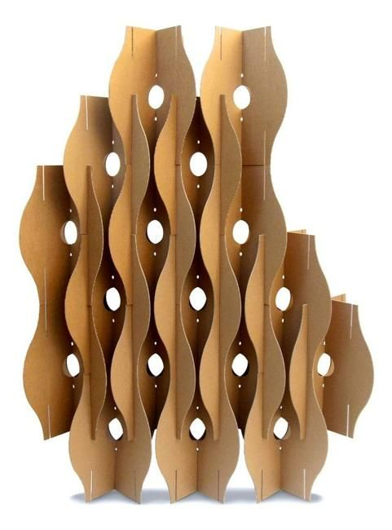
It took inspiration from this picture I found online. (left side)

Material List
- Chipboard (~.06 inches thick)
- Adobe Illustrator
- Vinyl (I used gold/silver/white)
- Tweezers and scissors
- Transfer tape (an adhesive to aid the application of vinyl)

Part 1- the Lasercut

- Open up Adobe Illustratior file attached
- Put the stroke to be .001 points.
- Configure settings for your specific lasercut printer
- Load the chipboard and print 10 cuts!
- The cuts should been cut all the way but if not take an exacto knife and cut it out.

Part 2- the Vinyl cut
- Use the same file to print out a cut on vinyl, 5 prints on one choice of color, 5 on another choice of color, and 10 on white.
- After you print it, use tweezers to take out the parts of vinyl that wouldn’t be needed for the design (the negative space).
- Use transfer tape to apply the colors on one side, and white on the other.

Part 3- putting it together
- Slide one side into another through the middle so that it creates a cross when you look at it at the bottom. Make sure you’re using the longer middle cuts so that they go through all the way!
- After you make 5 of the modules, put them together using the smaller cuts on the side. Imagine the two X’s are the modules as you view from the bottom, and the hash marks are the smaller cuts on the side. You would attach them as shown. Please overlook my hand-drawn level of finesse.
- Use this method to attach all 5 modules in any fashion you can imagine! Let your creativity flow for this step. I found that a longer project vertically accentuates the curves of the module, so I stacked it accordingly, but you can use your artistic judgement.

Taking it further:
The next step might be to find some way to hang this structure in the air, allowing it to rotate slowly and show off all the sides and angles that make the project interesting. Perhaps I will take the project home and attach some string to it and the ceiling and take some pictures!

