HOW TO MAKE AN “Arkansas Mudpie” dessert
While growing up, my grandma always told me the best thing about Arkansas is the mud-pies. That in fact is the truest statement I’ve heard especially considering this dessert. I am now going to show you how to make your very own mud pie.

Ingredients
-1 ¼ cups all purpose flour
- 10 tbs melted butter
- 1 cup finely chopped pecans
- 1 (8 oz) package of cream cheese
- 1 cup powdered sugar
- 1 tsp vanilla extract
- 2 (8 oz) containers of cool whip
- 1 (5.1 oz ) package of vanilla instant pudding
- 1 (5.9 oz) package of chocolate fudge instant pudding
- 3 cups of milk
- 1 ¼ cups of grated semi-sweet chocolate bar
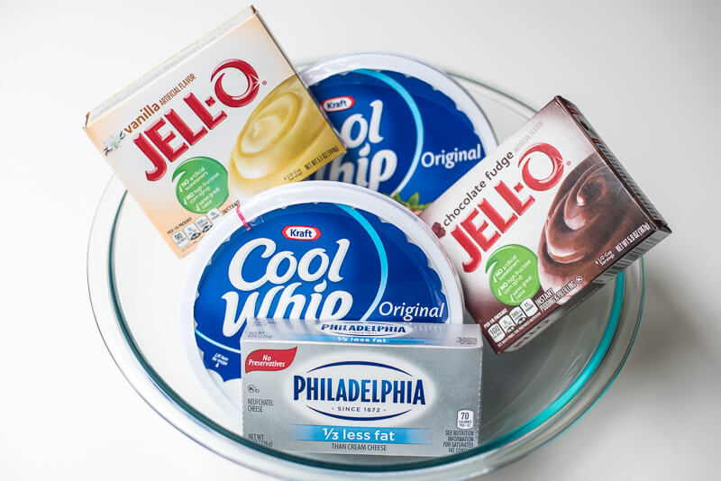
Now that we have listed all our ingredients, LETS GET TO COOKING!!!!

Instructions
- Preheat oven to 350 degrees- coat a 13in by 9 in baking dish with non stick cooking spray
- In a medium mixing bowl combine flour, melted butter, and chopped nuts until well combined and crumbly

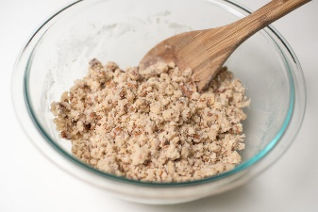
Press into a prepared baking dish and bake for 20-25 minutes until lightly golden brown around the edges- set aside to let cool
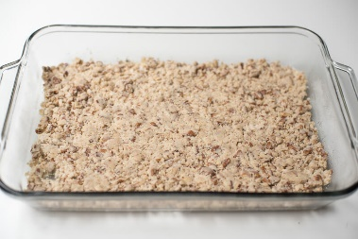
- In a separate bowl, use an electric mixer to beat cream cheese, powdered sugar, vanilla extract. Fold in one container of cool whip and stir to combine. Spread over cooled crust.
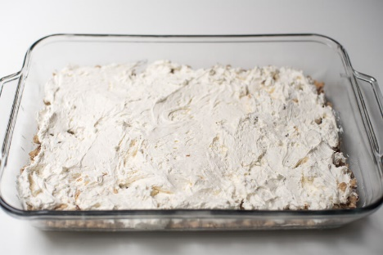
- In a clean bowl, whisk both the vanilla and chocolate pudding mix with 3 cups cold milk. Whisk together until smooth and thick and spread over cream cheese layer. Spread remaining container of cool whip over the top.
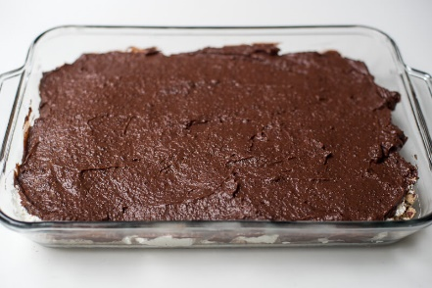
- Cover the dish and refrigerate for at least 2 hours- or over night. Garnish with grated chocolate.
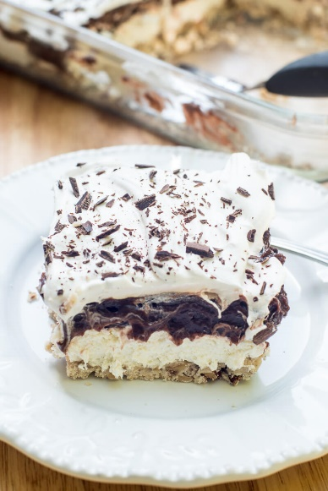
*WARNING: product contains nuts! If you have a nut allergy you may omit the pecans and proceed with the same instructions*

Now that you have learned to make your very own Arkansas Mud- Pie, I hope you enjoy them as much as me and my grandma! Thank you!

