Buzzer system for Quiz
Pre Project notes:
For a Quiz competition, the fastest and the correct answer will be considered, which is not possible manually for the quiz master to choose which player shall be given a chance, thus a Buzzer system is required to see the fastest player.

Aim: To make a Buzzer system for Quiz Competitions.

Apparatus: NI LabVIEW, Push Buttons, Jumper Chords, wires, NI MyRIO-1900, Buzzer.

Front Panel Screenshot in LabVIEW:
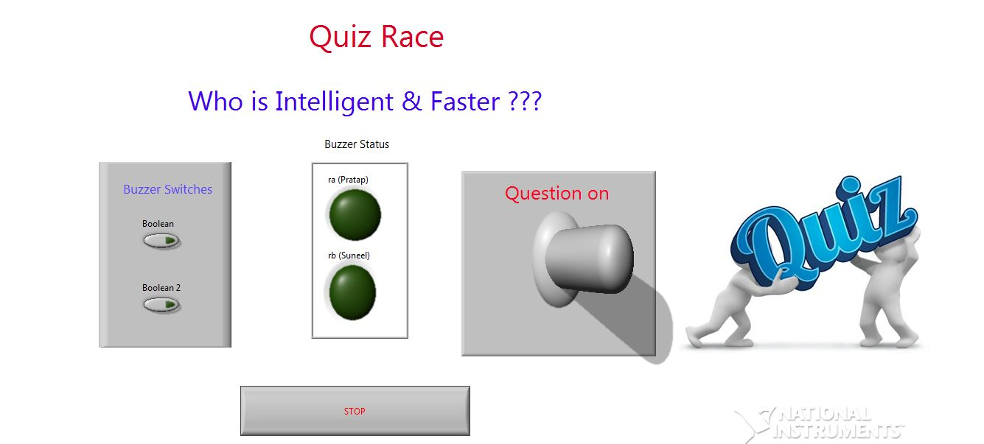
Figure (a):- Both the Buzzers off State

Logic of execution:
When the Buzzer Button is pressed, the Time is recorded, this happens for all the buzzers available and at the latter stage, when all the possible buzzers are pressed, the available times are compared to look for the smallest value and the corresponding buzzer will be switched on.

LabVIEW Block Diagram screenshot in LabVIEW:
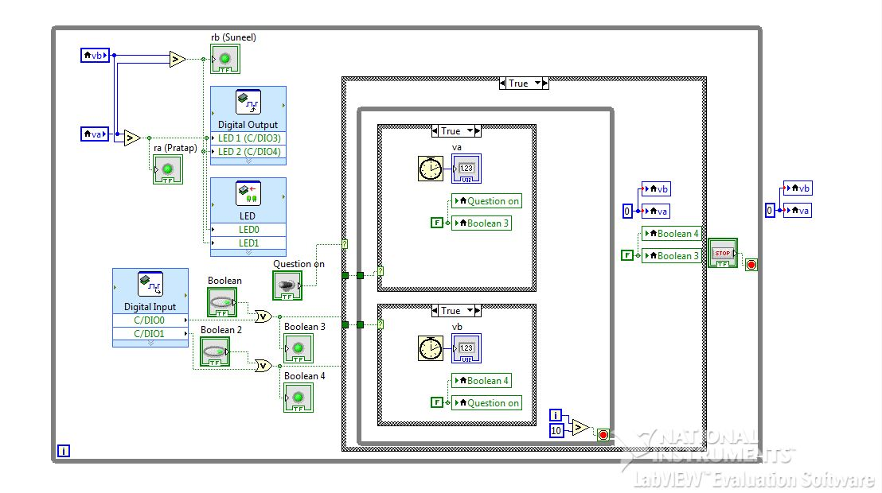
Figure (b): Block diagram in LabVIEW

Explanation of Block Diagram (Figure (b)):
Here there are two players, therefore we use two Boolean inputs (A, B), consider the Boolean A, the timer must store a value to an indicator, but in LabVIEW, the Boolean would continue in the state of ON, therefore a Local Variable is created for A and it is given a value FALSE or OFF, hence as soon as it is on, the Indicator gets the value of the timer and the Local variable sets the Conditional loop to Off. This is the similar condition with B.
There occurs another condition that in a quiz, when one player’s buzzer is on, no other player’s Buzzer should not get activated, for which We have a Boolean “Question on” which gets deactivated as soon as the timer value is noted in the Conditional thus allowing us to block all the other inputs after the first input. This “Question on” Boolean is connected to another Conditional Loop which facilitates the “Fastest finger first” type action. This conditional loop also sets the timer indicator values to initial Value ‘0’ and turns the player inputs to FALSE. (ie, the System is Reset)
The conditional loops of A and B Booleans (Player inputs) are executed in one execution cycle (ie, around one micro second) of the Micro processor of MyRIO-1900, therefore to make sure that user gets enough time for the press we used a While loop and ended it in the tenth iteration.
In this way, both the Timer values are now noted, which must be compared to see which one is the smaller one and switch the corresponding Buzzer. For which the Comparators are used in the outer while loop (ie, they keep on comparing the values.)
The initial values of the Timer indicators are set to ‘0’.
Hardware implementation:
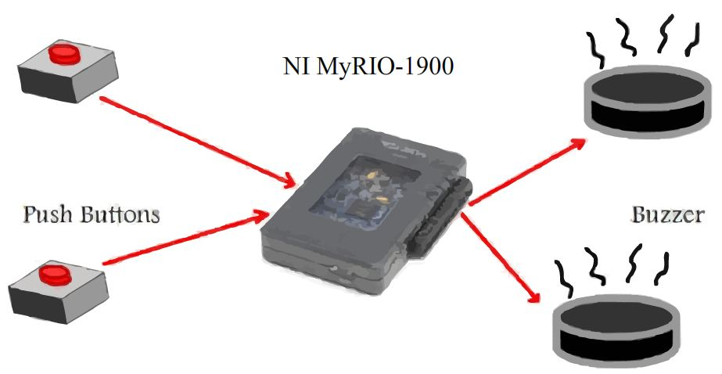
The C port of MyRIO-1900 microcontroller should be given preference over A, B ports as, the C port is having Pull Down resistor configuration while the ports A or B have Pull up Resistor configuration, which allows the input values of ports A or B only if it exceeds the value 3.3 V.

Precautions :
1) Ensure same version of LabVIEW and LabVIEW Runtime driver in the System and MyRIO-1900.
2) Ensure all the terminals are properly connected in correct polarity and in correct Pins.
3) Check the Datasheets of the Elements used to check that you are operating in proper rating values.
4) Set proper input time for user to avoid Erroneous result.

Applications:
*Can be used in Fastest finger First based Competitions.
*Can be used in Triggering circuitry.
*Can be used is Electronic Security System.

Mini-Project Done by:
Pilla Venkata Sai Suneel (EEE/V semester)
Mayank Pratap Singh (EEE/V semester)
With the Guidance of:
Suresh Venkatesan

