Design Notebook
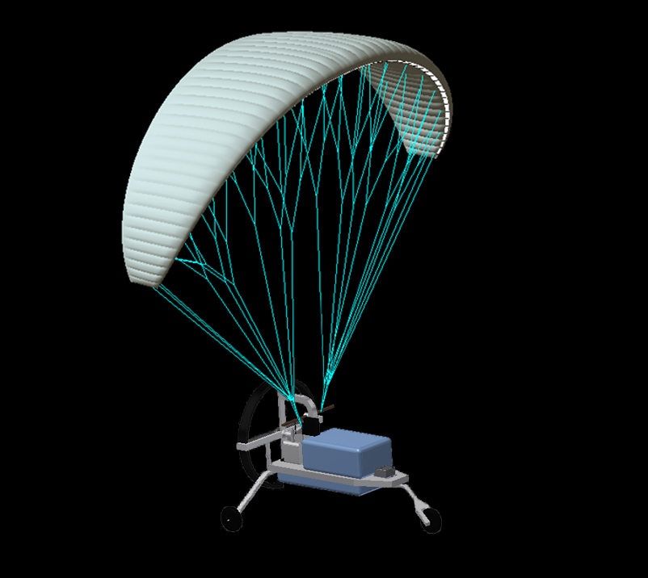
Project Name: RWDC FY14 Aviation National Challenge
School: The STEM Early College at N.C. A&T (North Carolina)
Team: First in Flight
Coach: Calvin Miller (STEM Early College Teacher)
Submission Date: November 3rd, 2014
Team has completed all formative surveys.
Objective Function Value: 129 Bushels/Dollar
Document Owner(s) | Age | Grade | Email Address | Phone Number
Dennis Quaintance | 16 | 11 | dcquaintance@gmail.com | (336)-580-8868
Carlo Lindner | 16 | 11 | carlolindner999@gmail.com | (336)-501-6889
Dylan Jordan | 16 | 11 | dylantylerj3@gmail.com | (336)-686-5607
Mercy Adekanle | 16 | 11 | mercyadekanle@gmail.com | (336)-517-7570
Dhaval Mheta | 15 | 10 | dmheta012@gmail.com | (336)-509-6673
Via Abiera | 15 | 10 | viaabiera@gmail.com | (336)-912-2165
Christine Nienhuis | 15 | 10 | christinenienhuis569@gmail.com | (336)-307-0222
Phillip Sous (past member) | 15 | 10 | phillip.sous@gmail.com | (336)-456-9731

ABSTRACT
The European Corn Borer is a type of bug that strives in crop fields, specifically corn fields, where it lives in populations to feed on the plants and reproduce in them. These bugs can be harmful to crops, and farmers annually lose large amounts of produce due to loss of corn stalks because of the European Corn Borer.
The “First in Flight” team designed an Unmanned Aircraft System to locate and track populations of European Corn Borers in a corn field of one square mile in order to reduce the crops lost due to this harmful species. To achieve this, students had to come up with a solution that included an efficient and productive UAV, the selection of numerous sensors, motors and other payloads, the creation of a time efficient and thorough flight plan, the analysis of the design’s performance and cost, and the creation of an effective business plan. This solution should be environmentally friendly and it should follow all regulations created by agencies such as the FAA, all while maximizing the increase in profit yielded by the detection and resulting elimination of these corn borers.
The team’s design is loosely based off of Tetracam’s Hawkeye, which is a small and cost efficient UAV that uses a parafoil to achieve lift. The Hawkeye is often used for purposes similar to locating populations of corn borers. For example, the Hawkeye may search for signs of pollution in an area. The team created a parafoil design which was relatively smaller than the Hawkeye, with similar design structure and payload placement. The Hawkeye contains an airframe, in the shape of a small “cart-like” object with wheels, where every component besides the wing lies. The wing is attached to the back of the airframe, and when the aircraft takes off, generates lift for the aircraft. The team made many modifications to the design when the national challenge was introduced, as the search area increased from 1 square mile to 25 square miles. A second plane was added to reduce time, although cost increased.
This year’s team gained a lot of valuable information, insight, and real-world skills from working through the challenge. The team learned how to operate effectively as a team, and produce an effective product from the efforts. The “First in Flight” team knows that the product that was produced was the ultimate output of all of the team’s members, and can operate efficiently under the required conditions.

TABLE OF CONTENTS
1 Project Goal
1.1 State the Project Goal
2 Document the Updated System Design
2.1 Updated Design
2.1.1 Engineering Design Process
2.1.2 Theory of Operation
2.1.3 Detailed Design
2.1.4 Lessons Learned
2.1.5 Project Plan Updates and Modifications
2.2 Selection of System Components
2.2.1 Sensor Payload Selection
2.2.2 Air Vehicle Element Selection
2.2.3 Command, Control, and Communications (C3) Selection
2.2.4 Support Equipment Selection
2.2.5 Human Resource Selection
2.3 System and Operational Considerations
2.4 Updated Component and Complete Flight Vehicle Weight and Balance
2.5 Updated Design Analysis
2.6 Updated Operational Maneuver Analysis
2.7 Updated CAD Models
2.8 Updated Three View of Final Design
3 Document the Updated Mission Plan
3.1 Precision Agriculture Crop Sensing Pattern
3.2 Legal/Regulatory Requirements
3.3 System Detection and Identification
3.4 Example Mission
3.5 Mission Time and Resource Requirements
4 Document the Updated Business Case
4.1 Identify Targeted Commercial Applications
4.2 Amortized System Costs
4.2.1 Initial costs
4.2.2 Direct Operational Cost per Mission
4.2.3 Amortization
4.3 Market Assessment
4.4 Cost/ Benefits Analysis and Justification

5 Team Engagement

5.1 Team Formation and Project Operation
5.2 Acquiring and Engaging Mentors
5.3 Tool Set-up / Learning / Validation
5.4 Impact on STEM

  - State the Project Goal
The project goal was to create a sUAS (small Unmanned Aerial System) to aid with precision agriculture. The challenge requires that the team base the design off of the needs of a farmer in Central Iowa dealing with European corn borers. The European corn borer is a pest of grain, particularly maize. The field of interest is approximately one square mile, at a 1,500 feet altitude limit. The project goal also includes developing the UAS with intent that it could be used in different industries (Defense, Government, etc.).
The challenge mandated that the objective function (Increase in Crop Yield divided by Life Cycle Cost) must be maximized. The team based their design on this function, analyzing every change in the design based on its effect on the objective function. This method allowed the team to create the most effective design. During the National Challenge, the team found new ways to make the design of the aircraft more efficient and run longer, when it came to details like the fuel mechanism and the amount of aircraft. The team opted to instead use two aircraft simultaneously during the mission, compared to the original one.

- SYSTEM DESIGN

Conceptual, Primary and Detailed Design

Engineering Design Process
Using the given resources, the team came up with several candidate processes; linear prototyping, evolutionary design, and concurrent development. The team decided to use a modified version of the concurrent development model. The team would start with a basic design (multicopter, HTOL, lighter than air, etc.) and develop it, making changes to improve the performance, analyze the changes, approve the changes, and make more changes. This process really became effective with the detailed design portion of the project as the team made many small changes.
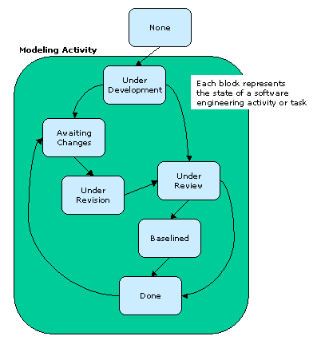
Figure 2.1

Theory of Operation
The main principle to note when considering the conditions the system was intended to operate under is that the system was designed to operate within challenge parameters. If a parameter wasn’t required by the challenge it was not considered in the design of the challenge. This allowed the team to maximize the performance of the aircraft by only considering the parameters stated by the challenge. Limitations of the design are that it is highly susceptible to winds, the maneuverability is severely reduced compared to fixed wing or VTOL designs, and that if the field area were to be expanded organization of refueling without interference between the two aircraft would be quite difficult. Additionally, in the event of a severed bridle the aircraft would have a hard time surviving the fall, however, this is a characteristic of most designs in a 400 foot free fall. In terms of coordination of mission planning to eliminate interference between the two aircraft, the team designed the mission plan so that one aircraft would start it’s sweeps 2.5 miles into the field and the other aircraft would start it’s sweep at the beginning of the field which would put 2.5 miles between the two aircraft at all times. The aircraft that would be starting 2.5 miles out would be launched first and the aircraft starting at the beginning would launch later so that the two aircraft reach the start of the detection pattern at the same time. Additionally, the aircraft would be impaired by the use of aircraft communications radio frequencies nearby. This could give false information to the autopilot and cause temporary loss of control, however since this is not a factor the challenge addresses it was not considered in the use of an autopilot. Additionally the transportation of the parafoils would have to be taken with care to not tangle the bridles of the two aircraft.

Detailed Design
The team initially was open to many designs, including some not listed in the RWDC State Challenge Detailed Background Guide. The team considered two types of HTOL designs; a pusher propeller design and a tractor propeller design. These would cover more distance, but posed challenges with launch and recovery. The team also considered four VTOL designs; the helicopter, the tricopter, the quadcopter, and the hexacopter. These designs were determined to have advantages with takeoff and recovery, but lacked speed. Additionally, the team considered a hybrid design based off of the Hawkeye UAV. The Hawkeye UAV is a pusher propeller fuselage, attached to a parafoil, making it possible to launch horizontally, while having vertical recovery. Additionally a parafoil design has high performance at low speeds and can glide for a long time.
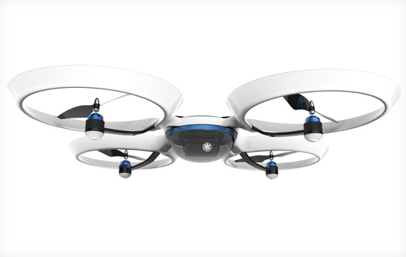
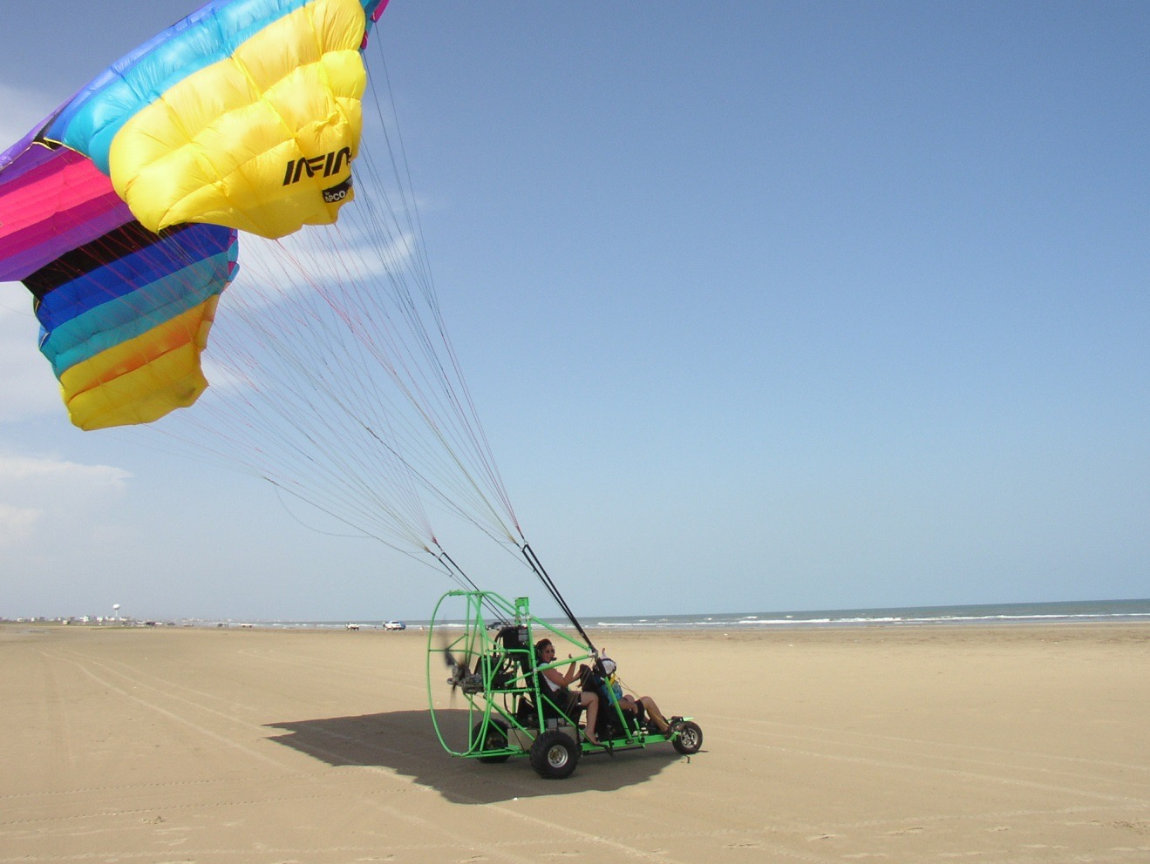
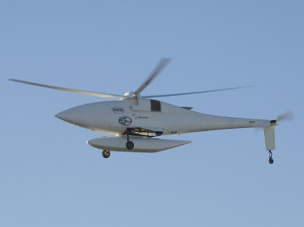
Design Descriptions
Figure 2.2 | Figure 2.2 shows the concept of the quad copter design that the team considered. This design would have allowed the team to have vertical takeoff and landing, however severely restricted the possible speed of forward flight. An added bonus of the quad copter design is the stability of level flight, which would allow the camera to capture steady pictures that would be good for analysis.
Figure 2.3 | Figure 2.3 shows the concept of the parafoil design the team considered. The parafoil design allows for short takeoffs and because of its parachute element nearly vertical landings. This would be beneficial for hard to reach locations, as well as places that have limited landing strips. Additionally the parafoil design has a great range of speed and altitude capabilities making the system very flexible for a variety of uses.
Figure 2.4 | Figure 2.4 shows the concept of the helicopter design that the team considered. The team considered it for its vertical takeoff and landing capability, however was wary of its slow forward speed, and was worried about its stability.
Figure 2.5 | Figure 2.5 details the concept of the fixed wing aircraft that the team considered. Some advantages to a fixed wing design is that a fixed wing design would be able to fly faster, and would be able to glide, unlike rotary wing models, however it requires long runways and would be a problem in hard to reach locations.

Additionally in the conceptual design stage the team made the decision to determine the internal components of the aircraft so that the aircraft mentioned above could be analyzed based on the ideas identified earlier in the conceptual design stage. To do this, the team first had to assess the best way to find the pests and design the most cost effective onboard systems based on that solution. First, the team defined the method for detecting the pests. This was done using the detection of the pheromones released by the mating pests, so that the pests could be identified before they became a problem for crop yield. The team concluded that a multispectral camera would be necessary for the task of identifying the pests. This realization gave the team the challenge of identifying the most cost effective camera for identifying the pests. For this the team turned to the catalog provided by RWDC. After analyzing the catalog the team decided to turn to third parties to find more cost effective components for the aircraft. After some internet research an article from a blog called aerial farmer turned up three companies which manufacture multispectral cameras; Tetracam (http://www.tetracam.com/), Headwall Photonics (http://www.headwallphotonics.com/hyperspectral/micro-hyperspec-vnir/ ) , and Rikola Ltd (http://www.impactmin.eu/downloads/lulea/022.pdf). These companies are manufacturing multispectral cameras for everything from agriculture to satellites. After some research the Tetracam ADC Micro was not only the most cost effective but its miniscule size and quality sensor made it the best choice for a third party camera. After analysis of third party cameras the team put all of the cameras against each other. The Tetracam ADC Micro was clearly the best camera for use on a small UAS such as the one the team was designing.
Given this, the team then moved forward in deciding the other system components. The team examined the catalog provided by RWDC and determined that the autopilot specified in the catalog (APM 2.6 Autopilot), although made some modifications to make the system more cost effective. The team figured out that the price of the autopilot listed in the catalog included a GPS with an onboard compass that cost $80. The team then determined that a cheaper method could be found, and through one $40 third party GPS and one $17 third party compass the team fashioned a similar system for less. The team then selected additional components, such as a motor, ESC, radio set, and battery; making sure that these components were compatible with those already chosen. The preliminary design is identical as in the state challenge.
The preliminary design stage served to further develop the designs already being considered and analyze them to decide which one to refine in the detailed design process. One of the first steps in doing this was defining some parameters for certain types of aircraft. One such parameter the team defined was the airfoil that would be used if the aircraft was either fixed wing or a parafoil design. The wing of a parafoil can be treated the same way a rigid wing is in the design process because when it is in the air it functions the same way that a rigid wing does.
In the team’s search for an airfoil to narrow down the plethora of airfoils in the world the team did some research about aircraft that had similar purposes to ours. Two airplanes that stood out were those made by Air Tractor, as well as the Embraer Ipanema. This gave the team two airfoils to base their studies on, the NACA 23015 and the NACA 4415. After analyzing the airfoils in javafoil it was determined that the NACA 23015 airfoil should be used. The data received from javafoil that allowed the team to make this decision is displayed below. The first image depicts the flow field at an angle of attack of 17 degrees which the team determined would be the maximum lift for the NACA 23015. The second image depicts the NACA 23015 at an angle of attack of only 5 degrees, the cruising angle of attack.
These flow fields helped the team analyze the airfoil at different angles of attack and visualize the way that each airfoil worked. After viewing the flowfield of each respective airfield, the group analyzed the performance based on the polar data for the NACA 23015, which is shown below. Through this the team determined that the NACA 23015 airfoil would be the most effective design for use on any fixed wing or parafoil aircraft.
Once the team had found an appropriate airfoil the team moved on to assessing the pros and cons of each design. Through this process the team determined that in this challenge, due to the fact that there would be a zero wind situation, a parafoil aircraft would be the most effective choice. This is because even through it has a very small takeoff space and needs virtually no room to land it has a high forward speed, which other easy to land craft (rotary wing craft) lacked. This made it more suitable than both rotary and fixed wing craft, making it the obvious choice for the team. 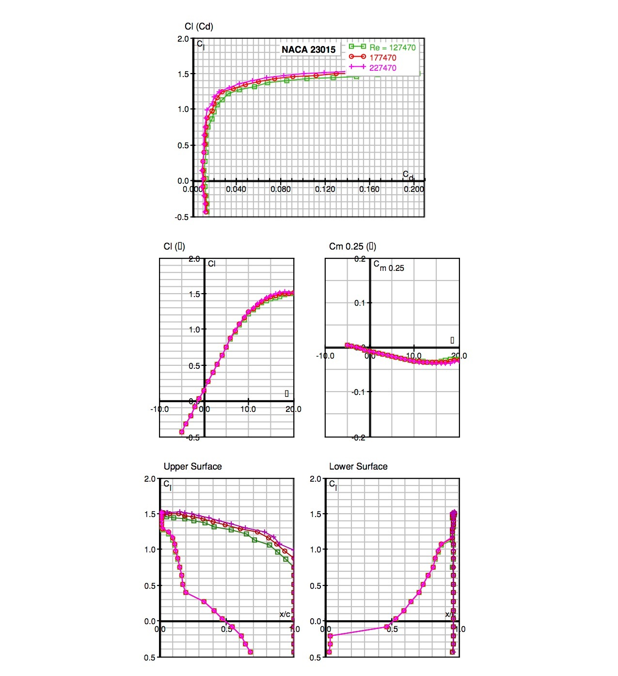

In addition to the airfoil analysis, in the conceptual design stage the team made an outline for the parafoil design which was being considered. This design consisted of a frame with room for all of the components inside of it as well as a propulsion system. This design was then exported into Autodesk Inventor and analyzed in order to gain a better understanding of the weakest parts of the model. The stress analysis, as well as the pictures of the CAD Model, is shown below. The final dimensions of the state challenge model were 3x3x10 inches.
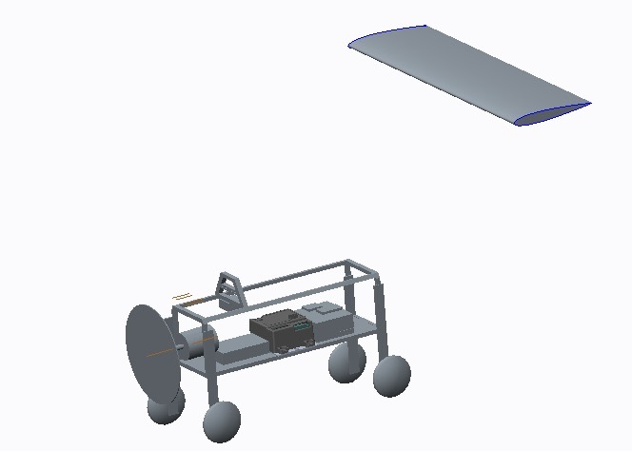
Figure 1.1.1

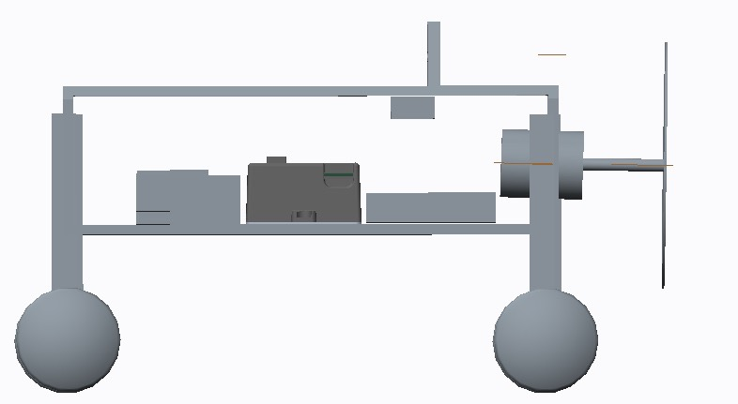
Figure 1.1.2
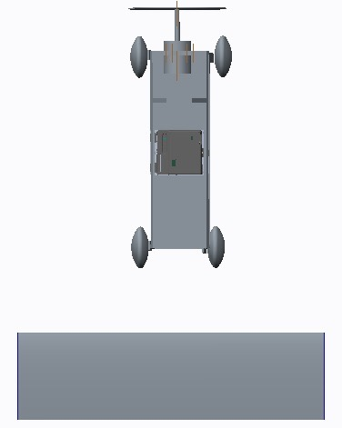
Figure 1.1.3

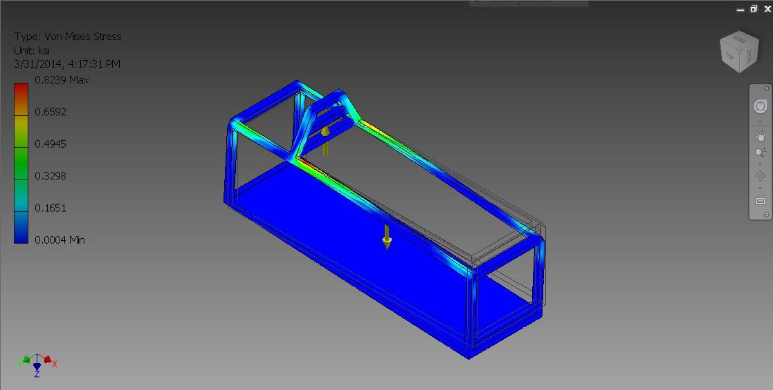

Figure 1.1.4

Table 1.1.3 Conceptual Design CAD Model Descriptions
Figure | Description
Figure 1.1.1 | This figure shows a perspective view of the original design that was created by the team
Figure 1.1.2 | This figure shows the side view of the original design.
Figure 1.1.3 | This is a top view of the original design.
Figure 1.1.4 | This picture shows which parts of the original design experience the most internal pressure under full flight loads as defined by FAA regulations

The model used in the preliminary design was the model used for the state challenge. This is because by the submission of the state challenge the team had an undeveloped version of the aircraft. The final design for the national challenge, however, is the product of many iterations.
The team used a few other computer programs. By using the MathCAD sheets, specifically the Performance sheet the team gained a broad understanding of the maneuvers which this aircraft would be able to perform. However, in an effort to further improve the design and optimize its performance, the team continued to analyze and refine the design using the software provided by PTC, as well as third party software to optimize the performance and efficiency. The designers continued to tweak a number of details about the design such as the fuselage, the wing span, the chord length, and the wing’s location. Given that the parafoil design would require the wing to be located reasonably far above the fuselage, this was especially a challenge to decide upon, but through further analysis and consultation of the mentors, the team decided on a height.
An additional tool that was used in the detailed design phase was the Autodesk Inventor Pro software. This software, which is very similar to Creo 2.0, provided us with a user friendly interface which we took advantage of by analyzing the strength and flexibility of our airframe. By running a stress analysis at various forces, the team was able to decide on which material to use, what shape to make the frame and other aspects of the final airframe.
The team also refined the original design to create a second iteration. The first modification made in the design was that the open walls of the original frame design were closed to eliminate the blunt end surfaces that resulted from the frame design. This lessened the overall drag of the design. A fan cage was also added for additional safety. Additionally, because the national challenge expanded the area to be searched the aircraft switched from battery to fuel to extend the range of the aircraft. This is because it is more efficient to have a higher initial cost with less refueling stops because the cost of paying the ground crew while waiting for the aircraft to come into refueling constantly multiplies over time, however, the initial cost is only spent one time, so over time, the money spent on the aircraft will come back in the form of saved operating costs.
Additionally the analysis of the new design changed. Instead of simply showing which parts of the design had the most stress on them the team also showed the safety factor of each of the different parts of the design. Several parts of the design were originally considered using a composite material and were changed to aluminum after it was found that the brittle nature of the composites could not handle the appropriate stress. Below are all of the parts and their stress analysis with companion labels that indicate the type of analysis performed. All stress analysis was done using the stress analysis feature of Inventor Professional.
After the second iteration, the design was changed wildly to reduce drag and balance the plane’s payload. The location of the motor and propeller was changed from the front to the back, which gave the aircraft more horizontal stability and allowed for more control over the pitch. This also prevented turbulences from interfering with the airflow around our parafoil. The box-like design was abandoned and the walls were removed and replaced with aluminum beams to add structural support. The base of the gondola was lengthened and tapered at the front to provide each payload with sufficient space.
Since the engine consumes a large amount of fuel during the mission, about 2.9 gallons of fuel had to be stored on the aircraft at takeoff. To do this, a big gas tank was needed. However, the team soon found that even with the elongated gondola, it was a challenge to store this fuel. A solution was found by placing one large gas tank containing 0.96 gallons of fuel on top of the gondola while a second gas tank containing 2.08 gallons of fuel was fastened to the bottom of the aircraft, effectively allowing us to store just over 3 gallons of gasoline. The unusual placement of the gas tank caused another problem to rise up, however, as the fuel would have to flow against the pull of gravity to reach the engine. This was resolved through a simple fuel pump.
Finally, the remaining payload was distributed across the base of the gondola while ensuring that weight was distributed evenly on both sides. The servo was mounted to an aluminum beam and connected to a 12 inch arm which allowed the aircraft to bank. The radio was installed at the highest point possible to prevent any interference by the aluminum frame. The ADC Micro camera was installed near the nose of the gondola, underneath which a whole was cut out of the base to allow a full sight of the field.
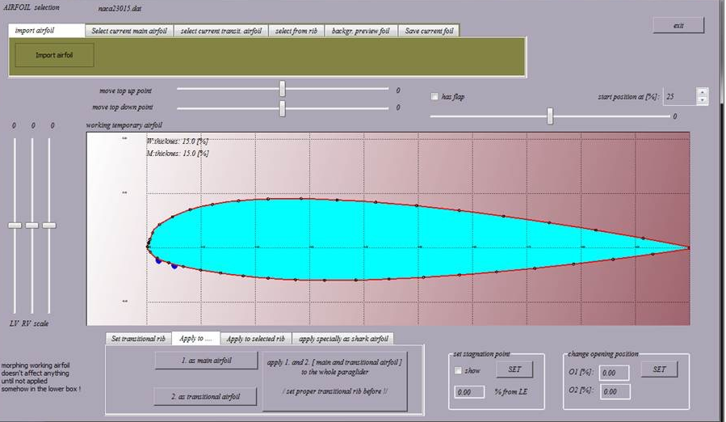

The analysis for the parafoil was done using Paratailor 2.0. First, the airfoil was imported as a coordinate system. The parameters were then defined and a fabric pattern was obtained for the parafoil. Then, the team designed ribs for the parafoil and analyzed the parafoil’s performance by determining the coefficient of drag, the coefficient of lift and the ratio of the two. Then, a pressure map was created using the CFD function of Paratailor. The analysis indicated that the parafoil would have a greater than expected performance in terms of lift, however, it would also have a high drag. This was compensated for by adding a larger engine.
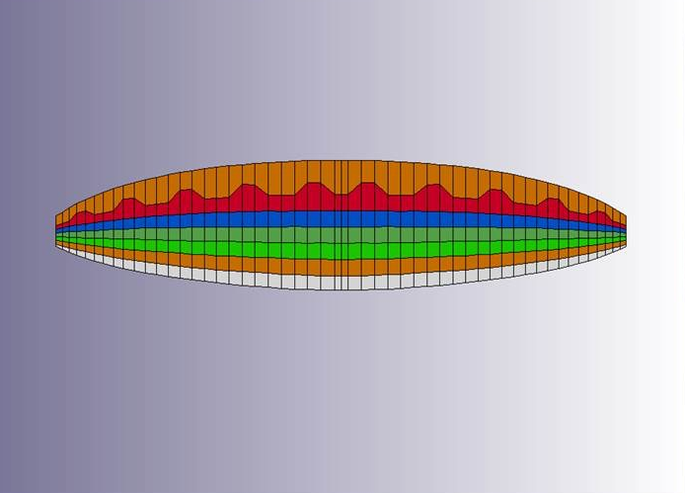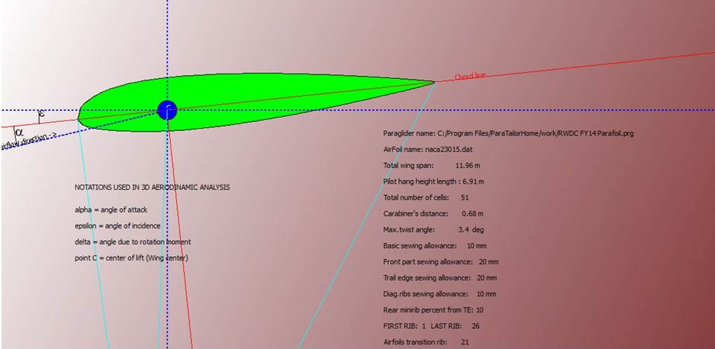
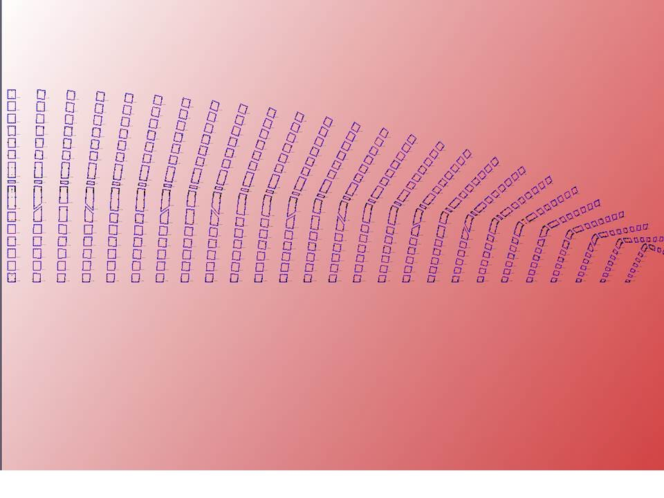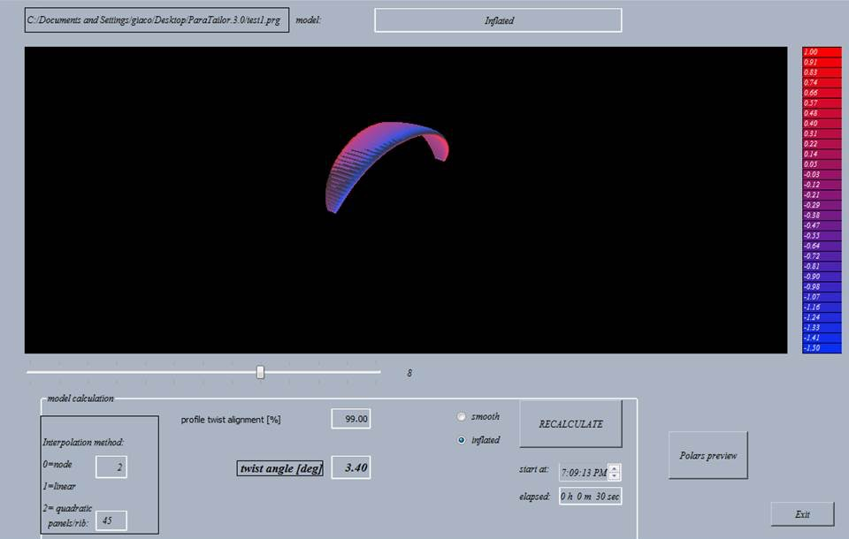
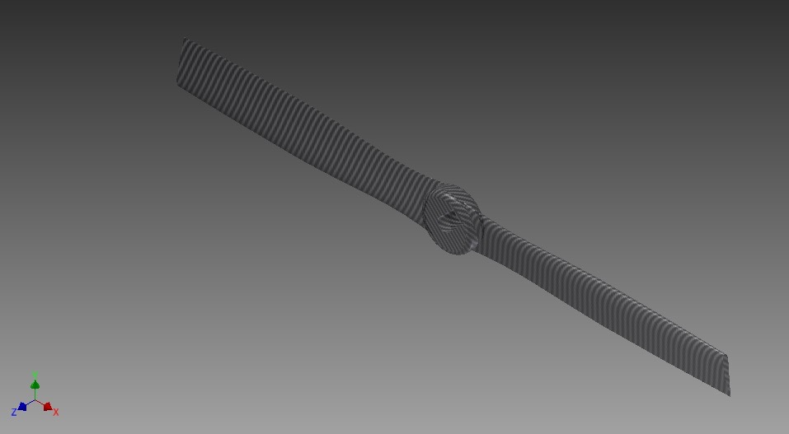
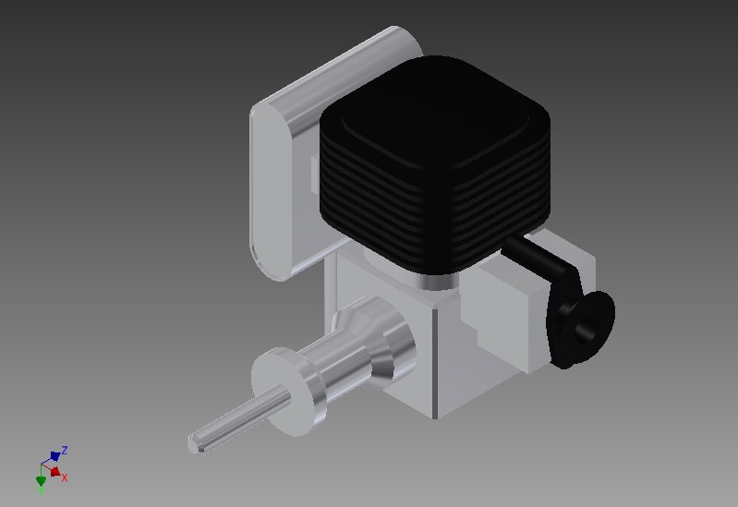
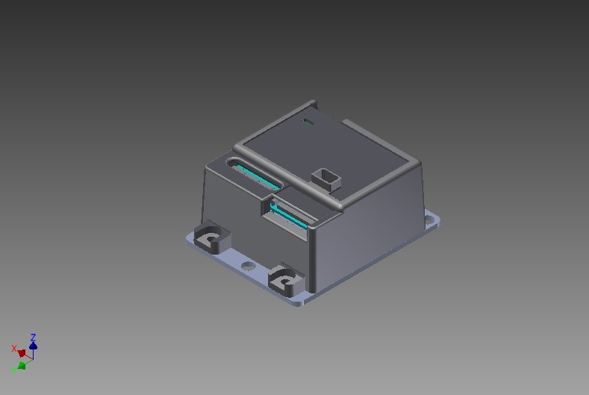

Lessons Learned
Throughout the design process, the team faced a number of challenges, most of which revolved around individual discipline and planning. From the very start, group members often lacked the discipline of spending extra time at home and at school to work on aspects of the project, which ultimately set us behind and drastically tightened the schedule. This was largely due to a rather unorganized approach which the team took at first, which included the lack of a log and unclear group roles. As the challenge progressed, however, the team removed a number of these flaws and began to clearly assign each team member specific roles and goals to be accomplished by the next meeting, along with a log which kept track of where the group had been, where it was at the moment, and where it should be in the future. Doing this gave the team a much better insight about the scope of the design challenge and the amount of work still required for the members to finish it in time. Additionally, the team learned to consider practical analysis in the decision making process. While in the state challenge the integrity of the design was poorly known, because the team was able to analyze the safety factor of the design in the national challenge the team was able to gain a greater understand as to which part of the aircraft were most susceptible to failure. This also helped the team change materials based on the safety of materials instead of just guesswork. Additionally, the national challenge design recognized the limitations of the state design in that the state design had a very poor aerodynamic profile as well as demonstrated a poor understanding of battery life as well as drag and thrust. In the national design considerations were made so that the thrust produced by the combination of the propeller and the engine would be enough to overcome the drag of the wing as well as the airframe. Additionally, the national challenge took into consideration the poor performance of batteries and changed the propulsion to gas. Also, the team better considered the design of the airfoil in the national challenge by using a new design program called Paratailor.

Project Plan Updates and Modifications
As the team began to work on the preliminary design, it soon became clear that the initiating phase of the project took much longer than expected and that the team was now under stress induced by a lack of time. Certain changes were made to the individual responsibilities of the members and the tools used to communicate among the group were reconsidered and adjusted appropriately. One major change which the team underwent was the introduction of a log designed to keep the time management in perspective. The log provided a better overview of which parts of the project took the longest to be complete, and it allowed an analysis of the efficiency at which the team had been working at. Using this tool, the group became much more self aware and organized, which motivated the members to work at a more productive pace. Once the state challenge was won the team focused much of its effort on the national challenge presentation. The team also focused some of its efforts after the winning of the state challenge on the updating of the design. This was done using an iterative process (design-analyze, design-analyze etc.). Additionally, the design notebook was updated to reflect the change in the design. Additional focus had to be delegated towards the flight plan and the decision to use two aircraft. The team used several team meetings to focus on this element.

Selection of System Components

Sensor Payload Selection

Pest Detection

Because the European Corn Borer is such a small creature the system must go beyond the visible spectrum to detect them. Because of this the team designed the system to detect the pheromones emitted by the pests. According to the department of Entomology at Iowa State University, the pheromone emitted by the pests is 11-tetradecenyl acetate,C₁₆H₃₀O₂. According to the Royal Society of Chemistry’s database the index of refraction for the pheromone is 1.451. The index of refraction is an integer that tells one how light changes as it passes through something, in this case, the gas. is the formula to calculate the wavelength of the light refracted out of the object using the wavelength of the light entering the object. Given the reflectance of corn as it has to do with wavelength according to a study done by the University of Nebraska-Lincoln (shown above) the team decided to base the study between the wavelengths of 400 and 800nm. Because the wavelength of the light passing through 11-tetradecenyl acetate is proportionally smaller than the light simply reflecting off of the corn the program could simply create a a graph for reflectance factor at different wavelengths for each pixel and identify if the pixel has 11-tetradecenyl acetate based on the location of the curve. (Because 11-tetradecenyl acetate would make the wavelengths proportionally shorter the graph would be shifted to the left).

Identifying the appropriate Sensor Payload

Given the range of wavelengths necessary to determine the presence of the pests (400-800nm) the appropriate camera can be easily identified. Because the team determined that the cheapest imager that would be able to complete the necessary listed in the catalog is the x5000, which costs $5,500 the team decided to look for a sensor from a third party. The optimal third party sensor was the ADC micro. With a price of $3,795 it was significantly cheaper than the x5000, and was a mere 9 grams. The ADC Micro also puts its information on an SD card, which would be more easily processed when on the ground. Additionally the ADC Micro could have a separate power system than the other components with power coming from its own battery, which helped the team take stress off of the main power system. Additionally the ADC micro had capability to use the onboard GPS to geotag the location each photo, giving the operator the ability to simply input the coordinates provided by the camera so that an additional UAV could come and fly a rout specified by the data obtained from the camera.

Table 2.1 Sensor Payload Details
Sensor Payload | X 5000
Price: | $5,500
Stabilization: | Excellent
Imager: | Multispectral Imager (3-Fixed Filters: Green, Red, NIR)
Roll Limits about x-axis: | 30° pan left | 30° pan right
Pitch Limits about y-axis: | 30° tilt up | 30° tilt down
Roll/Pitch Slew Rate | 50° per second
Format: | NTSC or PAL
Frame Rate: | 1 frame per second
Video Scan: | Interlaced
Continuous Zoom: | No Zoom
Camera Profile: | Horizontal: | Vertical:
Resolution: | 2048 pixels | 1536 pixels
Wide Angle Field of View: | 40° | 20°
Telescopic Field of View: | n/a | n/a
Weight: | 1.4 pounds
Center of Gravity: | (measured from front, right corner at red x)
X: | 1.75 inches
Y: | 1.75 inches
Z: | 1.00 inches
Dimensions when Mounted | Internal Volume: | Internal Volume:
X Length: | 2.50 inches | 2.50 inches
Y Width: | 2.50 inches | 2.50 inches
X Height: | 2.00 inches | 2.00 inches
Voltage In: | 2-12 volts
Power Draw: | 2 watts (nominal) | 3 watts (maximum)

Sensor Payload | Tetracam ADC Micro
Price | $ 3795
Manufacturer URL: | http://www.tetracam.com/Products-ADC_Micro.htm
Camera Type: | Multi-Spectral
Optics: | 8.34 mm fixed lens
Filters: | Green, Red, NIR
Pixels Per Exposure: | 3.2 MPel
Image Size: | 2048 Pixels | 1536 Pixels
Standard Storage Medium: | 2 GB Micro SD Card
Video Out: | NTSC or PAL
Power: | External: 9 to 12 VDC, 2 watts nominal
Weight: | .1984 lb
X Length: | 2.97 in
Y Width: | 2.33 in
Z Height: | 1.29 in

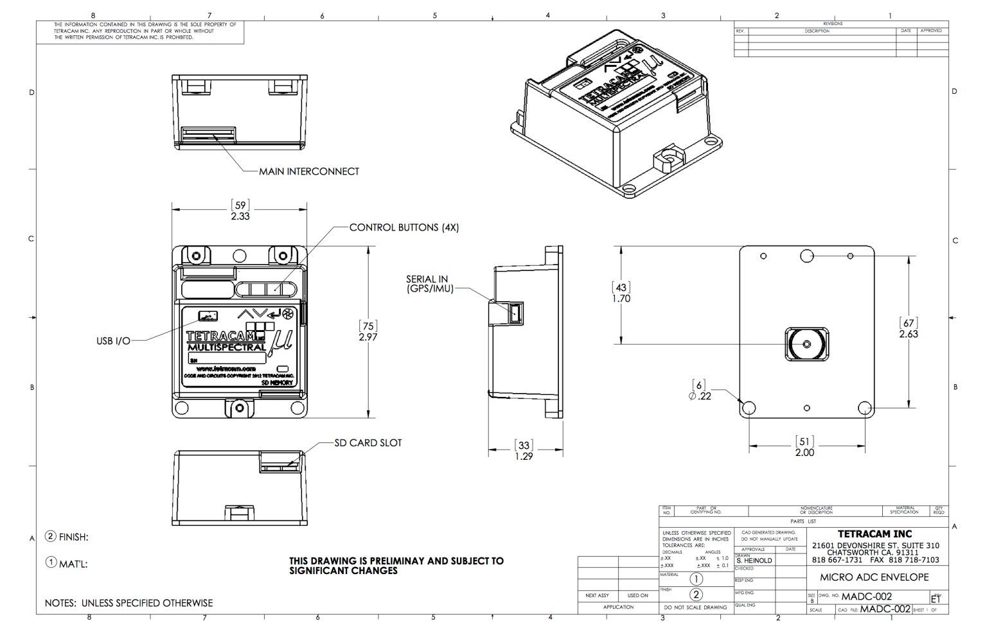
ADC Micro CAD Drawings

Air Vehicle Element Selection
In order to fasten the payloads, sensors and motor, the team created an aluminum frame, 29.09 inches wide, 29.99 inches high, and 33 inches long. This frame had a solid plate at the bottom, which the payload was mounted on. The design allowed us to securely carry the payload while using a reduced amount of resources, which reduced the initial building cost and also reduced the drag. On the ground, the airframe was supported by three wheels, attached to the aluminum frame using three flexible beams. A lightweight and resource efficient alternative to an enclosed fuselage, the airframe allowed for low energy consumption during flight, a relatively short takeoff and landing distance and easy transportation. To achieve economic feasibility, the team made the decision to choose a third party propulsion system, called the Turnigy 30cc Gas Engine. The team decided to use this in conjunction with a high precision carbon fiber 16x8 propeller, which, after assessment of the power generated, was proven to provide the aircraft with more than enough power during the mission. Below is the data regarding the fuselage station of all of the final components.

Component | Fuselage Station | Weight
High Precision Carbon Fiber Propeller 16x8 | 23.5 in | 0.0022 lbs
Turnigy 30cc Gas Engine with CDI Electronic Ignition | 17.9 in | 2.0701 lbs
APM 2.6 Autopilot | 21.25 | 0.0551 lbs
Hitec HS-805BB Servo | 15.3 in | 0.0265 lbs
Tetracam ADC Micro | 1.5 in | 0.1980 lbs
2000 mAh Polymer Lithium Ion Battery | 18.25 | 0.0794 lbs
Triple Axis Magnetometer | 21.7 | 0.0044 lbs
GPS Receiver GP-635T (50 Channel) | 18.3 | 0.0208 lbs
3DR Radio Set | 22.25 in | 0.0088 lbs
Gas Tank 1 | 4.5 in | 5.7420 lbs
Gas Tank 2 | 5.5 in | 12.468 lbs

Command, Control, and Communications (C3) Selections
After the team had figured out the base components being used in the aircraft, the team worked out the control system of the aircraft. To do this, the team worked out communications between the aircraft and the ground as well as the level of autonomy that the aircraft will be utilized. The two major components of the ground station are the data processing software, as well as the controller for the aircraft itself.
In the team’s research about the ground control station, the team figured out that all of the software needed to control the aircraft can be held on a traditional laptop. Therefore, the team attempted to find the most cost effective solution for a computer that is compatible with the software. The Dell Inspiron 11 turned out to be the most cost effective choice for the team.
Table 2.2 Dell Inspiron 11 Details
Processor | Intel® Celeron® processor 2955U (2M Cache, 1.4 GHz)
Operating System | Windows 8.1 (64Bit) English
RAM | 4GB Single Channel DDR3 SDRAM at 1600MHz
Hard Drive | 500GB 5400RPM SATA Hard Drive

The programs needed to run the aircraft are Tetracam’s Pixel Wrench software as well as the APM Planner 2.0. Pixel Wrench allows the user to analyze images taken by the aircraft to figure out what areas need to be targeted. APM Planner 2.0 allows the aircraft to set a pre-programmed course and execute it remotely using the autopilot. It also allows the operator the ability to change the course on the fly as well as perform emergency maneuvers.
Given the ability of the APM Autopilot software and hardware the team saw it prudent to work with an aircraft with full autonomy. This reduces the costs by reducing the members of the ground station needed as well as eliminating expensive user input devices. This is easily done through the APM Autopilot and the open source APM Planner 2.0 software which allows the team to plot a course using google maps waypoints.
To analyze the pictures taken by the UAS the team decided to use the Pixel Wrench Software provided for free with the camera. The pixel wrench software uses algorithms to take multispectral images and creates a visualization of them so that the user can easily identify the area of the infestation and have enough data to address the problem effectively. The image below depicts images analyzed by the pixel wrench software.
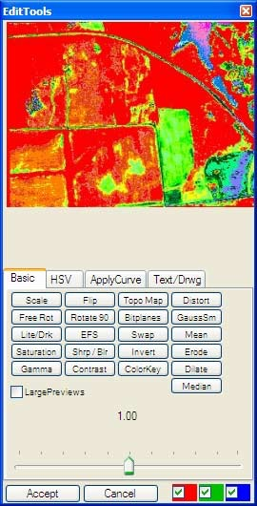
Additionally the pixel wrench software has the capability to tag photos with their coordinates so that farmers can figure out the coordinates of the affected areas. Also the pixel wrench software can calculate the field of view of the sensor on the fly based on the overlap area needed to capture relevant data as well as the height the UAS would be flying at. The team actually used pixel wrench to identify the field of view of the camera so that the team could develop a flight plan. A picture of the software as used to identify the field of view is included below.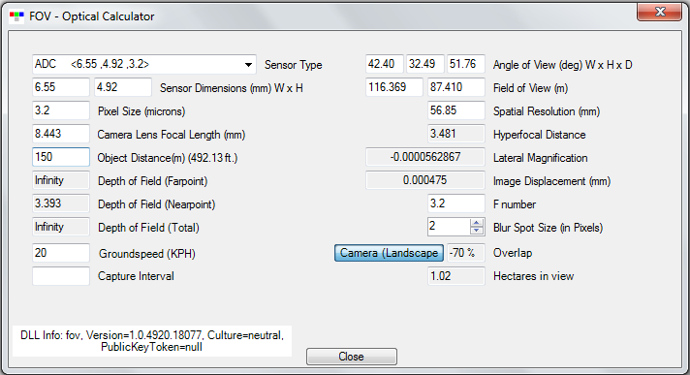
Table 2.3: Software System Requirements
Tetracam Pixel Wrench | APM Planner 2.0
Windows 32 bit or 64 bit Windows Operating system | Windows XP Or Later  300 MB Free Space  Internet Connection for maps

Additionally the ground station needs to have the capability to communicate with the aircraft. A 915 MHz radio set was chosen in accordance with US Government regulations. This radio connects directly to the autopilot system onboard the aircraft, therefore allows the software to communicate with the ground station in real time, offering the operator an up to date view of the data as well as the capability to reroute the flight plan during the flight and the ability to take over operation of the drone. The radio also includes connectors to Android devices so that operators in extremely remote areas can fly the aircraft using nothing but their android phone or tablet and the free, open source Android app that is provided by the manufacturer. In a case such as this the operator would take the SD card containing the captured images back to the computer in a more central location to retrieve the data recorded. During normal operation the Radio set would simply be plugged into the ground station computer, allowing the radio on the ground to communicate to the one in the aircraft giving it orders as well as receiving data from the aircraft. It is conceivable that in the near future an android app could be developed to allow the entire operation to be run from an Android tablet, further reducing the costs of the ground station.
Table 2.4 Radio Specifications
Transmission Frequency | 915 or 433 MHz
Sensitivity | 117 dBm
Connectors | Micro-USB, 6 Position DF13 Connector
Transmit Current | 100 mA at 20 dBm
Receive Current | 25 mA
Supply Voltage | 3.7-6 VDC (from USB or DF13 Connector

For the ground station to meet challenge requirements it needs to perform several tasks, all of which the team has verified that the ground station selected can perform. These tasks are detailed in table 2.4, which is below.
Table 2.5: Control Station/Pilot Interface Verification
Requirements | Verification
The control station layout and organization must allow the pilot to safely perform the functions necessary for flight. | The control station consists of just a computer and a radio link. The pilot can perform functions necessary for safe flight on the computer.
Any information necessary for the performance and maintenance of safe flight operations must be clearly displayed to the pilot and easy to identify and interpret. Examples include, but are not limited to, fuel remaining (i.e., flight time remaining), battery power remaining, engine performance, control link status, airspeed, altitude, and aircraft position. | The radio provides real time updates to the computer which in turn displays them to the pilot, allowing the pilot to access all of the data necessary for flight using just the computer.
Aircraft control and input devices must allow the pilot to safely operate the aircraft without unusual pilot skill or concentration, be intuitive and logically implemented, and have the necessary labels for proper identification of function. | Given the autonomy of the system it requires little to no pilot input, therefore any unusual pilot skill or concentration to operate the UAS.
Aircraft control and input devices must be designed to minimize human error. | The aircraft utilizes autonomous control to all but eliminate human error.
Critical control inputs that could cause an undesirable outcome if inadvertently activated, such  As an accidental “stop engine” input, must be safeguarded from inadvertent activation. | The pilot could not conceivably inadvertently affect any critical control inputs given the autonomy of the aircraft. An inadvertent pilot maneuver would cause only minor annoyances, such as the changing of the display.
The system must provide the necessary cautions, warnings, and advisories to the pilot to allow the pilot to troubleshoot and properly respond to abnormal and emergency situations. | The system gives the pilot real time data, including warnings and advisories that allow the pilot to make expedient decisions to help the aircraft if it is in a state of peril.
The control station must have a primary power source suitable for rugged field operations (e.g., a ruggedized and portable power generator). | The control station is provided with a generator, which is detailed in 2.2.4
The control station must have a backup power source in the event of a loss of primary power. | Because the control station runs off of a laptop even if the generator lost power the laptop would still be able to perform normally because of the laptop battery.
If applicable, the control station must allow a transfer of aircraft control to another airworthy control station without causing an unsafe condition. | Given that there exists only one control station and only one UAS it is not conceivable that the UAS would ever need to execute the maneuver detailed in the requirement.
The UAS must provide, or must allow the pilot to perform, a safe and appropriate response to the unanticipated loss of the primary propulsion system. | Because of the remarkable glide capacities of the UAS chosen the pilot could simply input the command to make the UAS land if need be and the UAS would be able to safely reach the ground without an accident.
The UAS must provide sufficient back-up power for safety critical systems in case of a loss of the primary power source sufficient to safely recover the aircraft. | Given the loss of primary power the backup battery which supplies the multispectral camera would begin to supply the main system, allowing for safe recovery of the aircraft, however, even given the recovery of the aircraft it would have to return to home to safely address the power issue.
The UAS must perform a predictable and safe flight maneuver in response to a loss of control link (lost-link) during any phase of flight. | The autopilot can be programmed to execute a predictable maneuver given a lost-link situation. It can also be programmed to finish the flight, however this is ill-advised given that additional failure at that point would likely result in the loss of the system.
The UAS must have a means to perform an emergency flight recovery, when appropriate, with both an active control link and during lost-link. | The UAS has sufficient means to perform an emergency flight recovery with and without the presence of an active control link due to the fact that the autopilot can be programmed with emergency maneuvers.
The UAS must be capable of continued safe flight and landing with an inoperative primary navigation sensor. | The onboard autopilot can be programmed to execute a series of commands following the loss of a primary navigation sensor which would allow the UAS to return home safely.
The UAS must be capable of continued safe flight and landing with the loss or malfunction of a single propulsion source in a multiple propulsion source configuration | The UAS is capable of continued safe flight with the malfunction of propulsion because in the event of the loss or malfunction of propulsion source the UAS is programmed to simply return to home base, which it is capable of doing given its superior glide capabilities.

Table 2.6 Ground Station Specifications
Component | Cost | Weight | Size
Tetracam PixelWrench 2 | Free | n/a | n/a
APM Planner 2.0 | Free | n/a | n/a
Dell Inspiron 11 | $349.99 | n/a | n/a
3DR Radio Set | $100 | 4 oz | 26.7x55.5x13.3 mm

Note that the weight and size of the computer are marked as N/A due to their being ground based components.

Support Equipment Selection
The existence of a ground station necessitates the existence of some equipment to support said station. To address this, the team analyzed the requirements for each of the components of the ground station. Both software programs; Tetracam PixelWrench 2, and APM Planner 2.0 require a computer to exist and function. That computer is provided in the Dell Inspiron 11, another component of the ground station. Additionally, the 3DR Radio Set requires power and input, both of which are provided by the Dell Inspiron 11, which is, as mentioned above, another component of the ground station. The Dell Inspiron 11 requires a source of power to keep its batteries charged; therefore the team identified that as the one key need of the ground station not addressed by other components in the ground station.
After some research the team decided to work with the light generator provided in the catalog. This provided the team with an easy option with predefined consumption statistics which would be necessary to calculate the cost per mission. The specifications also said that it is safe for PC equipment, therefore would be appropriate for use in the ground station support.
Table 2.7 Generator Specifications
Power Production | 2,000W (16.7 A) maximum/ 1600W (13.3 A) Rated
Output Voltage | 12 VDC
Weight | 47lbs
Noise Level | 59 dB(a) @ rated load (1,600W),  53dB(A) @ ¼ load
Fuel Efficiency | 9.6hrs per gallon of unleaded  Gasoline
Empty Weight | 46.3 lbs
Fuel Capacity | 0.95 gal
Engine displacement | 98.5 cc

Additionally, the aircraft runs on batteries which need to be recharged. Because of this the team accounted for an AC/DC Battery charger, specifically the component that was listed in the ground station support section of the RWDC catalog. This would be able to provide power to the rechargeable batteries when necessary.
Table 2.8 AC/DC Battery Charger Specifications
Battery Support | Supports Li-Po, Li-Ion, LiFe, NiMh, and NiCd  Batteries
Required Input Voltage | DC 11-18V (30 A)
Discharge Rate | .1 to 5.0A (maximum 25W, total  50W)
Charge Rate | Charge Rate: .1 to 10.0A (maximum 200W, total  400W)

Even though trailers were listed as a component in the catalog it was determined that a trailer would not be needed, as all of the components would be able to fit in either the trunk or the back seat of a standard car. While it was an option to add comforts such as air conditioning through the addition of a trailer it was decided against due to the cost of a trailer ($5,000 for the cheapest trailer)
Table 2.9 Support Equipment Cost
Component | Price
Generator | $1,150
AC/ DC Battery Charger | $150

Human Resource Selection
Because of the nature of the mission (that is, a launch and recovery type mission), the only operators that the group need were the Data Analyst for on-the-ground analysis, a safety pilot to monitor the aircrafts flight from the ground, and a maintenance official to monitor the overall team success and proceedings. The team was able to reduce the amount of ground support crew for a one aircraft, however, because the number of aircraft were increased to two all of the ground crew that were used with state challenge had to be reinstated to deal with the dynamics of two aircraft.

System and Operational Considerations
The FAA regulations impacted the design by making it so that the team had designed the UAV to be durable and sturdy so it won't break apart or damage anything while performing its operations. The designers also had to make some changes to some of the design’s aspects to better fit the type of job it will perform. The UAV was designed to withstand most conditions except for wind and rain due to its parachute and open fuselage, which leaves the aircraft vulnerable to such conditions. Also, the motor that was chosen had sufficient power to takeoff and it is also stable enough so the UAV can takeoff and maintain flight.
This regulation made sure that the team took into consideration how much power was needed to be generated. Having too little power would not be sufficient for the aircraft to work. So, it was important to take into consideration how the power distribution would be managed, which influenced the team’s design.
This regulation influenced what types of parts were needed to be selected. The team made sure to choose an appropriate data link that fit the requirements. This helped narrow down the search to a few possible candidates, which would then be added to the design notebook.
The team had to pick software that would make the operation of the UAV not only easier, but also safer. It was important to take into consideration the different things it needed to have to make sure the mission goes as planned. The software that was chosen is APM Planner 2.0; it is a ground station that can be run on Windows and other software. It will help the user do all the things they need in order for the mission to be successful. Using the software, the pilot can override the autopilot in case of an emergency or unplanned event that may occur. The team had to look at different options available to the team in order to use as a backup battery just in case the original had a malfunction.

Component and Complete Flight Vehicle Weight and Balance
The wing weighs 2.7 pounds, and while it is farther back than the sheet suggests, the wing and the airframe operate as two separate entities. Therefore, the wing actually takes into effect at the point of the servos, and it is measured at that Fuselage Station. The UAV does not have a conventional fuselage, as the plane’s body is made up of its payload components and an airframe. Also, the design does not have either a vertical or horizontal tail.
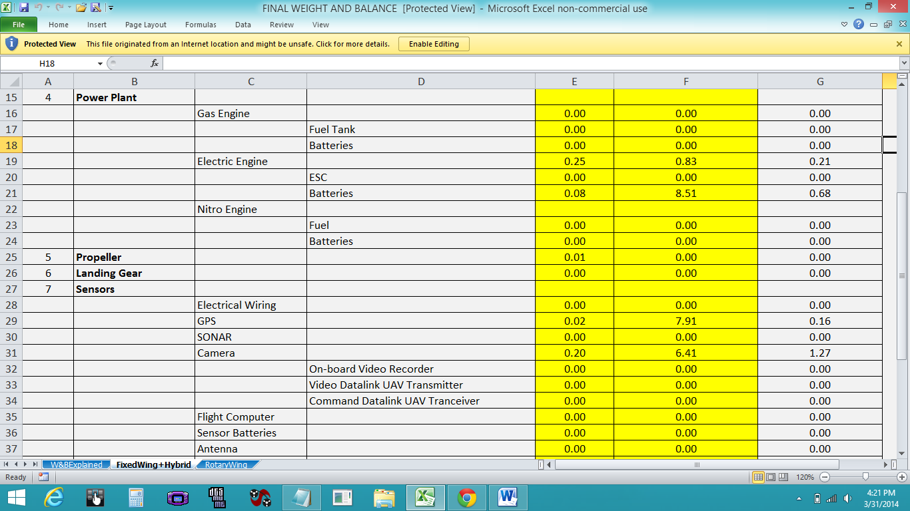

The plane has very small components, with the entire payload minus the gas tanks weighing in at less than a pound. The values for all of the components are listed here, including the propeller, engine, batteries, Global Positioning System, and ADC Micro Camera.

The above diagram lists the entire miscellaneous payload that were not quite adequate to include in the other categories, including autopilot, radio, compass, and servos. The total weight of the aircraft is only 3.35 pounds, and the Center of Gravity location is at 2.18 inches from the front tip of the aircraft.

Design Analysis

In order to make a successful UAS the team needed to verify that the UAS as a whole would be able to complete the mission, as well as comply with FAA Regulations. These requirements were split up into five sections, Aircraft requirements, Control Data Link requirements, Navigation and Orientation Requirements, Control Station/ Pilot Interface requirements, and Contingency Response requirements. Aircraft requirements deal with only the aircraft itself, whereas the control data link deals with only the ground component. The navigation and orientation deals with the telemetry of the aircraft and the Control Station/Pilot interface deals with the human input to the system. Finally, the Contingency response requirements deal with the UAS as a whole in emergency situations. To meet these requirements the team needed to make some tradeoffs, cutting performance for safety and “airworthiness.”
Table 2.10 FAA Requirements for Aircraft
Requirement | Description
Requirement 1.1 | The airframe must withstand anticipated aerodynamic flight loads throughout the complete range of maneuvers anticipated within the approved flight envelope with an appropriate margin of safety (+4/-6 g’s ultimate load)
Requirement 1.2 | The propulsion system must provide reliable and sufficient power to takeoff, climb, and maintain flight at all expected mission altitudes and environmental conditions.
Requirement 1.3 | The electrical system must generate, distribute, and manage power distribution to meet the power requirements of all receiving systems.
Requirement 1.4 | The UA must safely and expeditiously respond to pilot commands necessary to avoid conflict or collision with other aircraft or ground obstructions.
Requirement 1.5 | Aircraft with an autopilot must ensure the autopilot keeps the aircraft within the flight envelope and any other appropriate flight limits for autopilot enabled operations under any foreseeable operating condition.
Requirement 1.6 | Software used to control critical aircraft functions must be developed with the appropriate  software safety guidelines.

Table 2.11 FAA Requirements for Control Data Link
Requirement | Description
Requirement 2.1 | The control data link must provide sufficient link performance margin at the maximum allowed UA range specified in the system operating manual under worst case meteorological and RF interference environmental conditions and aircraft configuration.
Requirement 2.2 | The control data link must provide sufficient link performance margin at 1.5 times the maximum allowed UA range specified in the system operating manual under normal meteorological and RF  interference environmental conditions and aircraft configuration.
Requirement 2.3 | The radio frequencies used for UAS control must be appropriate for the operation of UAS and  approved by the appropriate government agency (e.g., Federal Communications Commission  [FCC]).
Requirement 2.4 | The control data link and aircraft system must continue to operate safely or perform the appropriate predictable contingency procedure in the presence of intentional or unintentional RF interference.

Table 2.12 FAA Requirements for Control Station/ Pilot Interface
Requirement | Description
Requirement 3.1 | The control station layout and organization must allow the pilot to safety perform the functions necessary for safe flight.
Requirement 3.2 | Any information necessary for the performance and maintenance of safe flight operations must be clearly displayed to the pilot and easy to identify and interpret. Examples include, but are not limited to, fuel remaining (i.e., flight time remaining), battery power remaining, engine performance, control link status, airspeed, altitude, and aircraft position.
Requirement 3.3 | Aircraft control and input devices must allow the pilot to safely operate the aircraft without unusual pilot skill or concentration, be intuitive and logically implemented, and have the necessary labels for proper identification of function.
Requirement 3.4 | Aircraft control and input devices must be designed to minimize human error.
Requirement 3.5 | Critical control inputs that could cause an undesirable outcome if inadvertently activated, such as an accidental “stop engine” input, must be safeguarded from inadvertent activation
Requirement 3.6 | The system must provide the necessary cautions, warnings, and advisories to the pilot to allow the pilot to troubleshoot and properly respond to abnormal and emergency situations.
Requirement 3.7 | The control station must have a primary power source suitable for rugged field operations (e.g., a ruggedized and portable power generator).
Requirement 3.8 | The control station must have a backup power source in the event of a loss of primary power.
Requirement 3.9 | If applicable, the control station must allow a transfer of aircraft control to another airworthy control station without causing an unsafe condition.

Table 2.13 FAA Contingency Response Requirements
Requirement | Description
Requirement 4.1 | The UAS must provide, or must allow the pilot to perform, a safe and appropriate response to the unanticipated loss of the primary propulsion system.
Requirement 4.2 | The UA must provide sufficient back-up power for safety critical systems in case of a loss of the primary power source sufficient to safely recover the aircraft.
Requirement 4.3 | The UAS must perform a predictable and safe flight maneuver in response to a loss of control link (lost-link) during any phase of flight.
Requirement 4.4 | The UAS must have a means to perform an emergency flight recovery, when appropriate, with both an active control link and during lost-link.
Requirement 4.5 | The UAS must be capable of continued safe flight and landing with an inoperative primary navigation sensor.
Requirement 4.6 | The UAS must be capable of continued safe flight and landing with the loss or malfunction of a single propulsion source in a multiple propulsion source configuration.

Table 2.14 FAA Requirements Verification
Requirement | Verification
Requirement 1.1 | Verification of the ability of the airframe to withstand forces applied in flight was done using third party software called Autodesk Inventor Pro. The frame was simply imported into this program and analyzed for the appropriate amount of load (+6/-4g’s ultimate load). For more information about the fulfillment of this requirement reference the operational maneuver analysis section.
Requirement 1.2 | The propulsion system provides more than enough power to complete the mission within operational conditions specified by the challenge. This conclusion was reached using the motor as well as the propeller efficiency to gain an understanding of the horsepower generated by the engine. After determining the required horsepower the team concluded that the chosen propulsion system would provide more than enough power for the aircraft to operate safely.
Requirement 1.3 | The electrical system was analyzed using two methods. The first was the team adding up the consumption of the electronics as well as the voltage required for each of the electronics to determine the amount of power that the batteries must supply to the system. The second method to make sure that the first method wasn’t errant was to check the operational needs of another aircraft with similar components to make sure that the calculations were at least in the ballpark of the proven systems.
Requirement 1.4 | The aircraft can safely and expeditiously respond to pilot commands using the software, autopilot, and radio chosen. These selection of these components allow for maximum efficiency in executing these tasks.
Requirement 1.5 | The autopilot selected (which was a slight variant from the item listed in the catalog) has the ability to execute the flight plan and correct for many foreseeable flight conditions. For the extremes the autopilot has the capability to be programmed to return to base.
Requirement 1.6 | The software used is already in use with many UAS and has been approved for use with them.
Requirement 2.1 | Given the range data as well as connection strength data the radio data connection link has more than enough capability to communicate with the aircraft within the flight envelope, given any foreseeable weather.
Requirement 2.2 | The range of the control data link is sufficient to cover the aircraft even when it 1.5 times the maximum range, allowing the operator sufficient control over the UAS even given whatever extreme emergency might get the aircraft 1.5 times the maximum range away from its flight path.
Requirement 2.3 | Given that the radio operates with a frequency if 915 Hz, which is an FCC approved frequency, the UAS satisfies this requirement.
Requirement 2.4 | The autopilot has the capability to execute a series of commands that are programmed by the user in the event of intentional or unintentional RF interference.
Requirement 3.1 | The control station layout and organization are particularly user friendly, so that even if the autonomous systems failed the safety pilot could easily take over the system.
Requirement 3.2 | All information is clearly displayed on the screen of the laptop positioned in the ground station. The software chosen provides all necessary data about the UAS to the pilot in a clean, well designed format.
Requirement 3.3 | The user friendliness of the aircraft allows the pilot to easily operate the aircraft, with no unusual concentration or skill. The software is logical and easy to use for any pilot in a variety of conditions.
Requirement 3.4 | The autonomy of the aircraft in and of itself minimizes human error; however the combined use of the software and the autopilot all but eliminates it due to the safety and ease of use of both components.
Requirement 3.5 | The software is programmed so that critical inputs can be activated; however it has a level of safety to make sure that they cannot be activated without the pilot’s approval. An errant gesture would do nothing to a system such as ours.
Requirement 3.6 | In the event of an abnormality all necessary warnings are displayed on the screen of the laptop by the software.
Requirement 3.7 | The control station includes the use of a portable generator which facilitates use in rugged field operations.
Requirement 3.8 | The batteries in the laptop provide sufficient backup power in the case of generator failure at any time during the flight,
Requirement 3.9 | There is only one control station, therefore Requirement 3.9 is inapplicable.
Requirement 4.1 | The software chosen allows the pilot to execute the appropriate response, no matter what situation might arise.
Requirement 4.2 | The UAS has battery redundancy to allow for sufficient backup power. In the event of a loss of primary power the aircraft would return to base to evaluate the damage and to search for electronic conditions that could lead to a fire.
Requirement 4.3 | The autopilot has the capability to be programmed with a maneuver to execute in a lost-link situation.
Requirement 4.4 | The autopilot chosen has the ability to perform an emergency flight maneuver no matter what control link conditions it is faced with.
Requirement 4.5 | The autopilot is programmed to execute a series of safe, predictable maneuvers based on the existing flight plan given an inoperative primary sensor.
Requirement 4.6 | The glide capabilities of the UAS allow it to continue flight even if it experiences a loss of propulsion systems.

Operation Maneuver Analysis

In order to assess the validity of the design as it has to do with the operational maneuvers the team did a study using third party software, Autodesk Inventor Pro, about how the model might function in flight. Analysis of the airframe revealed that it had sufficient strength to withstand the forces that it would be subjected to during flight.
The team arrived at the conclusion that the model had enough rigidity to stand up to in flight forces by subjecting it to stress analysis in inventor pro. This allowed the team two key insights, first, it showed the team which parts of the design were under the most stress, and second, it showed the team if the design was going to fail during operation. To tell if the design was going to fail during operation the team did an analysis of the safety factor in inventor professional. The pictures of the safety factor that are above back up the claims about safety made by the team in the earlier design analysis section. Additionally, the team was able to figure out which parts of the design had the most stress on them, therefore which parts would be more likely to break first by looking at the von mises stress. The von mises stress is simply an interaction of three dimensions of forces to cause internal pressure at different places in the model. This information can be used to check the model preflight and prevent accidents.

CAD Models
Below are three views of the team’s CAD models that were designed in Creo. Because the team chose the parafoil design the fuselage is simply a box which air can flow freely through, powered by a propeller on the front, and connected to a parafoil in the back. Also one may note that the aircraft is controlled by the actuation of servo motors which pull the trailing edge of the parafoil to execute maneuvers. The mounting bracket for these two servos is best viewed in the final design (the perspective design) and is the Isosceles Trapezoid atop the central frame of the design. One may note that all of the connections between the parafoil and the main body of the aircraft are made on that component. Additionally one may note that many of the components rest on a plate on the bottom of the aircraft to prevent them from falling through, however, there is a hole in that plate for the camera to see through.

Three Views of Final Design

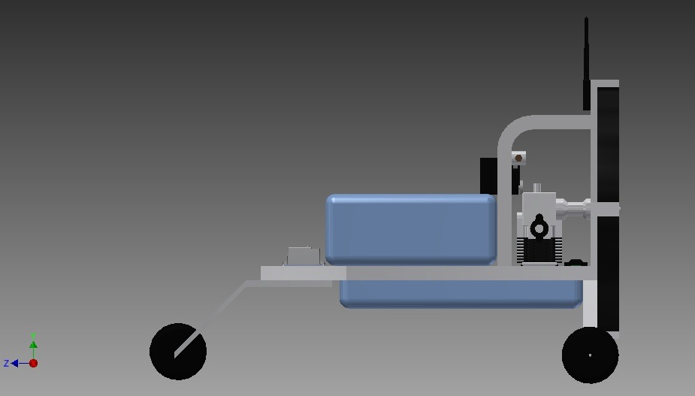
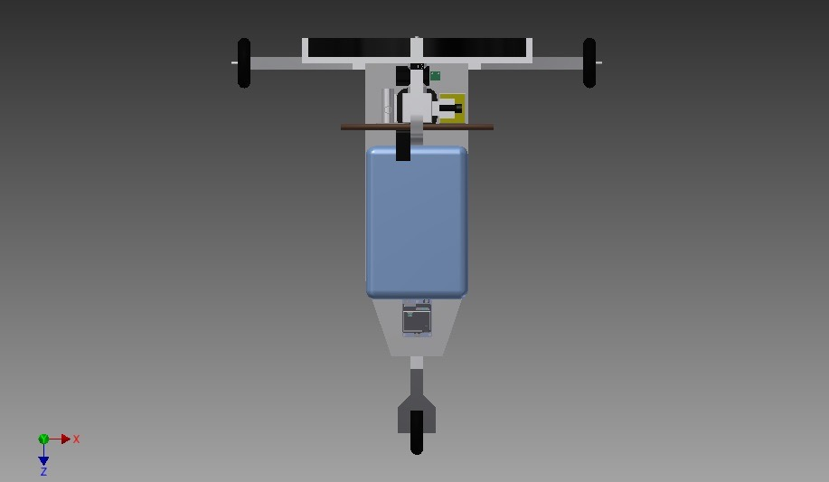

The dimensions of the final National Challenge design are 29.09 inches wide, 29.99 inches high and 33 inches long.
- MISSION PLAN

Precision Agriculture Crop Sensing Pattern

With the crop sensing plan the team thought it prudent to first analyze the field of view of the selected camera. In this case, the Tetracam PixelWrench software was selected to complete this task (which comes with the camera and is meant to calculate the field of view as well as analyze the images provided by the camera). The designers learned that this software allowed the team to input airspeed, capture rate, and sensor properties so that the team could understand the field of view of the aircraft as well as the overlap from one picture to another, fore and aft, as well as to starboard and port. At the cruise speed of 30 mph at 150 Meters (492.13 feet) Above Ground Level (AGL) altitude with the camera settings that were selected the aircraft would have a field of view of 116.369 x 87.410 meters (382 x 287 feet) with the long dimension being with a "fore and aft" overlap of 95% given that the camera would take pictures every 1/2 second. This redundancy in images would allow the final product; the panorama of all of these pictures, to be extremely accurate. The team also modified the flight pattern to allow for a 10% overlap starboard and port to enhance the quality of the data and to allow flight path adjustment should a cross wind gust push the aircraft off course faster than the autopilot could adjust. The equipment selection is such that each pixel with the altitude setting corresponds to an area of about 5.685 square centimeters. This would mean that each pixel would show an area much smaller than a corn plant allowing the farmer to find the location of the European corn borer with great accuracy.

Given this information, along with the fact that the field is a rectangular, the team decided to use the “lawnmower” approach to the flight coverage pattern. This is to say that the aircraft would “mow” back and forth over the search area until it was completely covered. With this pattern, and the 15% starboard and port overlap strategy, the team easily calculated the number of “sweeps” that the aircraft would need to make to cover the entire search area. This calculation was done by assuming that with the overlap each of the end sweeps would be 90% of the total width of which is 90% of 381.79 feet, therefore the width of the field of view for each of the end sweeps is 381.79 which multiplied by two is 687.222 feet, which is the area width of the field covered by two sweeps. Because the rest of the sweeps would be 80% of the full width of the field of view, 305.432 feet to calculate the number of sweeps left to cover the entire field the team subtracted the width covered the first two sweeps from the entire width of the field and divided the resulting distance by the width of the other sweeps. The results of this analysis indicated that 84 sweeps would be needed in addition to the two initial sweeps, therefore the total amount of sweeps required to cover the field is 86.

The length of the field is 25636.42 feet therefore to get the distance covered by the aircraft during the sweeps the team multiplied that width by 84. The turns which would be executed outside of the sensing area were calculated to be 539.7429 feet. The area of the turns multiplied by 84 was added to the distance covered without turns and converted to miles to indicate that 438.791 miles need to be covered for the field to be thoroughly covered.

Using the fuel consumption characteristics of a naturally aspirated fuel consuming gas engine the team was able to calculate the overall endurance distance of the motor/propeller/fuel tank combination to be 349.350 miles. This indicates that it would either take 2 aircraft to cover the field or one aircraft that would refuel. Given that operational costs would continue to accrue long after the amortization of the initial cost of a system has finished the team determined that it would be more efficient to cover the field with two aircraft, each covering half. Therefore, since there are two simultaneous operations the mission time would be the miles covered divided by 30 mph divided by two to account for the fact that two aircraft are simultaneously operating. This gives us the mission time to be 7.31 hours. That figure along together with the eight hours needed for setup is 15.313 hours, therefore given that the staff are paid at $425.37 per hour the overall cost is $6,513.77 per mission, which is calculated with a time that has 10 minutes added for takeoff and landing.

Legal/Regulatory Requirements
Given that a COA (Certificate of Authorization) would only be available in the event of an emergency and the primary purpose of the UAS is not disaster management the team decided to go with a SAC or Special Airworthiness Certificate. The SAC chosen was the restricted category because the choice of an experimental category SAC would have limited operation to strictly the proof of concept of the design. With a restricted SAC the aircraft would have authorization to do aerial surveying as defined by FAA regulation 21.25. This would allow the operator to execute all maneuvers necessary to complete the mission. Thus, the SAC restricted category would give the team authorization to execute all maneuvers specified in the mission plan.

System Detection and Identification
The purpose of precision agriculture is to detect and identify the targeted pests. . With an infestation, there is bound to be a multitude of small corn borers, bugs so small that they might only be detected until it is too late if a detection system like this isn’t used. It was agreed upon by the team that the aircraft and systems that were designed is a great solution. The system the team designed to find the pests so that the farmer can accurately assess the threat posed by the bugs so that the farmer can deal with them effectively and with minimum cost. The system that was designed detects the pests by using multispectral data of the field. If certain multispectral data was received then the pests would be detected, and since the pests are the only organisms that produce a chemical, 11-tetradecenyl acetate. If the spectral signature of that chemical is detected we would have successfully identified the areas colonized by the pests. Because of the nature of detection and identification in the context of this challenge the team was able to treat detection of that chemical and finding the bugs as the same thing. In other words, mere picture would equate to sufficient proof to both detect, as well as identify the pests. (More on this in section 2)

Example Mission

A typical mission with the Unmanned Aerial System (UAS), which includes the ground station equipment and staff plus the aircraft, would be performed in stages; preparation, preflight, positioning, data gathering, final positioning, decent and landing. First of all the user must determine when the borers are in their reproductive cycle so that the UAS could use its system to identify them. Doing the mission prior to being able to accurately find these pests or after they have already done too much damage obviously wouldn’t be smart. Once the date is determined and the team would be mobilized. The first step would be to check the weather conditions, and then a visual inspection of the UAS would be necessary allowing time to fix anything that is broken. Then the user needs to a technical check of the camera and navigation sensors. Then the user needs to review the flight plan and program it into the aircraft. Lastly, before takeoff, a last minute visual and forecast check of the weather would be the standard procedure.

When the user is done with all of the above they would take the UAV outside and make sure that everything is ready for takeoff. The takeoff and recovery area needs to be confirmed clear. Lastly the user needs to confirm that there are climb and decent paths that are free of hazards like trees and so that at any time the aircraft can take off and land into the wind. Given the extremely short takeoff and landing distances needed for the aircraft and the steep climb rates, the team can use relatively small open areas for this task potentially allowing us to launch and recover closer to the field that others might. The team agreed that this point shows just one of the many reasons that the light weight and affordable UAV is superior to heavier, more expensive aircraft and support systems. Right before takeoff all key structural elements of the aircraft would be examined, especially those that are under the most stress as indicated in the stress analysis portion of the detailed design.

When the aircraft is airborne the ground based staff needs to stay engaged even though the autopilot is doing handling many aspects of the flight. They would keep an eye on the sky and make sure that there is not going to be any change in weather. If there is rain, winds above 10 M.P.H., or a storm approaching, in which case they would land the aircraft as quickly as possible. However, considerations for these types of weather did not need to be taken into account for the challenge because they are not within the design requirements. They would also check visually, and with the monitors, to be sure that the aircraft is following the flight plan. There could be a malfunction of the GPS, flight plan program or autopilot. If any of those things happen, the safety pilot on the ground would take over and either carry on with the mission using the ground controls, or land. When the route is completed the flight plan loaded in the autopilot would allow the aircraft to land itself.

After a safe landing the ground based staff would take the UAV to a safe place so that it would not get damaged. Then they would retrieve the data from the UAV, via the SD card on the camera. They would load the data on that card into the PixelWrench program which would analyze the data and find the location of the corn borers. With that information the farmer can figure how much pesticide should be applied and where.

Mission Time and Resource Requirements
The time requirements of the flight plan plus the amount of time needed for the activities performed by the ground based staff will give us a time budget to calculate the resources needed. The search pattern takes 7.31 hours. That figure along together with the eight hours needed for setup is 15.313 hours. The mission time allows the team to determine the cost of labor as well as consumables. There will be three people working on the ground based staff:
- The Range Safety/Aircraft Launch & Recovery/Maintenance staff member,
  - In charge of making sure that the aircraft has no crashes, retrieving and launching the aircraft, as well as fixing the aircraft in the event of a crash.
  - In charge of coordinating flight plans to prevent a midair collision
- The Data Analyst
  - Responsible for taking the SD card from the camera and analyzing the data in the PixelWrench software
  - Data analyst also has a responsibility as a safety pilot for the second aircraft while the mission is being executed
- The safety pilot
  - Keeps an eye on the aircraft as well as the data coming from it to keep it safe. Due to the level of autonomy of the craft an operational pilot is not needed. They would also take control of the aircraft should some of the systems fail.
Table 3.1 Mission Labor Requirements
Position | Cost Per Hour
Range Safety/Aircraft Launch & Recovery/Maintenance | $175/hr
Data Analyst | $150/hr
Safety Pilot | $100/hr
Total | $425/hr

Beyond labor costs, fuel to power the generator during the time when the aircraft is flying would be required. The generator will run 9.6 hours for every gallon of fuel; therefore it consumes the inverse of that per hour, one divided by 9.6 gallons per hour. This makes the consumption of .10171875 gallons for the duration of the mission. Add to that a maximum time of one hour to run the generator prior to each mission to charge the batteries and you have the components necessary to calculate the total fuel consumption.
Table 3.2 Mission Resources Requirements
Resource | Quantity Per Hour | Cost Per Quantity | Subtotal
Gasoline | .10416667 | 3.56 | $.37

Table 3.3 Mission Resources Requirements
Total Per Hour Cost | $425.37/hr
Total Mission Cost | $6,513.77

4 BUSINESS CASE

4.1 Identify Targeted Commercial Applications

4.1.1 Agriculture:
The UAS can cut costs and save time by covering hundreds of acres in a small amount of time. Multispectral cameras can take a picture of the area and assess the damage to crops, as the wavelengths received vary when plants are diseased. Using the camera we can identify pests on crops by detecting pheromones on the plants that can make a change in the amount of light reflected off the leaves.

4.1.2 Antarctic Exploration:
The UAS can be used for research also. The UAS can be sent to Antarctica to collect data about survey wildlife and the rate of melting. It can take pictures of wildlife and use infrared to monitor wildlife movement, as well as find people and animals in low visibility situations. We can also measure the albedo of the ice which can provide us with information on how old it is, and if it is melting. If the ice is reflecting less than it will be absorbing more sunlight, which will cause it to melt.

4.1.3 Canopy Cover:
The UAS can be used to fly over forests and collect data on the canopy covering of forests. The UAS can provide scientists with key knowledge about the reflectivity of the canopy, allowing them to easily diagnose problems in forests on a large scale.

4.1.4 Oil:
The UAS can fly over the landscape and use cameras to observe oil spills in the water. The UAS can fly over the part of the water that is affected by the oil spill. They can provide multispectral imaging data to those in charge of the clean up, including adding capability to locate heat emitting objects, taking the guesswork out of low budget operations. We have to take into account the visibility of the oil and that depends on the thickness and the weather. The UAS may not be able to detect thin oil and other visual interruptions such as fog, ice and trash. The ADC micro would be the best camera to detect oil spills as it is economically efficient and has ultraviolet, infrared and visible light capabilities.

4.1.5 Soil :
The UAS can use its NIR capability to see the heat reflectivity of soil, building scientific knowledge, as well as giving farmers key insight. It would be able to help with crop management using the infrared camera to monitor crop growth. By using the UAS, it is much less expensive compared to collecting data from a manned aircraft. Including the low price, the UAV has the capability of flying at lower altitudes meaning that it increases the spatial resolution. The price point would give the UAS a competitive edge in this field as well.

4.1.6 Spectral Library:
Imaging spectroscopy is the measurement of solar radiation reflected from the Earth's surface in contiguous, narrow spectral channels spanning the wavelength region from 380 to 2,500 nm. Compared to the traditional red, green and blue, spectral imaging takes the range and divides it even further. Spectroscopic readings can help build scientific knowledge in astronomy, agriculture, life sciences, chemistry and physics. The UAS is a good choice for low budget researchers because of it’s wide range of uses.

4.1.7 Tsunami
The UAV can also be used to locate and save people who are affected by tsunamis. The UAVs can be immediately sent out after a tsunami hits. The UAVs camera can track changes in reflections at the disaster site, which will allow rescuers to locate people faster. Not only can a UAV track a person they can also track the actual tsunami. If it is suspected that a tsunami will hit soon, a UAV can be used to sense unusual plate movements. This will give ample time for the citizens of nearby cities to react and get out of the city safely. However, this method won’t always be accurate. The competitive pricing allows virtually any level of government access to these capabilities.

4.1.8 Water
The UAS can also be helpful when monitoring water leaks. The use of the UAS can help tell whether if there’s a leak in a water system. It is a cheaper way to keep track of water meters. This will prevent a city from losing unnecessary water and save money by using a more efficient way to keep track of water leakage. In the unfortunate situation of a flood the UAS could locate people, facilitating rescue efforts. The competitive pricing of the UAS could make this available to near any municipality.

4.2 Amortized System Costs

4.2.1 Direct costs
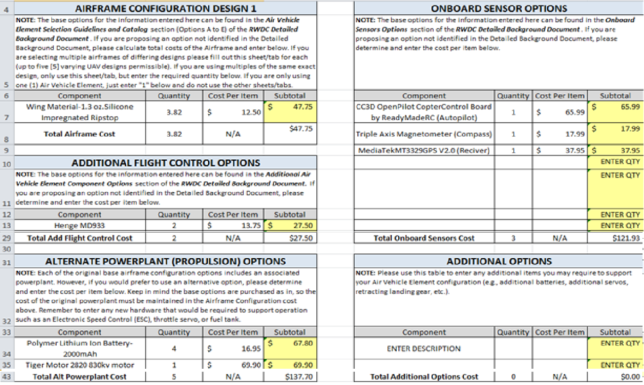
The initial cost of the system is the sum of all of its parts including the aircraft and its ground station. To determine the cost of this the team had to get the cost of each individual component, and while many components had costs that were readily available online, some posed a challenge to determine. One of those components was the parafoil, which is made out of a 1.3 oz silicone impregnated ripstop fabric. Because the material was so different from that considered in the cost calculator worksheet the team had to analyze how much fabric was used by the parafoil. To do this the team figured the patterns that would be needed to make the wing, and added together the sum of all of the fabric necessary, which ended up as 3.82 yards, and then inputted the cost per yard, which is $12.50 to get the cost of the wing at $47.75. After all of the costs had been inputted into the excel sheet for the aircraft itself, it was determined that the acquisition costs of one system would be $6,603.79

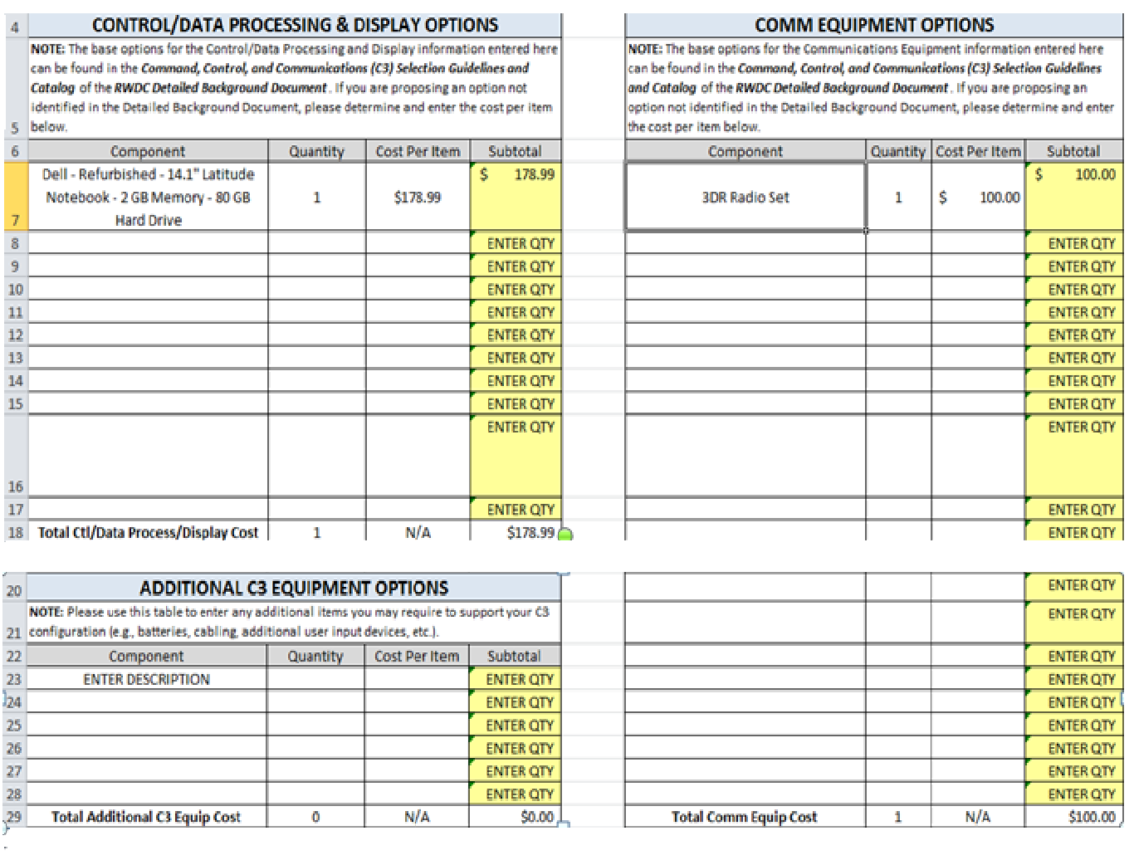4.2.2 Direct Operational Cost Per Mission
The direct operational cost for the UAS was the addition of the costs of all of the operational personnel as well as the consumables. The operation personnel cost $425, and the consumables cost $0.37 an hour, making the total per hour cost $425.37. This multiplied by the mission time which is detailed earlier in the document results in a mission cost of $24,875.64 per hour.
Table 4.1 Operational Costs
Total Per Hour Cost | $425.37/hr
Total Mission Cost | $6,603.79

4.2.3 Amortization
The goal for the amortization was to reduce the total amount of cost incurred due to the inevitable interest rate,and that was what was done. It was discovered that the more frequent the payments were made and the shorter the time span, then the lower the interest-only payment would be. Multiple experiments were done using an amortization calculator. We experimented on the amount of interest paid based on changes done to the payment frequency, which also played a role in how high or low the interest rate was. Using this information, a monthly payment plan was created, and with a principle cost of $6,603.79, an annual interest rate of 4.0%, and a total of sixty payments, the monthly payment amount would be $121.62. The total payment due at the end of the five years would be $7,297.20 with $693.41 of that being the cost accumulated from the interest.
After the first year we would have made enough money to support all future expense. With a total profit of $528,030,440.31 (also our cumulative net cash flow for the first year), we could pay off the cost of our consumables and staff, with enough money to continue our amortization plan. This would also prevent us from having to borrow money for the remainder of the four years since we have surplus, so the amortization cost does not go up.

4.3 Market Assessment
Given the data from the objective function Mathcad sheet, the objective function is 8.73 bushels per dollar this allows us to get a good look of about how many bushels of corn the aircraft is going to save from corn borer infestation each year. Because the amortized cost multiplied by the 50 missions traveled throughout the year is $330,189.69 the number of bushels saved from infestation over the course of a year is 2,348,269.47. Considering the amount of money saved, using a cost of $4.50 per bushel the extra earnings by farmers per year on a 50 mission basis would be $528,360,630.00. This would mean that for each mission the user is gaining $528,030,440.31. This would make the system very competitive given that a similar aircraft would cost upwards of $10,000 and have far more operating costs than the one designed by the team. Additionally the team has a more advanced detection system to detect the pests much earlier than any similar aircraft allowing for farmers to save more corn than they would have if the European Corn Borers were detected at a later stage. This provides the team with a huge advantage over the competition.

4.4 Cost/Benefits Analysis and Justification
The team placed a special emphasis on making sure the aircraft and its operations were as cost efficient as possible, while also assessing effectiveness of the materials we switched too. A large majority of the materials did not come from the RWDC Catalog, as the team tried to turn to cheaper third party sources whenever it was optimal. One example of this is with the sensor payload. The ADC Micro is equivalent or more efficient at detecting larger areas than a majority of the given sensor payloads, and at much less the cost ($3,795). The objective function factors in both cost and effectiveness in the final design. Because the objective function is ultimately the final variable by which a team is measured, the First in Flight team put specific emphasis on cost and benefits tradeoff. One other key example is the operational personnel selection. Because the per-hour cost of these individuals can be so expensive, the team tried to only include those persons absolutely necessary.
As far as Engineering and Construction personnel was concerned, the choice was made to only include a Project Manager to look over the “per-hour” workers, as all of the other tasks were not necessarily required for the aircraft!
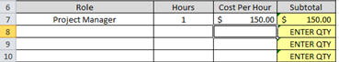

5 TEAM ENGAGEMENT

  - Team Formation and Project Operation

Roles
In the team’s project formation several roles were identified; Project Manager , Chief Design Consultant, Chief Operation Consultant, Chief Business Case Consultant, and Record Keeper. The Project Manager is accountable for the project as a whole. The Chief Design Consultant is accountable for the design of the craft. The Chief Operation Consultant is accountable for all decisions related to onboard sensors. The Chief Business Case Consultant is accountable for the business case. The Record Keeper is accountable for recording the entirety of the project, as well as working as the human resources manager.
Rationale of Role Assignments
Dennis Quaintance was selected for the Project Manager position because he took initiative, and his colleagues saw it appropriate. Carlo Lindner and Dylan Jordan were both selected for the position of Chief Design Consultant, because they were accountable for the plane design on the winning team for North Carolina last year. Phillip Sous was selected to be the Chief Operation Consultant because he showed ingenuity and a proficiency in electronics. After Phillip had to depart the team, Mercy Adekanle replaced him as Chief Operation Consultant seamlessly. Via Abiera and Christine Nenhuis were selected to be the Chief Business Case Consultants because they had a solid understanding of finance, and were both skillful writers. Dhaval Mheta was chosen as the Record Keeper, because of his observance and neutrality. It is important to note that these role assignments are solely indicative of each member’s highest responsibility, and that every member has experience in every area. The approach used for the National Challenge in determining team formation did not change from that used to address the State Challenge.

  - Acquiring and Engaging Mentors
We opted to use two mentors close to us, rather than exercise the option to choose one from the catalog located around the United States. These mentors were Mr. Samuel Bays (math teacher), and Mr. Dennis Quaintance (team parent). Mr. Bays offered his wisdom in the areas of flight dynamics and air vehicle construction. He helped with mathematical analysis throughout the whole project. Mr. Quaintance helped with the focusing the team on the overall scope of the project, and gave the team valuable advice when constructing the final design and product. For the National Challenge, the team opted to use their resources within North Carolina A&T State University, and contacted Dr. John Kizito, associate professor within the Mechanical Engineering Department. Dr. Kizito and his students provided valuable feedback for the team’s presentation and helped the team to refine the presentation of the material
  - Tool Set-up / Learning / Validation
Installing the software was quite straight forward, although, the group encountered some obstacles once the software was downloaded. Some members had software from last year, such as Creo and MathCad, which did not work. The team decided to use computers that didn’t have last year’s software on them. The modeling process, while challenging, was aided greatly by the tutorials available on ptc.com. The stress analysis feature of Inventor Pro, a third party program, helped greatly in verifying the design’s effectiveness. During the National Challenge, the team moved away from Creo and into Inventor to model the aircraft, both for ease of use and accessibility of downloaded parts (engine, fuel tank etc.)

  - Impact on STEM
    - Dennis Quaintance
“As Project Manager of the team the Real World Design Challenge greatly changed my view about STEM. I now have a much better idea of leadership and its application in STEM fields. Coordinating this project has been extremely rewarding and even though it was a lot of work I would love to do it again. Because when I worked the challenge last year I wasn’t exposed to Creo quite as much it was only this year that I realized the full magnitude of the challenges posed by professional engineering software. Fully understanding and working through challenges in Creo have really helped me grow as an engineer and as a person. Because of this challenge I have better problem solving skills and will be more successful in life.”

    - Dylan Jordan
“The Real World Design Challenge fully encompasses all aspects of STEM, and has enhanced my learning in each of the key areas. Science and Math are fully accounted for in processes like MathCAD, Microsoft Excel, and Creo in order to properly measure different parts of the project. Technological skills are required in order to properly use these programs, and Engineering concepts are used to design the plane and complete the project in as efficient a way as possible.
Personally, the Real World Design Challenge has meant a lot to me these past two years. As a freshman, RWDC introduced me to real-life STEM situations, in which I could finally start applying the logic I had been learning my whole life. It was also my first real engineering experience, and even further emphasized group dynamics. It was one of the first times I couldn’t complete a whole project by myself and we had to assign different roles, and let different people be fully accountable for separate parts of the project. It was the closest to an actual work setting in which we had to share information across a large team to accomplish an end goal.”
    - Carlo Lindner
“The Real World Design Challenge’s focus is Science, Technology, Engineering, and Math, or STEM for short. However, the competition differs from a normal classroom since it not only teaches about the subject of aeronautical engineering, but it also challenges the participants to find a solution to a complex problem in a professional environment. The competing teams learn not only about engineering and aviation, but also about teamwork, communication, planning, and professional etiquette.
RWDC also exposes students to professionals in the field, which provides an insight to how the engineering process is used in a business environment. Being able to talk to these mentors and ask them questions about their own engineering experiences helped me and my team organize ourselves and perform more efficiently by gaining a more profound understanding on how STEM can be used to solve problems in the real world. Not only was I able to apply my newly gained knowledge to the RWDC project, but I have also performed better in school through better time management and by learning more about STEM.”
- Mercy Adekanle

“The Real World Design Challenge has changed my view of jobs in the STEM related field. When I thought about STEM I thought of doctors, researchers, engineers, things like that, and although they are members of the STEM community, they are only a fraction. I never thought about the important roles that leaders and project managers had in the STEM community. I also never considered the interdisciplinary tasks that go on in STEM. When you look at people in the STEM community you only see the results. You see the brand new iPhone but you do not see the engineers who conducted the research and analyzed data. You also do not see the biology based researchers and the chemistry based researchers who came together to create the brand new microfluid screen, or the project manager who stressed to make sure everything was in the right order. All you see are the end products, but now I am aware of everything that goes into making that end product. Knowing this makes the thought of partaking in the STEM field more interesting because I get to work not only with people in my field, but with people outside of my field as well and meet new people who share similar, as well as different, views and theories. “

    - Via Abiera
“The Real World Design Challenge has altered my entire perspective on the concepts that I previously had acknowledged in STEM. One of the most important concepts that I have further developed is the fact that these fields constantly work together, instead of being thought of in vacuums.”
    - Christine Nienhuis
“The Real World Design Challenge has changed my view on the four fields of STEM, which are science, technology, engineering, and mathematics. Science is important when learning about the different aspects of a plane that allows it to fly. Once we learned the basic science behind a plane, then we use technology like Mathcad and Creo to calculate and design the plane. The mathematical calculations will make us certain that the plane will fly. The engineering process allows us to perfect this design, so that we have a more proficient product.
The Real World Design Challenge allowed me to have a broader understanding on these four topics, which will ultimately help later when I’m trying to find a career. I have learned what it’s like to work on a real design team and I think that it is a great experience for me to learn about all of these things which I will hopefully be able to take with me in my future.”
- Dhaval Mheta
“As my capstone project I am participating in the Real World Design Challenge (RWDC). RWDC is a project where we are given a problem and asked to fix it using technology. This technology is mostly unmanned vehicles (UAVs) and sensors to solve a problem in the Midwest with a bug that feeds on corn. This innovative experience has changed my view on STEM in certain ways.
I used to think of STEM as strictly math/science, but now I understand that it is more geared for the 21st century and that there is a big focus on technology and teamwork. We work in teams of seven or eight and discuss ideas for designs and solutions. This helps us learn how to cooperate with others and communicate with others too. Another thing we do is use computer programs. We also use Mathcad and Creo to calculate complex quantities and design UAVs. Open VSP is another program we use to create designs. This capstone has been a fun a learning experience so far, and I hope it gets better from here.”
- Philipp Sous (past member)
“The real world design challenge changed my view of STEM because it made me realize how I will have to work in the future if I get a job in the STEM field. For one, it taught me about time management. It is really important to do all of your work on time or else the whole group falls behind and it will be hard, if not impossible, to get back on track and be able to finish the whole project on time. Also, when you are working alone on a part of the project, you need time management because you will have to figure out at what time you need to do the work to be finished on time.
This project also taught me about how we are going to work in groups in the future and how hard it is to get the whole group organized. For example, we had to find days at which we could all meet, but that would not overlap with other activities that each group member had. The division of the work was also an important part because it was not easy to divide up the work so that each student had an equal amount and when each task was to be done, since some people need the work of others to be able to do their own. To be able to finish the project and get a good result, everyone has to do what they are supposed to and do it in the most efficient way possible.”

