Four-Bar Linkage
Lesson Plan

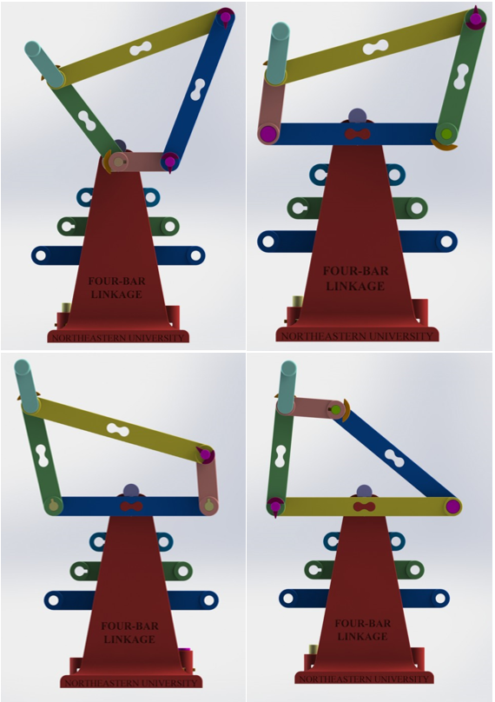

Goals
- Understand how linkages can be used to simply control motion within a bigger assembly
- Understand the difference between Grashof and non-Grashof four-bar linkages
- Be able to manipulate the same members to perform multiple different actions

Background
A linkage is a series of bars connected together, that are used to control motion. Four-Bar Linkages have a special set of constraints to them known as the Grashof Condition, in which the sum of the lengths of the shortest link and the longest link is less than or equal to the sum of the other two lengths. In this case the shortest link is able to fully rotate about itself. When the condition is not true the shortest links motion is constrained.

Instructor Prep
Follow the Instructables instructions to print and assemble the device.

Familiarize yourself with the concepts demonstrated by the device.

Class Activities
Describe to the students the different forms of Four-Bar Linkage.

Have the students work with the model to discover the different configurations.

Have the student draw the path of the shortest link along the path it travels during the full range of motion of each configuration.

After Class Activities
Have the students research the different uses of linkages in real world applications.

Have the students design a linkage to perform a simple task.

Additional Materials:

http://en.wikipedia.org/wiki/Grashof_Condition#Grashof_condition

