1. Go To https://www.bluehost.com/track/mkamilson/(or Any Other Web Host)
Remember: Since I’m using Bluehost myself, I’ve negotiated a small discount for websitesetup.org visitors. Use this link to activate it.
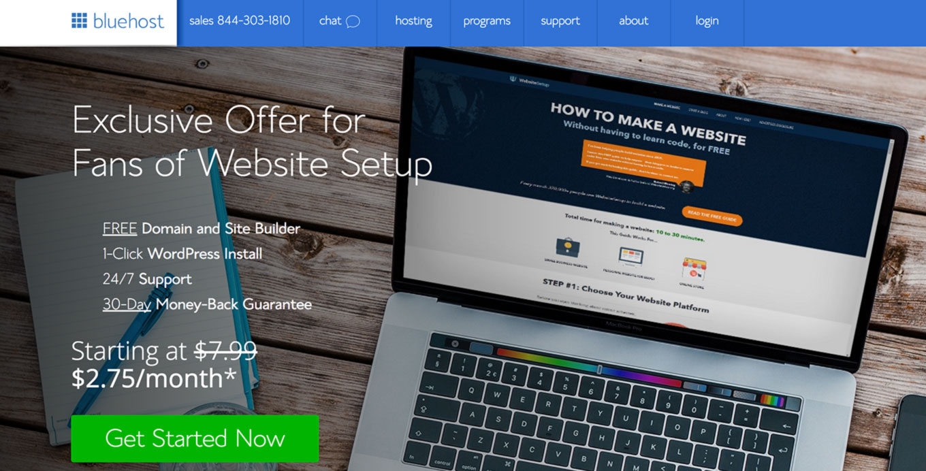

2. Choose Your Website Hosting Plan
Once you click “get started now,” you’ll be taken to a page to select the hosting plan of your choice.
- Basic
- Plus
- Choice Plus
If you are on a budget, you can use their “basic” plan. It’s great for smaller sites with low or no traffic.
However, if you want to scale or expect more traffic to your website, I recommend choosing their “choice plus” plan. It’s truly unlimited.
Whichever you choose, you can later upgrade or downgrade based on your needs.
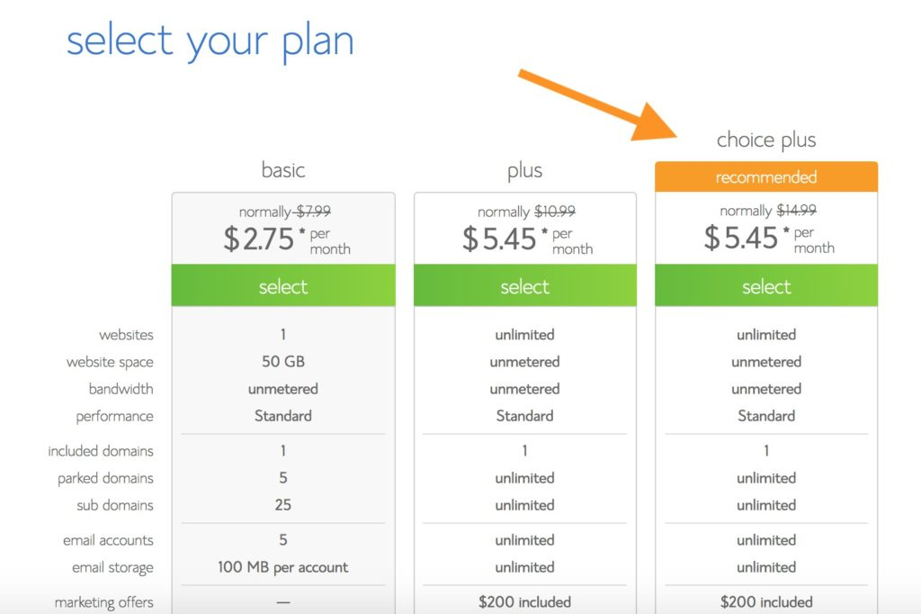

3. Choose a Domain Name
If you don’t have a domain name yet, here’s an easy starting point:
- If you’re making a website for your business, your domain name should match your company name. For example: YourCompanyName.com
- If you’re planning to set up a website for yourself, then YourName.com can be a great option.
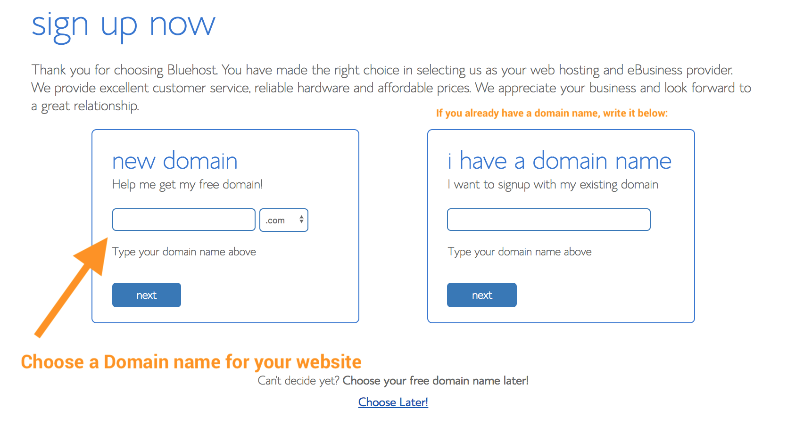
For this site (Website Setup), I chose websitesetup.org because WebsiteSetup.com was taken at that time.
Domain names usually end with .com, .org or .net, but in the recent months, a huge amount of domain extensions (the end part of the web address, like .com) have come out, ranging from .agency to .pizza.
My best advice? Avoid the weird extensions and go with .com, .net or .org unless they perfectly describe what you have to offer – and even then, see if you can find a more common name.
If you’ve already got a domain name, just enter it in and click “Next” on the “I have a domain name” form.
If you aren’t ready to choose a domain right off the bat, you can do it at a later point in your website setup.

4. Fill in Your Account Details
To create your account, just enter in your personal information on the “create your account” page.
You’ll need to add in your first name, last name, country, street address, city, zip code, phone number, and email address. Your receipt will be sent to the email address you enter here.
It’s optional to also add in your business name within this form.
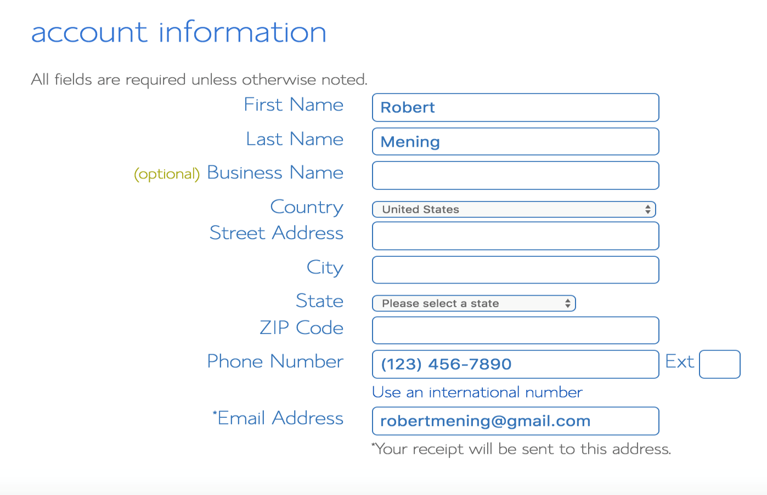
Enter your payment information to continue.

5. Check Your “Package Information” and Finish Registration
The next step in registering for a Bluehost account is to select your plan and package.
These are the last steps you’ll go through before your account creation is complete, so you are almost there…
Simply choose the length of your web hosting registration and you’re good to go.
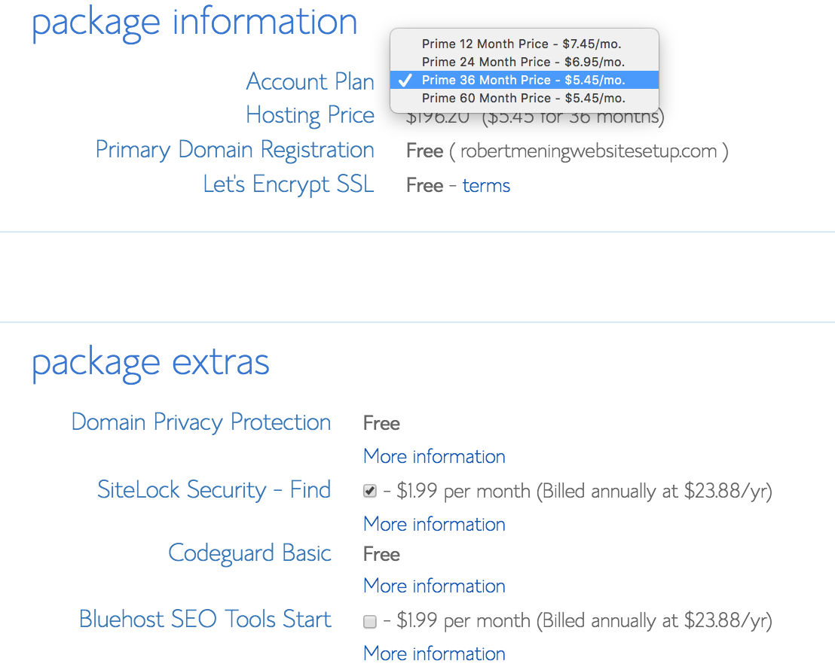
If you chose their “Choice Plus” plan you’ll already have Domain privacy and Codeguard basic included. Otherwise, I recommend getting a domain privacy protection.
This keeps your registration information fully hidden from the public. No-one can find out that you are the owner of your domain.

6. Create Your Password and Log into Bluehost
Once paid and registered, you’ll be able to create your password:
