Humane Spider Trap.

This “humane” spider trap was inspired by family members with severe arachnophobia. The worst spider for them is the huntsman because of its size. Other insects such as large cockroaches are also a problem.
The trap is designed to be attractive to a spider threatened by approaching predators, and suggests a safe haven or escape by offering what appears to be a black pathway to a black hole in which to hide. For the human, capture is done remotely, at the end of a broomstick or other piece of dowel. The trap seems to work as intended, because the cockroach or spider usually heads into the hole and curls up. This is comforting for the catcher who can place the lid on the open end of the trap, for safe disposal of the contents by a quick flip of the handle.
Description.
The trap is made from a transparent soft drink bottle with straight walls and a screw top lid. The label is removed and the bottom of the bottle cut off just where the curve forms. This acts as the lid of the trap. The bottle top is painted black inside and screwed to the end of a broom handle (or dowel) of a length chosen by the distance at which one wants to use the trap. For example if one wants to catch the spiders or insects on the ceiling or at similar distances, a standard broom handle length works well. If this is too clumsy, shorter rods and/or a smaller drink bottle can be used for more confined places.

Figure 1.

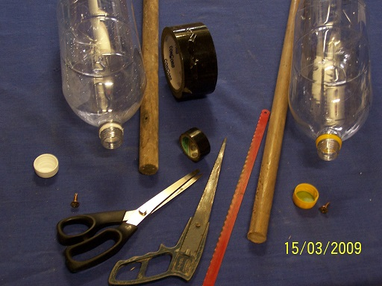
The reason for this type of bottle is that the walls are flexible for fitting into uneven places or corners in order to prevent escape. The transparency is important so that the prey can be observed at all times through the trap wall and so that the spider cannot see the trap approaching. A black stripe leading upwards from the edge of the trap provides the spider or insect with an apparent pathway to follow. This black stripe, representing a branch in shadow, leads all the way into the bottle top, the inside of which is painted black to represent the bolt hole, or safe spot.
Instructions.

Equipment and tools needed are shown in figure 1,
Instead of paint or a black felt tip pen, black insulating tape, or rough black carpet tape, which provides a good skid free surface can be used for the inside of the bottle top and for the black stripe.
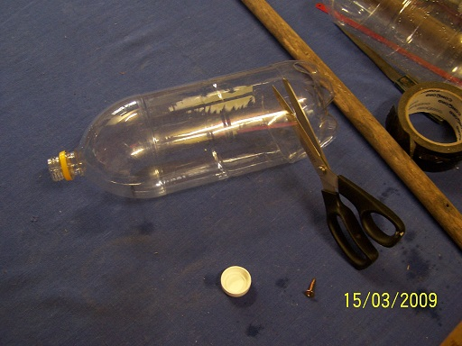
.
Figure 2.
Figure 2 shows removal of the bottle bottom, which is used for closing the trap after capture of the insect or spider, by rotating it and inserting into the bottle. (Figure 3.).
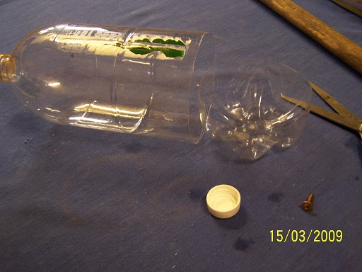

Figure 3.

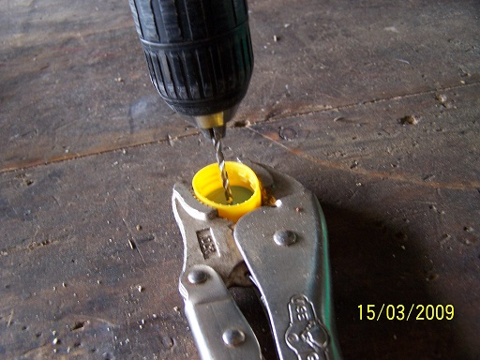
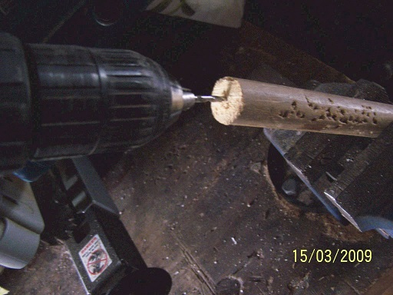
Figure 4. Figure 5.

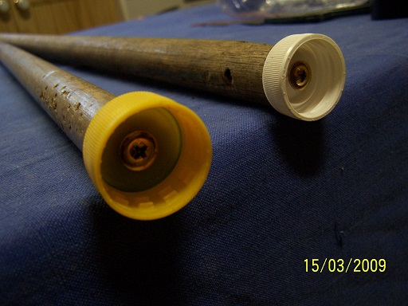
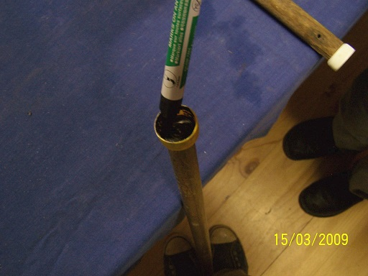
The bottle top is drilled centrally and a similar hole made in the end of the broom stick, (Figures 4 and 5).

Figure 6. Figure 7.

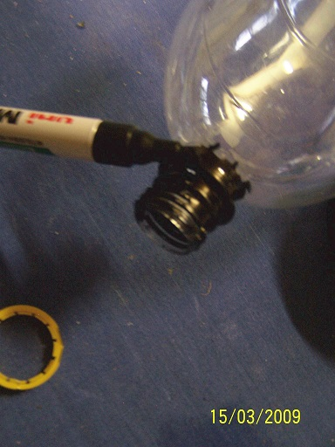
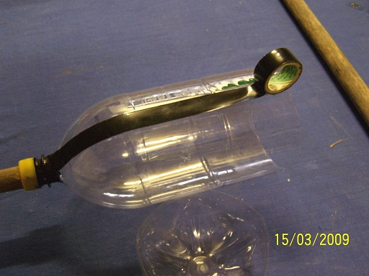
The next figures show the tops screwed in place and their insides coloured black.

Figure 8. Figure 9.

The black “hole” is completed by blackening the neck of the bottle (figure 8) and the black path to safety in the black hideaway is attached with the black insulating tape as in figure 9.

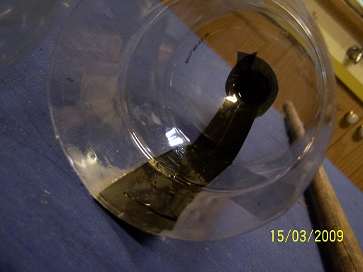
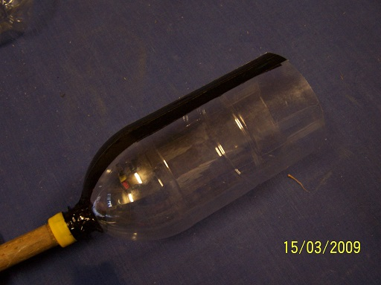
Figure 10. Figure 11.

A view of this is seen on figure 10, followed by the completed trap attached to the broom stick in figure 11.
Figure 12. Figure 13.
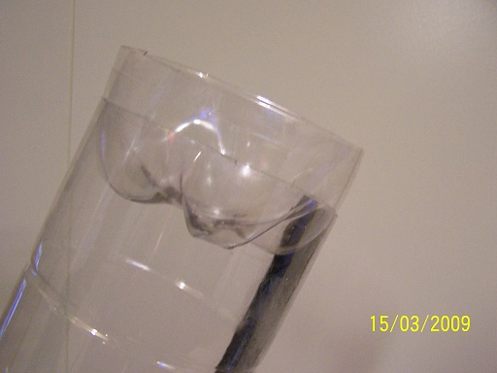
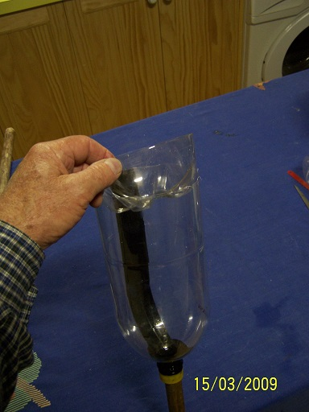
The bottom of the bottle can be attached with a string to the broom in order to prevent its loss when most needed! It is simply placed upside down into the end of the bottle, or the right way up if the bottle shape permits, after the capture. . (Figures 12 and 13.)

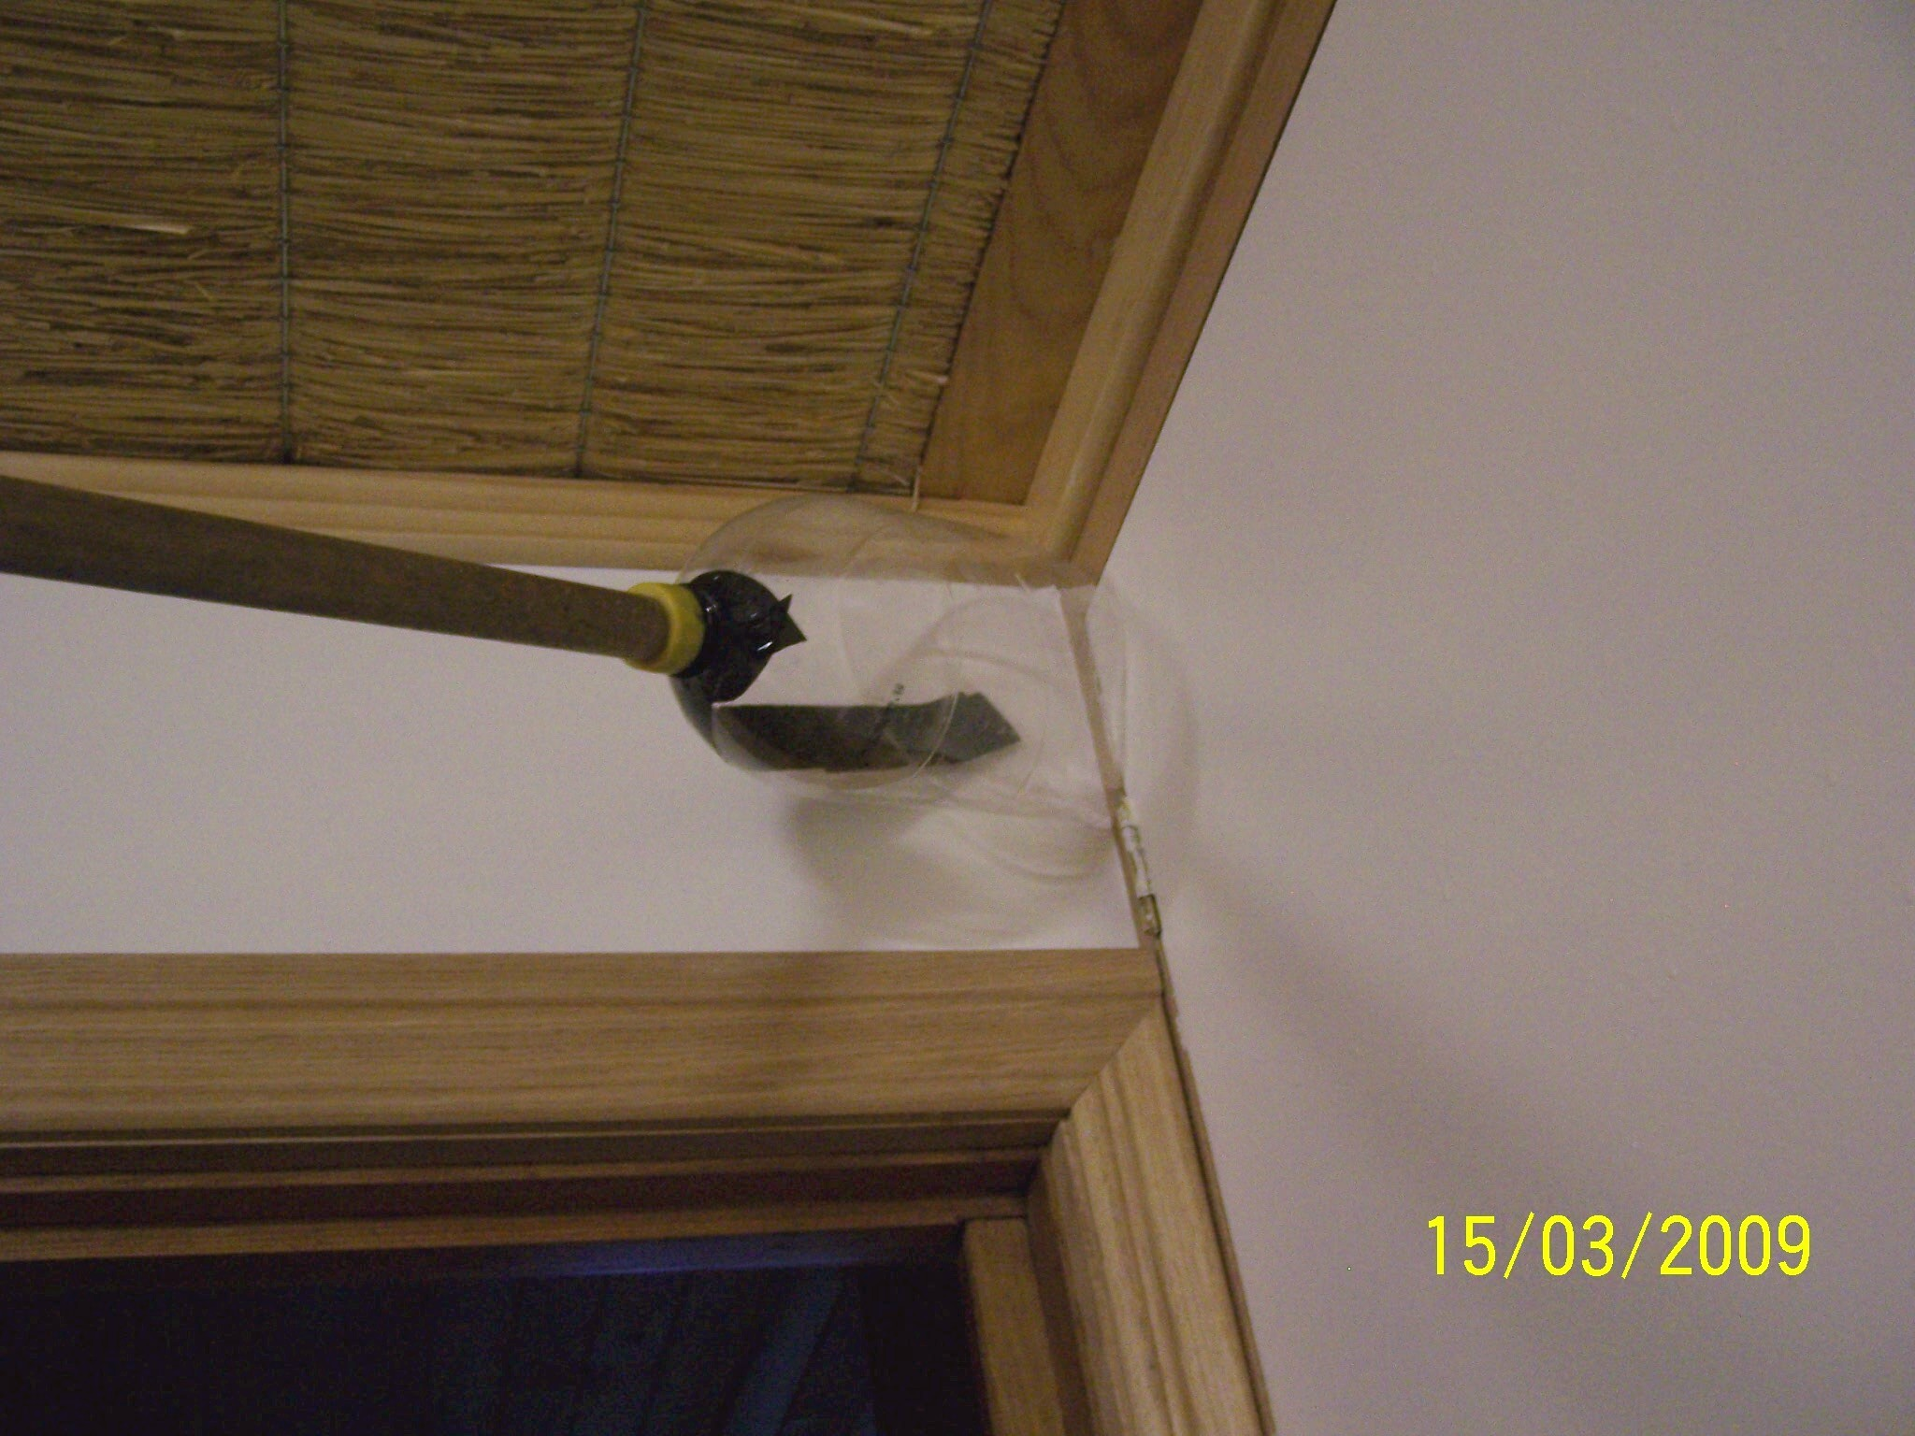
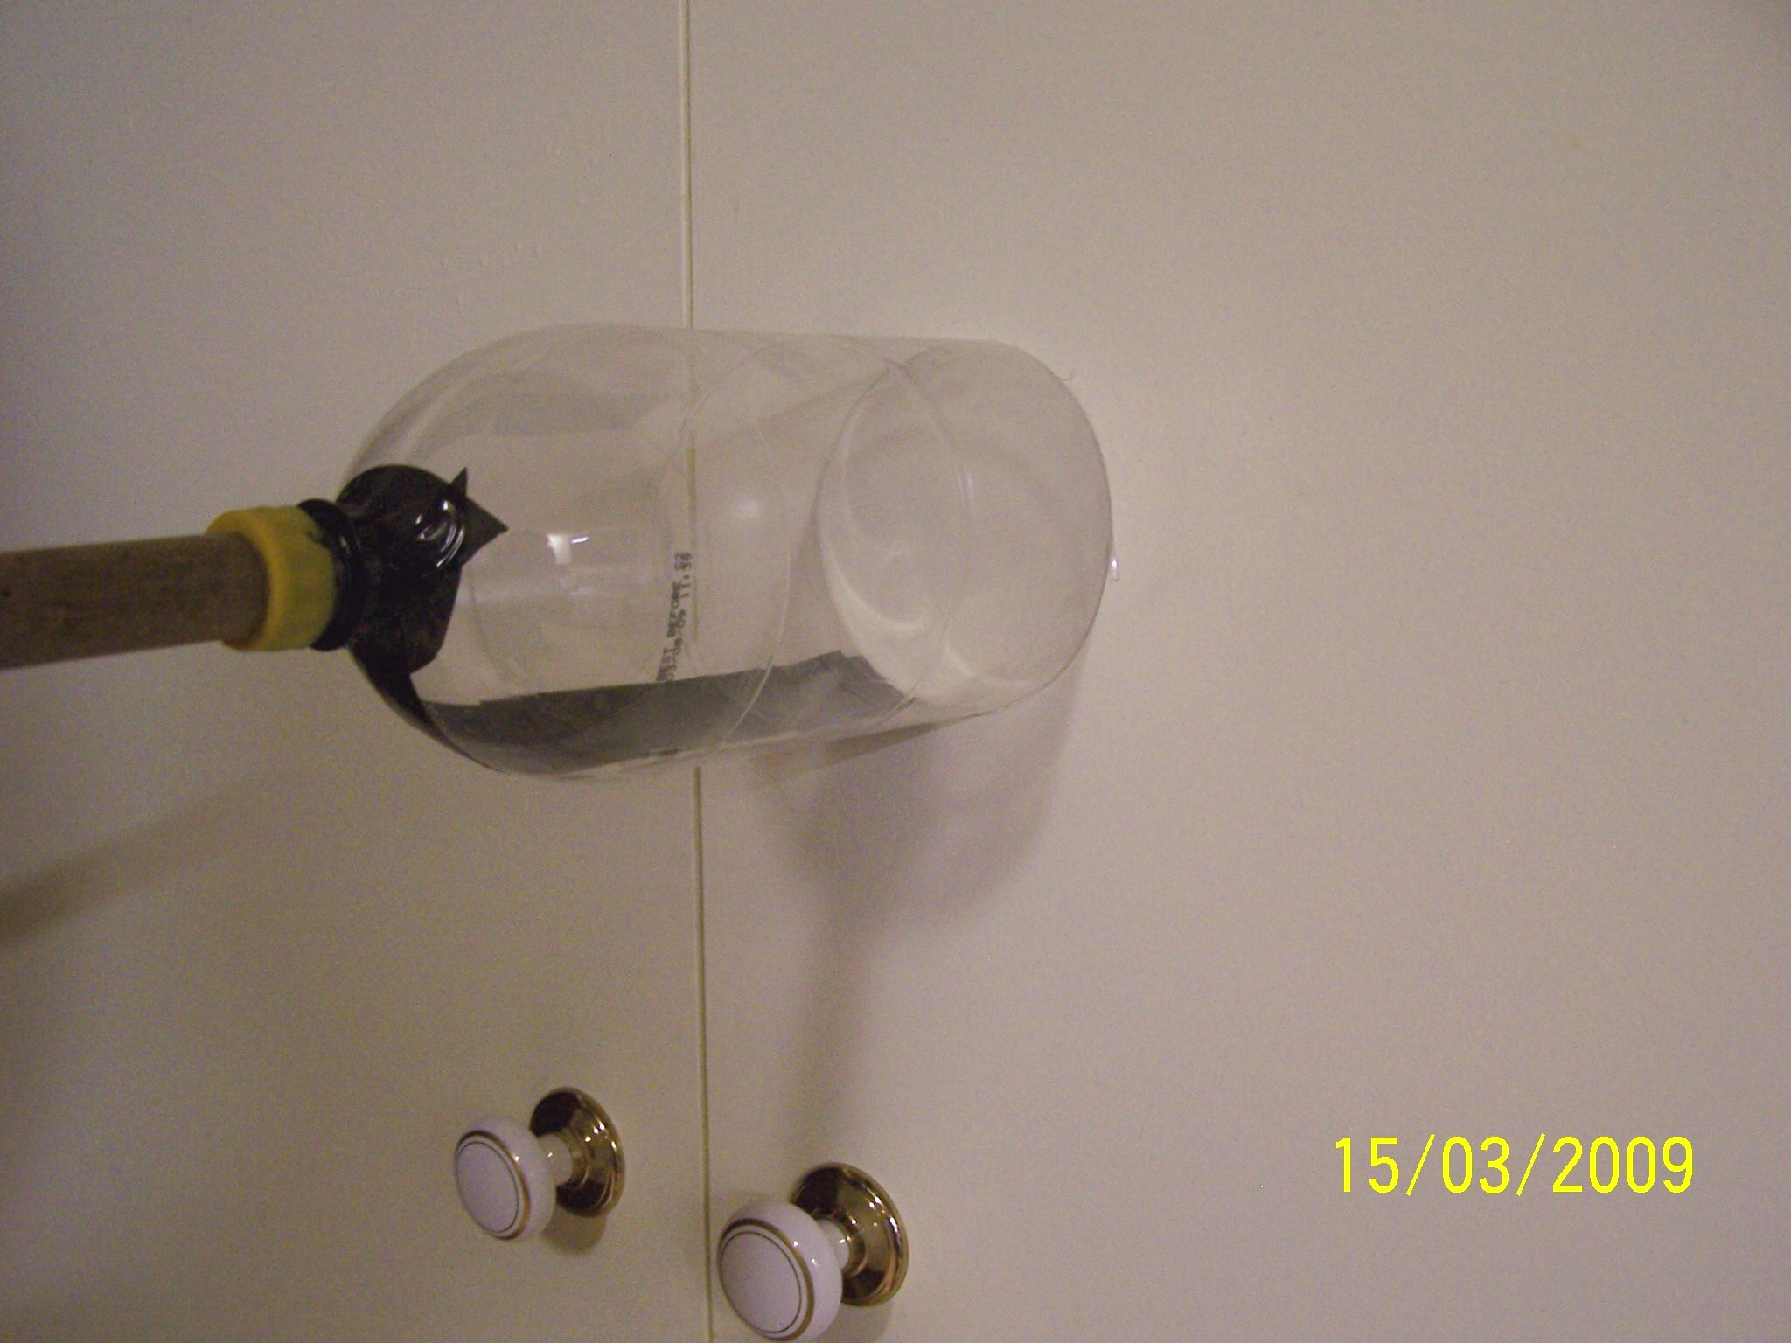
Figure 14. Figure 15.

The flexible sides of the trap can be used at an angle to the wall and in the corner between the wall and ceiling as shown in figures 14 and 15.

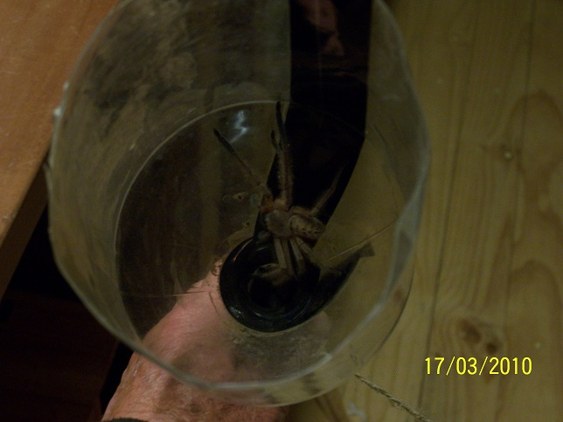
Figure 16. Huntsman spider in trap crawling down black pathway.
The latest small version of the trap, (the one litre plastic lemonade bottle on a short dowelling handle) has black matt carpet tape inside the bottle and its lid. This can be a problem occasionally because the spider has a better grip, and can resist being shaken out of the safe retreat! The trap has been a boon for all who have used it, and takes care of recycling of a few bottles.
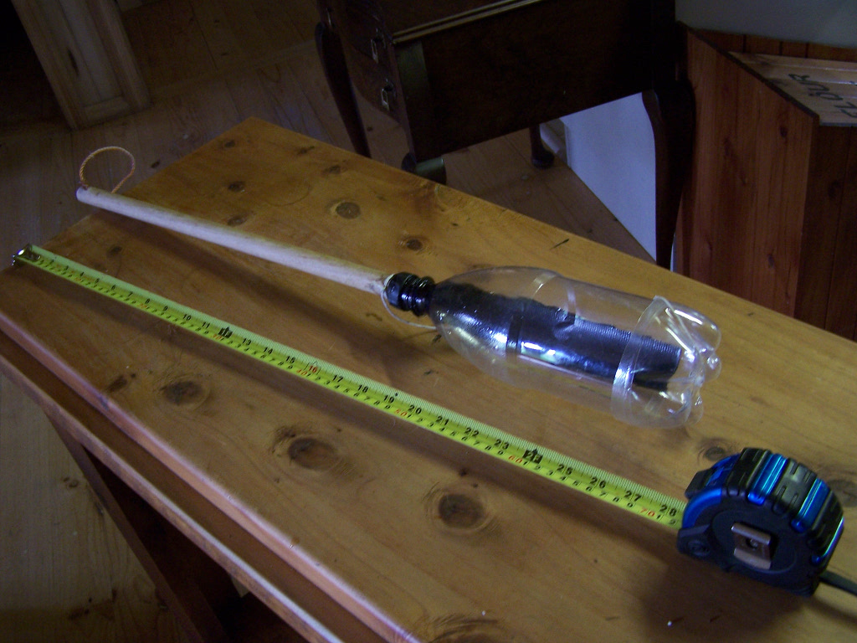
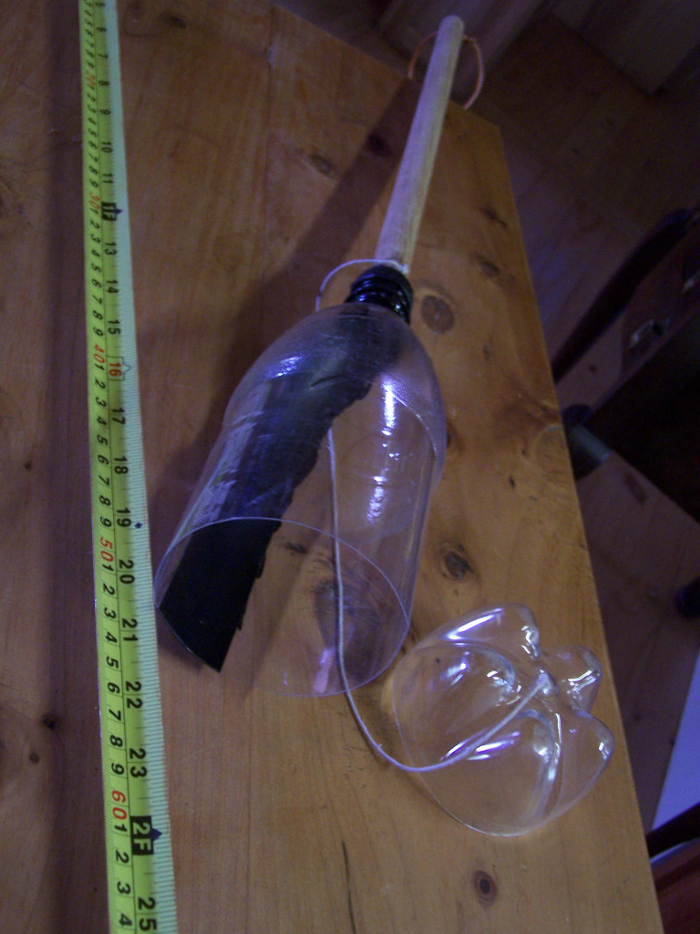
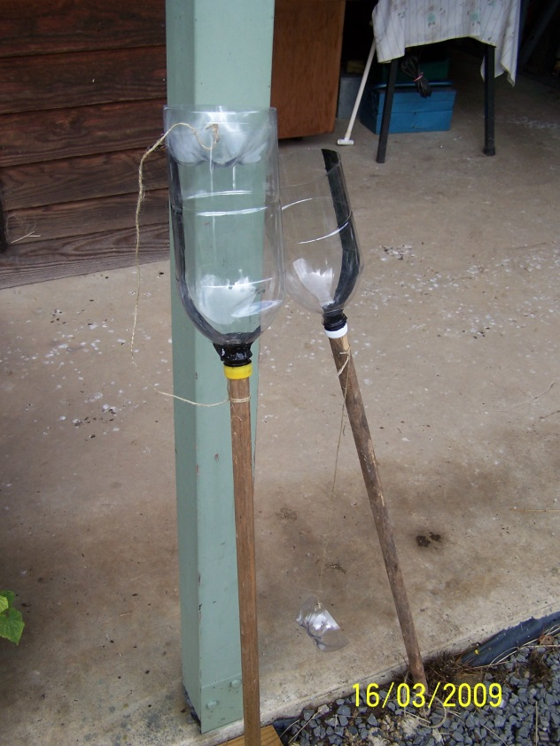

Figure 17. Large traps on the left and small (1 litre) version on the right.

