Rails

- Print rail with 3d printer.
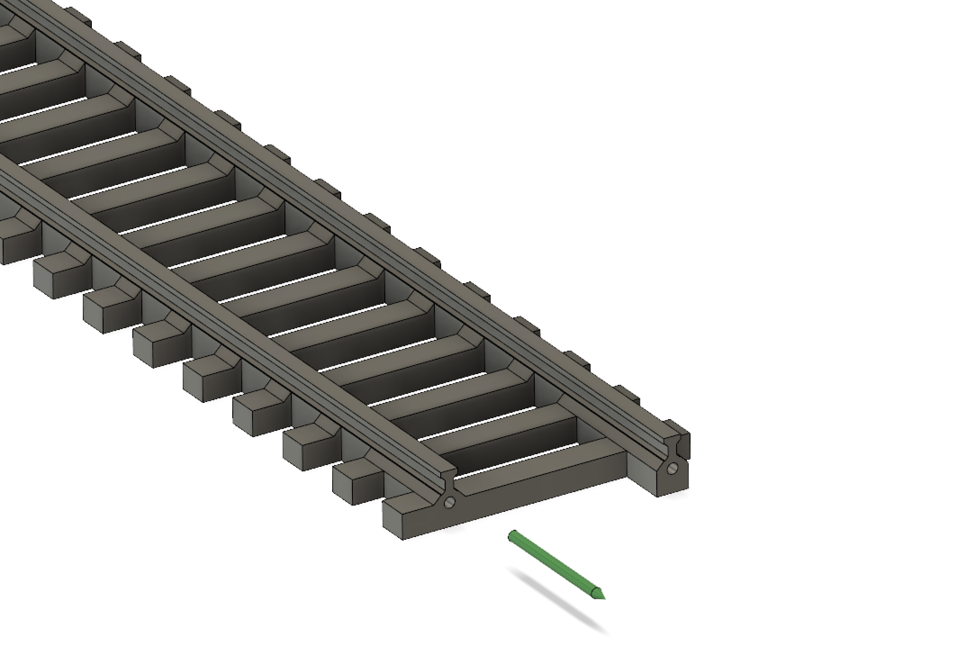
- Cut the 1mm diameter nail at 14 mm length and glue it inside left hole.
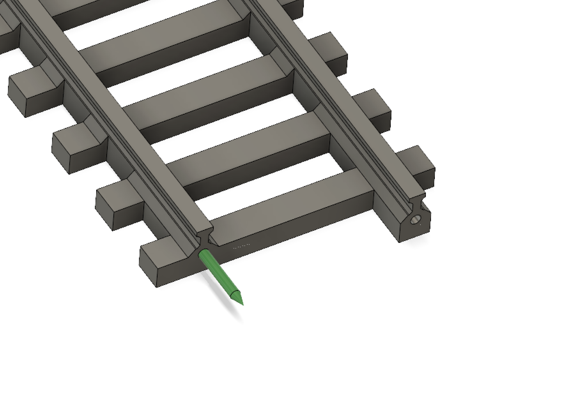
You can drill right hole with 1,1mm drill bit.
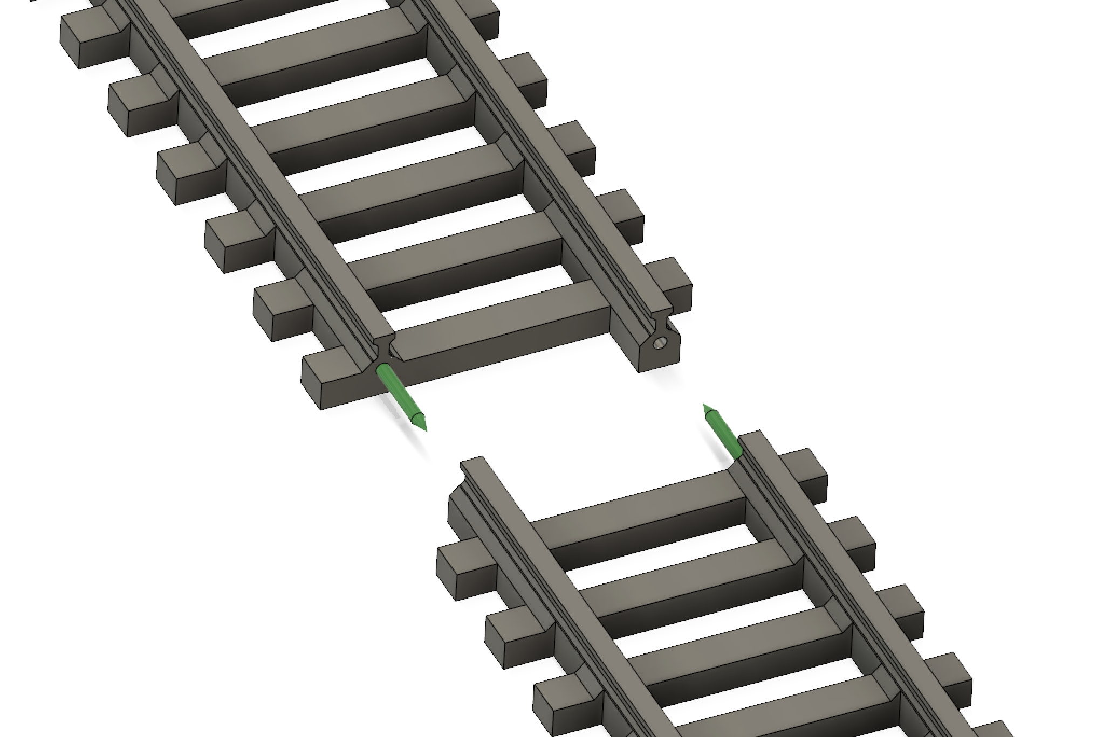

- Connect rails
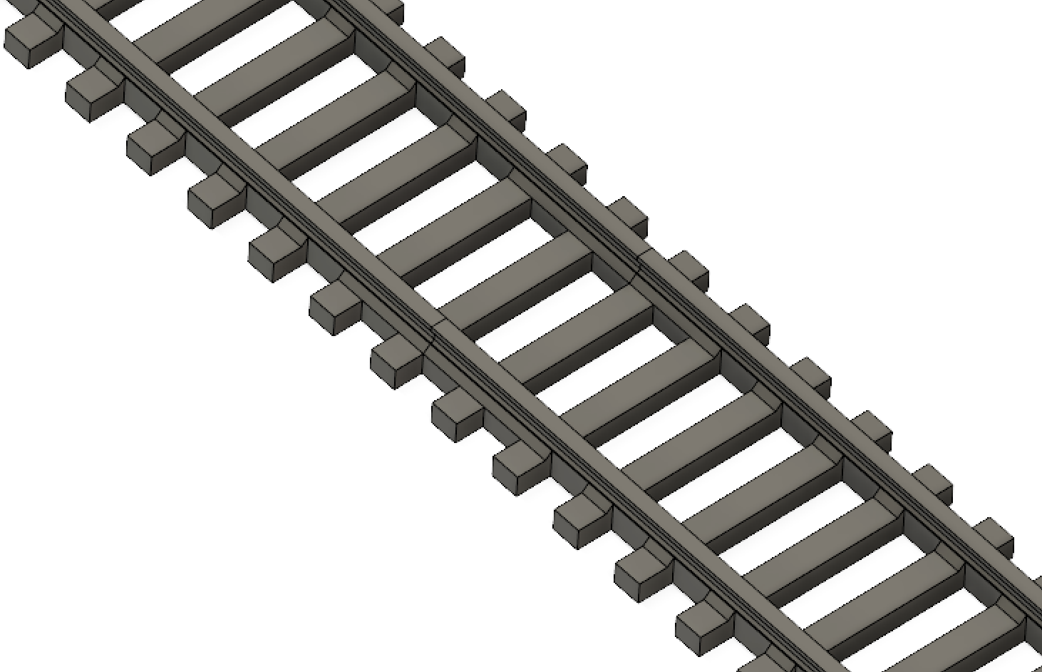
Process is same with curved rails.

