How does a 3D printer work?
Instructions: Label the four major parts of a 3D printer using their correct names.

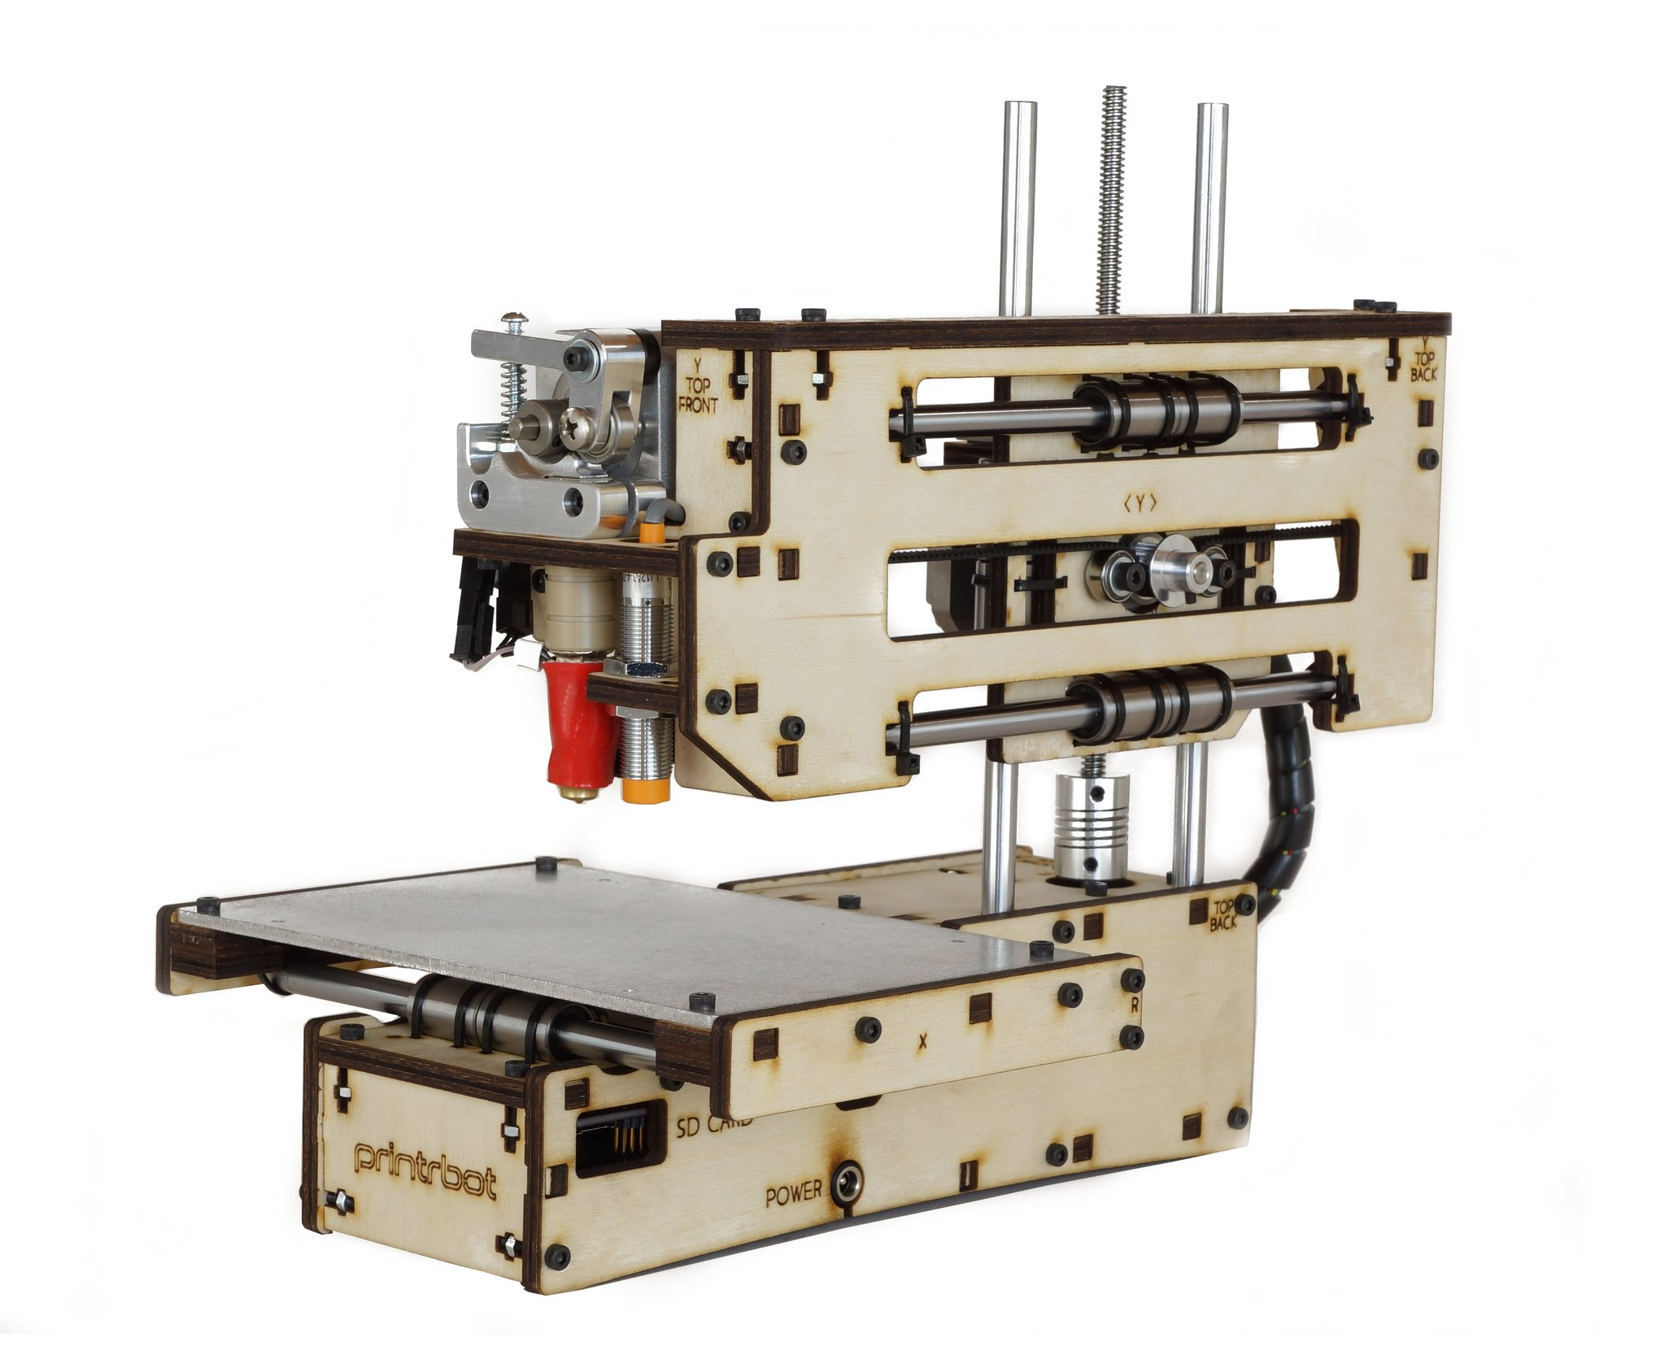

Next Step: Instructions: Sketch something that you would like to have 3D-printed below. Then use CAD or find a similar design online, and print it out...

