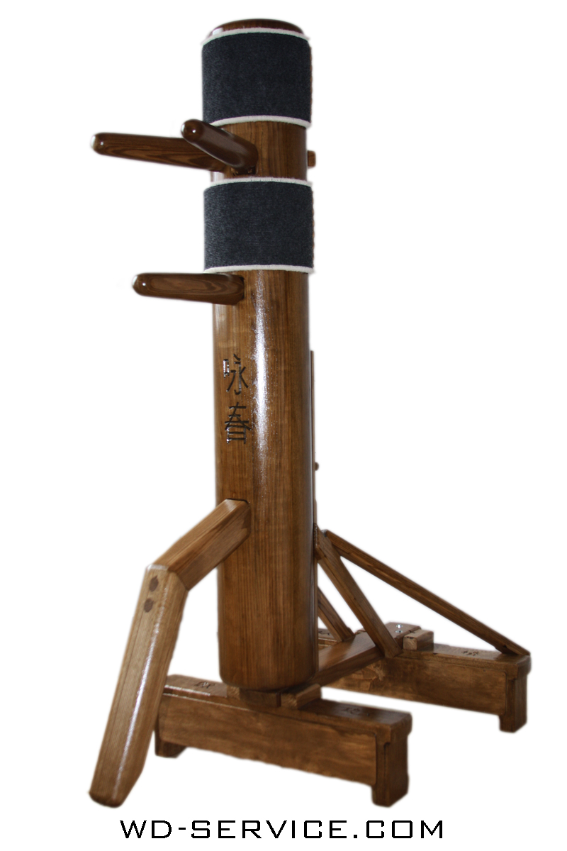

**PROPERTY OF LEO BRITT**

**SMART WOODEN DUMMY**

DATA-DRIVEN MARTIAL ARTS TRAINING AID

Final Project – Fall ‘19

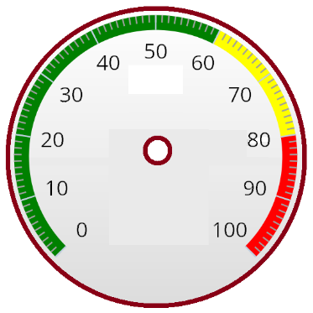   

ROUND TIME SPEED REQUIRED FORCE CALIBRATION

Contact IES before moving: 865-632-2IES (2437)

IES@TVA.GOV