Power Amplifier bridge 180W or stereo 2 x 80 Watts

Circuit dynamic power amplifier circuit with IC Dmos TDA7294 – bridge 180W or stereo 2 x 80 Watts

This circuit described here uses two cis tda 7294 for use in stereo (2 x 80Watts) or bridge mode (1x 180 Watts), to configure this setting just four jumpers. To facilitate mounting the circuit has power supply attached. The power is kind of simple symmetrical with a bridge rectifier 6A, and two large electrolytic capacitors , 10000μF the 22000μF/50v. This Power supply will for the two modules. The processor is recommended 22-0-22 to 28-0-28 / 5A, depending on the quality of the transformer is recommended at least 6 amps of current.
The TDA7294 is a monolithic integrated circuit in Multiwatt15 package, intended for use as audio class AB amplifier in Hi-Fi field applications (Home Stereo, self powered loudspeakers, Top-
class TV). Thanks to the wide voltage range and to the high out current capability it is able to supply the highest power into both 4Ω and 8Ω loads even in presence of poor supply regulation, with high Supply Voltage Rejection. The built in muting function with turn on delay simplifies the remote operation avoiding switching on-off noises.
Another application suggestion is the BRIDGE configuration, where two TDA7294 are used, In this application, the value of the load must not be lower than 8 Ohm for dissipation and current
capability reasons. A suitable field of application includes HI-FI/TV subwoofers realizations.
In stereo, all jumpers must be open and the speakers (speakers) are plugged into connectors Lout and Rout and audio input connectors in the Lin and Rin. In the amplifier in bridge mode all jumpers should be closed and the audio output Lout is (+ the speaker) Rout (- the speaker) and audio input will be Lin, Rin will be shorted to ground via JB2.
The main advantages offered by this solution are:
- High power performances with limited supply voltage level.
- Considerably high output power even with high load values (i.e. 16 Ohm).
With Rl= 8 Ohm, Vs = ±25V the maximum output power obtainable is 150 W, while with Rl=16Ohm, Vs = ±35V the maximum Pout is 170 W.
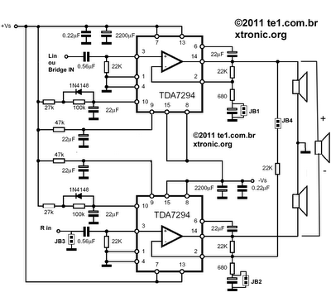

In bridge mode short circuit the jumper JB1, JB2, JB3, JB4

Suggested printed circuit board (PCB) for mounting circuit dynamic audio amplifier with tda7294 – Scale 1:1

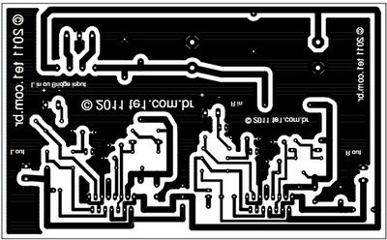

Component side to guide the assembly of the amplifier circuit – Click to enlarge
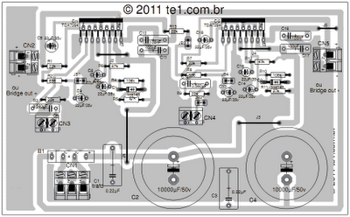
Component list
Components | Value
Resistors 1/4 Watt 5%
R1,R3,R7,R9,R13 | 22k – Red, Red, Orange, Gold
R2,R8 | 680 – Blue, Gray, Brown, Gold
R4,R10 | 100k – Brown, Black, Yellow, Gold
R5,R11 | 27k – Red, Violet, Orange, Gold
R6,R12 | 47k – Yellow, Violet, Orange, Gold
Capacitors
C1,C3 | 0.22µF – 100 volts – Polyester film capacitor
C2,C4 | 10000µF/50v – Electrolytic Capacitors
C5,C7,C8,C9,C13,C14,C15,C18 | 22µF/35v – Electrolytic Capacitor s
C6,C12 | 0.560µF – 100 volts – Polyester film capacitor
C10,C11,C16,C17 | 100nF – 100 volts – Polyester film capacitor
Semiconductors
CI1,CI2 | TDA7294 – Integrate Circuit from ST Microelectronics
D1,D2 | 1n4148 – Diode
B1 | Rectifier Bridge 6A/200 Volts
Connectors
CN1 | Connector to trafo 22-0-22 a 28-0-28
CN2 | Output Connector left channel (stereo mode) or (+) bridge mode
CN3 | Input Connector Left Channel (stereo mode) or Bridge input
CN4 | Input Connector Right Channel (stereo mode)
CN5 | Output Connector left channel (stereo mode) or (-) bridge mode
Several
J1,J2,J3,J4,J5 | Wires – note the current driven it will go through them
JB1,JB2,JB3,JB4 | Jumper to switch between the amplifier modes
Transformer 22-0-22 a 28-0-28 / 5 amperes, wires, box, etc.

Users electronic tags:
tda7294 BTL-paralleled circuit diagram, amplificador de audio bridge, bridging power amplifiers, Jrc4558 circuit pcb, power amplifier 80 watt with ic tda, tda7294 amplifier circuit stereo, tda7294 bridge amplifier, tda7294 bridge schematic pcb, tda7294 stereo

