Formulas for Tuning a Subwoofer

Now that you know the basics of speakers and subwoofers, how they work, and you’ve chosen one; it is time now that we build a box.

BEFORE I SAY ANYTHING: Building your own box will not necessarily bring better quality to your sound, professionally made boxes are equally as good if not any better.

Formulas and what they mean:

Select an equation to solve for a different unknown
efficiency bandwidth product
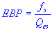 | efficiency bandwidth product
 | speaker resonance frequency
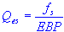 | speaker electrical Q
box or enclosure volume
 | box or enclosure volume
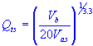 | speaker total Q at f_{s}
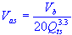 | air volume with same acoustic compliance  as the speaker suspension

box or enclosure tuning frequency
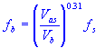 | box or enclosure tuning frequency
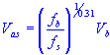 | air volume with same acoustic compliance  as the speaker suspension
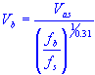 | box or enclosure volume
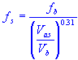 | speaker resonance frequency
box or enclosure tuning frequency
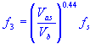 | minus three decibel half power frequency
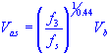 | air volume with same acoustic compliance  as the speaker suspension
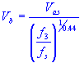 | box or enclosure volume
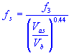 | speaker resonance frequency

peak sound pressure level
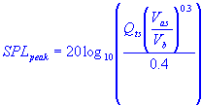 | peak sound pressure level
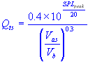 | speaker total Q at f_{s}
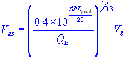 | equivalent air compliance
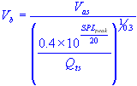 | box enclosure volume
sound pressure level
 | sound pressure level
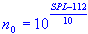 | free air reference efficiency
maximum air volume displaced by cone excursion
 | maximum air volume displaced by cone excursion
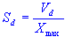 | cone effective radiation area
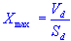 | cone peak linear displacement

cone effective radiation area
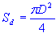 | cone effective radiation area
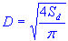 | cone diameter plus one third of surround
port or vent length
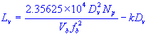 | port or vent length
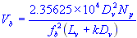 | volume of enclosure or box
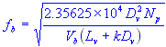 | tuning frequency
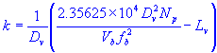 | end correction factor
minimum port or vent diameter
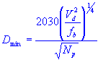 | minimum port or vent diameter
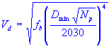 | maximum air volume displaced  by cone excursion
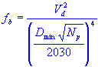 | tuning frequency

Courtesy of: http://www.ajdesigner.com/phpsubwoofervented/box_tuning_frequency_equation.php

Since all of these formulas seem quite daunting and confusing to most of us, instead of explaining each and everyone thoroughly enough and wasting your time, I’m going to list a few sites with calculators for these formulas.

Subwoofer Box Design Sites:

Subwoofer Box Calculator for Sealed, Ported, or Bandpass
http://www.ajdesigner.com/fl_subwoofer/subwoofer.php

Free Software Download for bandpass, sealed and ported subwoofer boxes
http://www.ajdesigner.com/speaker/index.php

Top of the page it brings you too… the lower part of the page explains each software in a summary

For most of the speakers/subwoofers you buy, you will get a data sheet with all of the numbers to punch in on the calculator, it may even be on their website.

Courtesy of: http://www.ajdesigner.com/fl_subwoofer/subwoofer.php

