APES UPCLYING PROJECT

WHAT IS THE 3 R’S AND UCYCLING?
The Three R's: Reduce, Reuse and Recycle. Tips on reducing waste and conserving resources. The three R's - reduce, reuse and recycle - all help to cut down on the amount of waste we throw away. They conserve natural resources, landfill space and energy.
REDUCE: Reducing the amount of waste you produce is the best way to help the environment. There are lots of ways to do this. For example: Buy products that don't have a lot of packaging. Or Start a compost bin. Some people set aside a place in their yard where they can dispose of certain food and plant materials.
REUSE: Instead of throwing things away, try to find ways to use them again.Like:Plastic containers and reusable lunch bags are great ways to take your lunch to school without creating waste.
RECYCLE: Many of the things we use every day, like paper bags, soda cans, and milk cartons, are made out of materials that can be recycled. Recycled items are put through a process that makes it possible to create new products out of the materials from the old ones.
UPCYCLING: reuse (discarded objects or material) in such a way as to create a product of a higher quality or value than the original.
WHAT IS THE DIFFERENCE BETWEEN UPCYLING AND RECYLING?
Upcycling is described as reusing a material without degrading the quality and composition of the material for its next use while recycling breaks down the material it was made of to.

INSTRUCTIONS TO BUILD A WOODEN FLOWER FRAME

Materials:
Old Wood Pieces (4 to make a rectangle shape)
2-3 Cans/Glass Drink (Used)
Nails
Hammer
Drill Machine
Flowers (Fake/Real)
Sandpaper
Saw (Electric/Manual)
Super Glue

Insructions:
- Cut Wood with a saw to make a rectangle. Adjust the width of the case to the cans/glass you will use. Use sandpaper to smooth out any cut edges.
- Next, nail the wood pieces together to make a rectangular frame.
- Next drill 2/3 holes on the top depending on the number cans you want to use.
- Align your cans to the holes on the top of the frame and super glue them to the bottom of the base of the frame.
- Place your flowers in each of the cans through the holes on the top and you have a wooden flower frame made of cans.
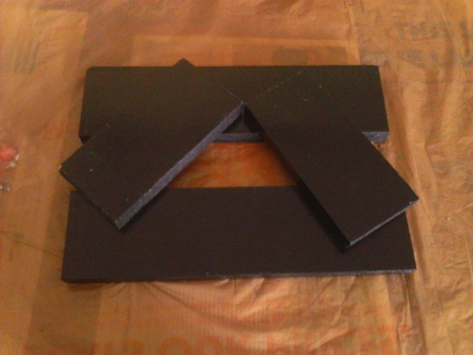
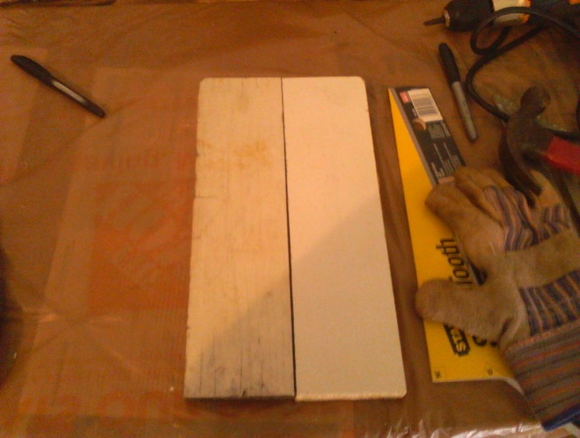
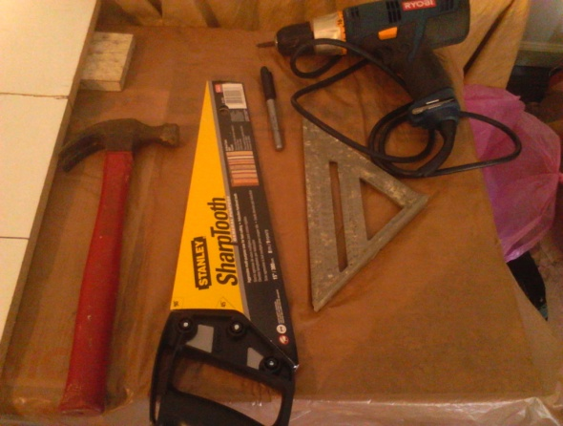
Pictures:
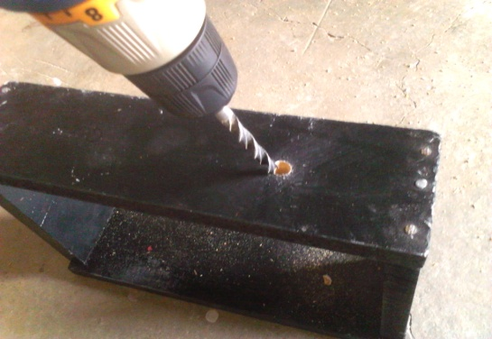

FINAL PRODUCT OF UPCYLING
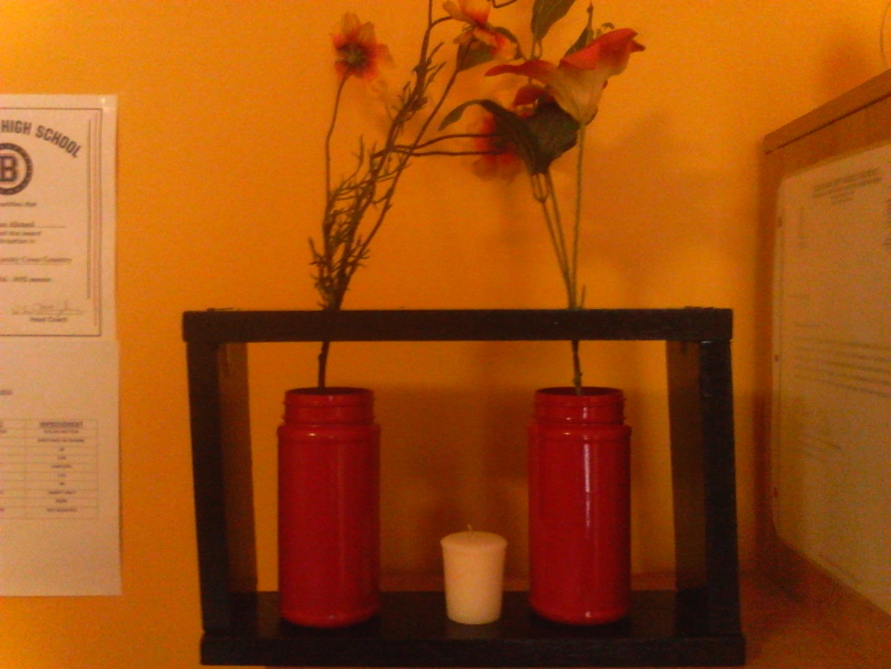

*CREDIT FROM
www.upcyclethat.com

