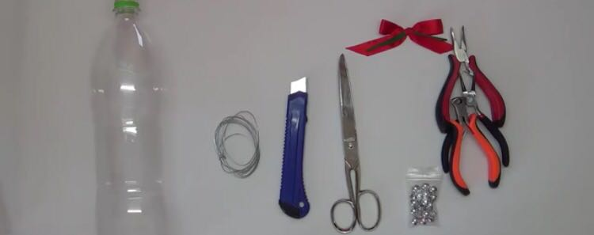

**Steps**

1. Cut the base of the bottle and mark 1cm separations along the bottle.

2. Cut some hoops/rings, using the separation marks as a guide.

3. Make two holes on every hoop, one on top and another one below the first one.

4. Cut 10cm of wire and make a knot on its top.

5. Start putting the hoops, using just one of the holes.

6. When you finish putting all the hoops, place the bun, BUT don’t cut the wire.

7. Now, cross the opposite top of the wire in the holes that you don’t use; by now it will start taking the shape of a sphere :)

8. Finally, use the rest of the wire to give it the form of a hook

9. Go ahead and place it on your christmas tree!

**MATERIALS**

**How to Create a Christmas Sphere**

* 1 plastic bottle
* Cutter
* Scissors
* Wire
* Tools for the wire
* Material to decorate (sheens, buns etc)

**Mildred Gradilla**

**José Haro**

**Miguel Casas**

**André Sosa**

**Rodrigo Gutiérrez**

